Supporting Information
Nano-scaled zeolitic imidazole framework-8 as an efficient carrier for the intracellular delivery of RNase A in cancer treatment

Jiaxin Jia, Shudi Zhang, Kai Wen, Quanshun Li*

Key Laboratory for Molecular Enzymology and Engineering of Ministry of Education, School of Life Sciences, Jilin University, Changchun 130012, China

*Corresponding author.
Tel.: +86-431-85155201; Fax: +86-431-85155200.
E-mail: quanshun@jlu.edu.cn.

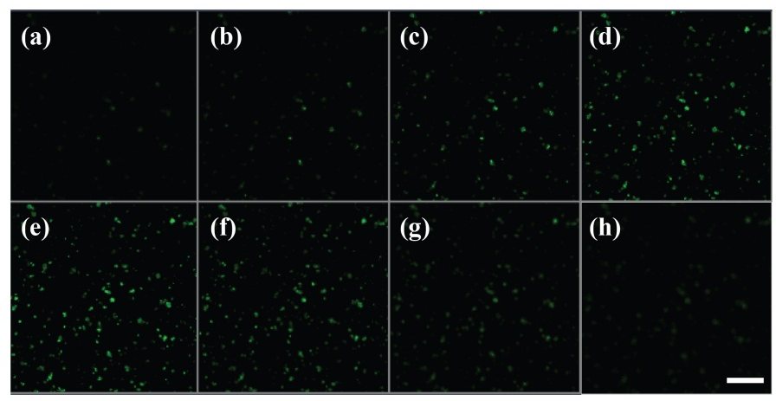
Figure S1. Layer-by-layer CLSM images of FITC-RNase A@ZIF-8 at different scanning depth along the z-axis position (a–h). Scale bar: 100 μm.

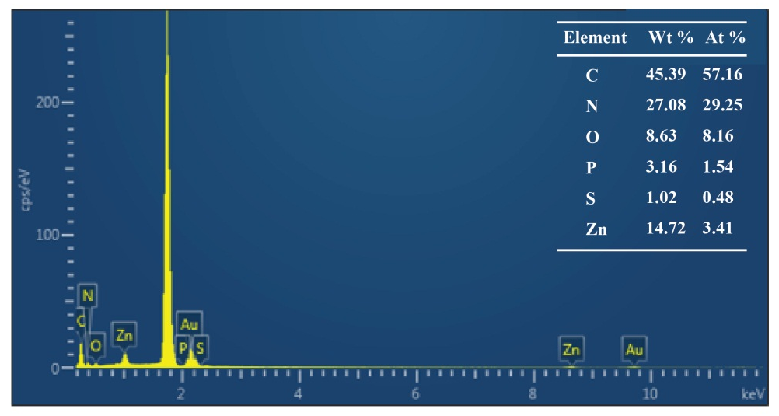
Figure S2. The EDS analysis of pure ZIF-8.

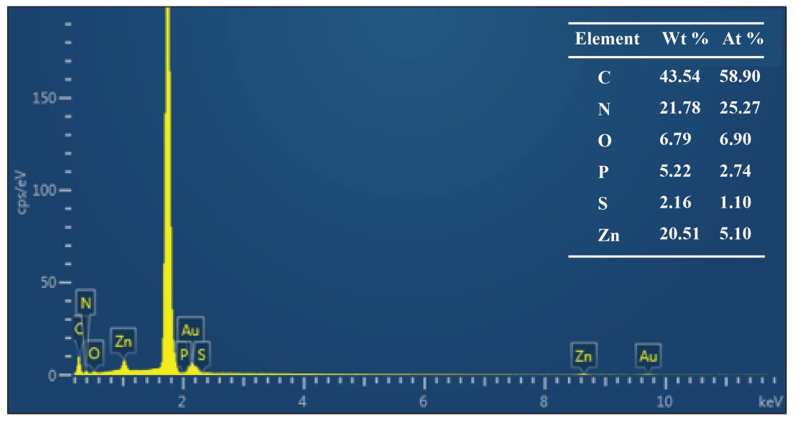
Figure S3. The EDS analysis of RNase A@ZIF-8 nanoparticles.

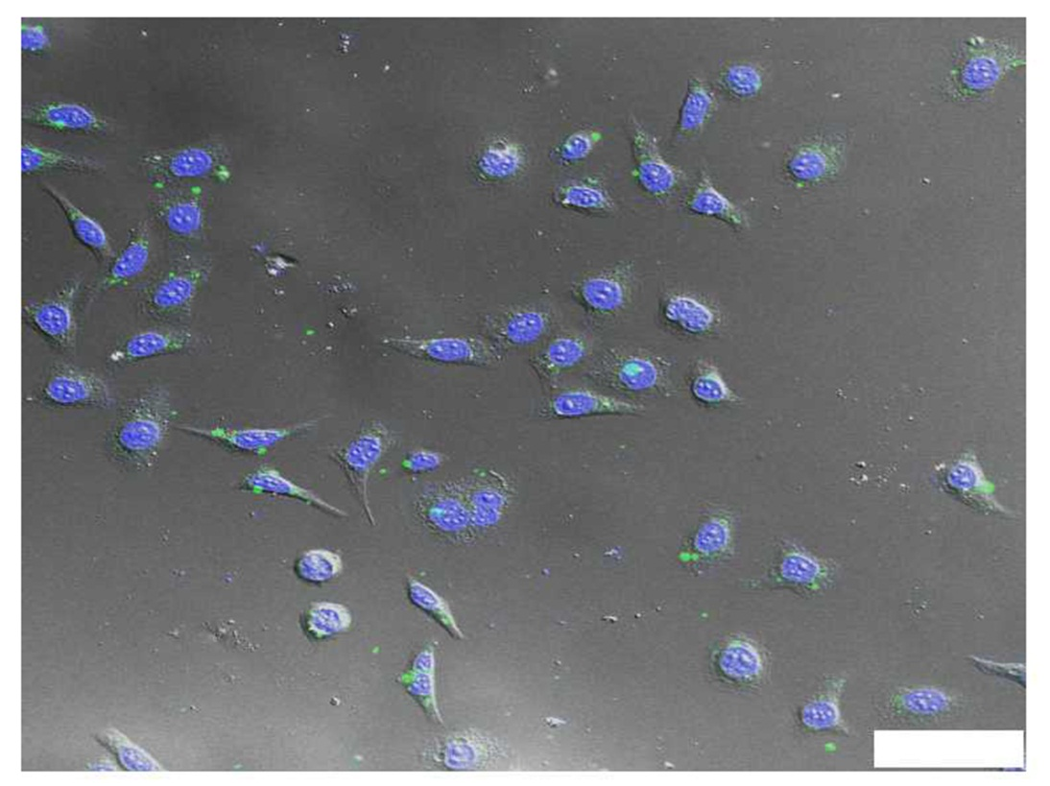
Figure S4. The cellular uptake of FITC-labelled RNase A@ZIF-8 nanoparticles in A549 cells, in which the nuclei were stained with DAPI. Scale bar: 50 μm.

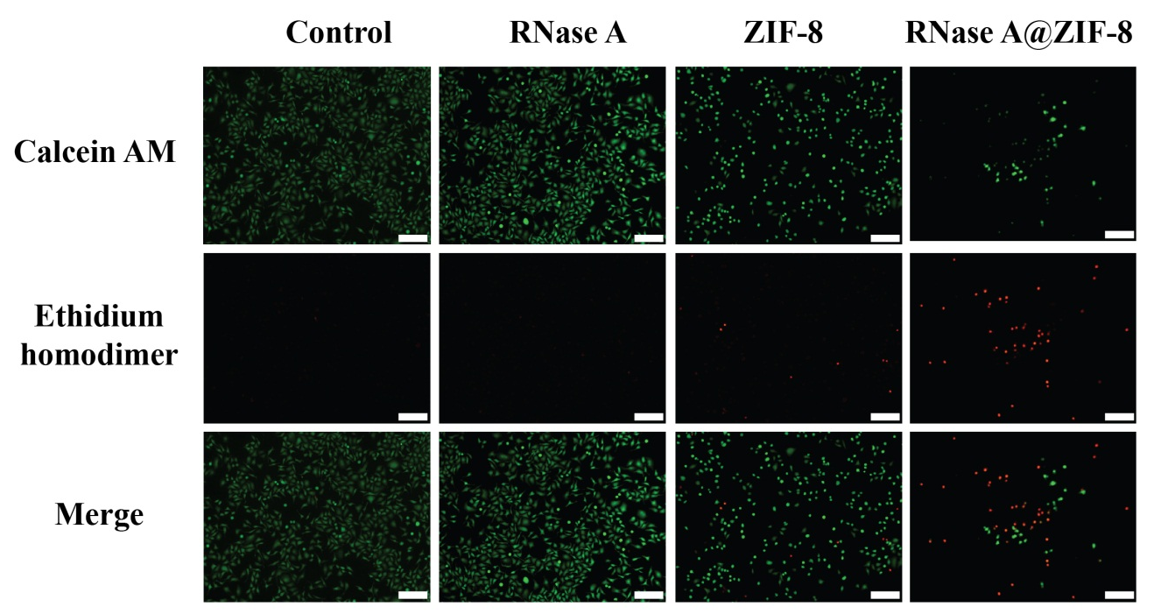
Figure S5. Live/Dead staining assay of A549 cells after the treatment with RNase A@ZIF-8 nanoparticles. Scale bar: 100 μm.

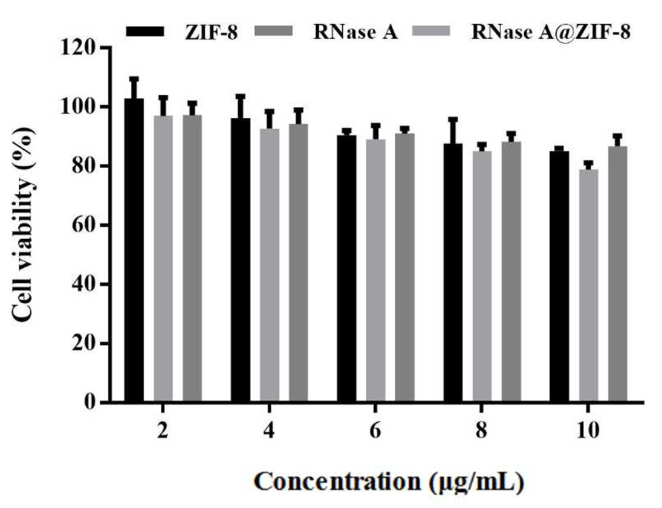
Figure S6. Cell viability as a function of ZIF-8, RNase A and RNase A@ZIF-8 nanoparticles with different concentrations, using L02 cells as a model. The dada were expressed as mean value ± SD of triplicate experiments.

