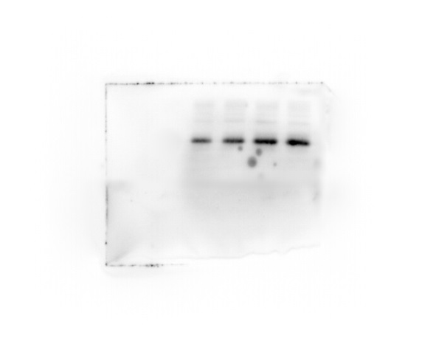
Supplement 1. Western Blot was used to detect the expression of LPL protein. From left to right, it is 0 μM、0.01μM、0.1μM and 1μM Na2SO3 treatment samples respectively.

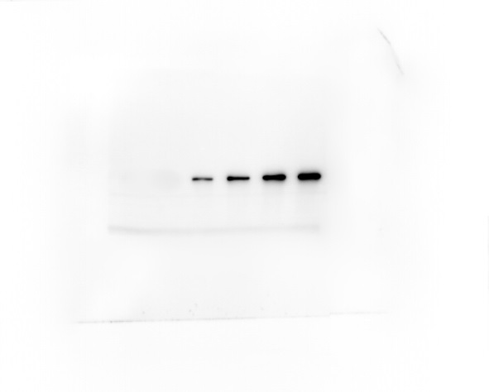
Supplement 2. Western Blot was used to detect the expression of PPARG protein. From left to right, it is 0 μM、0.01μM、0.1μM and 1μM Na2SO3 treatment samples respectively.

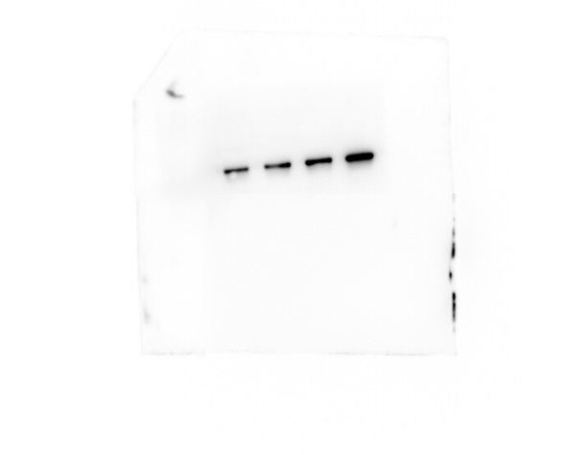
Supplement 3. Western Blot was used to detect the expression of RUNX2 protein. From left to right, it is 0 μM、0.01μM、0.1μM and 1μM Na2SO3 treatment samples respectively.

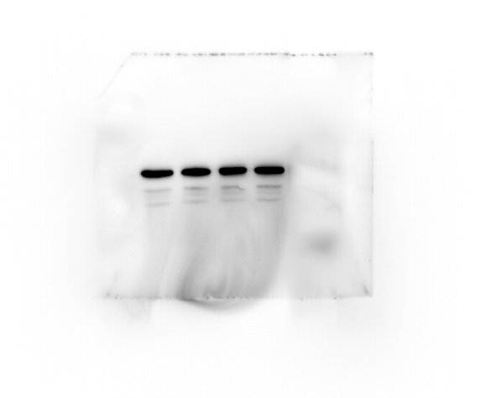
Supplement 4. Western Blot was used to detect the expression of GAPDH protein. From left to right, it is 0 μM、0.01μM、0.1μM and 1μM Na2SO3 treatment samples respectively.

