Supplementary data for:

Enhanced antibiotic activity of Ampicillin conjugated to gold nanoparticles on PEGylated rosette nanotubes
Yiwen Fan,¹ Alexander C. Pauer,¹ Arthur A. Gonzales,¹ Hicham Fenniri^{1-3,}*

¹Department of Chemical Engineering, Northeastern University, Boston, MA 02115, USA
²Department of Bioengineering, Northeastern University, Boston, MA 02115, USA
³Department of Chemistry and Chemical Biology, Northeastern University, Boston, MA 02115, USA

Figure S1 TEM images in samples (A) Au-PEG-RNT-1, (B) Au-PEG-RNT-2, (C) Au-PEG-RNT-3, and (D) Au-PEG-RNT-4. Scale bar in nm.

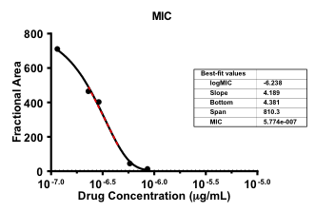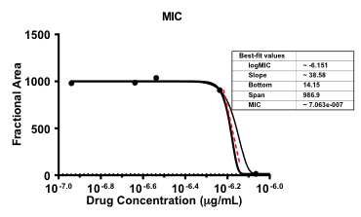
Figure S2 MIC fitting graph for Amp-AuNPs-PEG-RNT against S. aureus (left), and MIC fitting graph for ampicillin against S. aureus (right).
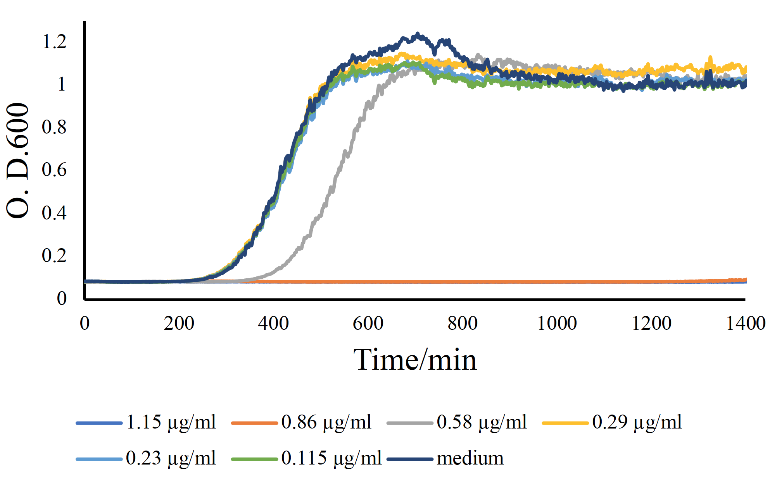
Figure S3. Bacterial growth inhibition graph for S. aureus up to 24h in the presence of ampicillin at concentrations: 1.15 μg/mL, 0.86 μg/mL, 0.58 μg/mL, 0.29 μg/mL, 0.23 μg/mL, and 0.115 μg/mL. Negative control groups received medium alone. N = 3.

