Title
Inhaled corticosteroids and risk of tuberculosis in patients with obstructive lung diseases: a systematic review and meta-analysis of non-randomized studies.

Authors
Giorgio Castellana ¹, Marco Castellana ², Carlo Castellana ³, Giuseppe Castellana ⁴, Emanuela Resta ⁵, Mauro Carone ¹, Onofrio Resta ⁶

Supplementary File
- PRISMA Checklist
- Search strategy
- e-Table 1. Risk of bias summary: review of authors’ judgements about each risk of bias item for each included retrospective cohort study.
- e-Table 2. Risk of bias summary: review of authors’ judgements about each risk of bias item for each included retrospective cohort study with nested case-control analysis.
- e-Figure 1. Forest plots of meta-analysis for difference in incident cases of tuberculosis between any ICS use and no ICS in low- and high-incidence countries.
- e-Figure 2. Forest plots of meta-analysis for difference in incident cases of tuberculosis between current ICS use and prior or ICS.
- e-Figure 3. Forest plots of meta-analysis for difference in incident cases of tuberculosis between high dose ICS use and no ICS.
- e-Figure 4. Forest plots of meta-analysis for difference in incident cases of tuberculosis between moderate dose ICS use and no ICS.
- e-Figure 5. Forest plots of meta-analysis for difference in incident cases of tuberculosis between low dose ICS use and no ICS.
- e-Table 3. Sensitivity analysis and publication bias
- References
- PRISMA Checklist

Section/topic | # | Checklist item | Reported on page #
TITLE
Title | 1 | Identify the report as a systematic review, meta-analysis, or both. | 1
ABSTRACT
Structured summary | 2 | Provide a structured summary including, as applicable: background; objectives; data sources; study eligibility criteria, participants, and interventions; study appraisal and synthesis methods; results; limitations; conclusions and implications of key findings; systematic review registration number. | 4
INTRODUCTION
Rationale | 3 | Describe the rationale for the review in the context of what is already known. | 5
Objectives | 4 | Provide an explicit statement of questions being addressed with reference to participants, interventions, comparisons, outcomes, and study design (PICOS). | 5
METHODS
Protocol and registration | 5 | Indicate if a review protocol exists, if and where it can be accessed (e.g., Web address), and, if available, provide registration information including registration number. | 5
Eligibility criteria | 6 | Specify study characteristics (e.g., PICOS, length of follow-up) and report characteristics (e.g., years considered, language, publication status) used as criteria for eligibility, giving rationale. | 6
Information sources | 7 | Describe all information sources (e.g., databases with dates of coverage, contact with study authors to identify additional studies) in the search and date last searched. | 6
Search | 8 | Present full electronic search strategy for at least one database, including any limits used, such that it could be repeated. | 6
Study selection | 9 | State the process for selecting studies (i.e., screening, eligibility, included in systematic review, and, if applicable, included in the meta-analysis). | 6
Data collection process | 10 | Describe method of data extraction from reports (e.g., piloted forms, independently, in duplicate) and any processes for obtaining and confirming data from investigators. | 6
Data items | 11 | List and define all variables for which data were sought (e.g., PICOS, funding sources) and any assumptions and simplifications made. | 6
Risk of bias in individual studies | 12 | Describe methods used for assessing risk of bias of individual studies (including specification of whether this was done at the study or outcome level), and how this information is to be used in any data synthesis. | 6-7
Summary measures | 13 | State the principal summary measures (e.g., risk ratio, difference in means). | 7
Synthesis of results | 14 | Describe the methods of handling data and combining results of studies, if done, including measures of consistency (e.g., I²) for each meta-analysis. | 7
Section/topic | # | Checklist item | Reported on page #
Risk of bias across studies | 15 | Specify any assessment of risk of bias that may affect the cumulative evidence (e.g., publication bias, selective reporting within studies). | 7
Additional analyses | 16 | Describe methods of additional analyses (e.g., sensitivity or subgroup analyses, meta-regression), if done, indicating which were pre-specified. | 7
RESULTS
Study selection | 17 | Give numbers of studies screened, assessed for eligibility, and included in the review, with reasons for exclusions at each stage, ideally with a flow diagram. | 7
Study characteristics | 18 | For each study, present characteristics for which data were extracted (e.g., study size, PICOS, follow-up period) and provide the citations. | Table 1
Risk of bias within studies | 19 | Present data on risk of bias of each study and, if available, any outcome level assessment (see item 12). | 8
Results of individual studies | 20 | For all outcomes considered (benefits or harms), present, for each study: (a) simple summary data for each intervention group (b) effect estimates and confidence intervals, ideally with a forest plot. | Figure 2,3; e-Figure 1-5
Synthesis of results | 21 | Present results of each meta-analysis done, including confidence intervals and measures of consistency. | 8-9
Risk of bias across studies | 22 | Present results of any assessment of risk of bias across studies (see Item 15). | 9
Additional analysis | 23 | Give results of additional analyses, if done (e.g., sensitivity or subgroup analyses, meta-regression [see Item 16]). | 9
DISCUSSION
Summary of evidence | 24 | Summarize the main findings including the strength of evidence for each main outcome; consider their relevance to key groups (e.g., healthcare providers, users, and policy makers). | 9
Limitations | 25 | Discuss limitations at study and outcome level (e.g., risk of bias), and at review-level (e.g., incomplete retrieval of identified research, reporting bias). | 10-11
Conclusions | 26 | Provide a general interpretation of the results in the context of other evidence, and implications for future research. | 11
FUNDING
Funding | 27 | Describe sources of funding for the systematic review and other support (e.g., supply of data); role of funders for the systematic review. | 2

From: Moher D, Liberati A, Tetzlaff J, Altman DG, The PRISMA Group (2009). Preferred Reporting Items for Systematic Reviews and Meta-Analyses: The PRISMA Statement. PLoS Med 6(7): e1000097. doi:10.1371/journal.pmed1000097 For more information, visit: www.prisma-statement.org.

- Search strategy

Pubmed
((((((tuberculosis) OR mycobacterium) OR tubercular) OR TB))) AND (((ICS) OR ((((((beclomethasone) OR budesonide) OR flunisolide) OR fluticasone) OR mometasone) OR triamcinolone)) OR (((((inhalatory) OR Inhaled)) AND ((((((glucocorticoid) OR glucocorticoids) OR steroid) OR steroids) OR Corticosteroid) OR Corticosteroids))))

CENTRAL
#1 beclomethasone
#2 budesonide
#3 flunisolide
#4 fluticasone
#5 mometasone
#6 triamcinolone
#7 #1 or #2 or #3 or #4 or #5 or #6
#8 Inhaled
#9 inhalatory
#10 #8 or #9
#11 Corticosteroids
#12 Corticosteroid
#13 steroids
#14 steroid
#15 glucocorticoids
#16 glucocorticoid
#17 #11 or #12 or #13 or #14 or #15 or #16
#18 #10 and #17
#19 "ICS"
#20 #18 or #19
#21 tuberculosis
#22 mycobacterium
#23 tubercular
#24 "TB"
#25 #21 or #22 or #23 or #24
#26 #20 or #7
#27 #26 and #25

Web of Science
(((((((tuberculosis) OR mycobacterium) OR tubercular) OR TB))) AND (((ICS) OR ((((((beclomethasone) OR budesonide) OR flunisolide) OR fluticasone) OR mometasone) OR triamcinolone)) OR (((((inhalatory) OR Inhaled)) AND ((((((glucocorticoid) OR glucocorticoids) OR steroid) OR steroids) OR Corticosteroid) OR Corticosteroids)))))

Scopus
( tuberculosis OR mycobacterium OR tubercular OR tb ) AND ( ( ( inhalatory OR inhaled ) AND ( glucocorticoid OR glucocorticoids OR steroid OR steroids OR corticosteroid OR corticosteroids ) ) OR ( beclomethasone OR budesonide OR flunisolide OR fluticasone OR mometasone OR triamcinolone ) OR ( ics ) ) AND ( LIMIT-TO ( DOCTYPE , "ar" ) ) AND ( LIMIT-TO ( SUBJAREA , "MEDI" ) )

e-Table 1. Risk of bias summary: review of authors’ judgements about each risk of bias item for each included retrospective cohort study.

Question | 1 | 2 | 3 | 4 | 5 | 6 | 7 | 8 | 9 | 10 | 11 | 12 | Total
Brassard, 2011¹ | Yes | Yes | No | Yes | Yes | Yes | Yes | Yes | Yes | Yes | NR | Yes | 10/12
Brode, 2017² | Yes | Yes | No | Yes | Yes | Yes | Yes | NR | Yes | Yes | NR | Yes | 9/12
Chung, 2014³ | Yes | Yes | No | Yes | Yes | Yes | Yes | Yes | Yes | Yes | NR | Yes | 10/12
Jian, 2016⁴ | Yes | Yes | No | Yes | Yes | Yes | Yes | Yes | Yes | Yes | NR | Yes | 10/12
Lee, 2013⁵ | Yes | Yes | No | Yes | Yes | Yes | Yes | Yes | Yes | Yes | NR | Yes | 10/12
Wu, 2016⁶ | Yes | Yes | No | Yes | Yes | Yes | Yes | Yes | Yes | Yes | NR | Yes | 10/12
Yeh, 2016⁷ | Yes | Yes | No | Yes | Yes | Yes | Yes | NR | Yes | No | NR | Yes | 8/12

Questions:
1. Was the research question or objective in this paper clearly stated and appropriate?
2. Was the study population clearly specified and defined?
3. Did the authors include a sample size justification?
4. Were controls selected or recruited from the same or similar population that gave rise to the cases (including the same timeframe)?
5. Were the definitions, inclusion and exclusion criteria, algorithms or processes used to identify or select cases and controls valid, reliable, and implemented consistently across all study participants?
6. Were the cases clearly defined and differentiated from controls?
7. If less than 100 percent of eligible cases and/or controls were selected for the study, were the cases and/or controls randomly selected from those eligible?
8. Was there use of concurrent controls?
9. Were the investigators able to confirm that the exposure/risk occurred prior to the development of the condition or event that defined a participant as a case?
10. Were the measures of exposure/risk clearly defined, valid, reliable, and implemented consistently (including the same time period) across all study participants?
11. Were the assessors of exposure/risk blinded to the case or control status of participants?
12. Were key potential confounding variables measured and adjusted statistically in the analyses? If matching was used, did the investigators account for matching during study analysis?

e-Table 2. Risk of bias summary: review of authors’ judgements about each risk of bias item for each included retrospective cohort study with nested case-control analysis.
Question | 1 | 2 | 3 | 4 | 5 | 6 | 7 | 8 | 9 | 10 | 11 | 12 | 13 | 14 | Total
Kim, 2013⁸ | Yes | Yes | Yes | Yes | No | Yes | No | Yes | Yes | Yes | Yes | Yes | n.a. | Yes | 11/14
Shu, 2010⁹ | Yes | Yes | Yes | Yes | No | Yes | Yes | Yes | Yes | Yes | Yes | NR | n.a. | Yes | 11/14

Questions:
1. Was the research question or objective in this paper clearly stated?
2. Was the study population clearly specified and defined?
3. Was the participation rate of eligible persons at least 50%?
4. Were all the subjects selected or recruited from the same or similar populations (including the same time period)? Were inclusion and exclusion criteria for being in the study prespecified and applied uniformly to all participants?
5. Was a sample size justification, power description, or variance and effect estimates provided?
6. For the analyses in this paper, were the exposure(s) of interest measured prior to the outcome(s) being measured?
7. Was the timeframe sufficient so that one could reasonably expect to see an association between exposure and outcome if it existed?
8. For exposures that can vary in amount or level, did the study examine different levels of the exposure as related to the outcome (e.g., categories of exposure, or exposure measured as continuous variable)?
9. Were the exposure measures (independent variables) clearly defined, valid, reliable, and implemented consistently across all study participants?
10. Was the exposure(s) assessed more than once over time?
11. Were the outcome measures (dependent variables) clearly defined, valid, reliable, and implemented consistently across all study participants?
12. Were the outcome assessors blinded to the exposure status of participants?
13. Was loss to follow-up after baseline 20% or less?
14. Were key potential confounding variables measured and adjusted statistically for their impact on the relationship between exposure(s) and outcome(s)?

e-Figure 1. Forest plots of meta-analysis for difference in incident cases of tuberculosis between any ICS use and no ICS in low- and high-incidence countries.
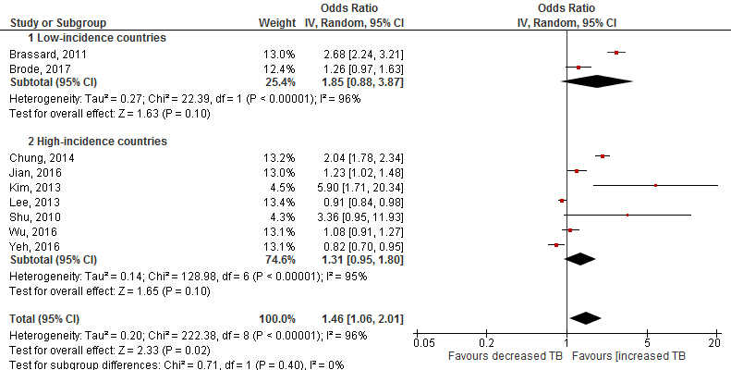

e-Figure 2. Forest plots of meta-analysis for difference in incident cases of tuberculosis between current ICS use and prior or no ICS.
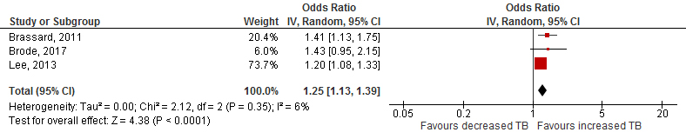
e-Figure 3. Forest plots of meta-analysis for difference in incident cases of tuberculosis between high dose ICS use and no ICS.
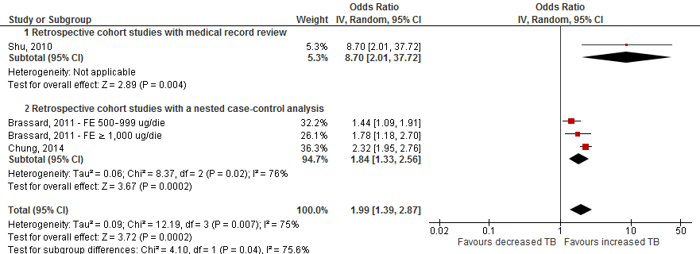

e-Figure 4. Forest plots of meta-analysis for difference in incident cases of tuberculosis between moderate dose ICS use and no ICS.
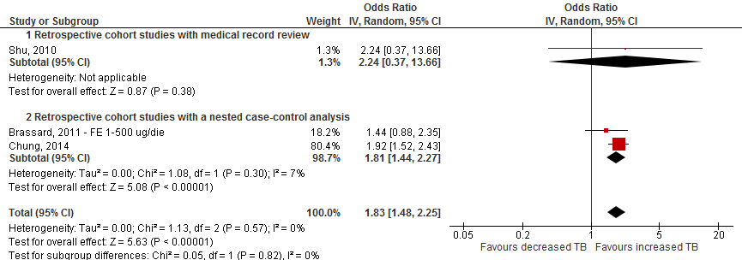

e-Figure 5. Forest plots of meta-analysis for difference in incident cases of tuberculosis between low dose ICS use and no ICS.
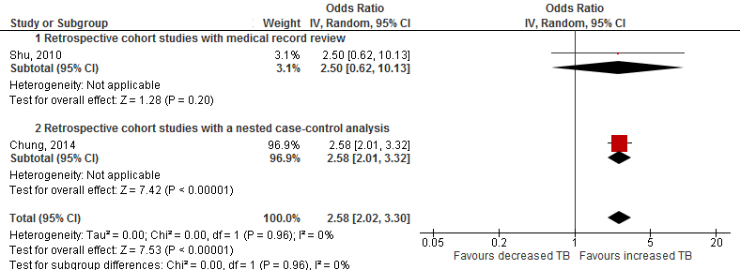

e-Table 3. Sensitivity analysis and publication bias.
Author, year | any ICS use  versus no ICS | any ICS use and no ICS with or without simultaneous OCS | current ICS use versus prior or no ICS | high dose ICS use versus no ICS | moderate dose ICS use versus no ICS | low dose ICS use versus no ICS
Brassard, 2011¹ | 0.08 | 0.02 | 0.001 | 0.04 | 0.001 | -
Brode, 2017² | 0.02 | - | 0.002 | - | - | -
Chung, 2014³ | 0.05 | 0.01 | - | 0.01 | 0.10 | n.a.
Jian, 2016⁴ | 0.03 | - | - | - | - | -
Kim, 2013⁸ | 0.11 | - | - | - | - | -
Lee, 2013⁵ | 0.08 | 0.04 | 0.001 | - | - | -
Shu, 2010⁹ | 0.11 | 0.05 | - | 0.001 | 0.001 | n.a.
Wu, 2016⁶ | 0.02 | - | - | - | - | -
Yeh, 2016⁷ | 0.06 | - | - | - | - | -
Egger’s test | 0.262 | 0.867 | 0.308 | 0.869 | 0.807 | n.a.

References
- Brassard P, Suissa S, Kezouh A, Ernst P. Inhaled corticosteroids and risk of tuberculosis in patients with respiratory diseases. Am J Respir Crit Care Med. 2011;183(5):675-8.
- Brode SK, Campitelli MA, Kwong JC, et al. The risk of mycobacterial infections associated with inhaled corticosteroid use. Eur Respir J. 2017;50(3):1700037.
- Chung WS, Chen YF, Hsu JC, Yang WT, Chen SC, Chiang JY. Inhaled corticosteroids and the increased risk of pulmonary tuberculosis: a population-based case-control study. Int J Clin Pract. 2014;68(10):1193-9.
- Jian ZH, Huang JY, Lin FC, et al. Post-Inhaled Corticosteroid Pulmonary Tuberculosis Increases Lung Cancer in Patients with Asthma. PLoS One. 2016;11(7):e0159683.
- Lee CH, Kim K, Hyun MK, Jang EJ, Lee NR, Yim JJ. Use of inhaled corticosteroids and the risk of tuberculosis. Thorax. 2013;68(12):1105-13.
- Wu MF, Jian ZH, Huang JY, et al. Post-inhaled corticosteroid pulmonary tuberculosis and pneumonia increases lung cancer in patients with COPD. BMC Cancer. 2016;16(1):778.
- Yeh JJ, Wang YC, Kao CH. Asthma-Chronic Obstructive Pulmonary Diseases Overlap Syndrome Increases the Risk of Incident Tuberculosis: A National Cohort Study. PLoS One. 2016;11(7):e0159012.
- Kim JH, Park JS, Kim KH, Jeong HC, Kim EK, Lee JH. Inhaled corticosteroid is associated with an increased risk of TB in patients with COPD. Chest. 2013;143(4):1018-24.
- Shu CC, Wu HD, Yu MC, et al. Use of high-dose inhaled corticosteroids is associated with pulmonary tuberculosis in patients with chronic obstructive pulmonary disease. Medicine (Baltimore). 2010;89(1):53-61.

