Supplementary materials

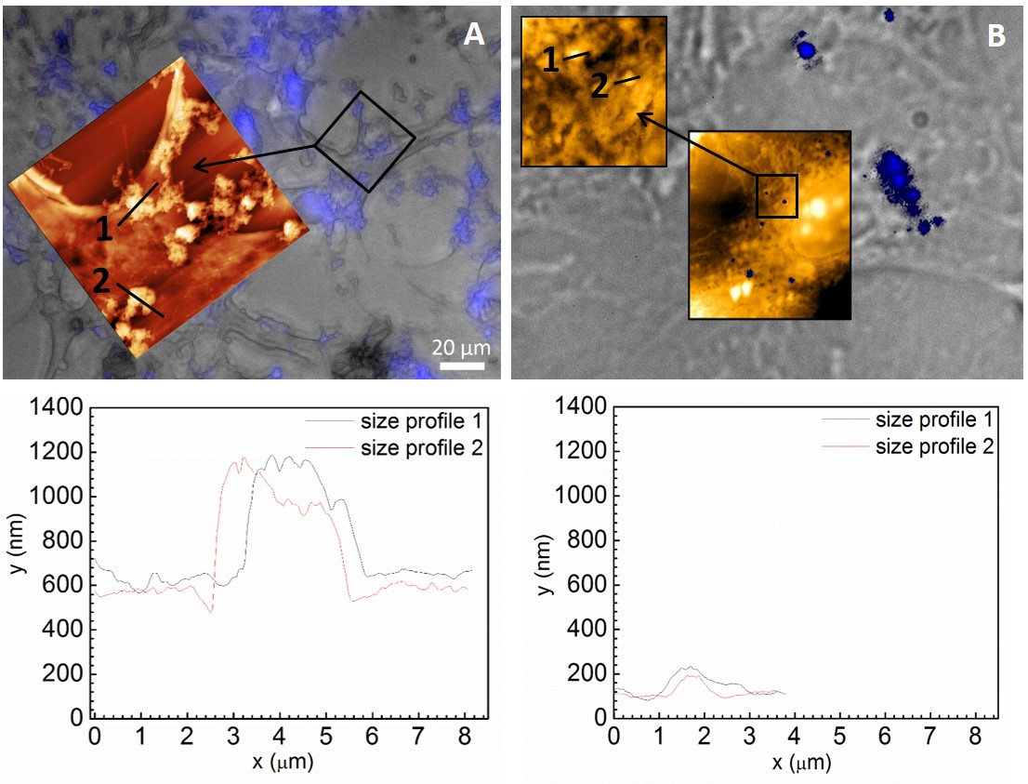
Figure S1 N-TER peptide – FluoNTC complexes (blue colored) at high (100 nM, image A) and low (5 nM, image B) nucleic acid concentrations on formaldehyde-fixated 3T3-L1 preadipocytes. Topography and cellular adhesion of the complexes are visualized by using a triple combination of AFM, BF and fluorescence microscopy at the same sample area. Corresponding size cross section profiles 1 and 2 of exemplary fluorescent complexes are presented at high (100nM, size cross section profile, left below) and low (5nM, size cross section profile, right below) nucleic acid concentrations being adhered to the surface of 3T3-L1 preadipocytes.

