Supplementary materials
- Carcinomas, Renal Cell
- Renal Cell Carcinomas
- Adenocarcinoma, Renal Cell
- Adenocarcinomas, Renal Cell
- Renal Cell Adenocarcinoma
- Renal Cell Adenocarcinomas
- Adenocarcinoma Of Kidney
- Adenocarcinoma Of Kidneys
- Kidney, Adenocarcinoma Of
- Kidneys, Adenocarcinoma Of
- Renal Cell Cancer
- Cancer, Renal Cell
- Cancers, Renal Cell
- Renal Cell Cancers
- Adenocarcinoma, Renal
- Adenocarcinomas, Renal
- Renal Adenocarcinoma
- Renal Adenocarcinomas
- Nephroid Carcinoma
- Carcinoma, Nephroid
- Carcinomas, Nephroid
- Nephroid Carcinomas
- Renal Cell Carcinoma
- Chromophobe Renal Cell Carcinoma
- Sarcomatoid Renal Cell Carcinoma
- Papillary Renal Cell Carcinoma
- Renal Cell Carcinoma, Papillary
- Chromophil Renal Cell Carcinoma
- Clear Cell Renal Cell Carcinoma
- Grawitz Tumor
- Tumor, Grawitz
- Clear Cell Renal Carcinoma
- Carcinoma, Hypernephroid
- Carcinomas, Hypernephroid
- Hypernephroid Carcinoma
- Hypernephroid Carcinomas
- Hypernephroma
- Hypernephromas
- Collecting Duct Carcinoma (Kidney)
- Carcinoma, Collecting Duct (Kidney)
- Carcinomas, Collecting Duct (Kidney)
- Collecting Duct Carcinomas (Kidney)
- Collecting Duct Carcinoma of the Kidney
- Renal Collecting Duct Carcinoma
- Collecting Duct Carcinoma
- Carcinoma, Collecting Duct
- Carcinomas, Collecting Duct
- Collecting Duct Carcinomas

- Dehydrogenase, Succinate
- Succinic Dehydrogenase
- Dehydrogenase, Succinic
- Succinic Oxidase
- Oxidase, Succinic
- Fumarate Reductase
- Reductase, Fumarate

PUBMED

History
Download historyClear history
Recent queries
Search | Add to builder | Query | Items found | Time
#29 | Add | Search ((("succinate dehydrogenase"[Title/Abstract]) OR "sdh mutations"[Title/Abstract]) AND "renal cell carcinoma"[Title/Abstract]) AND ("1990/01/01"[Date - Publication] : "2018/02/24"[Date - Publication]) | 74 | 08:31:45
#13 | Add | Search (((((Succinate dehydrogenase[Title/Abstract]) OR SDH[Title/Abstract]) AND "renal cell cancer"[Title/Abstract]) OR "kidney cell"[Title/Abstract]) OR Kidney cancers[Title/Abstract]) AND ("1990/01/01"[Date - Publication] : "2018/02/24"[Date - Publication]) | 2832 | 08:28:40
#12 | Add | Search ((((("succinate"[Title/Abstract]) OR "sdh mutations"[Title/Abstract]) OR "fumarate reductase"[Title/Abstract]) AND Renal[Title/Abstract]) OR Kidney[Title/Abstract]) AND ("1990/01/01"[Date - Publication] : "2018/02/24"[Date - Publication]) | 281443 | 08:12:10
#8 | Add | Search (("kidney cancer"[Title/Abstract]) AND "succinate dehydrogenase"[Title/Abstract]) AND ("1990/01/01"[Date - Publication] : "2018/02/24"[Date - Publication]) | 12 | 08:01:36
#7 | Add | Search ((("succinic dehydrogenase"[Title/Abstract]) AND "renal cell carcinoma"[Title/Abstract]) AND ("1990/01/01"[Date - Publication] : "2018/02/25"[Date - Publication]))/ | 1 | 01:57:32
#6 | Add | Search (("succinic dehydrogenase"[Title/Abstract]) AND "renal cell carcinoma"[Title/Abstract]) AND ("1990/0101"[Date - Publication] : "2018/02/25"[Date - Publication]) | 1 | 01:56:52
#5 | Add | Search Succinate dehydrogenase[Title/Abstract] | 6777 | 01:55:02

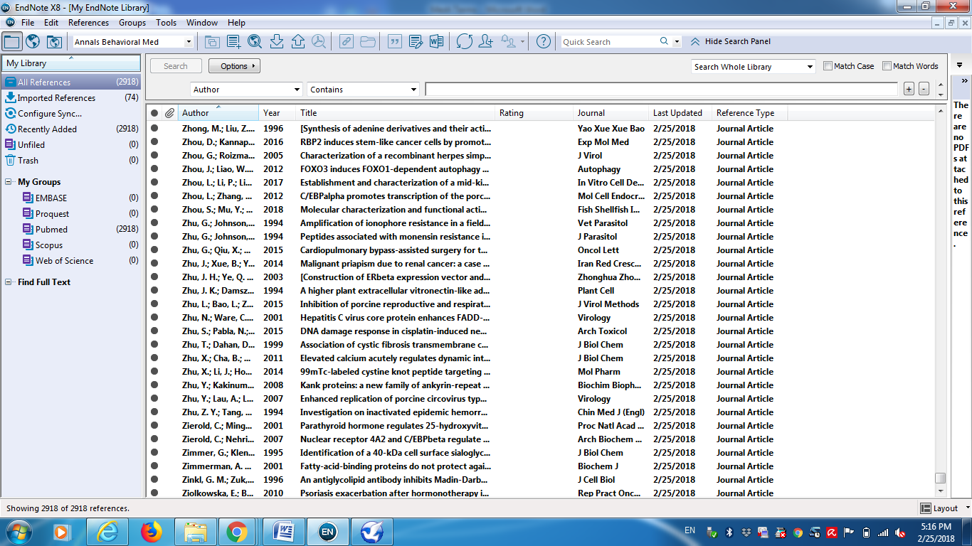

Web of Science
1 | TOPIC:("Succinate dehydrogenase") ANDTOPIC: ("renal cell")  Timespan: 1990-2018. Indexes: SCI-EXPANDED, SSCI, CPCI-S, CPCI-SSH, ESCI. | 178 | NNR: 20
 | TOPIC:("Succinate dehydrogenase") ORTOPIC: ("SDH")  Timespan: 1990-2018. Indexes: SCI-EXPANDED, SSCI, CPCI-S, CPCI-SSH, ESCI. | 9,475
 | You searched for: TOPIC: ("renal cell cancer") OR TOPIC: ("kidney")  Timespan: 1990-2018. Indexes: SCI-EXPANDED, SSCI, CPCI-S, CPCI-SSH, ESCI. | 372,647
 | #3 AND #2  Timespan: 1990-2018. Indexes: SCI-EXPANDED, SSCI, CPCI-S, CPCI-SSH, ESCI.  # 3:  TOPIC: ("renal cell cancer") OR TOPIC: ("kidney")  Indexes=SCI-EXPANDED, SSCI, CPCI-S, CPCI-SSH, ESCI Timespan=1990-2018  #2:  TOPIC: ("Succinate dehydrogenase") OR TOPIC: ("SDH")  Indexes=SCI-EXPANDED, SSCI, CPCI-S, CPCI-SSH, ESCI Timespan=1990-2018 | 276
 | TOPIC: ("renal cell carcinoma") AND TOPIC:("Succinate dehydrogenase")  Timespan: 1990-2018. Indexes: SCI-EXPANDED, SSCI, CPCI-S, CPCI-SSH, ESCI. | 147
 | TOPIC: ("renal cell ") AND TOPIC: ("Succinate dehydrogenase mutation")  Timespan: 1990-2018. Indexes: SCI-EXPANDED, SSCI, CPCI-S, CPCI-SSH, ESCI. | 2
 | TOPIC: ("renal cell carcinoma") AND TOPIC:("Succinate dehydrogenase")  Timespan: 1990-2018. Indexes: SCI-EXPANDED, SSCI, CPCI-S, CPCI-SSH, ESCI. | 147
 | TOPIC:("kidney cancers") AND TOPIC:("Succinate dehydrogenase")  Timespan: 1990-2018. Indexes: SCI-EXPANDED, SSCI, CPCI-S, CPCI-SSH, ESCI. | 8

Search History: Web of Science Core Collection
Set | Results |  | Edit Sets | Combine Sets  AND OR | Delete Sets
# 8 | 8 | TOPIC: ("kidney cancers") AND TOPIC: ("Succinate dehydrogenase")  Indexes=SCI-EXPANDED, SSCI, CPCI-S, CPCI-SSH, ESCI Timespan=1990-2018 | Edit
# 7 | 147 | TOPIC: ("renal cell carcinoma") AND TOPIC: ("Succinate dehydrogenase")  Indexes=SCI-EXPANDED, SSCI, CPCI-S, CPCI-SSH, ESCI Timespan=1990-2018 | Edit
# 6 | 2 | TOPIC: ("renal cell ") AND TOPIC: ("Succinate dehydrogenase mutation")  Indexes=SCI-EXPANDED, SSCI, CPCI-S, CPCI-SSH, ESCI Timespan=1990-2018 | Edit
# 5 | 147 | TOPIC: ("renal cell carcinoma") AND TOPIC: ("Succinate dehydrogenase")  Indexes=SCI-EXPANDED, SSCI, CPCI-S, CPCI-SSH, ESCI Timespan=1990-2018 | Edit
# 4 | 276 | #3 AND #2  Indexes=SCI-EXPANDED, SSCI, CPCI-S, CPCI-SSH, ESCI Timespan=1990-2018 | Edit
# 3 | 372,647 | TOPIC: ("renal cell cancer") OR TOPIC: ("kidney")  Indexes=SCI-EXPANDED, SSCI, CPCI-S, CPCI-SSH, ESCI Timespan=1990-2018 | Edit
# 2 | 9,475 | TOPIC: ("Succinate dehydrogenase") OR TOPIC: ("SDH")  Indexes=SCI-EXPANDED, SSCI, CPCI-S, CPCI-SSH, ESCI Timespan=1990-2018 | Edit
# 1 | 178 | TOPIC: ("Succinate dehydrogenase") AND TOPIC: ("renal cell")  Indexes=SCI-EXPANDED, SSCI, CPCI-S, CPCI-SSH, ESCI Timespan=1990-2018 | Edit
 |  |  |  | AND OR
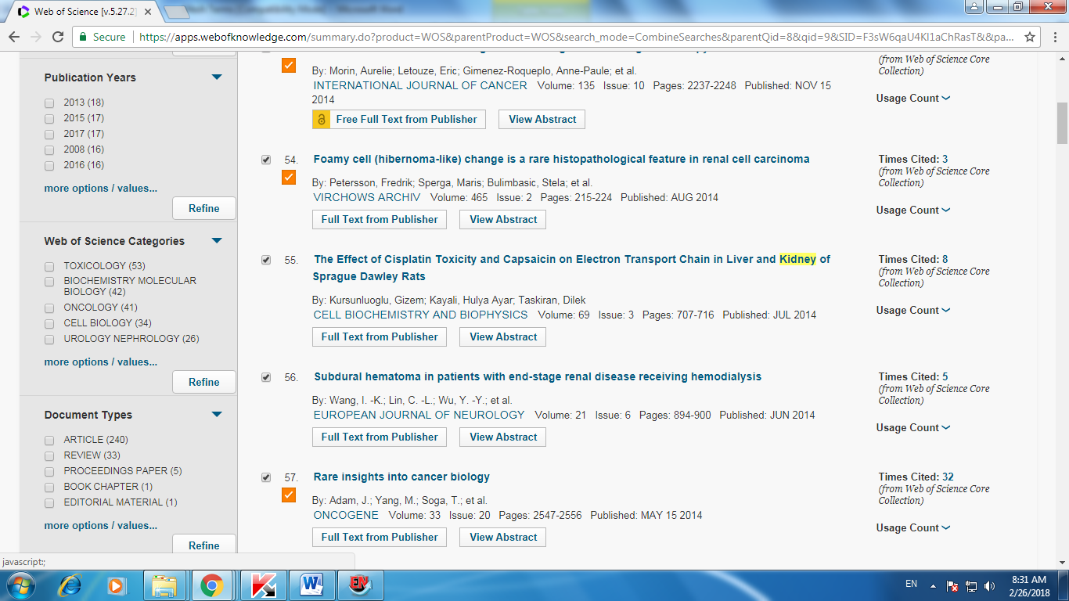
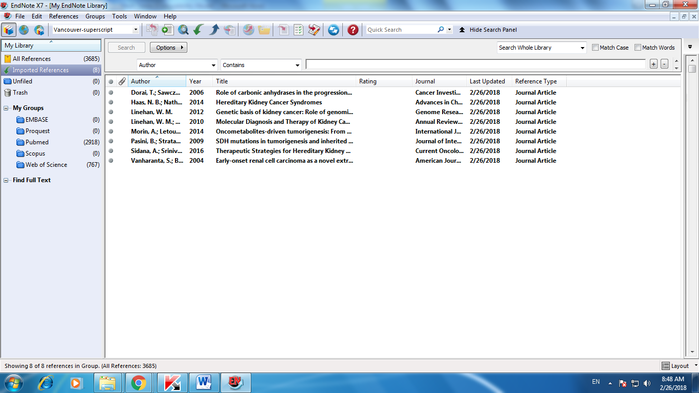

Scopus
1 | ( TITLE-ABS-KEY ( "succinate dehydrogenase" ) AND TITLE-ABS-KEY ( "renal cell carcinoma" ) OR TITLE-ABS-KEY ( "renal cell cancer" ) ) AND PUBYEAR > 1989 | 156
 | ( TITLE-ABS-KEY ( "succinate dehydrogenase" ) OR TITLE-ABS-KEY ( "SDH" ) AND TITLE-ABS-KEY ( "renal cell cancer" ) OR TITLE-ABS-KEY ( "kidney cancer" ) ) AND PUBYEAR > 1989 | 82
 | ( TITLE-ABS-KEY ( "succinate dehydrogenase" ) OR TITLE-ABS-KEY ( "SDH" ) AND TITLE-ABS-KEY ( "renal cell" ) OR TITLE-ABS-KEY ( "kidney cancer" ) ) AND PUBYEAR > 1989 | 209
 | ( TITLE-ABS-KEY ( "succinate dehydrogenase" ) OR TITLE-ABS-KEY ( "SDH" ) AND TITLE-ABS-KEY ( "kidney" ) ) AND PUBYEAR > 1989 | 716
 | ( TITLE-ABS-KEY ( "succinate dehydrogenase" ) OR TITLE-ABS-KEY ( "SDH" ) AND TITLE-ABS-KEY ( "renal cell" ) ) AND PUBYEAR > 1989 | 193
 | ( TITLE-ABS-KEY ( "succinate dehydrogenase" ) OR TITLE-ABS-KEY ( "SDH" ) OR TITLE-ABS-KEY ( fumarate ) AND TITLE-ABS-KEY ( "renal cell" ) OR TITLE-ABS-KEY ( "kidney" ) ) AND PUBYEAR > 1989 | 1,814
 | ( TITLE-ABS-KEY ( "succinate dehydrogenase" ) OR TITLE-ABS-KEY ( "SDH" ) AND TITLE-ABS-KEY ( "renal cell" ) OR TITLE-ABS-KEY ( "kidney" ) ) AND PUBYEAR > 1989 | 749
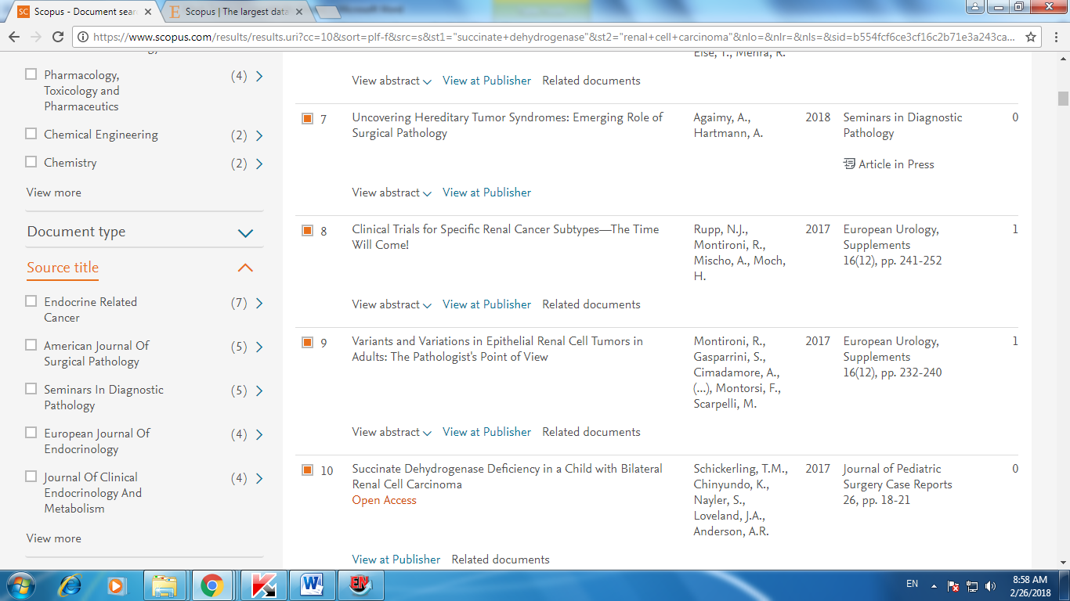
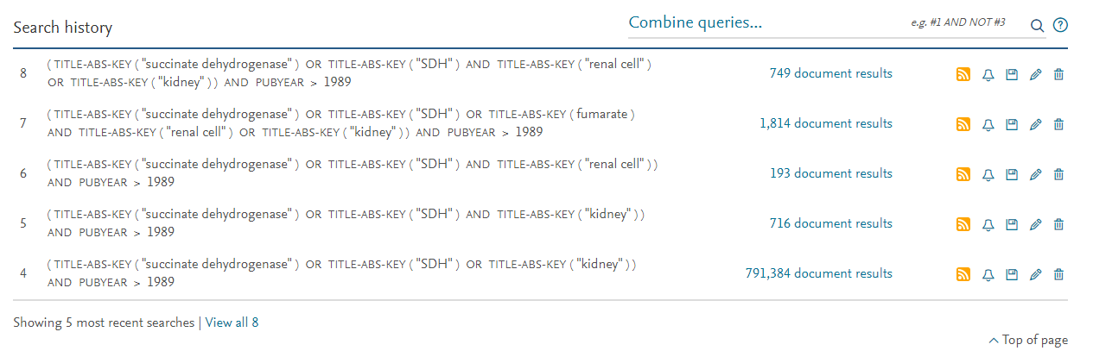

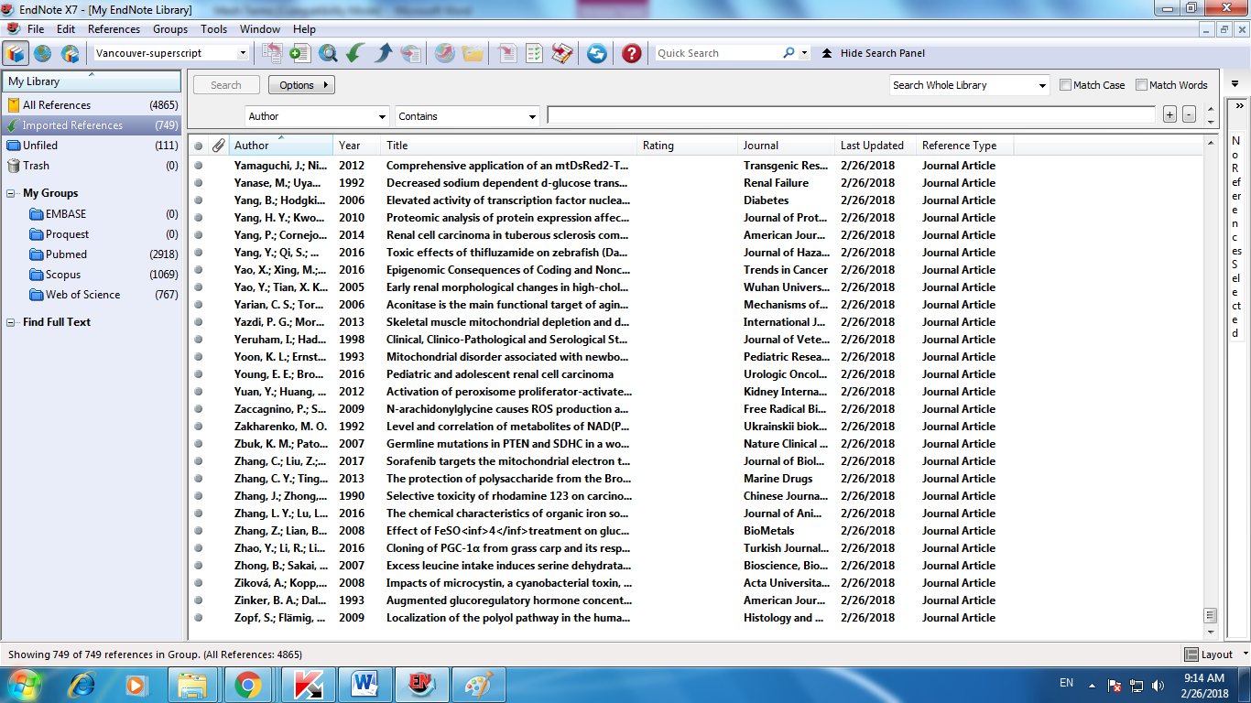

EMBASE
 | 'renal cell carcinoma':ab,ti AND 'succinate dehydrogenase':ab,ti AND [2018-2018]/py | 5
 | (('renal cell':ab,ti OR 'kidney':ab,ti) AND 'succinate dehydrogenase':ab,ti OR 'sdh gene':ab,ti) AND [1990-2018]/py | 356
 | ('renal cell':ab,ti AND 'succinate dehydrogenase (ubiquinone)':ab,ti OR 'sdh gene':ab,ti) AND [1990-2018]/py | 90
 | (('succinate dehydrogenase (ubiquinone)':ab,ti OR 'succinate dehydrogenase':ab,ti OR 'sdh gene':ab,ti) AND 'kidney disease':ab,ti OR 'urinary tract':ab,ti OR 'renal cell carcinoma':ab,ti) AND [1990-2018]/py | 116,939
 | ('succinate dehydrogenase':ab,ti OR 'sdh gene mutations':ab,ti) AND [1990-2018]/py | 4816
 | Ombine #11 AND #13  #11(('succinate dehydrogenase (ubiquinone)':ab,ti OR 'succinate dehydrogenase':ab,ti OR 'sdh gene':ab,ti) AND 'kidney disease':ab,ti OR 'urinary tract':ab,ti OR 'renal cell carcinoma':ab,ti) AND [1990-2018]/py  #13('succinate dehydrogenase':ab,ti OR 'sdh gene mutations':ab,ti) AND [1990-2018]/py | 111
 | Combine #4 AND #5 | 5
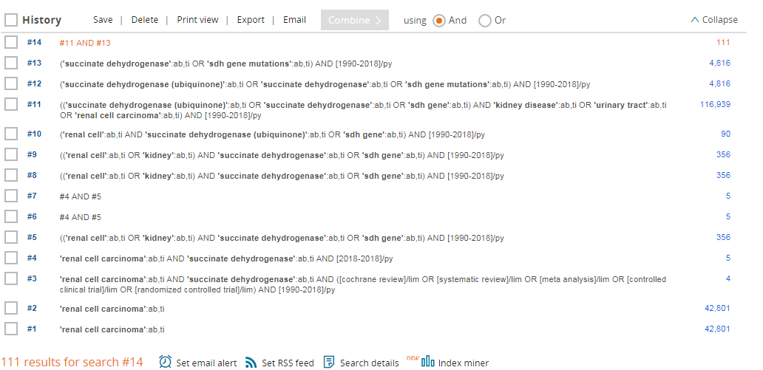
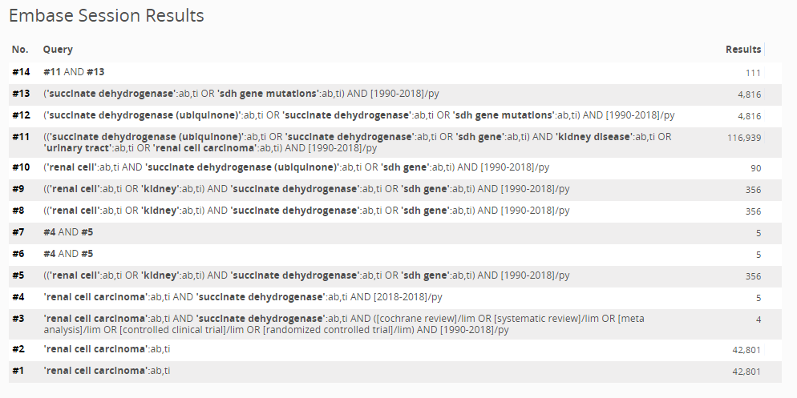
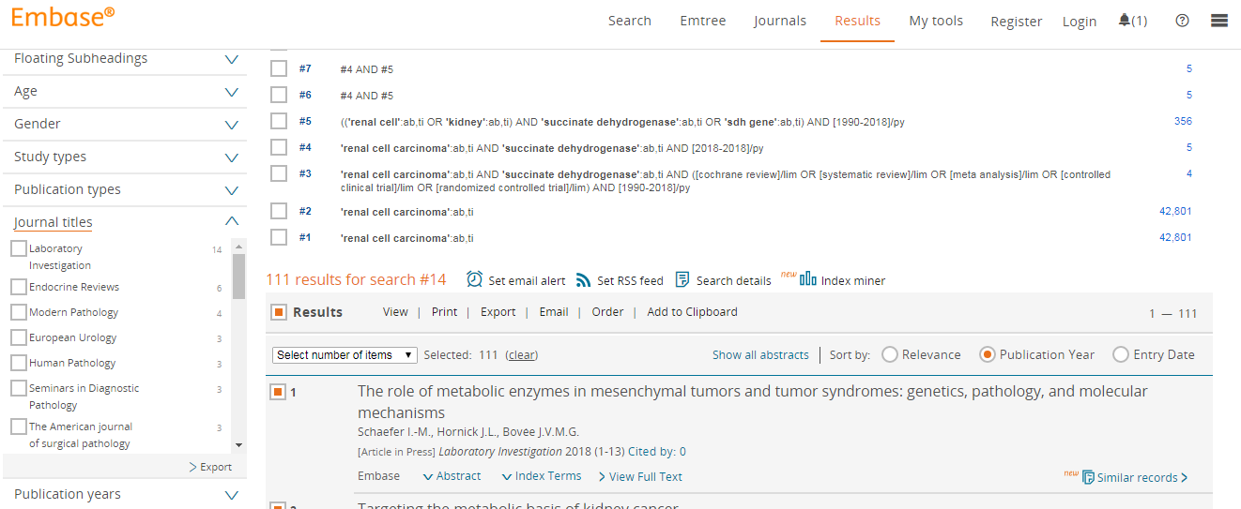

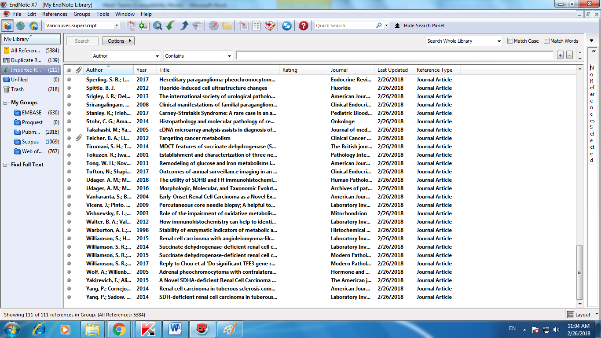

2050 duplicated removed
