Supplementary material
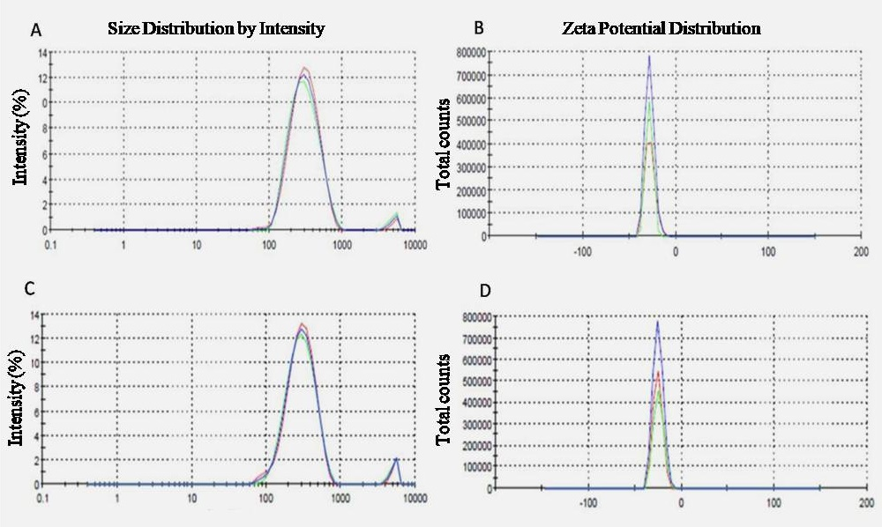
Figure S1. Distribution of mean size (A, C) and zeta potential (B, D) of alginate nanoparticles. Representative graphs for unloaded (Nano.Alg) (A, B) and miltefosine-loaded alginate nanoparticles (MFS.Alg) (C, D) are presented. Each graph depicts the results of three analyses of the same batch.

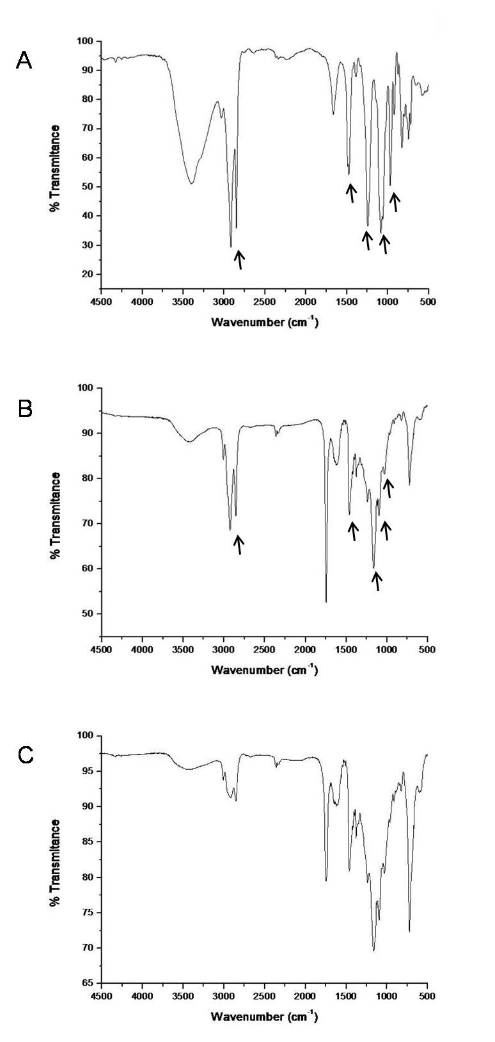
Figure S2. Fourier Transform Infrared Spectra. Free miltefosine (MFS) (A), miltefosine-loaded alginate nanoparticles (MFS.Alg) (B) and unloaded alginate nanoparticles (Nano.Alg) (C). Peaks marked with black arrows in panels A and B were assigned as follows: peaks at 2950–2850 cm⁻¹ correspond to CH₂ stretching in the long hexadecyl-chain, peaks at 1520–1490 cm⁻¹ correspond to CH₂ bending, and peaks at 1260–960 cm⁻¹ correspond to the phosphocholine group. Peaks were assigned as previously published by Dorlo et al. (2012).²⁶

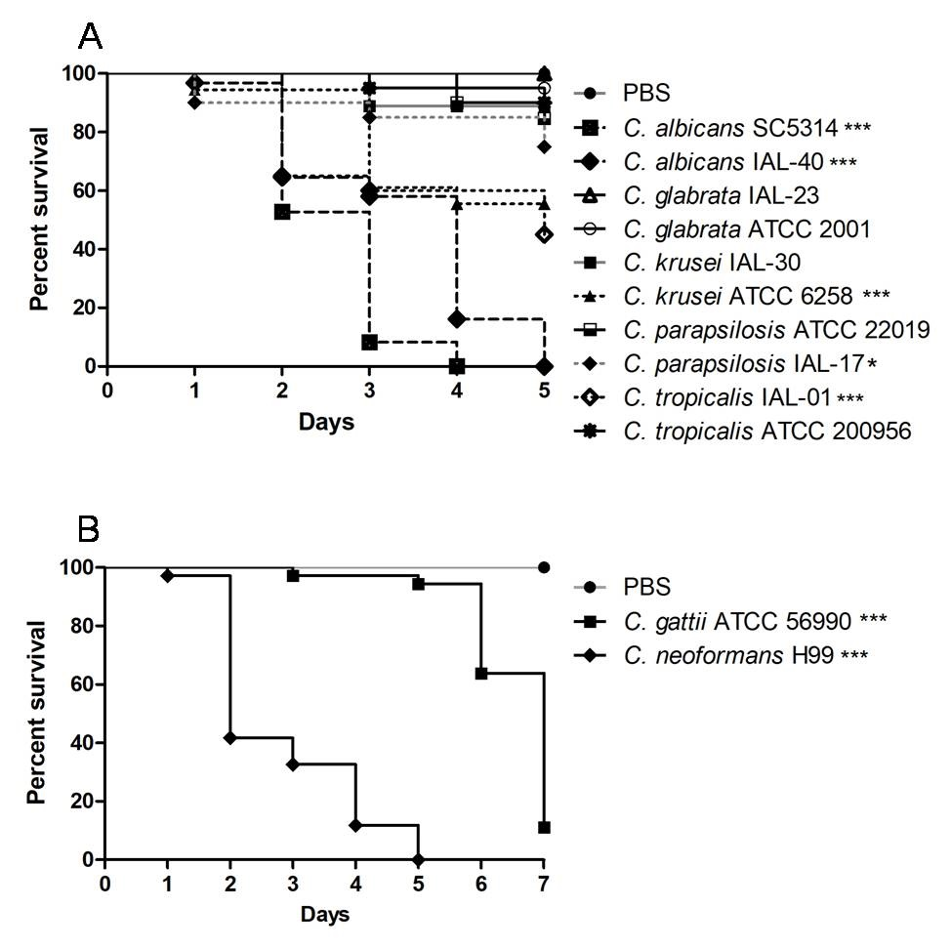
Figure S3. Virulence of yeasts in Galleria mellonella larvae. A: Candida spp. (5 x 10⁵ CFU/larvae); B: Cryptococcus spp. (5 x 10⁶ CFU/larvae). *p < 0.05 and ***p < 0.0001 when compared with the PBS group.

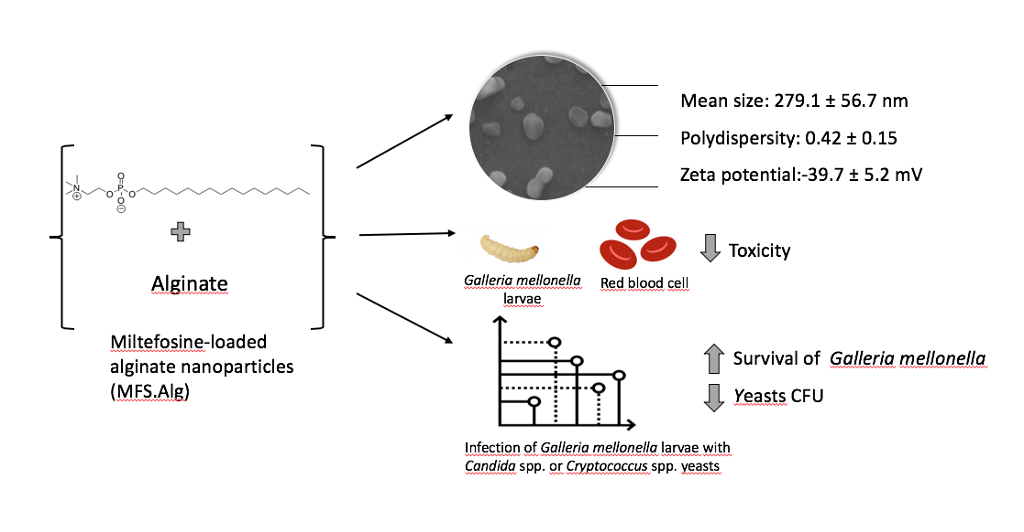
Figure S4. Graphical representation summarizing the work’s findings.

Table S1. Semi-quantitative analysis of the fungal burden, filamentation and dissemination of Candida albicans (SC5314 and IAL-40), Cryptococcus neoformans H99 and Cryptococcus gattii ATCC 56990 in Galleria mellonella larvae untreated, treated with free miltefosine (MFS), or treated with miltefosine-loaded alginate nanoparticles (MFS.Alg).
 | Fungal burden | Filamentation | Dissemination
C. albicans SC5314
PBS | 0 | 0 | 0
Untreated | +4 | +3 | 0
MFS.Alg 200 mg/Kg | +1 | 0 | 0
MFS.Alg 100 mg/Kg | +1 | 0 | 0
MFS 40 mg/Kg | +2 | +2 | 0
MFS 20 mg/Kg | +2 | +2 | 0
MFS 10 mg/Kg | +2 | +2 | 0
C. albicans IAL-40
PBS | 0 | 0 | 0
Untreated | +4 | +3 | 0
MFS.Alg 200 mg/Kg | +1 | 0 | 0
MFS.Alg 100 mg/Kg | +2 | +2 | 0
MFS 40 mg/Kg | +3 | +3 | 0
MFS 20 mg/Kg | +3 | +3 | 0
MFS 10 mg/Kg | +3 | +3 | 0
C. neoformans H99 |  | N.E
PBS | 0 |  | 0
Untreated | +4 |  | +4
MFS.Alg 200 mg/Kg | +3 |  | +3
MFS.Alg 100 mg/Kg | +4 |  | +4
MFS 40 mg/Kg | +4 |  | +4
MFS 20 mg/Kg | +4 |  | +4
MFS 10 mg/Kg | +4 |  | +4
C. gattii ATCC 56990 |  | N.E
PBS | 0 |  | 0
Untreated | +4 |  | +3
MFS.Alg 200 mg/Kg | +2 |  | +2
MFS.Alg 100 mg/Kg | +3 |  | +2
MFS 40 mg/Kg | +2 |  | +2
MFS 20 mg/Kg | +3 |  | +4
MFS 10 mg/Kg | +4 |  | +4
N.E.: not evaluated. 0: no fungal; +1: up to five fungal elements per section (standard: 5 mm punch); +2: from 6 fungal elements per section to 5 per field at high magnification (×400); +3: from 6 to 50 per field at high magnification; +4: more than 50 per field at high magnification.

