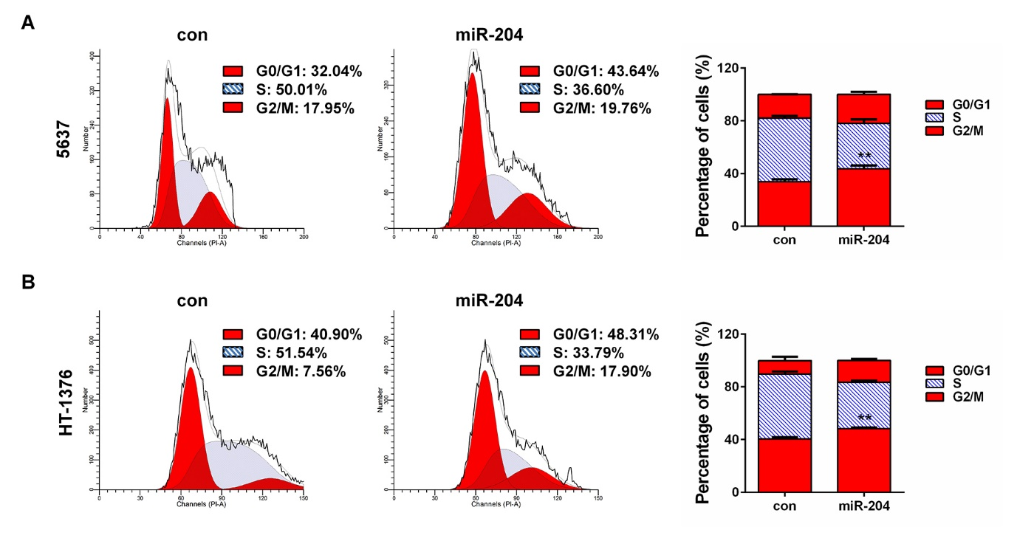
Supplementary Figure 1: Overexpression of miR-204 results in significant G1 phase arrest in in bladder cancer cells. Cell cycle assay was conducted 48h after miR-204 mimics transfection in (A) 5637 and (B) HT-1376 cells. The left panel depicts DNA content while the right shows the quantitative results. **: P<0.01.

