Supplementary materials

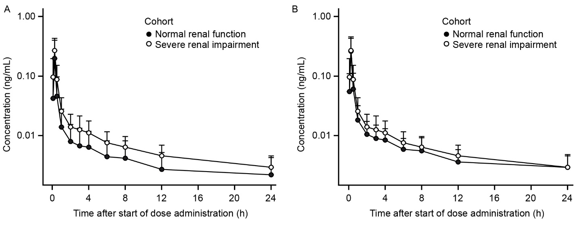

Figure S1 Mean + SD plasma concentration-time profiles for revefenacin in all subjects (n=8 per group) (A) and after excluding two subjects in the normal function group who had very low concentration measurable to only 4 hours and 1 hour post dose, respectively, (B) in the renal impairment study.
Abbreviations: h, hours; SD, standard deviation.

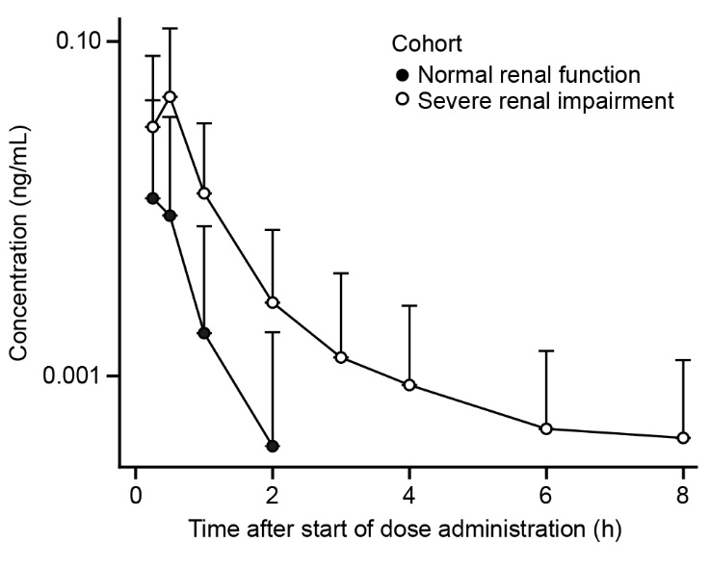

Figure S2 Mean + SD plasma concentration-time profiles for THRX-195518 in subjects with and without severe renal impairment.
Notes: All mean concentrations were below the limit of quantitation after 2 hours in normal renal function group and 8 hours in severe renal impairment group postdose.
Abbreviation: SD, standard deviation.

