Supplementary Information

¹³¹I-Labeled Polyethylenimine-Entrapped Gold Nanoparticles for Targeted Tumor SPECT/CT Imaging and Radionuclide Therapy

Na Sun ^{1,*} Lingzhou Zhao^{1,*} Jingyi Zhu^{2,*} Ningning Song¹ Yujie Li¹ Yan Xing¹ Wenli Qiao¹ He Huang² Jinhua Zhao¹
1 Department of Nuclear Medicine, Shanghai General Hospital, Shanghai Jiao Tong University School of Medicine, Shanghai 200080, China
2 State Key Laboratory of Material-Oriented Chemical Engineering, School of Pharmaceutical Sciences, Nanjing Tech University, Nanjing 211816, China

*These authors equally contributed to this work.
________________________________________________________
Correspondence: Jinhua Zhao, Department of Nuclear Medicine, Shanghai General Hospital, Shanghai Jiao Tong University School of Medicine, Shanghai 200080, China
Fax +86 21 3779 8352, Tel +86 21 3779 8352, Email zhaojinhua1963@126.com

He Huang, State Key Laboratory of Material-Oriented Chemical Engineering, School of Pharmaceutical Sciences, Nanjing Tech University, Nanjing 211816, China
Fax +86 25 58139942, Tel +86 25 5813 9942, huangh@njtech.edu.cn
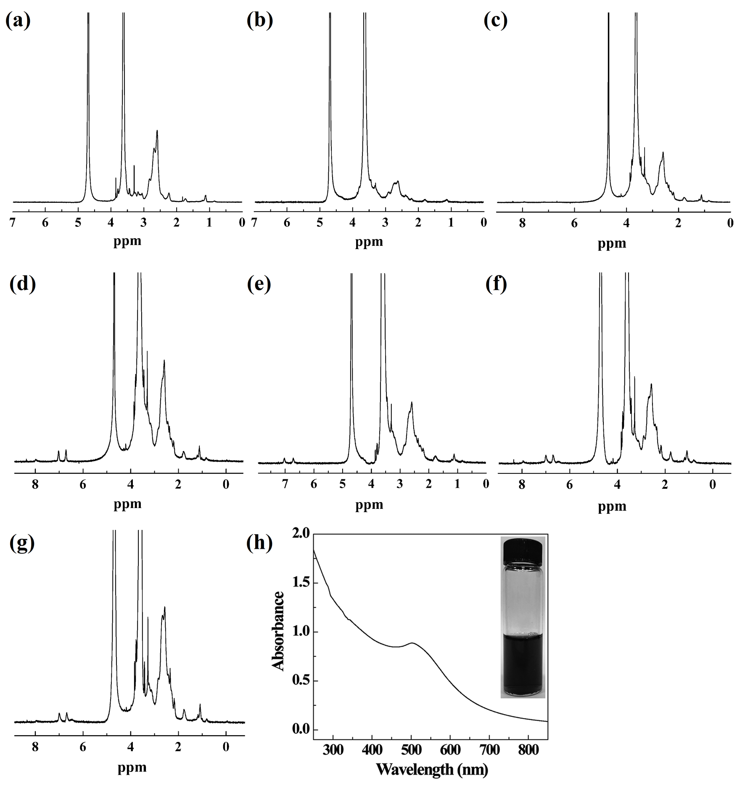
Figure S1 Characterization of intermediate products and UV-vis spectroscopy of BmK CT-Au PENPs.
Notes: ¹H NMR spectra of (a) PEI.NH₂-mPEG, (b) PEI.NH₂-mPEG-(PEG-MAL), (c) PEI.NH₂-mPEG-(PEG-BmK CT), (d) PEI.NH₂-mPEG-(PEG-BmK CT)-HPAO, (e) PEI.NH₂-mPEG-(PEG-Bu)-HPAO, (f) PEI.NH₂-mPEG-(PEG-BmK CT)-HPAO-FI, and (g) PEI.NH₂-mPEG-(PEG-Bu)-HPAO-FI, respectively. (h) UV-vis spectroscopy and photograph of BmK CT-Au PENPs dispersed in water.
Abbreviations: PEI, polyethylenimine; mPEG-COOH, methoxy-PEG-carboxymethy; MAL-PEG-SVA, maleimide-PEG-succinimidyl valerate; BmK CT, Buthus martensii Karsch chlorotoxin; FI, fluorescein isothiocyanate; HPAO, 3-(4′-hydroxyphenyl) propionic acid-OSu; BmKCT-Au PENPs-¹³¹I, ¹³¹I-labeled BmK CT modified polyethylenimine-entrapped gold nanoparticles.

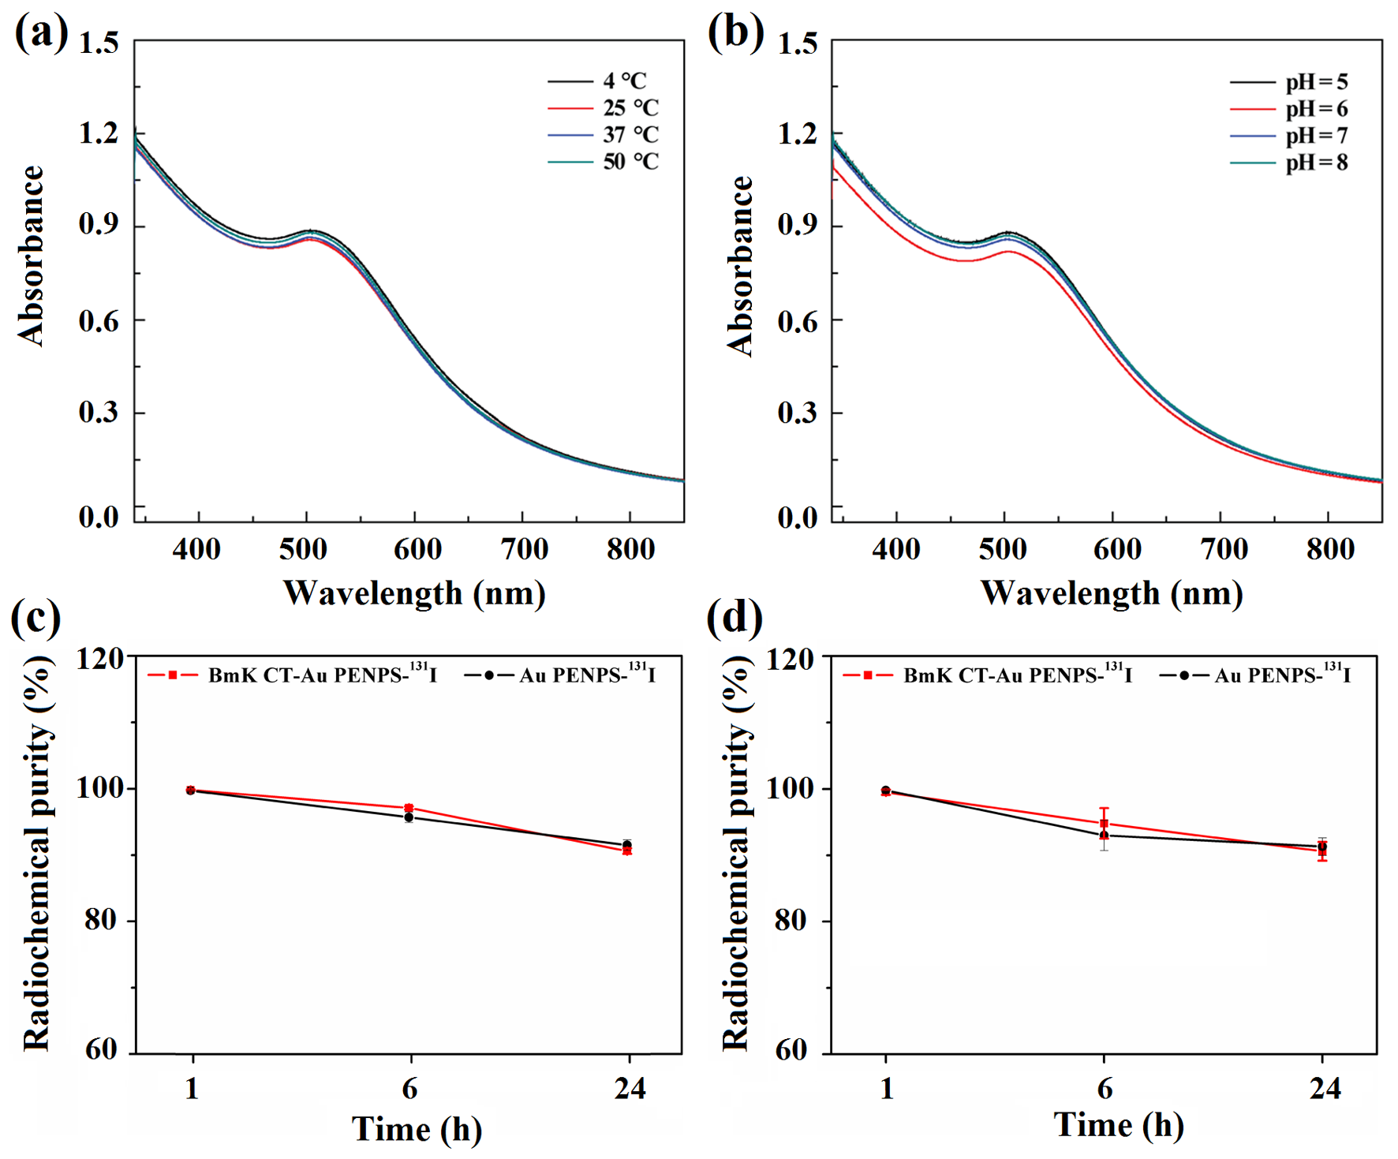
Figure S2 Stability of the multifunctional PEI-based Au NPs before and after ¹³¹I labeling in vitro.
Notes: UV-vis spectra of the BmK CT-Au PENPs dispersed in water at different (a) temperature and (b) pH conditions. Radiochemical purities of the BmK CT-Au PENPs-¹³¹I and Au PENPs-¹³¹I exposed to (c) PBS at room temperature and (d) FBS at 37 °C for different time periods.
Abbreviations: PEI, Polyethylenimine; Au NPs, gold nanoparticles; BmK CT, Buthus martensii Karsch chlorotoxin; BmK CT-Au PENPs, BmK CT modified polyethylenimine-entrapped gold nanoparticles; BmK CT-Au PENPs-¹³¹I, ¹³¹I-labeled BmK CT modified polyethylenimine-entrapped gold nanoparticles; Au PENPs-¹³¹I, ¹³¹I-labeled polyethylenimine-entrapped gold nanoparticles. PBS, phosphate buffered solution; FBS, fetal bovine serum.

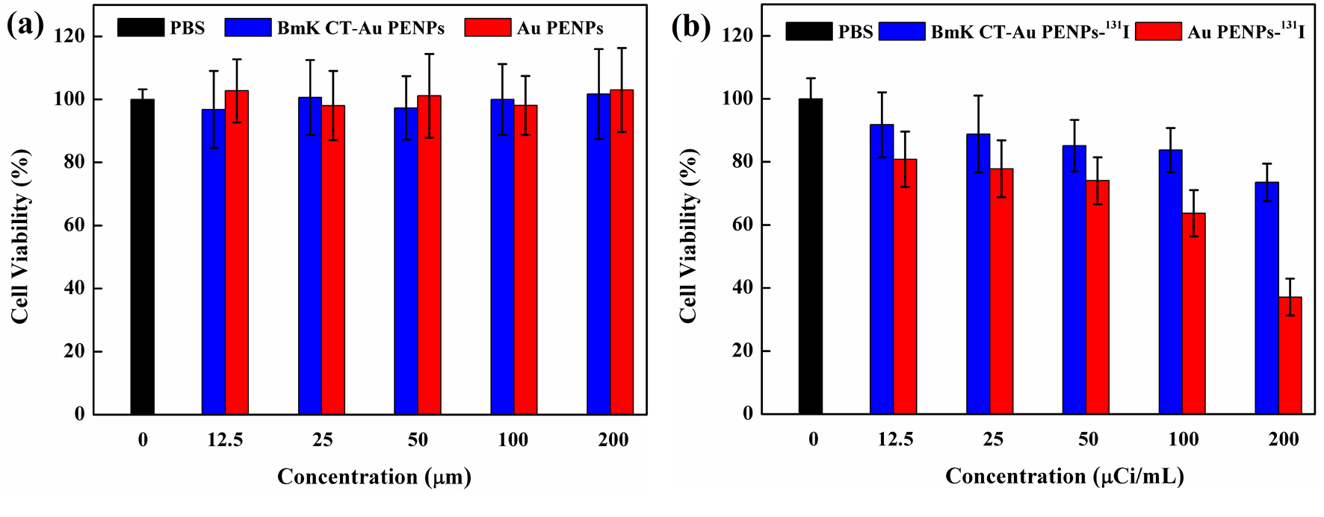
Figure S3 In vitro cytotoxicity of the multifunctional PEI-based Au NPs before and after ¹³¹I labeling
Notes: (a) CCK-8 assay of C6 cells treated with the BmK CT-Au PENPs or Au PENPs at different Au concentrations for 24 h, respectively. (b) CCK-8 assay of C6 cells treated with the BmK CT-Au PENPs-¹³¹I or Au PENPs-¹³¹I at different ¹³¹I concentrations for 24 h, respectively.
Abbreviations: BmK CT, Buthus martensii Karsch chlorotoxin; BmK CT-Au PENPs, BmK CT modified polyethylenimine-entrapped gold nanoparticles; Au PENPs, polyethylenimine-entrapped gold nanoparticles; BmK CT-Au PENPs-¹³¹I, ¹³¹I-labeled BmK CT modified polyethylenimine-entrapped gold nanoparticles; Au PENPs-¹³¹I, ¹³¹I-labeled polyethylenimine-entrapped gold nanoparticles; PBS, phosphate buffered solution; CCK-8, Cell Counting Kit-8.

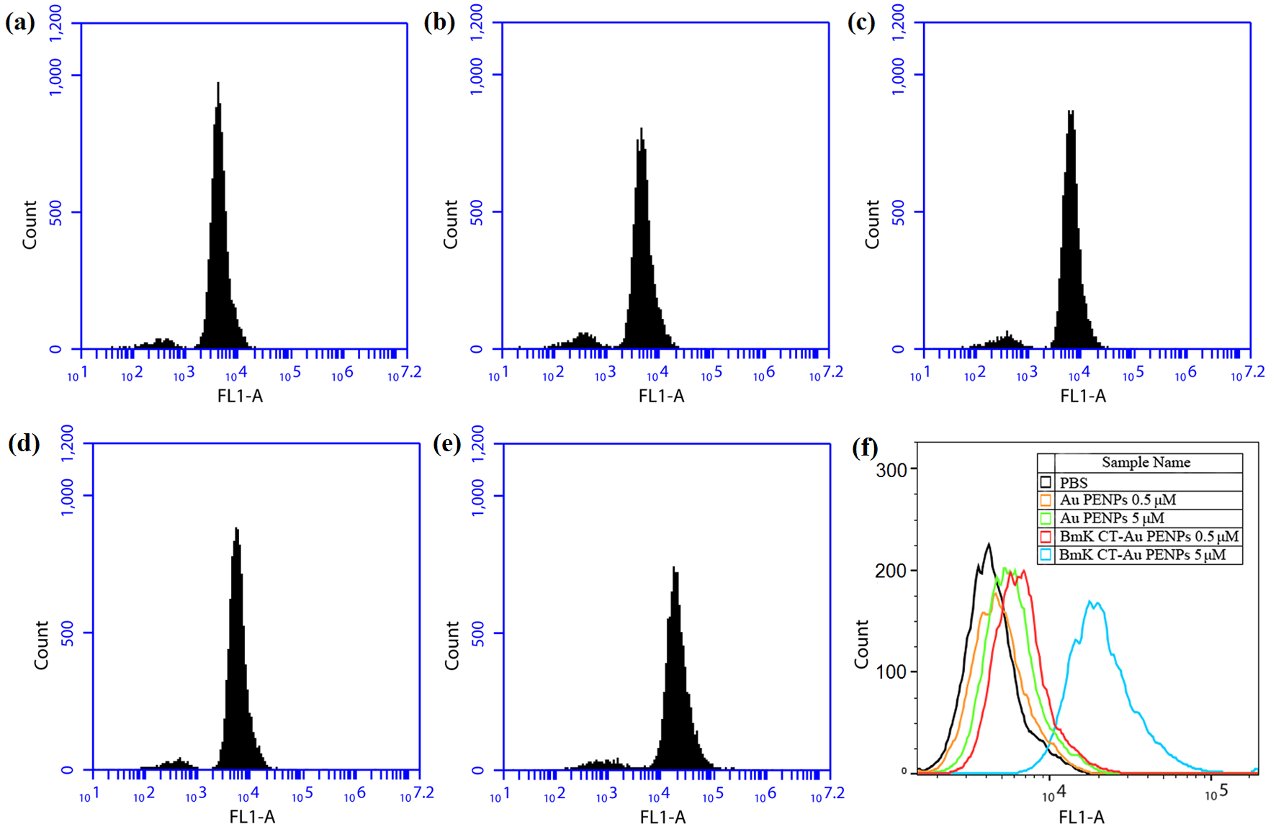
Figure S4 Flow cytometric analysis of C6 cells incubated with (a) PBS, (b) Au PENPs (0.5 μM), (c) BmK CT-Au PENPs (0.5 μM), (d) Au PENPs (5 μM), or (e) BmK CT-Au PENPs (5 μM) for 4 h, respectively. Part (f) shows the comparison of the binding of Au PENPs and BmK CT-Au PENPs with C6 cells using PBS as a control.
Abbreviations: BmK CT, Buthus martensii Karsch chlorotoxin; BmK CT-Au PENPs, BmK CT modified polyethylenimine-entrapped gold nanoparticles; Au PENPs, polyethylenimine-entrapped gold nanoparticles; PBS, phosphate buffered solution.

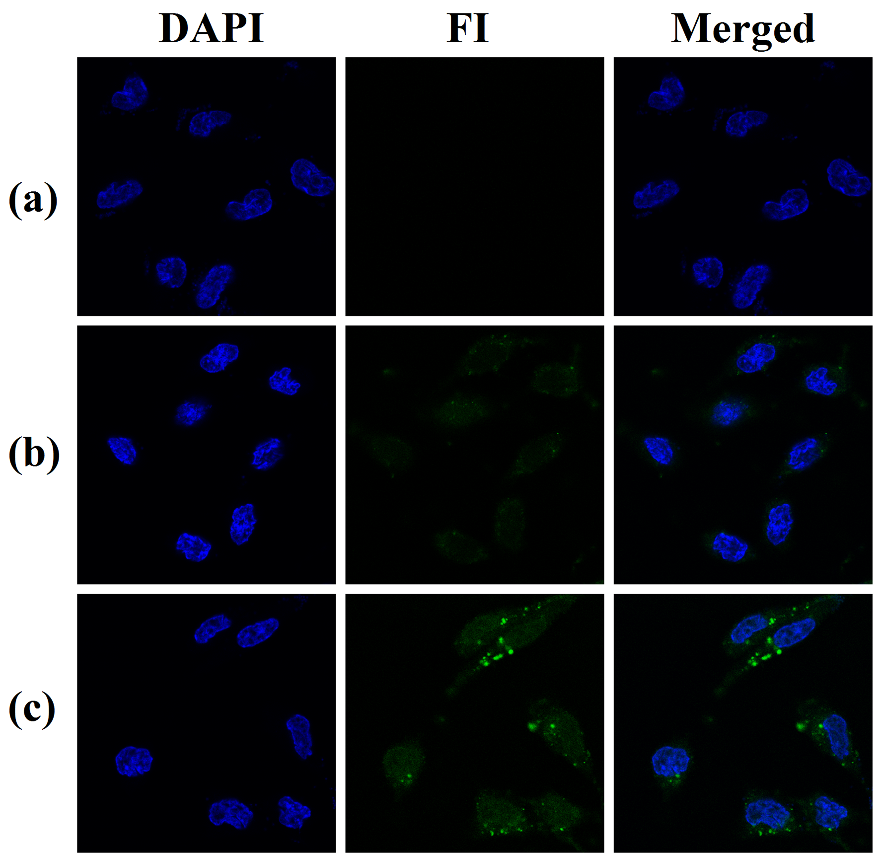
Figure S5 Confocal microscopy images of C6 cells treated with (a) PBS, (b) Au PENPs or (c) BmKCT-Au PENPs with an Au concentration of 5 μM for 4 h, respectively.
Abbreviations: BmK CT, Buthus martensii Karsch chlorotoxin; BmK CT-Au PENPs, BmK CT modified polyethylenimine-entrapped gold nanoparticles; Au PENPs, polyethylenimine-entrapped gold nanoparticles; PBS, phosphate buffered solution.

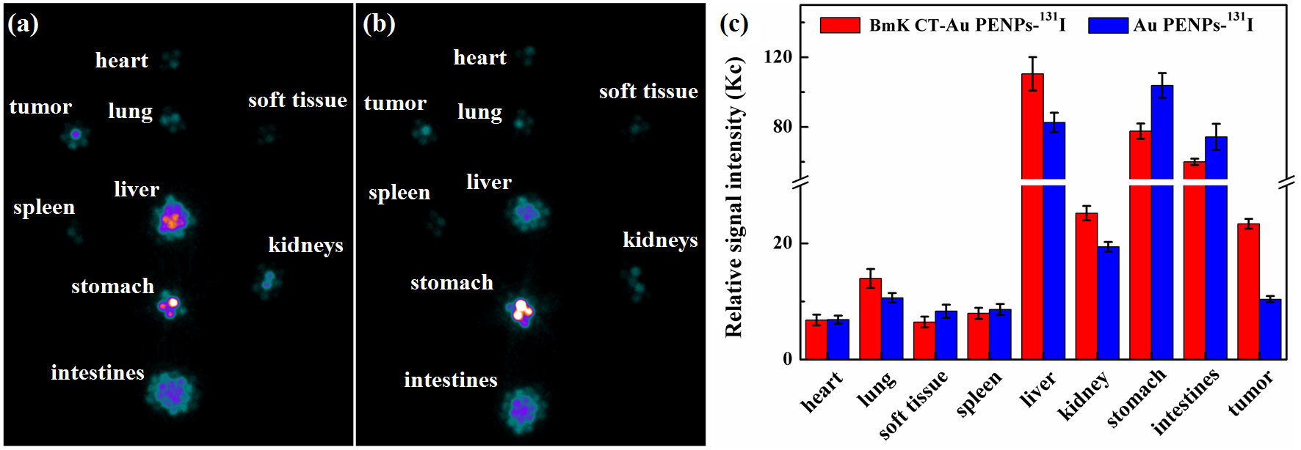
Figure S6 The biodistribution of (a) BmKCT-Au PENPs-¹³¹I and (b) Au PENPs-¹³¹I, and (c) their relative signal intensities of different organs at 8 h postinjection.
Abbreviations: BmK CT, Buthus martensii Karsch chlorotoxin; BmK CT-Au PENPs-¹³¹I, ¹³¹I-labeled BmK CT modified polyethylenimine-entrapped gold nanoparticles; Au PENPs-¹³¹I, ¹³¹I-labeled polyethylenimine-entrapped gold nanoparticles.

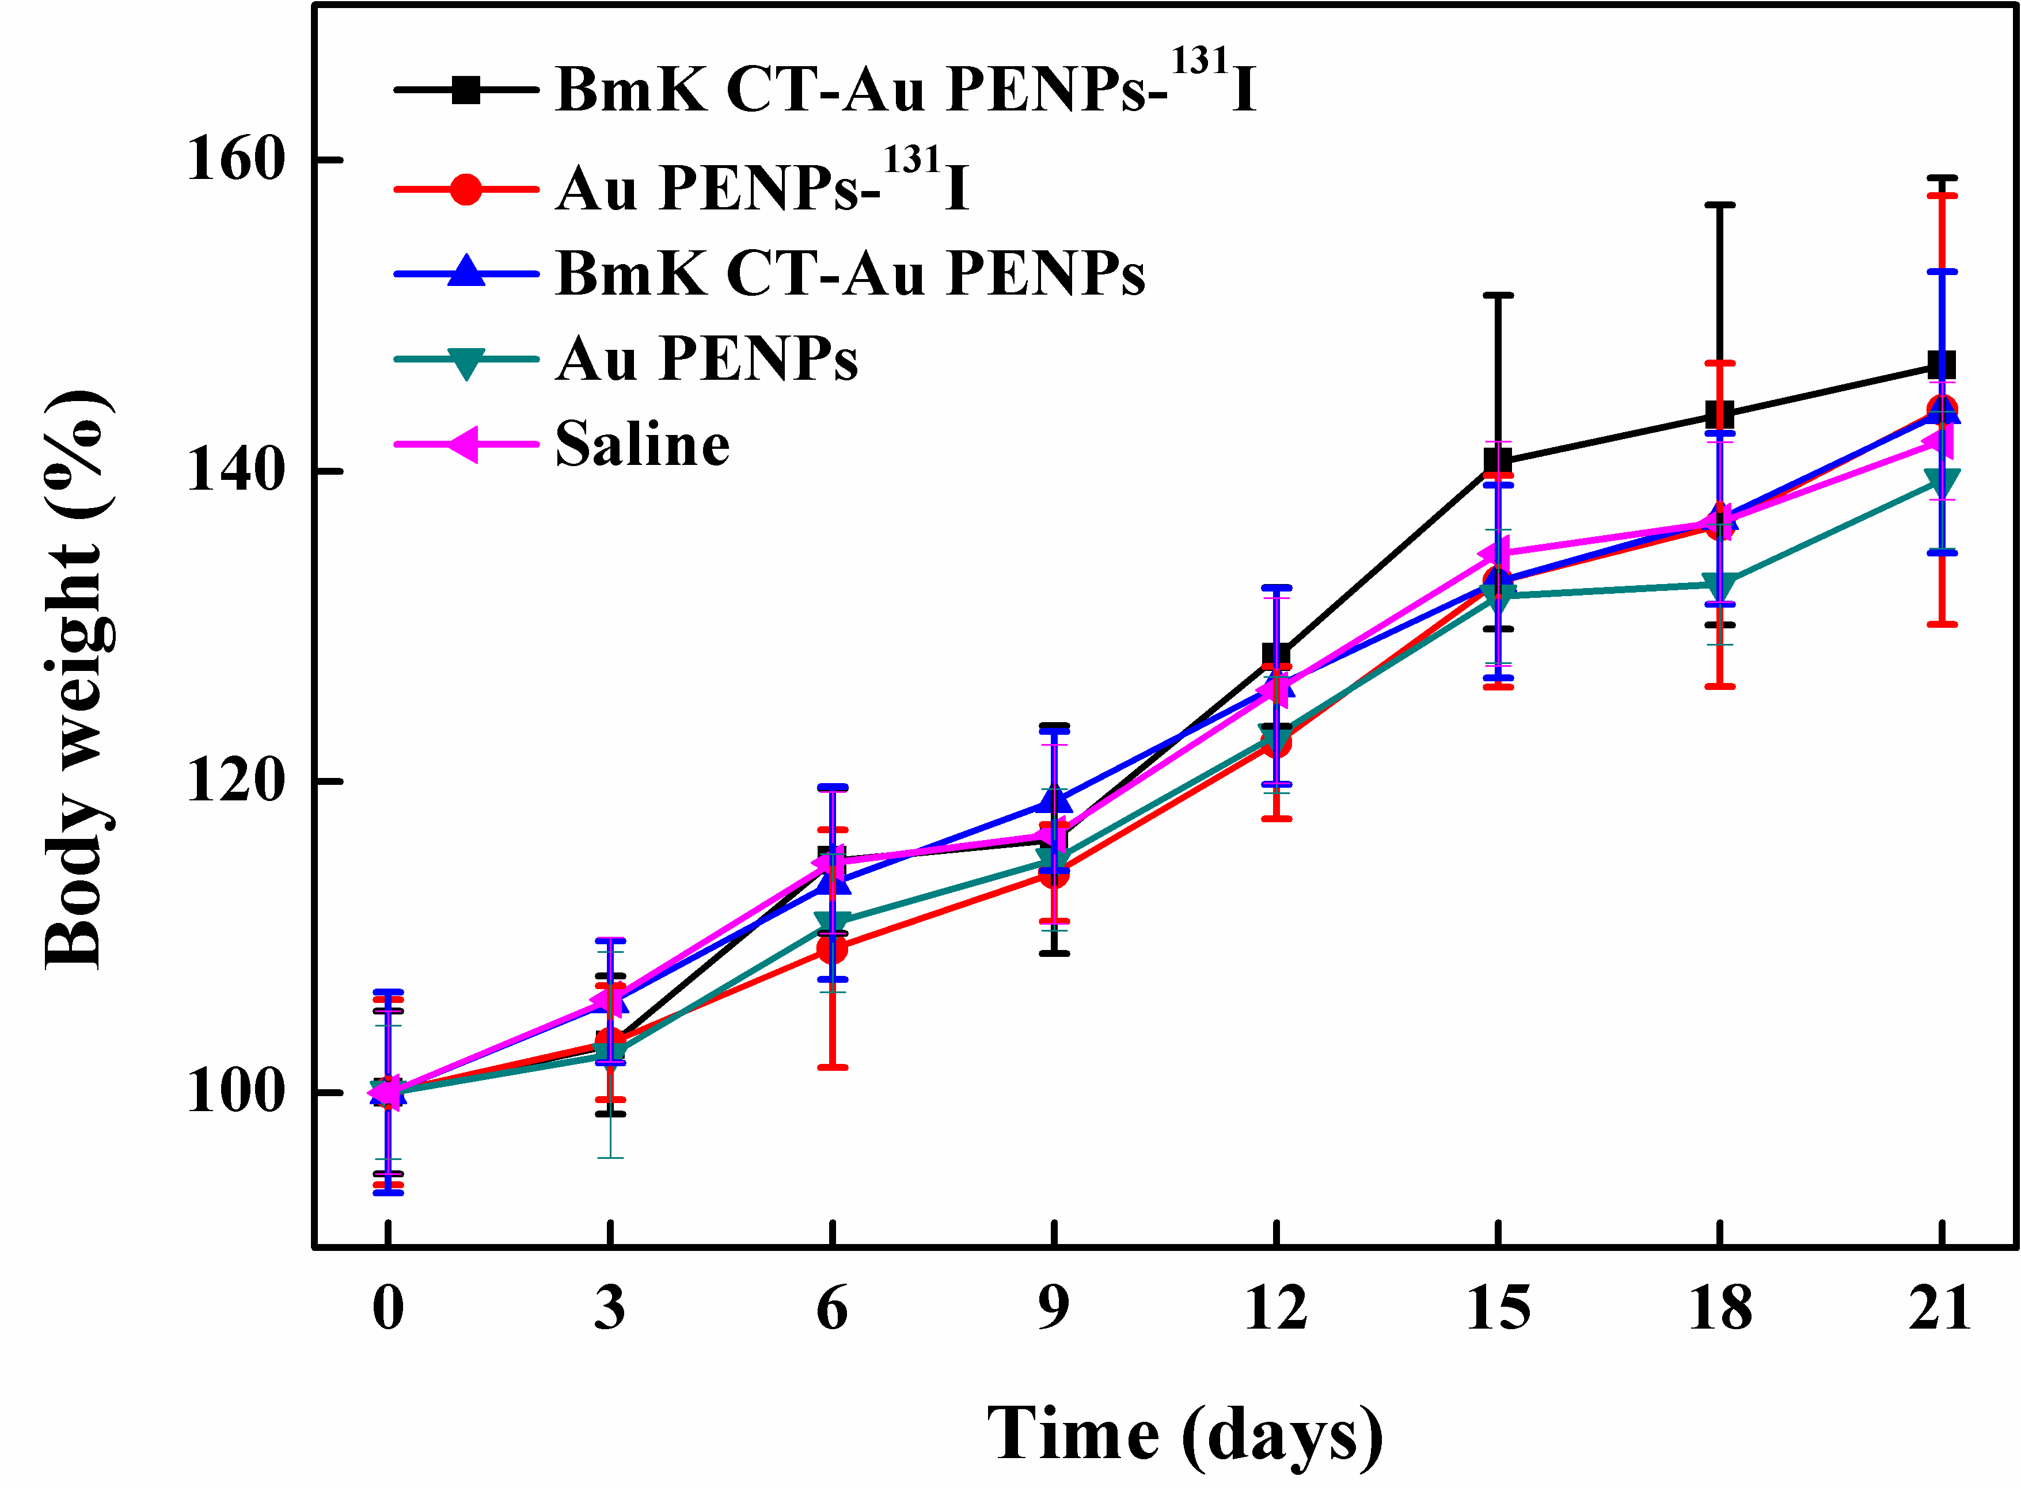
Fig. S7 The body weight of C6 tumor-bearing mice after treatments of saline, Au PENPs, BmK CT-Au PENPs, Au PENPs-¹³¹I and BmK CT-Au PENPs-¹³¹I. The relative body weight were normalized according to their initial weights (Mean ± SD, n = 5).
Abbreviations: BmK CT, Buthus martensii Karsch chlorotoxin; BmK CT-Au PENPs, BmK CT modified polyethylenimine-entrapped gold nanoparticles; Au PENPs, polyethylenimine-entrapped gold nanoparticles; BmK CT-Au PENPs-¹³¹I, ¹³¹I-labeled BmK CT modified polyethylenimine-entrapped gold nanoparticles; Au PENPs-¹³¹I, ¹³¹I-labeled polyethylenimine-entrapped gold nanoparticles.

