Supplementary materials
Figure S1 The distribution of quantitative information of 15 endometrial tissues after median normalization by boxplot analysis. N: normal control; A: GnRH antagonist treated group (GnRH-ant); La: GnRH agonist treated group (GnRH-a).
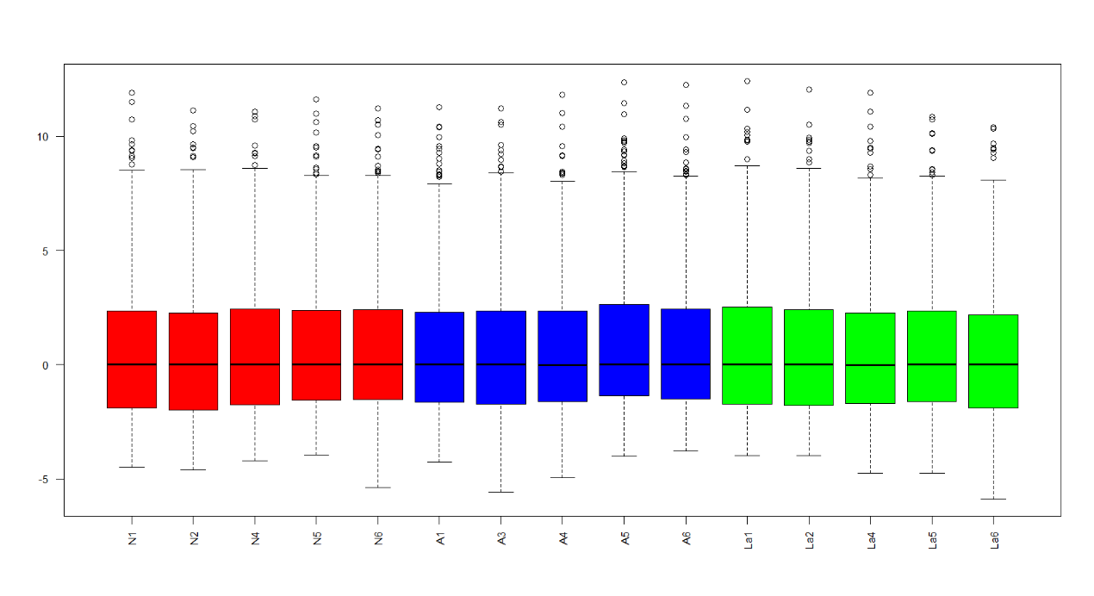
Figure S2 Reproducibility of Lable-freeLC-MS/MS separations and identification. The correlations between the data of duplicate 1 and duplicate 2 were analyzed.

