Supplementary materials
Table S1 MEDLINE search strategy
#
1 | Hemiplegia/
2 | exp Upper Extremity/
3 | 1 and 2
4 | ((Hemipleg* or stroke or Hemipares*) adj5 (shoulder or Glenohumeral or hand or arm or (upper adj1 (arm or limb or extremit*)))).tw.
5 | Shoulder-hand syndrome.tw,kf.
6 | or/3-5
7 | 3 or 6
8 | exp pain/
9 | (pain* or discomfort*).tw,kf.
10 | or/7-8
11 | 7 and 10
12 | (review or review,tutorial or review, academic).pt.
13 | (medline or medlars or embase or pubmed or cochrane).tw,sh.
14 | (scisearch or psychinfo or psycinfo).tw,sh.
15 | (psychlit or psyclit).tw,sh.
16 | cinahl.tw,sh.
17 | ((hand adj2 search$) or (manual$ adj2 search$)).tw,sh.
18 | (electronic database$ or bibliographic database$ or computeri?ed database$ or online database$).tw,sh.
19 | (pooling or pooled or mantel haenszel).tw,sh.
20 | (peto or dersimonian or der simonian or fixed effect).tw,sh.
21 | (retraction of publication or retracted publication).pt.
22 | or/13-21
23 | 12 and 22
24 | meta-analysis.pt.
25 | meta-analysis.sh.
26 | (meta-analys$ or meta analys$ or metaanalys$).tw,sh.
27 | (systematic$ adj5 review$).tw,sh.
28 | (systematic$ adj5 overview$).tw,sh.
29 | (quantitativ$ adj5 review$).tw,sh.
30 | (quantitativ$ adj5 overview$).tw,sh.
31 | (quantitativ$ adj5 synthesis$).tw,sh.
32 | (methodologic$ adj5 review$).tw,sh.
33 | (methodologic$ adj5 overview$).tw,sh.
34 | (integrative research review$ or research integration).tw.
35 | or/24-34
36 | 23 and 35
37 | 11 and 36

Table S2 HSP intervention outcomes for included systematic reviews - QOL
Review | Intervention | Number of Studies (participants) | Outcome (measure) | Summary of Effect
Appel et al. (2014) ¹ | Shoulder strapping | 1 (12) ² | Participation restriction (SS-QOL) | MD 0.54 (-1.287, 2.367)

Table S3 HSP intervention outcomes for included systematic reviews - function
Review | Intervention | Number of Studies (participants) | Outcome (measure) | Summary of Effect
Appel et al. (2014) ¹ | Shoulder strapping | 3 (117) ^{1,3,4} | Activity limitation (MAS) | pooled SMD 0.26 (-0.11, 0.62), P=0.17, I² = 0%
Qui et al. (2019) ⁵ | Electrical stimulation (surface and percutaneous) | 3 (167) ⁶⁻⁸ | Activities of daily living (BI) | MD 8.96 (5.26, 12.66) I² = 45%
Chau et al. (2018) ⁹ | Conventional acupuncture | 19 (1623) ¹⁰⁻²⁸ | Upper-limb function (PSP) | Range SMD 0.32 (-0.10, 0.73) to 1.52 (1.07, 1.97)  Moderate heterogeneity see Figure S2
Chau et al. (2018) ⁹ | Conventional acupuncture | 5 (457) ^{13,17,26-28} | Physical function (subjective scales, NR) | pooled SMD 0.41 (0.15,0.68). p<0.01) I²= 49%  Moderate heterogeneity, visualised in Figure S3
Chau et al. (2018) ⁹ | Electroacupuncture | 5 (339)²⁹⁻³³ | Upper-limb function (FMA) | Range SMD 0.36 (-0.19, 0.91) to 2.68 (1.90, 3.46)  High heterogeneity, see Figure S2
Chau et al. (2018) ⁹ | Electroacupuncture | 2 (170) ^{31,34} | Physical function (BI) | Range SMD 0.45 (0.02, 0.87) to 1.39 (0.90, 1.87)  High heterogeneity, see Figure S3
Chau et al. (2018) ⁹ | Fire Needle Acupuncture | 2 (170) ^{35,36} | Upper-limb function (FMA) | SMD 1.19 (0.76, 1.63), I²=43%, p < 0.001
Chau et al. (2018) ⁹ | Warm Needle Acupuncture | 1 (40) ³⁷ | Upper-limb function (FMA) | SMD 0.88 (0.71, 1.05), P=0.23), I²=71%  No statistically significant difference

Figure S1 Funnel plot of pain outcome from acupuncture trials as reported in Chau et al (2018). ⁹

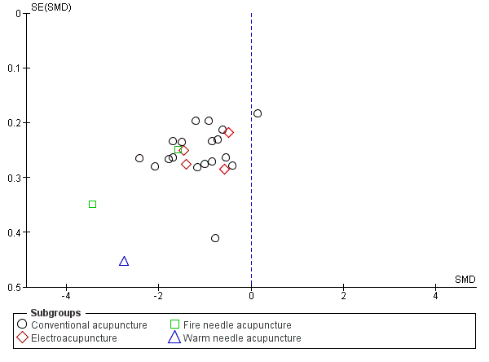

Figure S2 Forest plot of upper limb function outcome from acupuncture trials as reported in Chau et al (2018) ⁹
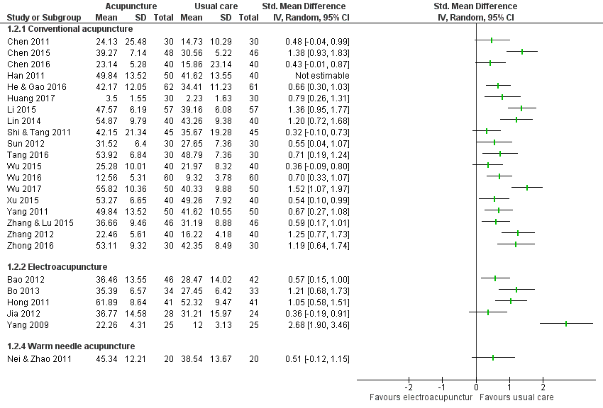
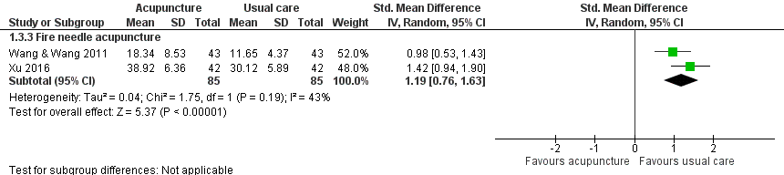

Figure S3 Forest plot of physical function outcome from acupuncture trials as reported in Chau et al (2018) ⁹
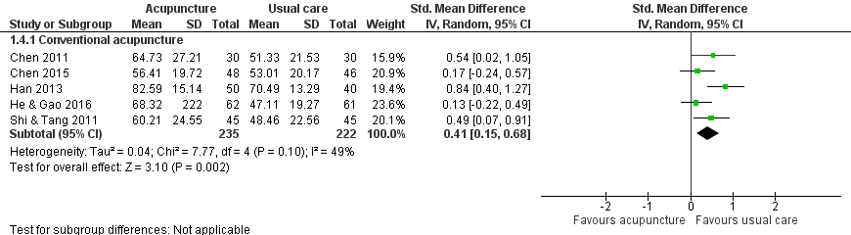

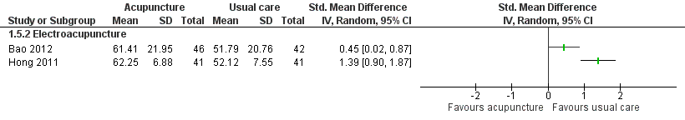
Table S4 Excluded Studies
Author, year | Intervention | Reason for exclusion
Ada, 2005 ³⁸ | Shoulder orthoses | Not most recent review on this intervention
Ezendam, 2009 ³⁹ | Mirror therapy | Wrong patient population
Gu, 2016 ^{40,41} | Electrical Stimulation | Retracted
Jae-Hyoung, 2017 ⁴² | Electrical Stimulation | Not most recent review on this intervention
Lee, 2012 ⁴³ | Acupuncture | Not most recent review on this intervention
Liu, 2019 ⁴⁴ | Acupuncture | Not most recent review on this intervention
Magee, 2017 ⁴⁵ | Music | Wrong patient population
Page, 2003 ⁴⁶ | Shoulder taping  Biofeedback therapy | Not most recent review on this intervention  Review considered likely to be outdated
Peng, 2018 ⁴⁷ | Acupuncture | Not most recent review on this intervention
Price, 2000 ⁴⁸ | Electrical Stimulation | Not most recent review on this intervention
Ravichandran, 2019 ⁴⁹ | Shoulder taping | Wrong patient population
Tao, 2015 ⁵⁰ | Corticosteroid injection | Meets inclusion criteria, but subsequently excluded due to poor quality
Vafadar, 2015 ⁵¹ | Electrical Stimulation | Not most recent review on this intervention

Reviews from within the Evidence-Based Review of Stroke Rehabilitation (EBRSR), ⁵² Chapter 11 were not considered eligible for inclusion in this overview due to lack of availability of methodological detail to confirm review eligibility, including but not limited to search dates, specific search strategies, lists of included study characteristics and excluded studies, whether or not study selection or data extraction were performed in duplicate and lack of details and presentation of quantitative study results.

Table S5 Risk of Bias of Included Reviews

Study | AMSTAR2 Item
 | 1 | 2 | 3 | 4 | 5 | 6 | 7 | 8 | 9 | 10 | 11 | 12 | 13 | 14 | 15 | 16
Appel et al. 2014 | L | H | L | H | L | L | L | U | L | H | L | H | L | L | U | L
Nadler et al. 2017 | L | U | H | U | L | L | U | U | H | L | U | U | H | H | H | L
Singh et al. 2010 | L | U | L | U | L | L | L | U | L | L | L | L | L | L | L | L
Qiu et al. 2019 | L | U | L | U | L | L | U | U | L | L | L | L | L | L | U | H
Lim et al. 2015 | H | H | H | L | L | L | H | U | L | H | H | L | L | H | U | L
Koog et al. 2010 | L | H | U | H | U | L | U | L | L | L | L | L | L | L | U | U
Chau et al. 2018 | L | H | H | H | L | H | L | U | H | H | U | U | L | L | U | L
Tao et al. 2015 | H | H | H | H | H | H | H | H | H | H | U | U | H | U | H | H

References:
1. Appel C, Perry L, Jones F. Shoulder strapping for stroke-related upper limb dysfunction and shoulder impairments: systematic review. NeuroRehabilitation. 2014;35(2):191-204.
2. Appel C, Mayston M, Perry L. Feasibility study of a randomized controlled trial protocol to examine clinical effectiveness of shoulder strapping in acute stroke patients. Clin Rehabil. 2011;25(9):833-843.
3. Hanger HC, Whitewood P, Brown G, et al. A randomized controlled trial of strapping to prevent post-stroke shoulder pain. Clin Rehabil. 2000;14(4):370-380.
4. Griffin A, Bernhardt J. Strapping the hemiplegic shoulder prevents development of pain during rehabilitation: a randomized controlled trial. Clin Rehabil. 2006;20(4):287-295.
5. Qiu H, Li J, Zhou T, Wang H, Li J. Electrical Stimulation in the Treatment of Hemiplegic Shoulder Pain: A Meta-Analysis of Randomized Controlled Trials. Am J Phys Med Rehabil. 2019;98(4):280-286.
6. Ekim A, Armagan O, Oner C. [Efficiency of TENS treatment in hemiplegic shoulder pain: a placebo controlled study]. Agri. 2008;20(1):41-46.
7. Mao Y, Xue L, Xue J. Efficacy of low frequency electric stimulation plus acupuncture for hemiplegia and shoulder pain. Med J Qilu. 2016;31:592-593.
8. Fu M, Kong S. Efficacy observation on functional electrical stimulation for shoulder pain after stroke. Chinese Manipul Rehabil Med. 2015(6):11-14.
9. Chau JPC, Lo SHS, Yu X, et al. Effects of Acupuncture on the Recovery Outcomes of Stroke Survivors with Shoulder Pain: A Systematic Review. Front Neurol. 2018;9:30.
10. Huang Y-C, Leong C-P, Wang L, et al. The effects of hyaluronic acid on hemiplegic shoulder injury and pain in patients with subacute stroke: A randomized controlled pilot study. Medicine. 2016;95(49):e5547-e5547.
11. Wu DJ, Wu ZJ, Liu WY. Effects of acupuncture combined with rehabilitation for patients with shoulder hand syndrome after stroke. J Pract Tradit Chin Med. 2017;33:169-170.
12. Chen J. Effects of acupuncture combined with exercise for patients with post-stroke shoulder pain. Womens Health Res. 2016;9:79-81.
13. He SS, Gao SY. Evaluation of abdominal acupuncture and rehabilitation treatment for shoulder-hand syndrome (period 1) after stroke. J Clin Acupunt Moxi. 2016;32:11-13.
14. Tang D, Wu WP, Sun XH. A randomized controlled trial on the effects of meridians-based acupuncture combined with function training for shoulder hand syndrome after stroke. J Clin Acupunt Moxi. 2016;32:26-29.
15. Wu MB, Liao RX, Yang HH, Li N, ling HL, Liu XH. Observation on the clinical effects of the internal and external combined with sequential therapy for treating shoulder-hand syndrome. China Med Pharm. 2016;6:13-17.
16. Zhong CQ, Ni DL, Lim WJ, Chen FH. Effects of acupuncture combined with rehabilitation for patients with hand shoulder syndrome after stroke. Hainan Med J. 2016;27(1687-8).
17. Chen Y, Huang TS, Liu KC. Clinical research of using acupuncture and rehabilitation training in the treatment of post-stroke shoulder-hand syndrome stage I. J Sichuan Tradit Chin Med. 2015;33:150-152.
18. Li B. Treating 57 cases of stroke shoulder-hand syndrome by acupuncture. Chin J Chin Med. 2015;7:40-41.
19. Wu JY, Ye BY, Xue XH, Huang SE, Lin ZC, Hong JC. Observations on the efficacy of wrist-ankle acupuncture plus continuous exercise therapy for post-stroke shoulder pain. Shang J Acupunct Moxi. 2015;34:409-411.
20. Xu F, Li HL, Zhang Z. A randomized controlled trial ont eh effectiveness of acupuncture combined with rehabilitation for post-stroke shoulder hand syndrome. Chin J Trauma Disabil Med. 2015;23:141-142.
21. Zhang XR, Lu WX. The effects of acupuncture combined with rehabilitation for stage I shoulder hand syndrome patients. China Med Eng. 2015;23:200.
22. Lin HX, Ye GQ, Liao HX, Lin FY, Liang BJ. Acupuncture combined with rehabilitation training in the treatment of shoulder-hand syndrome after stroke. World Chin Med. 2014;9(84):85-88.
23. Yang WH, Yang GF, Han SK. Effects of acupuncture combined with herbal medicine treatments for post-stroke shoulder hand syndrome. J Emerg Tradit Chin Med. 2011;20(1404):1405012.
24. Sun YZ, Wang YJ, Wang W. Effect of acupuncture plus rehabilitation training on shoulder-hand syndrome due to ischemic stroke. J Acupunct Tuina Sci. 2012;10:109-113.
25. Zhang ZX, Zhang Y, Yu TY, Gao HY. The effects of acupuncture on Jiantong point combined with exercise for post-stroke shoulder pain patients. Shandong Med J. 2012;52:82-83.
26. Chen HX, He MF, Xie RM. Clinical observation on the combination of abdominal acupuncture and rehabilitation in treating omalgia after stroke. J Nanjing Univ Tradit Chin Med. 2011;27:333-335.
27. Shi DK, Tang XS. Carpus-ankle acupuncture combined with physical therapy for patients with post-stroke shoulder pain: a randomized controlled trial. J Changdu Uni Tradit Chin Med. 2011;34:33-35.
28. Han SK. Effect of Buqi Huatan Tongluo recipe combined with interior-exterior meridians acupuncture for patients with should-hand syndrome after stroke. J New Chin Med. 2011;43:97-99.
29. Jia CJ, Ni GX, Tan H, Zhang X. Effects of acupuncture combined with rehabilitation for stroke survivors with stage I shoulder hand syndrome. J Changchun Univ Tradit Chin Med. 2012;4:711-712.
30. Bao YH, Wang YW, Chu JM, Zhu GX, Wang CM, Hou HM. Effects of electro-acupuncture combined with rehabilitation for patients with post-stroke shoulder pain. Chin Arch Tradit Chin Med. 2011;29:2536-2539.
31. Hong LR, Chen B, Yu SM, Huang XS, Wang JP, Xia Y. Efficacy of acupuncture plus rehabilitation training in treating shoulder-hand syndrome after hemiparalysis. Med J Chin Peoples Armed Police Forces. 2011;22:658-660.
32. Bu L, Xu HQ, Tan WJ, Di RK. Effects of electro-acupuncture combined with scapular control training on shoulder pain and upper limbs function in hemiplegia patients. Glob Tradit Chin Med. 2013;6:246-247.
33. Yang D, Xie M, Zhang CE, Ye BY, Song GM. Effects of electro-acupuncture combined with rehabilitation for patients with should hand syndrome. Liaoning J Tradit Chin Med. 2009;36:1770-1771.
34. Bao YH, Wang YW, Chu JM, Zhu GX, Wang CM, Hou HM. Effects of electro-acupuncture combined with rehabilitation on improving upper extremity function for patients with post-stroke shoulder pain. Chin J Tradit Med Sci Tech. 2012;19:59-60.
35. Xu ZQ, Wang SX, Zhou ZH. Clinical studies on fire needle treatment of stroke shoulder-hand syndrome stage I. Chin J Chin Med. 2016;31:753-755.
36. Wang X, Wang WQ. Clinical studies on the effectiveness of fire needle treatment for patients with shoulder hand syndrome. Guangming J Chin Med. 2011;26(4):754-756.
37. Nie W, Zhao H. Clinical study on the treatment of shoulder-hand syndrome by warming and dredging triple energizer plus rehabilitation training. Shanghai J Acupunct Moxi. 2011;30:217-219.
38. Ada L, Foongchomcheay A, Canning C. Supportive devices for preventing and treating subluxation of the shoulder after stroke. The Cochrane database of systematic reviews. 2005(1):CD003863.
39. Ezendam D, Bongers RM, Jannink MJA. Systematic review of the effectiveness of mirror therapy in upper extremity function. Disability and rehabilitation. 2009;31(26):2135-2149.
40. Gu P, Ran J-J. RETRACTED: Electrical Stimulation for Hemiplegic Shoulder Function: A Systematic Review and Meta-Analysis of 15 Randomized Controlled Trials. Archives of physical medicine and rehabilitation. 2016;97(9):1588-1594.
41. Gu P, Ran J-j. Electrical Stimulation for Hemiplegic Shoulder Function: A Systematic Review and Meta-Analysis of 15 Randomized Controlled Trials. Archives of Physical Medicine & Rehabilitation. 2016;97(9):1588-1594.
42. Jae-Hyoung L, Baker LL, Johnson RE, Tilson JK. Effectiveness of neuromuscular electrical stimulation for management of shoulder subluxation post-stroke: a systematic review with meta-analysis. Clinical Rehabilitation. 2017;31(11):1431-1444.
43. Lee JA, Park SW, Hwang PW, et al. Acupuncture for shoulder pain after stroke: a systematic review. J Altern Complement Med. 2012;18(9):818-823.
44. Liu S, Zhang CS, Cai Y, et al. Acupuncture for Post-stroke Shoulder-Hand Syndrome: A Systematic Review and Meta-Analysis. Frontiers in neurology. 2019;10:433.
45. Magee WL, Clark I, Tamplin J, Bradt J. Music interventions for acquired brain injury. The Cochrane database of systematic reviews. 2017;1:CD006787.
46. Page T, Lockwood C. Prevention and management of shoulder pain in the hemiplegic patient. JBI library of systematic reviews. 2003;1(4):1-28.
47. Peng L, Zhang C, Zhou L, Zuo H-X, He X-K, Niu Y-M. Traditional manual acupuncture combined with rehabilitation therapy for shoulder hand syndrome after stroke within the Chinese healthcare system: a systematic review and meta-analysis. Clinical Rehabilitation. 2018;32(4):429-439.
48. Price CIM, Pandyan AD. Electrical stimulation for preventing and treating post‐stroke shoulder pain. Cochrane Database of Systematic Reviews. 2000(4).
49. Ravichandran H, Janakiraman B, Sundaram S, Fisseha B, Gebreyesus T, Yitayeh Gelaw A. Systematic Review on Effectiveness of shoulder taping in Hemiplegia. Journal of stroke and cerebrovascular diseases : the official journal of National Stroke Association. 2019;28(6):1463-1473.
50. Tao W, Fu Y, Hai-Xin S, Yan D, Jian-Hua L. The application of sonography in shoulder pain evaluation and injection treatment after stroke: a systematic review. Journal of physical therapy science. 2015;27(9):3007-3010.
51. Vafadar AK, Côté JN, Archambault PS. Effectiveness of Functional Electrical Stimulation in Improving Clinical Outcomes in the Upper Arm following Stroke: A Systematic Review and Meta-Analysis. BioMed Research International. 2015;2015:1-14.
52. Canadian Stroke Network. The Stroke Rehabilitation Evidence-Based Review: 19th edition. www.ebrsr.com. Published 2018. Accessed August 13, 2020.
53. Nadler M, Pauls M. Shoulder orthoses for the prevention and reduction of hemiplegic shoulder pain and subluxation: systematic review. Clin Rehabil. 2017;31(4):444-453.
54. Singh JA, Fitzgerald PM. Botulinum toxin for shoulder pain: a cochrane systematic review. J Rheumatol. 2011;38(3):409-418.
55. Singh JA, Fitzgerald PM. Botulinum toxin for shoulder pain. Cochrane Database Syst Rev. 2010(9):CD008271.
56. Lindgren I, Jönsson AC, Norrving B, Lindgren A. Shoulder pain after stroke: a prospective population-based study. Stroke. 2007;38(2):343-348.
57. Koog YH, Jin SS, Yoon K, Min B-I. Interventions for hemiplegic shoulder pain: systematic review of randomised controlled trials. Disabil Rehabil. 2010;32(4):282-291.
58. Tao W, Fu Y, Hai-Xin S, Yan D, Jian-Hua L. The application of sonography in shoulder pain evaluation and injection treatment after stroke: a systematic review. J Phys Ther Sci. 2015;27(9):3007-3010.

