Supplementary Materials
Figure S1. Targeted Literature Review Results
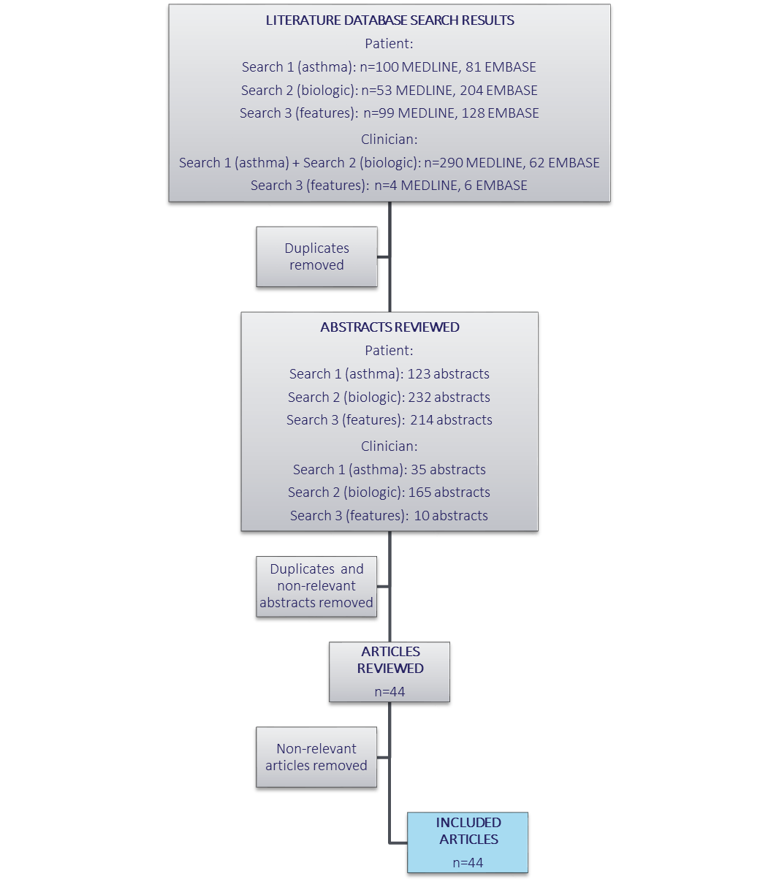

Figure S2. Social Media Data Mining Methodology
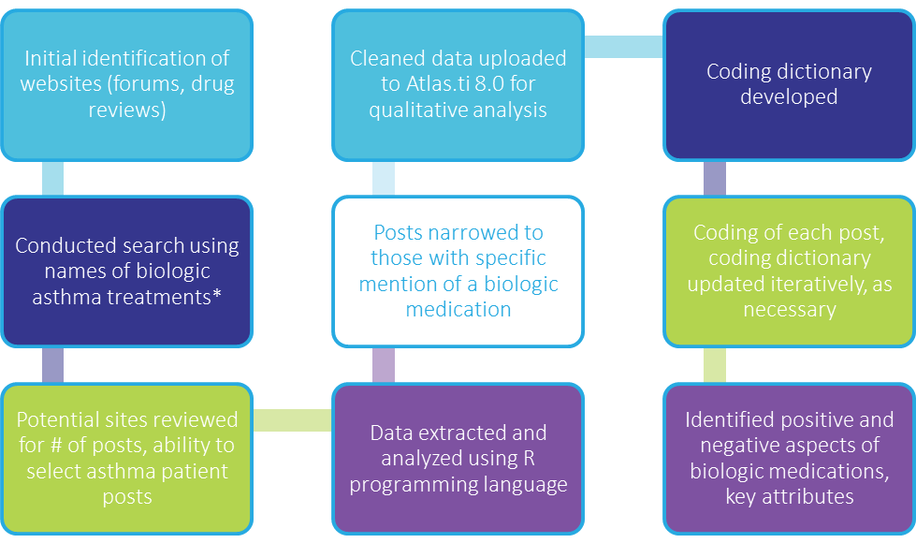
* Biologic asthma treatments: benralizumab, Cinqair, Cinquil, Mepolizumab, Nucala, omalizmab, reslizumab, and Xolair

Figure S3. Results of Data Mining Social Media: Positive Views of Biologic Medications (N=431)

Figure S4. Results of Data Mining Social Media: Negative Views of Biologic Medications (N=278)

Figure S5. Patients' Preferences in Biologic Treatment: Rating Importance of Biologic Medication Attributes (N=46)¹

¹ Only n=46 were included in final analysis. One patient was excluded due to low literacy that prevented accurate collection of quantitative data.

Figure S6. Physicians' Preferences in Biologic Treatment: Rating Importance of Biologic Medication Attributes (N=25)

Table S1a. Preferences Between 4 Biologic Treatment Profiles: Patient Version
Characteristic | Biologic A | Biologic B | Biologic C | Biologic D
How the medication is administered: | Injected under the skin | Injected under the skin | Injected into a vein | Injected under the skin
Frequency of treatment | Every 8 weeks  (after first 3 doses given every 4 weeks) | Every 4 weeks | Every 4 weeks | Every 2 or 4 weeks
Number of injections each treatment | 1 | 1 | 1 | 1 to 3
Preferred Option
(choose one)

Table S1b. Preferences Between 4 Biologic Treatment Profiles: Physician Version
Characteristic | Biologic A | Biologic B | Biologic C | Biologic D
Mode of Administration: | Subcutaneous injection | Subcutaneous injection | Intravenous infusion | Subcutaneous injection
Frequency of Administration | Every 8 weeks  (after first 3 doses given every 4 weeks) | Every 4 weeks | Every 4 weeks | Every 2 or 4 weeks
Process required for administration (based on FDA prescribing information) | Remove from refrigerator & allow to reach room temperature (30 minutes) prior to administration. No HCP action required during that time. | Need to reconstitute lyophilized powder: Add sterile water to center of powder, gently swirl for 10 seconds at 15-second intervals until powder dissolves (5-6 minutes); ensure solution is clear to opalescent and colorless to pale yellow | Weight-based dosage; insert into infusion bag & invert; administer immediately after preparation | Determine dose & dosing frequency by serum total IGE level & body weight using dose charts; need to reconstitute lyophilized powder: vial must be upright to inject sterile water & swirl for 5-10 seconds every 5 minutes to dissolve; takes 15-20 minutes to dissolve; invert vial before admin
Number of injections at each administration | 1 | 1 | 1 | 1 to 3
Preferred Option
(choose one)

Survey-Patient. Patient Preference Questions
Note: Patients were administered a paper and pencil survey and were randomized to receive either version A or version B of the preference survey. The versions only differed by the order of the response options in two questions (questions 10 and 15).
Please rate the following characteristics of biologic medications on how important each one is to you when considering a treatment option for your asthma.
- How the medication is administered (injected under the skin versus injected into a vein (intravenous or IV))
0 | 1 | 2 | 3 | 4 | 5 | 6 | 7 | 8 | 9 | 10
Not at all important |  |  |  |  |  |  |  |  | Extremely important

- Where you receive the medication (administration at home versus administration by a healthcare provider in a doctor’s office or clinic)
0 | 1 | 2 | 3 | 4 | 5 | 6 | 7 | 8 | 9 | 10
Not at all important |  |  |  |  |  |  |  |  | Extremely important

- Time required for the medication to be administered (how long you spend in the doctor’s office each time you receive biologic therapy)
0 | 1 | 2 | 3 | 4 | 5 | 6 | 7 | 8 | 9 | 10
Not at all important |  |  |  |  |  |  |  |  | Extremely important

- Frequency of treatment (whether you receive the biologic therapy every 2, 4, or 8 weeks)
0 | 1 | 2 | 3 | 4 | 5 | 6 | 7 | 8 | 9 | 10
Not at all important |  |  |  |  |  |  |  |  | Extremely important

- Number of injections each time you receive a treatment (how many needle sticks are required each time you receive a treatment)
0 | 1 | 2 | 3 | 4 | 5 | 6 | 7 | 8 | 9 | 10
Not at all important |  |  |  |  |  |  |  |  | Extremely important
- Speed of onset (how long it takes when you first start taking the medication until you notice an improvement in your asthma symptoms)
0 | 1 | 2 | 3 | 4 | 5 | 6 | 7 | 8 | 9 | 10
Not at all important |  |  |  |  |  |  |  |  | Extremely important

- Your out-of-pocket cost (how much you pay out-of-pocket for your biologic therapy)
0 | 1 | 2 | 3 | 4 | 5 | 6 | 7 | 8 | 9 | 10
Not at all important |  |  |  |  |  |  |  |  | Extremely important

- Scheduling treatment (the availability of appointments for receiving biologic therapy at a time and place that are convenient for you)
0 | 1 | 2 | 3 | 4 | 5 | 6 | 7 | 8 | 9 | 10
Not at all important |  |  |  |  |  |  |  |  | Extremely important

- Please rank the following medication characteristics in order from most important to least important, when considering biologic therapy for your severe asthma. Assume that the medications have the same benefit for your asthma symptoms and same side effects and only differ in terms of the characteristics listed.
Rank the most important characteristic as #1 and the least important as #8.
Medication Characteristic | Rank
- How the medication is administered  (injected under the skin versus injected into a vein (intravenous or IV)) | _______
- Where you receive the medication  (administration at home versus administration by a healthcare provider in a doctor’s office or clinic) | _______
- Time required for the medication to be administered  (how long you spend in the doctor’s office each time you receive biologic therapy) | _______
- Frequency of treatment  (whether you receive the biologic therapy every 2, 4, or 8 weeks) | _______
- Number of injections each time  (how many injections/needle sticks are required each time) | _______
- Speed of onset  (how long it takes when you first start taking the medication until you notice an improvement in your asthma symptoms) | _______
- Your out-of-pocket cost  (how much you pay out-of-pocket for your biologic therapy) | _______
- Scheduling treatment  (the availability of appointments for receiving biologic therapy at a time and place that are convenient for you) | _______

- VERSION A

Given the choice between biologic asthma medications that differed only in how they are administered, which one of the following options would you prefer?
Subcutaneous injection  (injection under the skin) | Intravenous infusion  (injection into a vein)

10. VERSION B:
Given the choice between biologic asthma medications that differed only in how they are administered, which one of the following options would you prefer?
Intravenous infusion  (injection into a vein) | Subcutaneous injection  (injection under the skin)

- Given the choice between biologic asthma medications that differed only in the amount of time between taking the medication (e.g., after initial loading doses), which one of the following options would you prefer?
Less than one month  between treatments | One month  between treatments | More than one month  between treatments

- Given the choice between biologic asthma medications that differed only in who administers the therapy, which one of the following options would you prefer?
Self-administered at home | Family member or other caregiver administers at home | Health care provider administers at office/clinic

- Given the choice between biologic asthma medications that differed only in how often you had to take the medication (e.g., after initial loading doses), which one of the following options would you prefer?
Every 2 weeks | Every 4 weeks | Every 8 weeks

- Given the choice between biologic asthma medications that differed only in where the therapy was administered by a healthcare provider, which one of the following options would you prefer?
At your primary care provider’s office | At a specialist’s office | At a hospital clinic

- VERSION A:

There are 4 hypothetical biologic medications presented below. Assume that they all have the same benefit for your asthma symptoms and same side effects. Please choose the medication you would prefer for the treatment of your severe asthma.
Characteristic | Biologic A | Biologic B | Biologic C | Biologic D
How the medication is administered: | Injected under the skin | Injected under the skin | Injected into a vein | Injected under the skin
Frequency of treatment | Every 4 weeks | Every 8 weeks  (after first 3 doses given every 4 weeks) | Every 4 weeks | Every 2 or 4 weeks
Number of injections each treatment | 1 | 1 | 1 | 1 to 3
Preferred Option
(choose one)

15. VERSION B:
There are 4 hypothetical biologic medications presented below. Assume that they all have the same benefit for your asthma symptoms and same side effects. Please choose the medication you would prefer for the treatment of your severe asthma.
Characteristic | Biologic A | Biologic B | Biologic C | Biologic D
How the medication is administered: | Injected under the skin | Injected under the skin | Injected into a vein | Injected under the skin
Frequency of treatment | Every 2 or 4 weeks | Every 4 weeks | Every 4 weeks | Every 8 weeks  (after first 3 doses given every 4 weeks)
Number of injections each treatment | 1 to 3 | 1 | 1 | 1
Preferred Option
(choose one)

Survey-Physician. Physician Preference Questions
Note: Physician preference questions were administered online. The order of responses in questions 3 through 8 were randomized.
- Please rate the following characteristics of biologic therapies on how important each one is when deciding on biologic therapy for treatment of a severe asthma patient.

- Mode of administration (subcutaneous injection versus intravenous)
0 | 1 | 2 | 3 | 4 | 5 | 6 | 7 | 8 | 9 | 10
Not at all important |  |  |  |  |  |  |  |  | Extremely important

- Formulation (premixed liquid in prefilled syringe versus lyophilized vial that requires reconstitution)
0 | 1 | 2 | 3 | 4 | 5 | 6 | 7 | 8 | 9 | 10
Not at all important |  |  |  |  |  |  |  |  | Extremely important

- Dosing frequency (every 2 weeks or 4 weeks or 8 weeks)
0 | 1 | 2 | 3 | 4 | 5 | 6 | 7 | 8 | 9 | 10
Not at all important |  |  |  |  |  |  |  |  | Extremely important

- Number of injections each treatment (how many needle sticks are required each treatment)
0 | 1 | 2 | 3 | 4 | 5 | 6 | 7 | 8 | 9 | 10
Not at all important |  |  |  |  |  |  |  |  | Extremely important

- Time to onset of efficacy after a patient starts taking the medication (a few days to six or more months)
0 | 1 | 2 | 3 | 4 | 5 | 6 | 7 | 8 | 9 | 10
Not at all important |  |  |  |  |  |  |  |  | Extremely important

- Administration burden (time and effort required for clinic staff to prepare the medication, administer the medication, and monitor the patient)
0 | 1 | 2 | 3 | 4 | 5 | 6 | 7 | 8 | 9 | 10
Not at all important |  |  |  |  |  |  |  |  | Extremely important

- Insurance reimbursement/access (the degree to which the medication is covered by insurance and the time required to obtain insurance authorization)
0 | 1 | 2 | 3 | 4 | 5 | 6 | 7 | 8 | 9 | 10
Not at all important |  |  |  |  |  |  |  |  | Extremely important

- Setting for administration (whether the medication must be administered in a healthcare setting or whether it can be administered at home by the patient)
0 | 1 | 2 | 3 | 4 | 5 | 6 | 7 | 8 | 9 | 10
Not at all important |  |  |  |  |  |  |  |  | Extremely important

- Please rank the following medication characteristics in order from most important to least important, when recommending biologic therapy to a severe asthma patient. Assume that the medications have equivalent efficacy and side-effect profiles and only differ in terms of the characteristics listed.
Rank the most important characteristic as #1 and the least important as #8.
Medication Characteristic | Rank
- Mode of administration  (subcutaneous injection versus intravenous) | _______
- Formulation  (premixed liquid in prefilled syringe versus lyophilized vial that requires reconstitution) | _______
- Dosing frequency  (every 2 weeks or 4 weeks or 8 weeks) | _______
- Number of injections each treatment  (how many needle sticks are required each treatment) | _______
- Time to onset of efficacy after a patient starts taking the medication  (a few days to six or more months) | _______
- Administration burden  (time and effort required for clinic staff to prepare the medication, administer the medication, and monitor the patient) | _______
- Insurance reimbursement/access  (the degree to which the medication is covered by insurance and the time required to obtain insurance authorization) | _______
- Setting for administration  (whether the medication must be administered in a healthcare setting or whether it can be administered at home by the patient) | _______

For the next questions, please consider your preferences when recommending biologic therapy to a severe asthma patient.
- Given the choice between biologic asthma medications that differed only in how they are administered, which one of the following options would you prefer?
Subcutaneous injection  (injection under the skin) | Intravenous infusion  (injection into a vein)

- Given the choice between biologic asthma medications that differed only in the amount of time between taking the medication (e.g., after initial loading doses), which one of the following options would you prefer?
Less than one month  between treatments | One month  between treatments | More than one month  between treatments

- Given the choice between biologic asthma medications that differed only in who administers the therapy, which one of the following options would you prefer?
Self-administered at home | Family member or other caregiver administers at home | Health care provider administers at office/clinic

- Given the choice between biologic asthma medications that differed only in how often you had to take the medication (e.g., after initial loading doses), which one of the following options would you prefer?
Every 2 weeks | Every 4 weeks | Every 8 weeks

- Where would you prefer patients receive their biologic asthma medications? Please select one.
At primary care provider’s office | At a specialist’s office | At a hospital clinic

- There are 4 biologic medication options presented below. Assume that all are indicated for severe, uncontrolled asthma, and that they all have equivalent efficacy and side-effect profiles.
Please select the profile of the biologic medication you would be most likely to recommend to a patient with severe asthma.
Characteristic | Biologic A | Biologic B | Biologic C | Biologic D
Mode of Administration: | Subcutaneous injection | Subcutaneous injection | Intravenous infusion | Subcutaneous injection
Frequency of Administration | Every 8 weeks  (after first 3 doses given every 4 weeks) | Every 4 weeks | Every 4 weeks | Every 2 or 4 weeks
Process required for administration (based on FDA prescribing information) | Remove from refrigerator & allow to reach room temperature (30 minutes) prior to administration. No HCP action required during that time. | Need to reconstitute lyophilized powder: Add sterile water to center of powder, gently swirl for 10 seconds at 15-second intervals until powder dissolves (5-6 minutes); ensure solution is clear to opalescent and colorless to pale yellow | Weight-based dosage; insert into infusion bag & invert; administer immediately after preparation | Determine dose & dosing frequency by serum total IGE level & body weight using dose charts; need to reconstitute lyophilized powder: vial must be upright to inject sterile water & swirl for 5-10 seconds every 5 minutes to dissolve; takes 15-20 minutes to dissolve; invert vial before admin
Number of injections at each administration | 1 | 1 | 1 | 1 to 3
Preferred Option (choose one)

