Supplementary Tables

Table A.₁
Imaging parameters of MRI acquisition protocol (Discovery 750 3.0T, GE Healthcare)
Acquisition order | Sequence | TR  (ms) | TE  (ms) | TI (ms) | Acquisition matrix | Thickness/Gap (mm) | Field of view (FOV) (cm) | NEX | Acquisition  (min/s)
1 Axial | T₁WI | 1750 | 24 | 780 | 256×256 | 5/1.5 | 24×24 | 1 | 1min29s
2 Axial | T₂WI | 4247 | 93 | – | 512×512 | 5/1.5 | 24×24 | 1 | 1min3s
3 Axial | FLAIR | 8000 | 165 | 2100 | 256×256 | 5/1.5 | 24×24 | 1 | 2min15s
4 Axial | 3D-ASL | 4632 | 10.5 | – | 512×512 | 4/0.0 | 24×24 | 3 | 4min29s
5 Axial | Multi-b DWI | 3000 | Minimums | – | 128×128 | 5/1.5 | 24×24 | 3 | 5min45s
6 Axial | DCE | 2.9 | 1.3 | – | 128×128 | 5/0.0 | 24×24 | – | 5min23s
7 Axial | T₁CE | 1750 | 24 | 780 | 256×256 | 5/1.5 | 24×24 | 1 | 1min29s

Table A_{.2}
ROC results of qualitative analysis for multimodal parameters in differentiating LGGs from HGGs.
Parameter | AUC*(95%CI) |  | Sensitivity(%)  * (95%CI) |  | Specificity(%)  * (95%CI) |  | P Value |  | Cutoff  Value
DCE_Patlak
K_{trans}^{mean}  V_{p}^{mean} | 0.7896 (0.6833 to 0.8959)  0.7267 (0.6246 to 0.8288) |  | 75.00 (64.89-83.45)  51.09 (40.44-61.66) |  | 78.57 (59.05-91.70)  89.29 (71.77-97.73) |  | <0.0001****  0.0003** |  | 0.0088  0.0305
DCE_Tofts
K_{trans}^{mean}  K_{ep}^{mean}  V_{e}^{mean} | 0.7209 (0.6122 to 0.8295)  0.7081 (0.5818 to 0.8343)  0.7981 (0.6981 to 0.8982) |  | 71.74 (61.39-80.64)  80.43 (70.85-87.97)  63.04 (52.34-72.88) |  | 71.43 (51.33-86.78)  67.86 (47.65-84.12)  85.71 (67.33-95.97) |  | 0.0004**  0.0009***  <0.0001**** |  | 0.0580  1.328  12.20
DCE_Extended Tofts
K_{trans}^{mean}  K_{ep}^{mean}  V_{e}^{mean}  V_{p}^{mean} | 0.7329 (0.6268 to 0.8390)  0.6871 (0.5631 to 0.8111)  0.8005 (0.7001 to 0.9008)  0.5101 (0.3873 to 0.6329) |  | 59.78 (49.04-69.88)  80.43 (70.85-87.97)  63.04 (52.34-72.88)  69.57 (59.10-78.73) |  | 82.14 (63.11-93.94)  64.29 (44.06-81.36)  85.71 (67.33-95.97)  42.86 (24.46-62.82) |  | 0.0002**  0.0028**  <0.0001****  0.8718 |  | 0.0628  1.061  11.85  0.1449
DCE_Incremental
K_{trans}^{mean}  K_{ep}^{mean}  V_{e}^{mean} | 0.7255 (0.6193 to 0.8318)  0.6976 (0.5724 to 0.8227)  0.7892 (0.6893 to 0.8891) |  | 64.13 (53.46-73.87)  73.91 (63.71-82.52)  63.04 (52.34-72.88) |  | 78.57 (59.05-91.70)  75.00 (55.13-89.31)  85.71 (67.33-95.97) |  | 0.0003**  0.0016**  <0.0001**** |  | 0.0322  0.4518  8.847
DCE
IAUGC₉₀^{mean}  BF^{mean}  Peak^{mean}  TTP^{mean} | 0.8133 (0.7298 to 0.8967)  0.6887 (0.5673 to 0.8100)  0.6941 (0.5722 to 0.8160)  0.6324 (0.5078 to 0.7570) |  | 67.39 (56.82-76.80)  73.91 (63.71-82.52)  72.83 (62.55-81.58)  77.17 (67.25-85.28) |  | 85.71 (67.33-95.97)  60.71 (40.58-78.50)  64.29 (44.06-81.36)  53.57 (33.87-72.49) |  | <0.0001****  0.0026**  0.0019**  0.0344* |  | 2.250  11.67  0.9994  10.68
3D_ASL
CBF^{mean} | 0.6572(0.5420 to 0.7724) |  | 68.89 (58.26-78.23) |  | 59.26 (38.80-77.61) |  | 0.0135* |  | 38.6
IVIM_DWI
ADC_{fast}^{mean}  f_{fast}^{mean}  ADC_{slow}^{mean}  f_{slow}^{mean} | 0.6353 (0.5232 to 0.7473)  0.6771 (0.5577 to 0.7966)  0.7476 (0.6449 to 0.8503)  0.6824 (0.5572 to 0.8076) |  | 47.83 (37.30-58.50)  72.83 (62.55-81.58)  69.57 (59.10-78.73)  79.35 (69.64-87.08) |  | 85.19 (66.27-95.81)  66.67 (46.04-83.48)  74.07 (53.71-88.89)  62.96 (42.37-80.60) |  | 0.0031**  0.0053**  <0.0001****  0.0041** |  | 280.6  0.3741  80.08  0.6236
Note.—****indicate results with the relative high differentiating efficiency.
* = P < 0.05, ** = P < 0.01, *** = P < 0.001, **** = P < 0.0001.

TableA_{.3}
ROC analysis for histogram metrics of multimodal parameters in differentiating LGGs from HGGs.
Parameters | Mean | Max | Median | Percentiles i  75% 90% 95% |  |  |  |  |  | Skwessness |  | Kurtosis |  |  |  |  | Energy |  |  | Entropy
Patlak_K_{trans}
AUC  P value | 0.7896  <0.0001 | 0.6231  0.0492 | 0.7638  <0.0001 | 0.7865  <0.0001 | 0.7972**<0.0001 |  |  | 0.7875  <0.0001 |  | 0.7252  0.0003 |  | 0.7073  0.0009 |  |  |  |  | 0.7714  <0.0001 |  | 0.7869  <0.0001
Toft_V_{e}
AUC  P value | 0.7981  <0.0001 | 0.7374  0.0002 | 0.6362  0.0323 | 0.6704  0.0074 | 0.6926  0.0025 |  |  | 0.6992  0.0018 |  | 0.6152^  0.0702 |  | 0.6095^  0.0855 |  |  |  |  | 0.7370  0.0002 |  | 0.7403  0.0002
Extended Toft_V_{e}
AUC  P value | 0.8005  <0.0001 | 0.5893^  0.1536 | 0.8007**<0.0001 | 0.7939  <0.0001 | 0.7910  <0.0001 |  |  | 0.7778  <0.0001 |  | 0.6832  0.0034 |  | 0.6724  0.0059 |  |  |  |  | 0.7345  0.0002 |  | 0.7667  <0.0001
Incremental_V_{e}
AUC  P value | 0.7892  <0.0001 | 0.6456  0.0200 | 0.7628  <0.0001 | 0.7962**<0.0001 | 0.7869  <0.0001 |  |  | 0.7776  <0.0001 |  | 0.6564  0.0124 |  | 0.6444  0.0210 |  |  |  |  | 0.6704  0.0065 |  | 0.7329  0.0002
DCE_IAUGC₉₀
AUC  P value | 0.8133  <0.0001 | 0.8296**<0.0001 | 0.5256^  0.6822 | 0.6456  0.0200 | 0.7166  0.0005 |  |  | 0.7296  <0.0001 |  | 0.7426  0.0001 |  | 0.7508  <0.0002 |  |  |  |  | 0.6580  0.0116 |  | 0.6642  0.0087
Parameters | Mean | Min | Median | Percentiles I |  |  |  |  |  | Skwessness |  | Kurtosis |  |  |  | Energy |  | Entropy
 |  |  |  | 5% 10% 25%
IVIM_ADC_{slow}
AUC  P value | 0.7476  <0.0001 | 0.5278^  0.6616 | 0.7428  0.0001 | 0.6695  0.0076 |  | 0.6632  0.0101 | 0.7413  0.0001 |  | 0.6675  0.0083 |  |  |  | 0.5056^  0.9292 |  | 0.5411^  0.5175 |  |  |  |  |  | 0.5415^  0.5134
**The results of histogram analysis which is more accurate than homologus primarily mean.
^, The results of histogram metrics with no significant diagnostic efficacies.

Table A_{.4}
ROC results of qualitative analysis for multimodal parameters in predicting 12-, 15-, 18-month survival.
Parameter | 12-month survival  AUC (P value) | 15-month survival  AUC (P value) | 18-month survival  AUC (P value)
DCE_Patlak
K_{trans}^{mean}  V_{p}^{mean} | 0.7288 (0.0055)**  0.6238 (0.1330) | 0.7612 (0.0029)**  0.7165 (0.0206)* | 0.9118 (0.0003)***  0.6912 (0.0959)
DCE_Tofts
K_{trans}^{mean}  K_{ep}^{mean}  V_{e}^{mean} | 0.6473 (0.0739)  0.6677 (0.0419)*  0.7163 (0.0087)** | 0.7254 (0.0159)*  0.7009 (0.0317)*  0.7634 (0.0049)** | 0.7206 (0.0547)  0.8676 (0.0014)**  0.9007 (0.0005)***
DCE_Extended Tofts
K_{trans}^{mean}  K_{ep}^{mean}  V_{e}^{mean}  V_{p}^{mean} | 0.6552 (0.0598)  0.6661 (0.0439)*  0.7179 (0.0082)**  0.5204 (0.8047) | 0.7455 (0.0087)**  0.6741 (0.0627)  0.7612 (0.0052)**  0.5536 (0.5667) | 0.7684 (0.0194)*  0.8456 (0.0026)**  0.9044 (0.0004)***  0.5993 (0.3872)
DCE_Incremental
K_{trans}^{mean}  K_{ep}^{mean}  V_{e}^{mean} | 0.6473 (0.0739)  0.6740 (0.0348)*  0.6991 (0.0158)* | 0.7299 (0.0140)*  0.6830 (0.0503)  0.7634 (0.0049)** | 0.7463 (0.0319)*  0.8860 (0.0008)***  0.8640 (0.0015)**
DCE
IAUGC₉₀^{mean}  BF^{mean}  Peak^{mean}  TTP^{mean} | 0.7304 (0.0052)**  0.6850 (0.0249)*  0.6944 (0.0184)*  0.6944 (0.0184)* | 0.7835 (0.0024)**  0.7188 (0.0194)*  0.7232 (0.0170)*  0.7076 (0.0265)* | 0.8713 (0.0012)**  0.7831 (0.0137)*  0.7794 (0.0150)*  0.7647 (0.0211)*
IVIM_DWI
f_{slow}^{mean}  f_{fast}^{mean}  ADC_{slow}^{mean}  ADC_{fast}^{mean} | 0.5987 (0.2309)  0.5893 (0.2784)  0.6740 (0.0348)*  0.5909 (0.2700) | 0.5848 (0.3644)  0.5670 (0.4739)  0.7299 (0.0140)*  0.6228 (0.1892) | 0.5772 (0.5012)  0.5221 (0.8476)  0.6654 (0.1495)  0.5625 (0.5861)
3D-ASL
CBF^{mean} | 0.5408 (0.6210) | 0.5268 (0.7745) | 0.6691 (0.1407)
Note.— *** indicate results with the relative high efficiency of differentiation.
* = P < 0.05, ** = P < 0.01, *** = P < 0.001.

Table A_{.5}
ROC results of qualitative analysis for histogram metrics in predicting 12-, 15-, 18-month survival.
Parameters | mean | max | median | percentiles  75% 90% 95% |  |  |  |  |  | skwessness |  | kurtosis |  | energy |  |  | entropy
Extended Tofts_V_{e} (18-month survival)
AUC  P value | 0.9044  0.0004 | 0.6618^  0.1588 | 0.7831  0.0137 | 0.8621  0.0016 |  | 0.9007  0.0005 |  | 0.9154**  0.0003 |  | 0.7978  0.0095 |  | 0.8199  0.0053 |  | 0.6691^  0.1407 |  | 0.7647  0.0211
Patlak_K_{trans} (18-month survival)
AUC  P value | 0.9118  0.0003 | 0.7169^  0.0588 | 0.8676  0.0013 | 0.8989  0.0005 |  | 0.9118  0.0003 |  | 0.9265**  0.0002 |  | 0.7390  0.0374 |  | 0.7610  0.0230 |  | 0.8015  0.0067 |  | 0.8309  0.0040
Extended Tofts_V_{e} (15-month survival)
AUC  P value | 0.7612  0.0052 | 0.5781^  0.4034 | 0.7467  0.0084 | 0.7199  0.0187 |  | 0.7366  0.0114 |  | 0.7556  0.0063 |  | 0.6987  0.0337 |  | 0.6987  0.0337 |  | 0.7366  0.0114 |  | 0.7344  0.0122
Patlak_K_{trans} (15-month survival)
AUC  P value | 0.7790  0.0029 | 0.5960^  0.3047 | 0.7567  0.0061 | 0.7377  0.0110 |  | 0.7522  0.0070 |  | 0.7679  0.0042 |  | 0.7009  0.0317 |  | 0.7254  0.0159 |  | 0.7210  0.0182 |  | 0.7210  0.0182
Extended Tofts_V_{e} (12-month survival)
AUC  P value | 0.7179  0.0082 | 0.5580^  0.4817 | 0.6779  0.0309 | 0.6669  0.0429 |  | 0.6991  0.0158 |  | 0.7202**  0.0076 |  | 0.6959  0.0175 |  | 0.7069  0.0120 |  | 0.6928  0.0194 |  | 0.6897  0.0214
Patlak_K_{trans} (12-month survival)
AUC  P value | 0.7288  0.0055 | 0.5596^  0.4699 | 0.7077  0.0118 | 0.6834  0.0261 |  | 0.7155  0.0089 |  | 0.7351**  0.0044 |  | 0.6426  0.0836 |  | 0.6599  0.0525 |  | 0.6677  0.0419 |  | 0.6677  0.0419
**, The results of histogram analysis which is more accurate than homologous primarily mean.
^, The results of histogram metrics with no significant predicting efficacies.

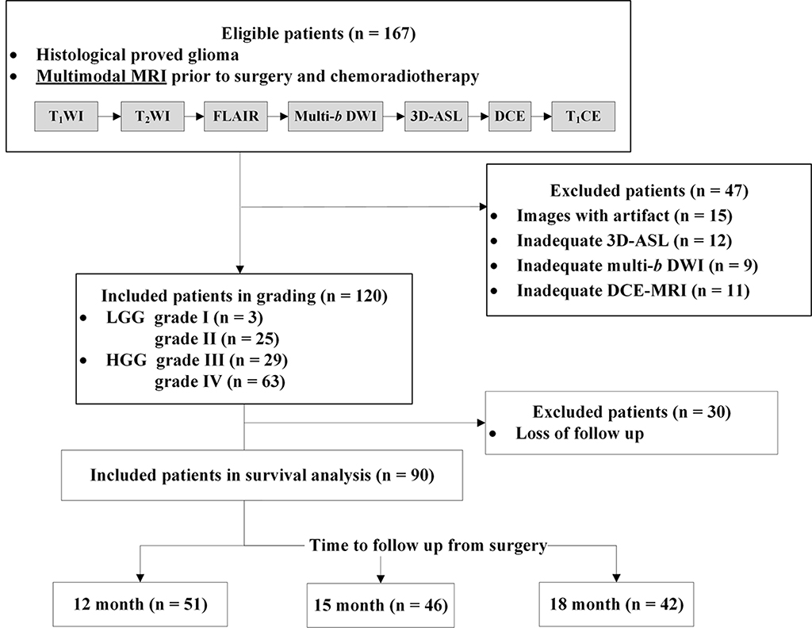

Supplementary Figure 1 (Fig. A.₁) Flow diagram of the current study design, including population, inclusion and exclusion criteria. FLAIR = Fluid-attenuated inversion recovery, 3D ASL = Three dimension pseudo-continuous arterial spin labeling，Multip-b DWI = Multiple b value diffusion weighted imaging, DCE-MRI = Dynamic contrast enhanced MRI, T1CE = T1-weighted contrast enhanced imaging.

