Supplement materials

Table S1 Proportion of patients with COPD-related pharmacy encounters in the observation period by EOS and MITT treatment status
 |  |  |  | Not receiving MITT |  | Receiving MITT
 | Population of interest (N=34,268) |  | EOS  <150 cells/µL (N=6892) | EOS  ≥150 cells/µL (N=16,480) | EOS  <150 cells/µL (N=3199) |  | EOS  ≥150 cells/µL (N=7697)
Drug class, %
SABA-SAMA | 71.5 |  | 65.9 | 68.8 | 79.2 |  | 79.1
SAMA | 30.0 |  | 26.2 | 26.6 | 37.7 |  | 37.6
SABA | 86.8 |  | 82.0 | 83.3 | 94.8 |  | 95.2
Antibiotics | 82.3 |  | 79.2 | 81.6 | 84.9 |  | 85.7
Any OCS use | 86.9 |  | 83.7 | 84.6 | 92.2 |  | 92.4
ICS/LABA | 59.1 |  | 42.2 | 42.7 | 95.4 |  | 94.5
LABA/LAMA | 3.0 |  | 2.0 | 1.8 | 5.3 |  | 5.4
LABA | 7.5 |  | 5.4 | 5.7 | 11.6 |  | 11.6
LAMA | 55.3 |  | 35.0 | 35.5 | 98.2 |  | 98.1
PDE4 | 5.2 |  | 3.8 | 3.1 | 9.6 |  | 9.1
Theophylline | 48.8 |  | 43.3 | 45.1 | 57.8 |  | 58.2
Abbreviations: EOS, blood eosinophil count; ICS, inhaled corticosteroid; LABA, long-acting β₂-agonist; LAMA, short-acting muscarinic-antagonist; MITT, multiple inhaled triple therapy; OCS, oral corticosteroid; PDE4, phosphodiesterase 4; SABA, short-acting β₂-agonist; SAMA, short-acting muscarinic-antagonist.

Table S2 Demographic and clinical characteristics at the index date in patients receiving MITT
 | Patients receiving MITT
 | Total (N=10,896) | EOS  <150 cells/µL (N=3199) | EOS  ≥150–<300 cells/µL (N=3418) | EOS  ≥300–<500 cells/µL (N=2503) | EOS  ≥500 cells/µL (N=1776)
Age at index, years, mean (SD) | 70.1 (10.6) | 69.9 (10.6) | 70.0 (10.5) | 70.1 (10.6) | 70.7 (10.5)
Female, % | 56.4 | 61.1 | 56.9 | 53.9 | 50.2
Insurance, %
Private | 62.6 | 63.0 | 63.5 | 61.0 | 62.6
Medicare | 75.2 | 73.9 | 74.7 | 76.6 | 76.4
Medicaid | 21.2 | 21.5 | 21.4 | 20.6 | 21.5
Self-pay | 18.7 | 19.5 | 19.1 | 16.9 | 18.9
Other public | 6.8 | 6.2 | 7.1 | 7.1 | 6.9
Other | 3.2 | 3.2 | 3.3 | 3.0 | 3.1
Unknown | 14.2 | 15.2 | 13.5 | 14.3 | 13.3
BMI, mean (SD) ª | 28.7 (8.7) | 27.6 (8.4) | 29.2 (8.7) | 29.5 (8.9) | 28.8 (8.5)
Smoking status, %ª
Current | 15.6 | 16.5 | 15.2 | 15.8 | 14.7
Ex-smoker | 31.0 | 30.4 | 29.4 | 33.1 | 32.1
Non-smoker | 6.3 | 5.2 | 6.2 | 6.8 | 7.7
Passive smoker | 0.2 | 0.1 | 0.1 | 0.2 | 0.3
Missing | 47.0 | 47.9 | 49.1 | 44.1 | 45.3
EOS, cells/µL, geometric mean (95% CI) | 213.5  (209.9, 217.2) | 74.5  (72.7, 76.3) | 206.8  (205.7, 208.0) | 357.1  (354.9, 359.2) | 733.5  (720.0, 747.2)
Notes: ªReported data on BMI and smoking status were the most recent records within the study period.
Abbreviations: BMI, body mass index; CI, confidence interval; EOS, blood eosinophil count; MITT, multiple inhaled triple therapy; SD, standard deviation.

Table S3 Comorbidities in the observation period (including the index date) in patients receiving MITT
 | Patients receiving MITT
 | Total (N=10,896) | EOS  <150 cells/µL (N=3199) | EOS  ≥150–<300 cells/µL (N=3418) | EOS  ≥300–<500 cells/µL (N=2503) | EOS  ≥500 cells/µL (N=1776)
Quan-Charlson Comorbidity Index, mean (SD) | 5.17 (3.67) | 4.83 (3.58) | 5.13 (3.62) | 5.32 (3.68) | 5.67 (3.84)
Comorbidities, %
Hypertension | 81.4 | 78.1 | 82.1 | 82.9 | 83.7
Diabetes | 39.4 | 34.3 | 39.5 | 42.1 | 44.5
CHF | 48.2 | 45.9 | 48.2 | 49.3 | 51.1
AMI | 7.9 | 6.9 | 7.8 | 8.1 | 9.4
TIA | 3.7 | 3.3 | 3.3 | 4.2 | 4.3
Stroke | 13.0 | 11.3 | 12.4 | 14.1 | 15.4
Asthma | 37.5 | 35.3 | 36.2 | 38.8 | 42.1
Anxiety | 42.0 | 41.7 | 42.3 | 41.5 | 42.8
Depression | 30.6 | 29.6 | 30.2 | 31.7 | 31.7
Respiratory infections | 23.7 | 22.3 | 23.5 | 25.1 | 24.8
Allergic rhinitis | 12.9 | 12.7 | 12.9 | 13.4 | 12.7
Respiratory tract neoplasm | 12.2 | 12.6 | 12.1 | 12.1 | 11.5
Acute sinusitis | 8.1 | 7.4 | 8.8 | 8.3 | 7.5
Chronic sinusitis | 6.3 | 6.4 | 6.4 | 5.6 | 6.7
GERD | 47.0 | 44.0 | 48.4 | 47.8 | 48.8
Rheumatoid arthritis | 5.7 | 6.2 | 5.4 | 5.4 | 6.0
Abbreviations: AMI, acute myocardial infarction; CHF, congestive heart failure; EOS, blood eosinophil count; GERD, gastroesophageal reflux disease; MITT, multiple inhaled triple therapy; SD, standard deviation; TIA, transient ischemic attack.

Table S4 COPD-related pharmacy encounters in the observation period in patients with exacerbations while receiving MITT
 | Patients receiving MITT
 | Total (N=10,896) | EOS  <150 cells/µL (N=3199) | EOS  ≥150–<300 cells/µL (N=3418) | EOS  ≥300–<500 cells/µL (N=2503) | EOS  ≥500 cells/µL (N=1776)
Drug class, %
SABA-SAMA | 79.1 | 79.2 | 77.2 | 79.3 | 82.3
SAMA | 37.6 | 37.7 | 36.1 | 37.3 | 40.7
SABA | 95.1 | 94.8 | 95.0 | 94.8 | 95.9
Antibiotics | 85.5 | 84.9 | 83.9 | 85.8 | 89.0
Any OCS use | 92.4 | 92.2 | 91.3 | 92.9 | 93.7
ICS/LABA | 94.8 | 95.4 | 94.7 | 94.6 | 93.9
LABA/LAMA | 5.4 | 5.3 | 5.4 | 5.3 | 5.4
LABA | 11.6 | 11.6 | 11.2 | 11.7 | 12.2
LAMA | 98.1 | 98.2 | 98.1 | 98.1 | 98.0
PDE4 | 9.2 | 9.6 | 8.5 | 9.5 | 9.7
Theophylline | 58.0 | 57.8 | 56.4 | 57.2 | 62.9
Abbreviations: EOS, blood eosinophil count; ICS, inhaled corticosteroid; LABA, long-acting β₂-agonist; LAMA, short-acting muscarinic-antagonist; MITT, multiple inhaled triple therapy; OCS, oral corticosteroid; PDE4, phosphodiesterase 4; SABA, short-acting β₂-agonist; SAMA, short-acting muscarinic-antagonist.

Table S5 Pairwise p-values for EOS category comparisons for mean numbers of moderate and severe exacerbations, mean uses of COPD-related and all-cause HCRU in patients receiving MITT
 | <150 vs ≥150−<300 cells/µL | <150 vs ≥300−<500 cells/µL | <150 vs ≥500 cells/µL | ≥150−<300 vs ≥300−<500 cells/µL | ≥150−<300 vs ≥500 cells/µL | ≥300−<500 vs ≥500 cells/µL
 | p-value | p-value | p-value | p-value | p-value | p-value
Exacerbations
Moderate | 0.0390 | 0.0003 | <0.0001 | <0.0001 | <0.0001 | <0.0001
Severe | 0.0029 | 0.1494 | 0.0202 | 0.5312 | 0.8003 | 0.6888
COPD-related HCRU
Inpatient admission | 0.0049 | 0.9384 | 0.7657 | 0.0197 | 0.0003 | 0.8688
ED visits | 0.0766 | <0.0001 | <0.0001 | 0.0010 | <0.0001 | 1
Outpatient office visits | 0.8478 | 0.3079 | <0.0001 | 0.329 | <0.0001 | <0.0001
Other outpatient office visits | 0.5895 | 0.4387 | <0.0001 | 0.2084 | <0.0001 | 0.0001
Pharmacy prescriptions | 0.1896 | 0.0414 | <0.0001 | 0.0015 | <0.0001 | <0.0001
All-cause HCRU
Inpatient admission | 0.2497 | 0.5437 | 0.3690 | 0.1159 | 0.0342 | 0.8638
ED visits | <0.0001 | <0.0001 | <0.0001 | 0.0079 | <0.0001 | 0.0057
Outpatient office visits | 0.1066 | <0.0001 | <0.0001 | <0.0001 | <0.0001 | 0.0195
Other outpatient office visits | <0.0001 | <0.0001 | <0.0001 | 0.1857 | <0.0001 | <0.0001
Pharmacy prescriptions | <0.0001 | <0.0001 | <0.0001 | <0.0001 | <0.0001 | <0.0001
Abbreviations: COPD, chronic obstructive pulmonary disease; ED, emergency department; EOS, blood eosinophil count; HCRU, healthcare resource utilization; MITT, multiple inhaled triple therapy.

Figure S1 All-cause HCRU visits (A) and pharmacy prescriptions (B) during the observation period in patients with exacerbations by EOS and MITT treatment status.
A.
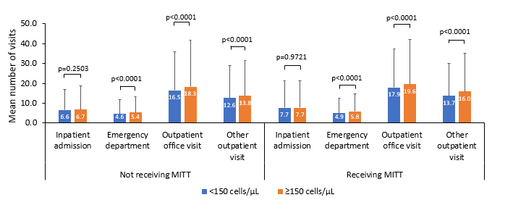
B.
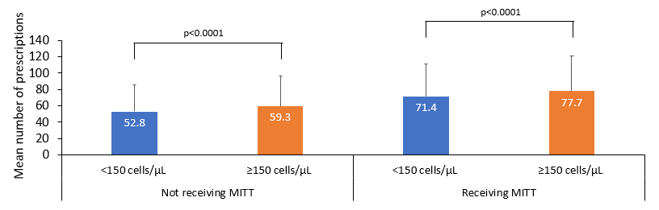
Notes: Error bars represent standard deviation.
Abbreviations: COPD, chronic obstructive pulmonary disease; EOS, blood eosinophil count; HCRU, healthcare resource utilization; MITT, multiple inhaled triple therapy.
Figure S2 Numbers of moderate and severe exacerbations according to EOS in patients with exacerbations while receiving MITT during the observation period.
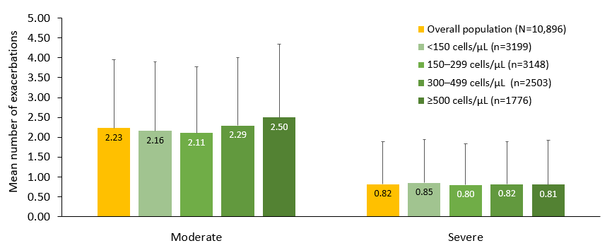Notes: Error bars represent standard deviation. Please see the p-values for the pair-wise comparisons of the blood eosinophil categories for moderate and severe exacerbations in Supplementary Table 5.
Abbreviations: EOS, blood eosinophil count; MITT, multiple inhaled triple therapy; SD, standard deviation.

Figure S3 COPD-related HCRU (A) and all-cause HCRU (B) according to EOS in patients with exacerbations while receiving MITT during the observation period.
A.
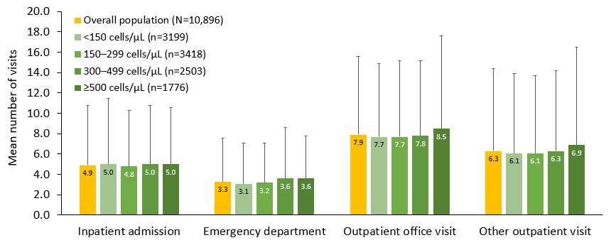
B.
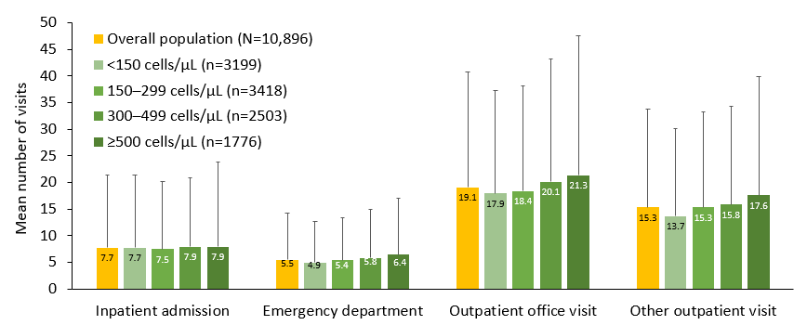
Notes: Error bars represent standard deviation. Please see the p-values for the pair-wise comparisons of the blood eosinophil categories for COPD-related and all-cause HCRU in Supplementary Table 5.
Abbreviations: COPD, chronic obstructive pulmonary disease; EOS, blood eosinophil count; HCRU, healthcare resource utilization; MITT, multiple inhaled triple therapy.
Figure S4 COPD-related pharmacy prescriptions (A) and all-cause pharmacy prescriptions (B) according to EOS in patients with exacerbations while receiving MITT during the observation period.
A.
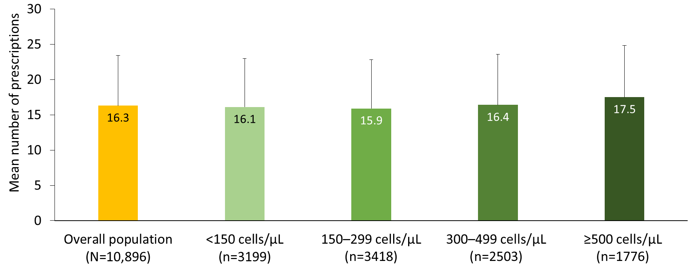
B.
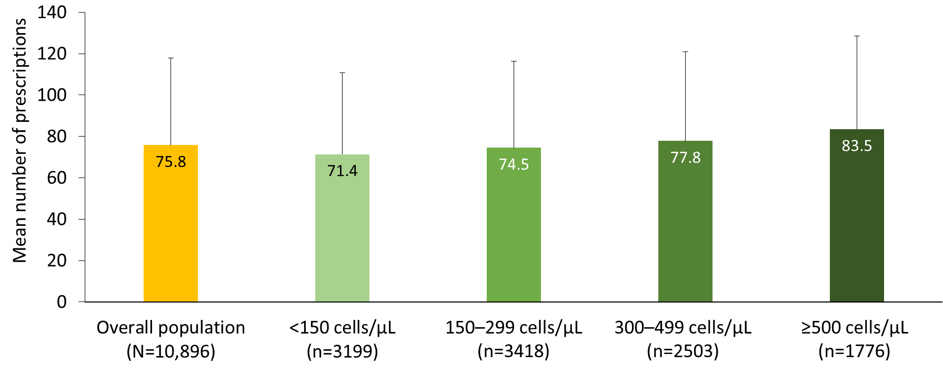
Notes: Error bars represent standard deviation. Please see the p-values for the pair-wise comparisons of the blood eosinophil categories for COPD-related and all-cause pharmacy prescriptions in Supplementary Table 5.
Abbreviations: COPD, chronic obstructive pulmonary disease; EOS, blood eosinophil count; MITT, multiple inhaled triple therapy.

