Supplemental data from preliminary experiments
Journal: International Journal of Nanomedicine Submission ID: 193963
Takanori Kumai, MD., St. Marianna University School of Medicine

1) Organ culture of bone mallow cells into the self-organized scaffold (2-week incubation)
To evaluate the osteochondral potential of the scaffold in vitro, we had done the organ culture of rabbit bone marrow cells into the self-assembled biphasic cartilage and bone like scaffold with hydroxyapatite (2-week organ culture in the flask with culture medium at 37°C in a humidified 95% air and 5% CO₂ atmosphere).

i) Chondrocyte differentiation and growth from rat bone marrow cells (mesenchymal
stem cells) into the scaffold (organ culture in vitro)
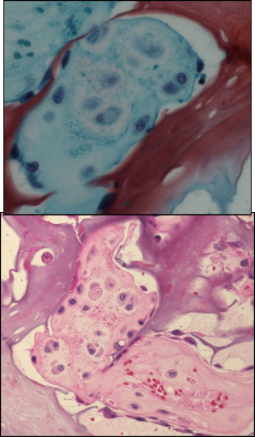
After 2-week organ culture in vitro, we found the chondrocyte like cells with rounded/spheroidal morphology and typical cartilage lacuna formation into the scaffold.
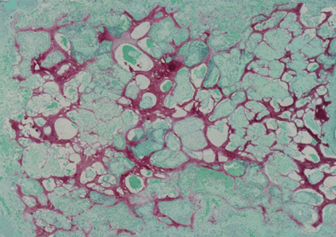
Self-organized scaffolds (safranin O positive: proteoglycan) chondrocytes and lacuna
In this preliminary experiment, the organ culture of bone mallow cells into the self-assembled may suggest the chondrogenic potential of the scaffold [chondrocyte differentiation from bone marrow cells (including mesenchymal stem cells), chondrocyte growth and survival]

ii) Expressions of chondrogenic and osteogenic makers of cells derived from the organ culture of the scaffold.
In the other experiment of organ culture of the scaffold,
- the scaffold was washed with PBS and treated with collagenase overnight.
- Then after centrifugation, cell pellet was collected.
- From the cell pellet, cellular proteins were isolated (the cell pellet was derived from inoculated bone marrow cells into the organ cultured scaffold.)
- Using the cellular proteins, chondrogenic and osteogenic makers were analyzed in vitro.
- Chondrocyte specific marker: aggrecan
- Osteoblast specific marker: osteocalcin (marker of mature osteoblast)
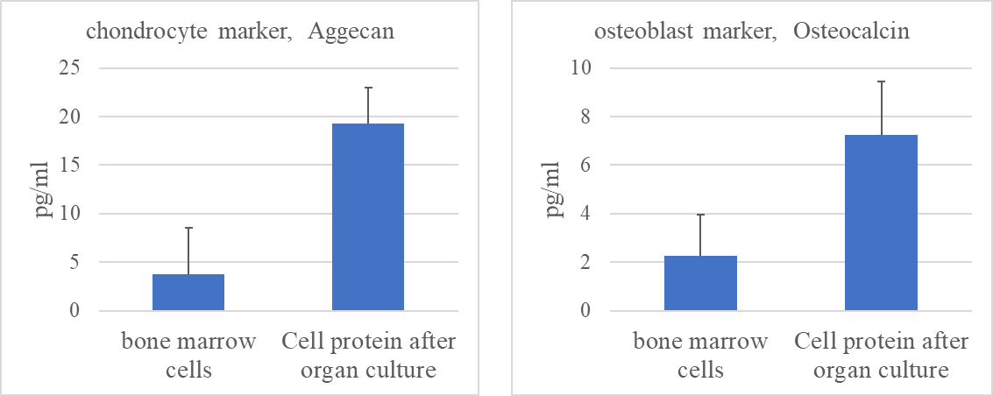
Both levels of concentrations of chondrocyte marker and osteoblast marker are significantly higher in cell protein derived from organ cultured bone marrow cells into the scaffold than in original bone marrow cells.
These findings suggest that the scaffolds may induce chondrogenesis and osteogenesis from bone marrow cells (including rat mesenchymal stem cells).
Although further studies are needed to clarify whether our scaffolds have the chondrogenic and osteogenic potentials, these in vitro findings (results in Figure 2C and preliminary data above mentioned) may indicate that our scaffolds are environment suitable for chondrocyte/osteoblast differentiation from bone marrow cells, cell growth and survival.

2) Preliminary in vivo experiment for the present study
We show the representative image of HE and Safranin O staining of the self-assembled cartilage like scaffold-inoculated knee joint in preliminary in vivo experiments (rabbit knee osteochondral defect model).
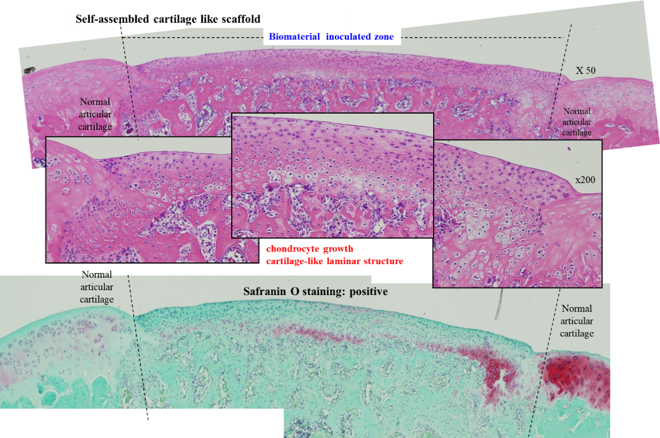
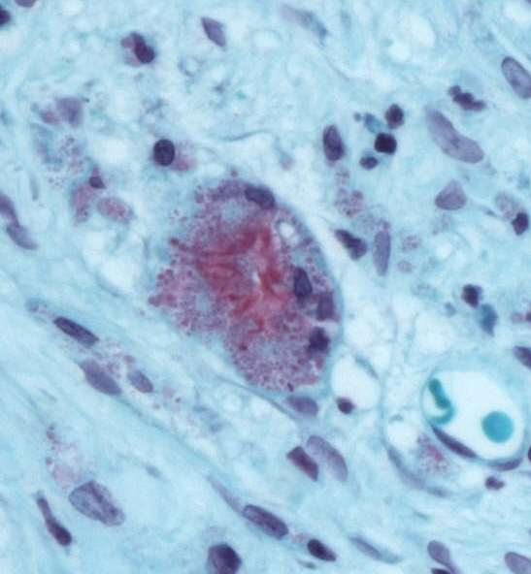
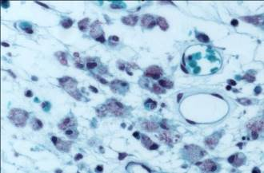
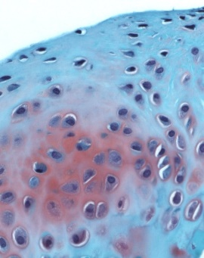

Typical cartilage lacuna formation into the inoculated scaffolds
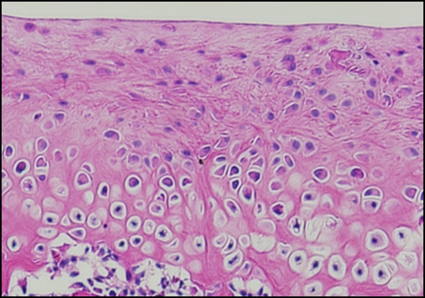
We can observe the safranin O positive-cytoplasmic staining in chondrocytes with typical rounded/spheroidal morphology and typical cartilage lacuna formation into the inoculated scaffold. Safranin O staining positive-cytoplasmic staining means the expression of chondrocyte marker, proteoglycan, into the cells, indicating that the cells into the scaffold are chondrocytes.
Also, the degree of regeneration/repair of cartilage/subchondral bone (repair of osteochondral defect/degeneration) by biomaterials were macroscopically analyzed according to the cartilage repair scoring system (ICRS II: International Cartilage Repair Society). From the results of this in vivo experiment, we can observe and estimate the degree of osteochondral tissue repair by each biomaterial.

