Appendix A. Treatment Decision Making Model as implemented in Treatment Navigation Study.
INTRODUCTION
I’d like to share with you some information about recovery options and support you in making a decision about what types of treatments you would like to try, if any. This will involve:
- Describing what opiate use disorder is
- Comparing treatment and recovery options
- Asking some questions about your preferences
- Providing feedback about the tradeoffs (pros and cons) of options you are interested in
- If you are interested in treatment we’ll work on a plan to get you started including finding a treatment provider if you are interested in counseling or medication
After today, I will be available to work with you for six months to talk through how things are going, if you’d like to try a different type of treatment, and to help you get back on treatment if you stop.
Treating opiate use disorder is like treating other health conditions. Often different methods need to be tried until the one that works best is found. I will stick with you through this process, even if you relapse.
WHAT IS OPIATE USE DISORDER?
To understand opiate use disorder, it is helpful to look at the difference between physical dependence on opiates and opiate use disorder.
Opiate dependence:
- A physical condition in which the body gets used to the amount of opiates taken. This happens whether a person takes pain pills like Vicodin, Percocet or OxyContin or uses heroin.
- The body adapts by needing more opiates to feel the same effect (tolerance) and then feels terrible when opiates are reduced or removed (withdrawal).
- This is normal and happens to anyone who takes opiates for a while.
Opiate use disorder: The current medical term used to describe what has been commonly known as addiction.
- Opiate use disorder involves being physically dependent on opiates, as well as negative impacts on a person’s thinking, relationships, and ability to function.
- Opiate use disorder lasts a long time and can keep coming back, much like diabetes and high blood pressure. It can also be managed very well with medication and supportive services.
- A person can be on treatment medications and be in recovery. With opiate medications, a person can still be physically dependent while no longer having the disorder – without having the social and thinking problems seen in people with opioid use disorder.
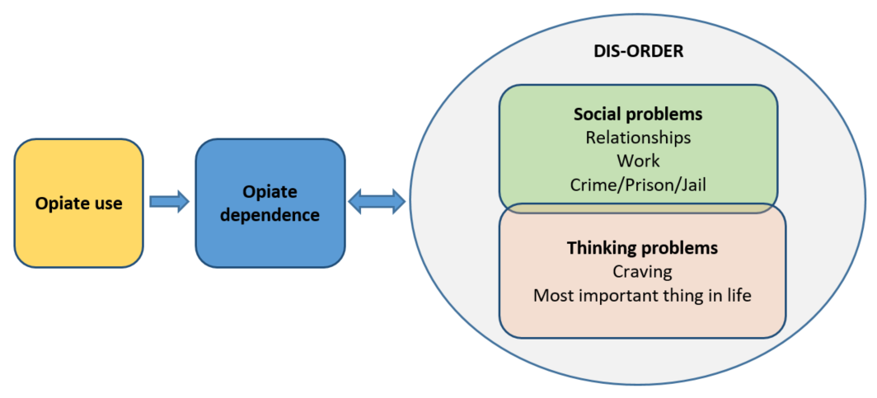
WHY MIGHT OPIATE USE DISORDER BE RELEVANT TO YOU?
People releasing from prison or jail are at very high risk for using opiates again as well as fatal overdose.
- Over three-quarters of people releasing from incarceration relapse to opioid use within 3 months.
- Fatal overdoses are most common in the weeks after releasing from incarceration.
If not treated, opiate use disorder can cause great physical, social and psychological harm- both to the person with the disorder and to others in their life. People with opiate use disorder are at increased risk for HIV, hepatitis, other serious health problems, and dying from an overdose.

WHAT ARE TREATMENT OPTIONS FOR OPIATE USE DISORDER?

Three types of treatments may be combined, or you may choose to do nothing at this point.
- Watchful waiting. Do nothing right now, but observe how you are feeling and what you are doing. Notice if you are having cravings or start using opiates or other drugs or alcohol.
- Social support. May include organized peer groups like Narcotics Anonymous (NA) or Smart Recovery. Can also include other social support groups for other things impacting your life, such as groups for people with chronic pain.

  - Narcotics Anonymous (NA). A nonprofit 12-step addiction recovery support group with a spiritual approach. There are many NA meetings and they vary in how they conduct meetings, so you may need to try out different meetings to find the one that fits you.
  - Smart Recovery. A nonprofit evidence-based addiction recovery support group based on self-empowerment and self-reliance. Teaches how to change self-defeating thinking, emotions, and actions, including identifying triggers and avoiding risky situations

- Counseling. Get individual or group counseling from a mental health therapist or chemical dependency professional.
  - Substance Use Disorder (SUD)/Chemical Dependency (CD) counseling. A behavioral health treatment focused on issues relating to substance use disorder with the guidance of a chemical dependency professional (CDP). Most SUD/CD counseling will include urine drug testing.

  - Mental health counseling. A behavioral health treatment that takes a holistic approach to mental health issues through counseling with a licensed therapist. Can provide cognitive behavioral therapy and referral to a psychiatrist for psychiatric medications if needed

- Treatment medications. Includes methadone, buprenorphine, or naltrexone.
  - Methadone is an opiate medication that lasts approximately 24 hours and is taken by mouth. It is dispensed at an opiate treatment program. At these programs, most days you will be observed while you take your dose. You will also have regular urine drug testing and counseling. Methadone is a full opiate meaning that the more you take the more you will feel it.

  - Buprenorphine is an opiate medication that you take orally that lasts approximately 24 hours. It is a partial opiate and has a “ceiling effect,” meaning you don’t get the full opiate effect even with higher doses. You can get it at different settings including from a medical provider or opiate treatment program. Common brand names are Suboxone and Zubsolv.
    - You could get it at an opiate treatment program where most days you will be observed while you take your dose. You will also have regular urine drug testing as well as counseling.
    - You could get it prescribed to you by a medical provider and pick it up at a pharmacy. Typically you would start with a prescription for a few days, then weekly prescriptions for a while, and eventually a 30 day prescription. Most will do urine drug testing and some include counseling support as part of their care.

  - Naltrexone is an opiate blocker. It is typically given as a shot/injection that lasts 30 days. This form of the drug is called Vivitrol. It is not an opiate. It is prescribed by a medical provider who may require urine drug testing and may offer other services, including counseling.
What is the evidence for the medications and other recovery supports?
Methadone and buprenorphine are opiate medications and have been shown to reduce overdose deaths by half. They have been very well studied and are very effective at preventing cravings, relapse and overdose when taken as directed.
Naltrexone, the opiate blocker, is a newer medication which doesn’t have as much data on how it impacts the risk for fatal overdoses; however it is protective against overdose during the 30 days the medication is active in the body. After it wears off, a person’s overdose risk is very high because the body has a lower tolerance to opiates.
While some people with opiate use disorder are able to abstain from problem opiate use on their own or by entering a treatment program that does not include recovery medications, the scientific data overwhelmingly supports medications as the most effective way of supporting long term recovery for most people. For many people social supports and counseling can also be very helpful though research shows that on average the effects are not significant.

WHICH TREATMENT IS RIGHT FOR ME?
It is important that a person with opiate use disorder understand the pros and cons of different recovery and treatment options. I’d like to ask you some questions about your personal preferences relating to recovery and treatment.
COMPARE OPTIONS
The right choice for you may change over time. This decision aid aims to help you make the best choice for right now, but you may want to change your mind as your use, cravings, or life changes. You also may try a treatment or recovery option that ends up not working for you and want to try something different. The ultimate decision about what treatment options you will be able to use, and exactly how, will be made between you and the treatment providers if you choose to see any.

Treatment decision making
Things to consider:
- Convenience/visit frequency
- Overdose risk
- How you will feel
- Impact on housing/other requirements
- Impact on relationships
- Other things important to you: _______________________________

 | Watchful waiting | Social support | Counseling | Naltrexone | Buprenorphine | Methadone
PRO

CON

- Make a decision
What treatment options sound good for you?
Let’s make a plan to help you get you started and remember you can change your mind in the future.

________________________________________________________________________________

Example of a local resource map utilized by navigators to create a concrete plan with participants.
