Supplementary materials

A chemoenzymatically synthesized cholesterol-g-poly(amine-co-ester) mediated p53 gene delivery for achieving anti-tumor efficacy in prostate cancer

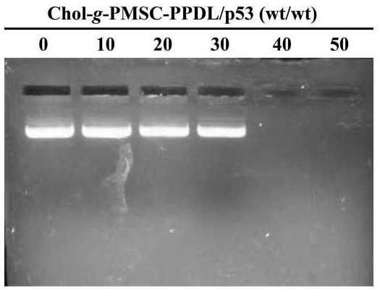
Figure S1 Gel retardation assay for the binding and condensation ability of Chol-g-PMSC-PPDL with the plasmid p3XFLAG-CMV-p53 at different mass ratios.

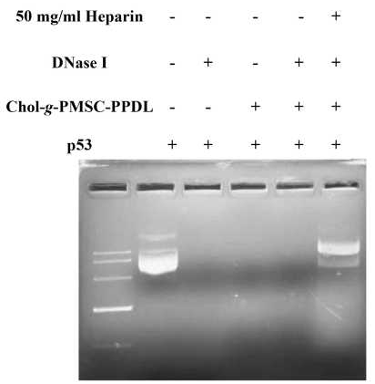
Figure S2 Gel retardation assay of Chol-g-PMSC-PPDL/p53 nanoparticles at a mass ratio of 40.0 after the treatment of 10 µg/mL of DNase I for 15 min.

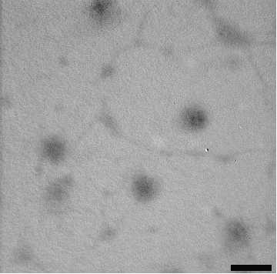
Figure S3 The TEM image of Chol-g-PMSC-PPDL/p53 nanoparticles at a mass ratio of 40.0. The scale bar is 200 nm.

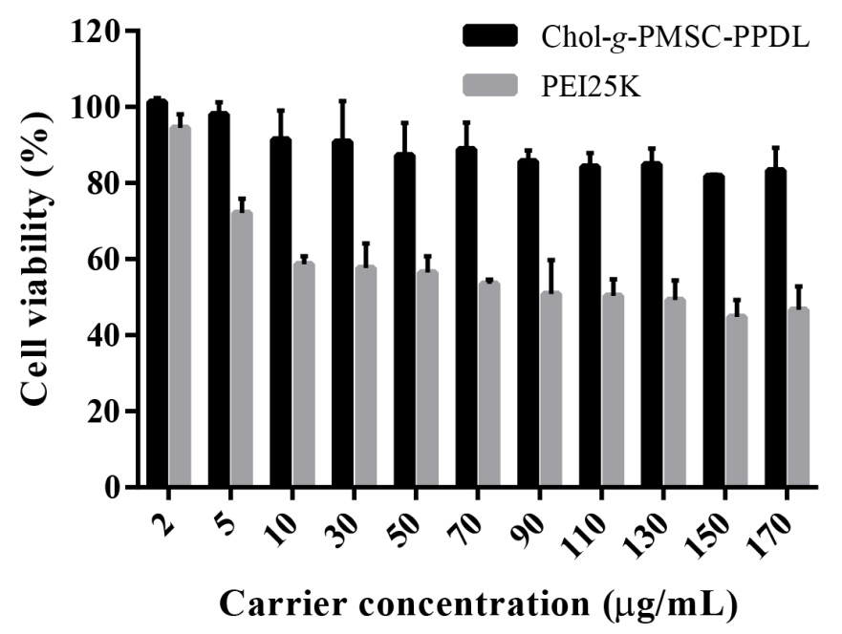
Figure S4 In vitro cytotoxicity analysis of PEI25K and Chol-g-PMSC-PPDL at different concentrantions by MTT method. Data are presented as mean value ± SD of triplicate experiments.

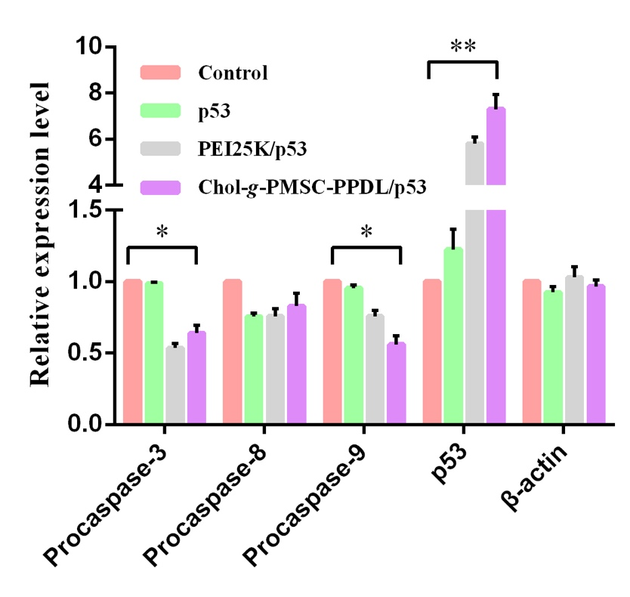
Figure S5 Quantitative analysis for the expression level of specific proteins in PC-3 cells after p53 transfection by different carriers. The assay was conducted using the software Image J.

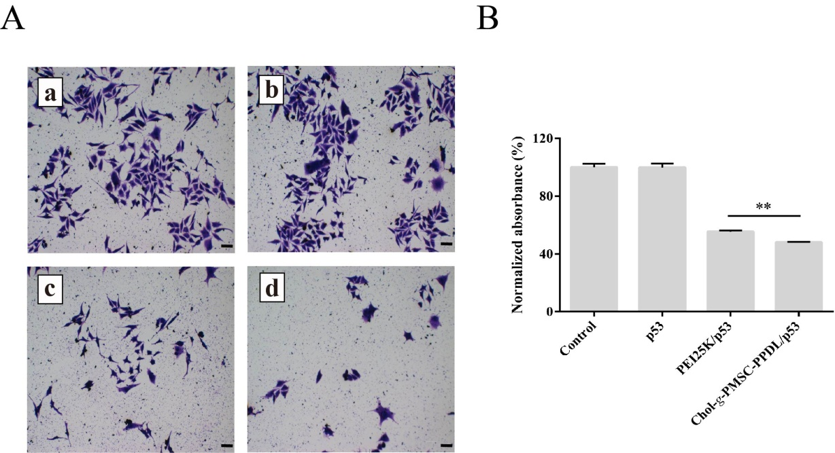
Figure S6 The inhibition of colony formation after p53 transfection (A) and the quantitative analysis through the measurement of optical density at 578 nm of eluent (B): (a) control; (b) free p53 plasmid; (c) PEI25K/p53; and (d) Chol-g-PMSC-PPDL/p53. Data are presented as mean value ± SD of triplicate experiments. The scale bar is 100 μm.

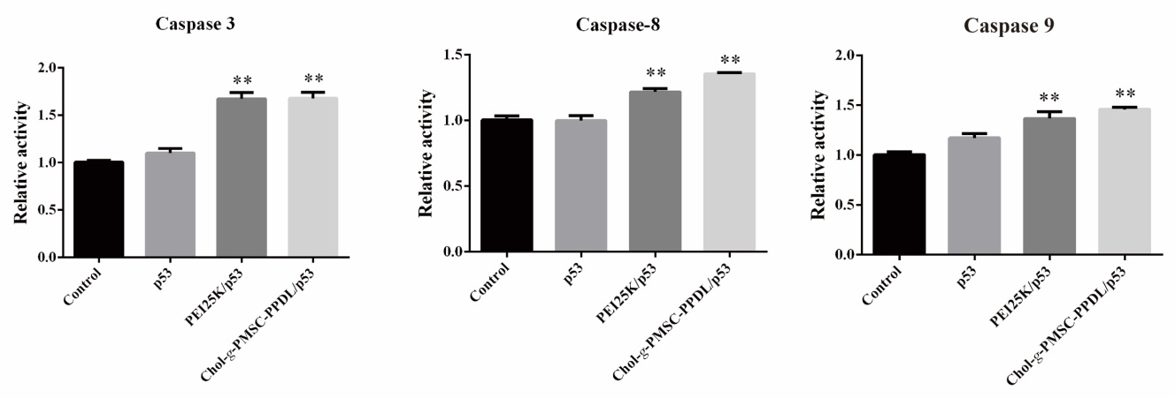
Figure S7 The caspase activity measurement after p53 transfection by the corresponding detection kits. Data are presented as the mean value ± SD of triplicate experiments.

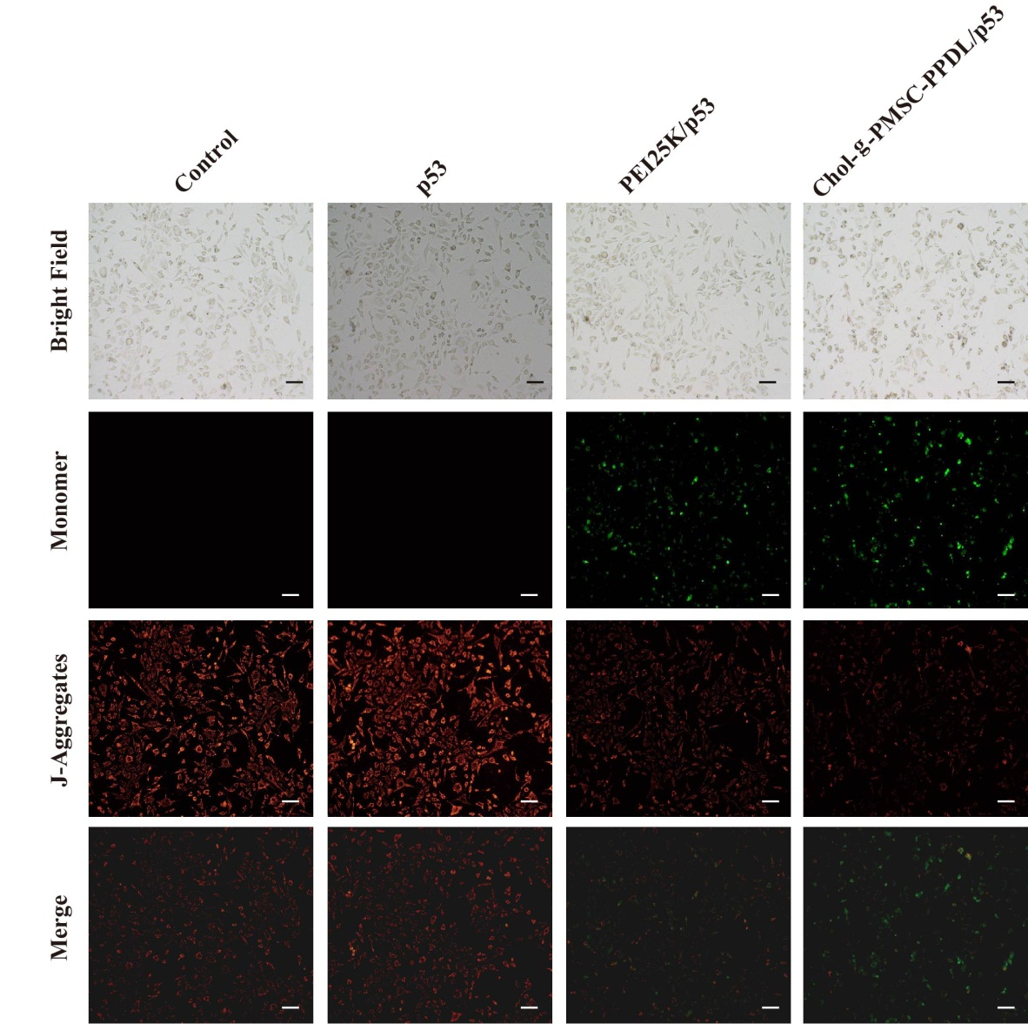
Figure S8 Mitochondrial membrane potential analysis of PC-3 cells after p53 transfection mediated by different carriers. The scale bar is 100 μm.

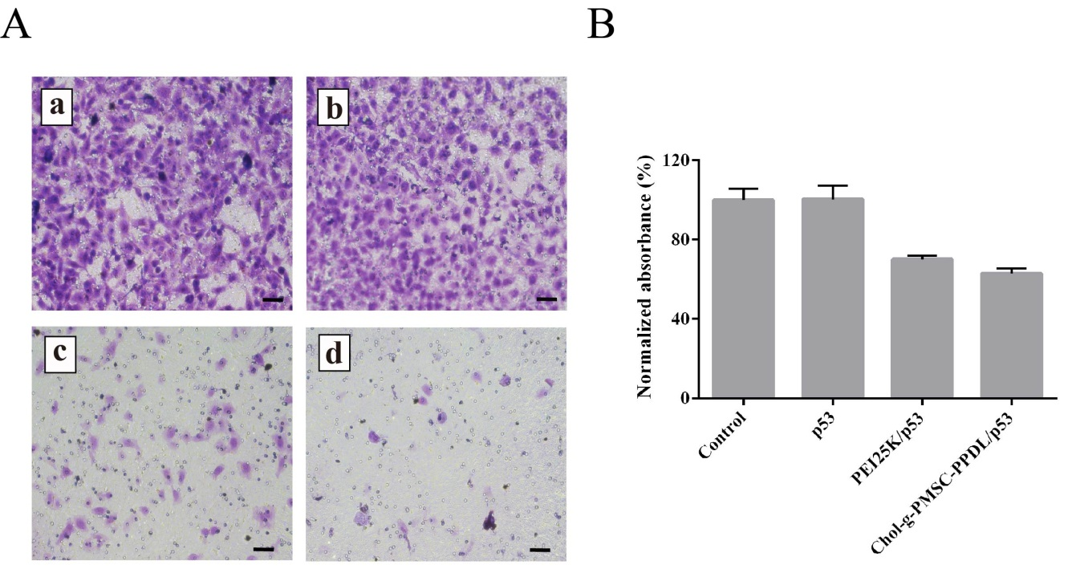
Figure S9 Transwell migration assay of PC-3 cells after p53 transfection (A) and the quantitative analysis (B): (a) control; (b) free p53 plasmid; (c) PEI25K/p53 and (d) Chol-g-PMSC-PPDL/p53. Data are presented as the mean value ± SD of triplicate experiments. The scale bar is 50 μm.

