Supporting Information (SI)

Novel self-nanomicellizing solid dispersion based on Rebaudioside A: A potential nanoplatform for oral delivery of curcumin

Running title: Rebaudioside A micelles for oral delivery

Yuzhen Hou¹, Hui Wang¹, Fan Zhang¹, Fengyuan Sun¹, Meng Xin^{1,2}, Mengshuang Li^{1,3}, Jun Li⁴, Xianggen Wu^{1*}

1 Department of Pharmacy, College of Chemical Engineering, Qingdao University of Science and Technology, Qingdao 266042, China;
2 Department of Ophthalmology, Yantai Affiliated Hospital of Binzhou Medical University, Yantai 264100, China;
3 Pharmacy Intravenous Admixture Services, Qingdao Women and Children’s Hospital, Qingdao 266034, China;
4 Qingdao Eye Hospital, Shandong Eye Institute, Shandong Academy of Medical Sciences, Qingdao 266071, China

*Correspondence: Xianggen Wu, Department of Pharmacy, College of Chemical Engineering, Qingdao University of Science and Technology, Qingdao 266042, China. E-mail: wuxianggen@126.com Phone/Fax: 0086-532-84023003
SI MATERIALS AND METHODS
Chemical reagents and animals
Rebaudioside A (RA) with a purity of more than 98% was purchased from Jining Aoxing Stevia Products Co., Ltd. (Jining, China) and used as received. Curcumin (Cur) and dextran sodium sulfate (DSS) were purchased from Dalian Meilun Biotechnology Co., LTD. (Dalian, China).
Male Sprague-Dawley (SD) rats and male Kunming mice were purchased from Qingdao DRFC Bioscience Co., Ltd. (Qingdao, China). The animal care and procedures were conducted according to the Principles of Laboratory Animal Care. All animals were healthy and free from clinically observable abnormalities. The use of animals in this study adhered to the Guide for the Care and Use of Laboratory Animals, and the animal study was approved by the Qingdao University of Science and Technology Ethics Committee for Animal Experimentation (approval document no. 2017-1, Qingdao, China).
In vitro drug release
In vitro release of Cur from RA-Cur was studied using a dialysis bag (MWCO 500-1000, Solarbio) method, as previously reported. ^{1,2} SGF (pH 1.2) and SIF (pH 6.8) were used as release media. To achieve the sink condition, 1% Tween 80 (w/v) was introduced into artificial gastrointestinal fluid. ¹ An appropriate volume of RA-Cur, solubilized in deionized water with 600 μg of Cur, was added to the dialysis bag and both ends of the bag were tied tightly. In the first 2 h, the dialysis bag was immersed in 100 ml SGF, and then transferred into 100 ml SIF for the next 22 h. During the experiment, the release system was shaken at 120 rpm and the fluid temperature was set at 37 °C. At each designated time point, 1 ml of release medium was taken out and an equal volume of fresh medium was added to the release system. An equal amount of free Cur in a propylene glycol solution was studied as a control in the same way. All samples were analyzed by HPLC.
In vitro parallel artificial membrane permeability assay (PAMPA)
This test was performed according to previous reports. ^{3,4} Briefly, 0.5 ml of Cur containing donor solutions (known quantities of free Cur or RA-Cur diluted in a solution of 5 ml DMSO in 100 ml of water) was added to each well of the donor plate. The plate was covered and incubated at +25 °C with shaking at 200 rpm and permeation was evaluated after 0.5, 1.0, 1.5, 2.0, 2.5, 3.0, and 3.5 h.
Endocytosis mechanism of RA-Cur
The absorption pathways of RA-Cur in rat intestine were evaluated as described previously. ⁵ The intestinal rings were pre-incubated at 37 °C for 45 min with the following series of specific inhibitors: chlorpromazine (16 μg/ml), sodium azide (3 μg/ml), quercetin (1.6 μg/ml), amiloride (4 μg/ml), and indomethacin (36 μg/ml). The medium was removed, and the intestinal rings were treated with the RA-Cur at a Cur concentration of 20 μg/ml for another 45 min at 37 °C. The intestinal segments were then washed with cold Krebs Ringer's solution to terminate the uptake. Control experiments were performed at 4 °C and 37 °C in the absence of specific inhibitors. The intestinal rings were weighed, homogenized, and analyzed by HPLC.

FIGURES FOR THE SI
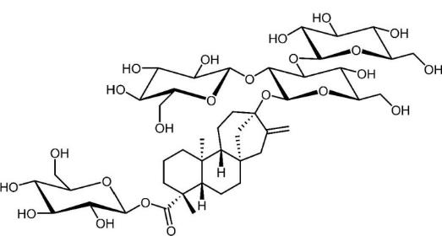
Figure S1 Chemical structure of rebaudioside A (RA)

Figure S2 Experimental groups and protocols. Kunming female mice (8 weeks old) were housed under standard conditions and supplied with normal food. The normal mouse group was supplied with distilled water, and the ulcerative colitis (UC) mouse group was supplied with water containing dextran sodium sulfate (DSS; 3.5%, w/v) to establish UC mouse model. After 7 days, the UC mice were divided into the following 6 groups: DSS control group, RA treated group, Cur 150 mg/kg treated group, RA-Cur 50 mg/kg treated group, RA-Cur 100 mg/kg treated group, and RA-Cur 150 mg/kg treated group. The normal mice were set as the healthy control group. After 5 days of treatment, the mice were sacrificed and their colons and spleens were excised for measurement. The resected colon tissues were opened longitudinally, rinsed with PBS, and pieces of colon tissue were sectioned into slices (5 μm) and stained with hematoxylin and eosin (H&E) for histopathological analysis. Throughout the 11 day experimental period, the mouse body weights were monitored every day. Nor mice: normal mice; DSS: dextran sodium sulfate; UC mice: Ulcerative colitis mice

Results for the SI
IR spectra of RA-Cur with RA/ Cur weight ratio of 5:1
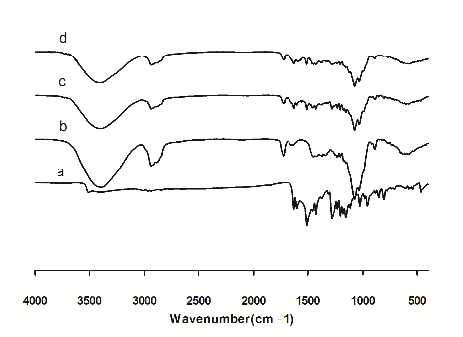
Figure S3 IR spectra of RA-Cur with an RA/ Cur weight ratio of 5:1 in the solid state. RA: rebaudioside A; Cur: curcumin; RA-Cur: RA-based self-nanomicellizing solid dispersion containing Cur.

Comparison of the IR spectra of RA-Cur with Cur, RA, and the physical mixture of RA and Cur revealed no new absorption peaks, indicating the absence of any chemical reactions during the sample preparation procedures.

In vitro drug release
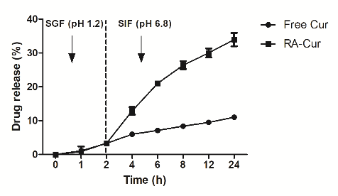
Figure S4 Characterizations of in vitro release assay. In vitro release profiles of Cur from RA-Cur with using dialysis method. RA: rebaudioside A; Cur: curcumin; RA-Cur: RA-based self-nanomicellizing solid dispersion containing Cur.

For the purpose of simulating in vivo biological environment, the in vitro release studies were performed in a pH gradient condition. As shown in Figure S3, both free Cur and RA-Cur released ~3.3% within 2 h in simulated gastric fluid (SGF; pH 1.2). A further 7.7% release was determined for free Cur following a 22 h release period in simulated intestinal fluid (SIF; pH6.8). By contrast, the ratio of Cur release from RA-Cur was 30.6%.
Parallel artificial membrane permeability assay (PAMPA) studies
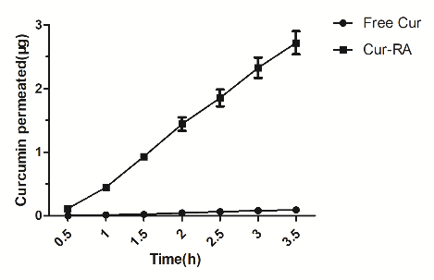
Figure S5 Characterizations by PAMPA. In vitro parallel artificial membrane permeability assay using a transwell method. RA: rebaudioside A; Cur: curcumin; Cur-RA: RA-based self-nanomicellizing solid dispersion containing Cur.

The PAMPA enables fast determination of the trends in the ability of compounds to permeate membranes by passive diffusion and is thus suitable for evaluating potential drugs. Results (Figure S4) showed a strong increase in the amount of Cur permeated when compared with an aqueous solution of free Cur used as control. Permeation of RA-Cur was as high as 2.72±0.25 μg after 3.5 h, while permeation was only 0.091±0.016 μg for free Cur, suggesting that RA-Cur could promote faster membrane permeation of Cur.

Endocytosis mechanism
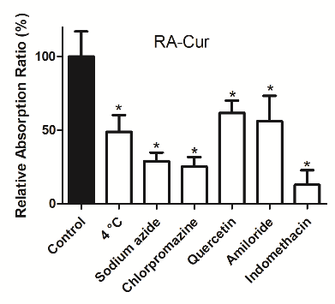
Figure S6 Endocytosis pathways. Endocytosis pathway profiles of RA-Cur after incubation at 4 °C or with different endocytosis inhibitors at 37 °C (*P < 0.05 vs control group) (mean ± SD, n = 5). RA: rebaudioside A; Cur: curcumin; RA-Cur: RA-based self-nanomicellizing solid dispersion containing Cur.

To understand the endocytosis mechanism of RA-Cur, an absorption experiment was performed using the everted intestinal ring model. ⁵ As plotted in Figure S5, endocytosis was significantly suppressed at 4 °C compared with 37 °C (P < 0.05). In addition, NaN₃ markedly inhibited the absorption of RA-Cur. The internalization of RA-Cur was significantly inhibited by chlorpromazine (a clathrin dependent endocytosis inhibitor), indomethacin (a caveolin-dependent endocytosis inhibitor), amiloride (a macropinocytosis inhibitor), and quercetin (a caveolae- and clathrin-independent endocytosis inhibitor).

References
1. Duan Y, Zhang B, Chu L, Tong HH, Liu W, Zhai G. Evaluation in vitro and in vivo of curcumin-loaded mPEG-PLA/TPGS mixed micelles for oral administration. Colloids Surf B Biointerfaces. 2016;141:345-354.
2. Chen Q, Si X, Ma L, et al. Oral delivery of curcumin via porous polymeric nanoparticles for effective ulcerative colitis therapy. J Mater Chem B. 2017;5(29):5881-5891.
3. Feng B, Mills JB, Davidson RE, et al. In vitro P-glycoprotein assays to predict the in vivo interactions of P-glycoprotein with drugs in the central nervous system. Drug Metab Dispos. 2008;36(2):268-275.
4. Zhang Q, Polyakov NE, Chistyachenko YS, et al. Preparation of curcumin self-micelle solid dispersion with enhanced bioavailability and cytotoxic activity by mechanochemistry. Drug Deliv. 2018;25(1):198-209.
5. Cheng B, Pan H, Liu D, et al. Functionalization of nanodiamond with vitamin E TPGS to facilitate oral absorption of curcumin. Int J Pharm. 2018;540(1-2):162-170.

