Supplementary Materials
Grafting of multi-walled carbon nanotubes with pyrazole derivatives: characterization, antimicrobial activity and molecular docking study

Nadia Hanafy Metwally¹*, Gamal Riad Saad¹and Esraa Azmy Abd El- Wahab²
¹Chemistry Department, Faculty of Science, Cairo University, Giza, Egypt
²Department of Engineering Mathematics and Physics, Faculty of Engineering Shoubra, Benha University.

Figure S1. TEM micrographs of (d) CNTs (1b), (e) CNTs (1c), (f) CNTs (2b) and (g) CNTs (2c).
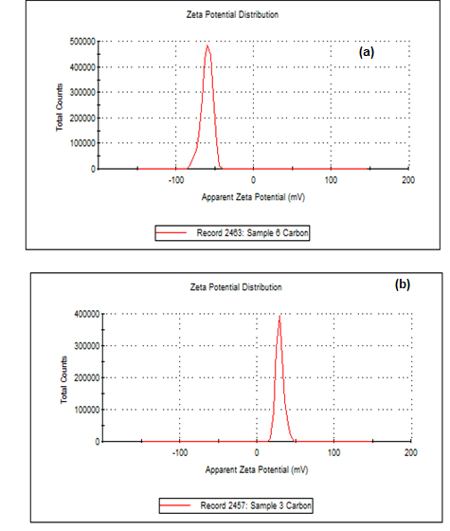
Figure S2. Examples of zeta potential distribution (ξ) in aqueous suspension (a) CNTs and (b) CNTs (1c).

Molecular docking figures
2D and 3D of the active site of 1UBY.

2D and 3D Lignad interaction of 2a with the active site of 1UBY.

2D and3D Ligand interaction of CNTs-2a with the active site of 1UBY.

