Supporting Information

Nudol, a phenanthrene derivative from Dendrobium nobile, induces cell cycle arrest and apoptosis and inhibits migration in osteosarcoma cells

Yuying Zhang¹, Qianqian Zhang¹, Wei Xin², Na Liu¹*, Hua Zhang¹*

Affiliation
¹ School of Biological Science and Technology, University of Jinan, Jinan, China
² Central Laboratory, Shandong Provincial Hospital, Shandong University, Jinan, China

Correspondence
*Prof. Dr. Hua Zhang, School of Biological Science and Technology, University of Jinan, 336 West Road of Nan Xinzhuang, Jinan 250022, China. Phone: +86 531 8973 6199,
E-mail: bio_zhangh@ujn.edu.cn.
*Prof. Dr. Na Liu, School of Biological Science and Technology, University of Jinan, 336 West Road of Nan Xinzhuang, Jinan 250022, China. Phone: +86 531 8973 6799,
E-mail: mls_liun@ujn.edu.cn.
For compound 1
Fig. S4. ¹H NMR spectrum (600 MHz) of 1 in CDCl₃.
Fig. S5. ¹³C NMR spectrum (150 MHz) of 1 in CDCl₃.

For compound 2
Fig. S6. ¹H NMR spectrum (600 MHz) of 2 in CDCl₃.
Fig. S7. ¹³C NMR spectrum (150 MHz) of 2 in CDCl₃.

For compound 3
Fig. S8. ¹H NMR spectrum (600 MHz) of 3 in CDCl₃.
Fig. S9. ¹³C NMR spectrum (150 MHz) of 3 in CDCl₃.

For compound 4
Fig. S10. ¹H NMR spectrum (600 MHz) of 4 in CDCl₃.
Fig. S11. ¹³C NMR spectrum (150 MHz) of 4 in CDCl₃.

For compound 5
Fig. S12. ¹H NMR spectrum (600 MHz) of 5 in CDCl₃.
Fig. S13. ¹³C NMR spectrum (150 MHz) of 5 in CDCl₃.

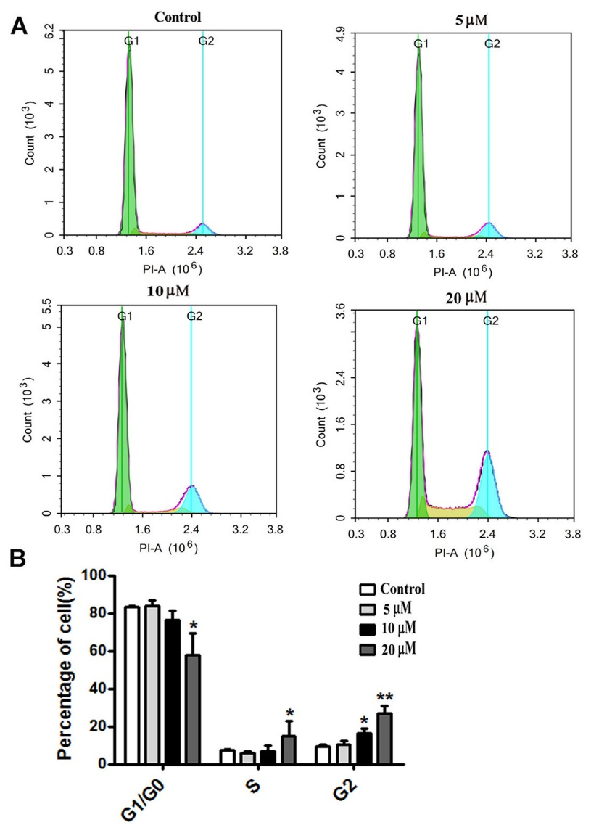
Figure S1. Nudol (1) induced MG63 cells cycle arrest at G2/M phase.
Notes: (A ) MG63 cells were treated with graded concentrations of 1 for 48 h. The distribution of cell cycle was assessed by flow cytometry. (B)The percentage of cells in different phases of cell cycle was analyzed. Data represent the mean ± SD (n = 3). *p < 0.05, **p < 0.01 compared to control cells..

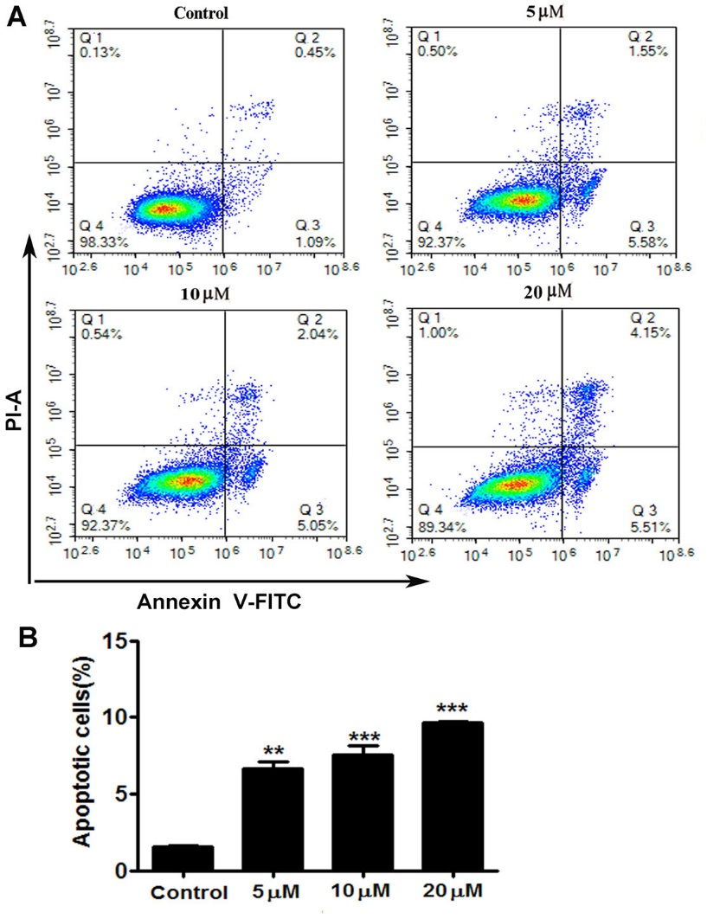
Figure S2. Nudol (1) induced MG63 cell apoptosis.
Notes:. (A) The apoptotic status was determined by flow cytometry analysis, and representative results were shown. (B) Quantitative analysis of apoptosis of MG63 cells as shown in (A). Values were presented as mean ± SD (n = 3). **p < 0.01 and ***p < 0.001 vs. normal control.

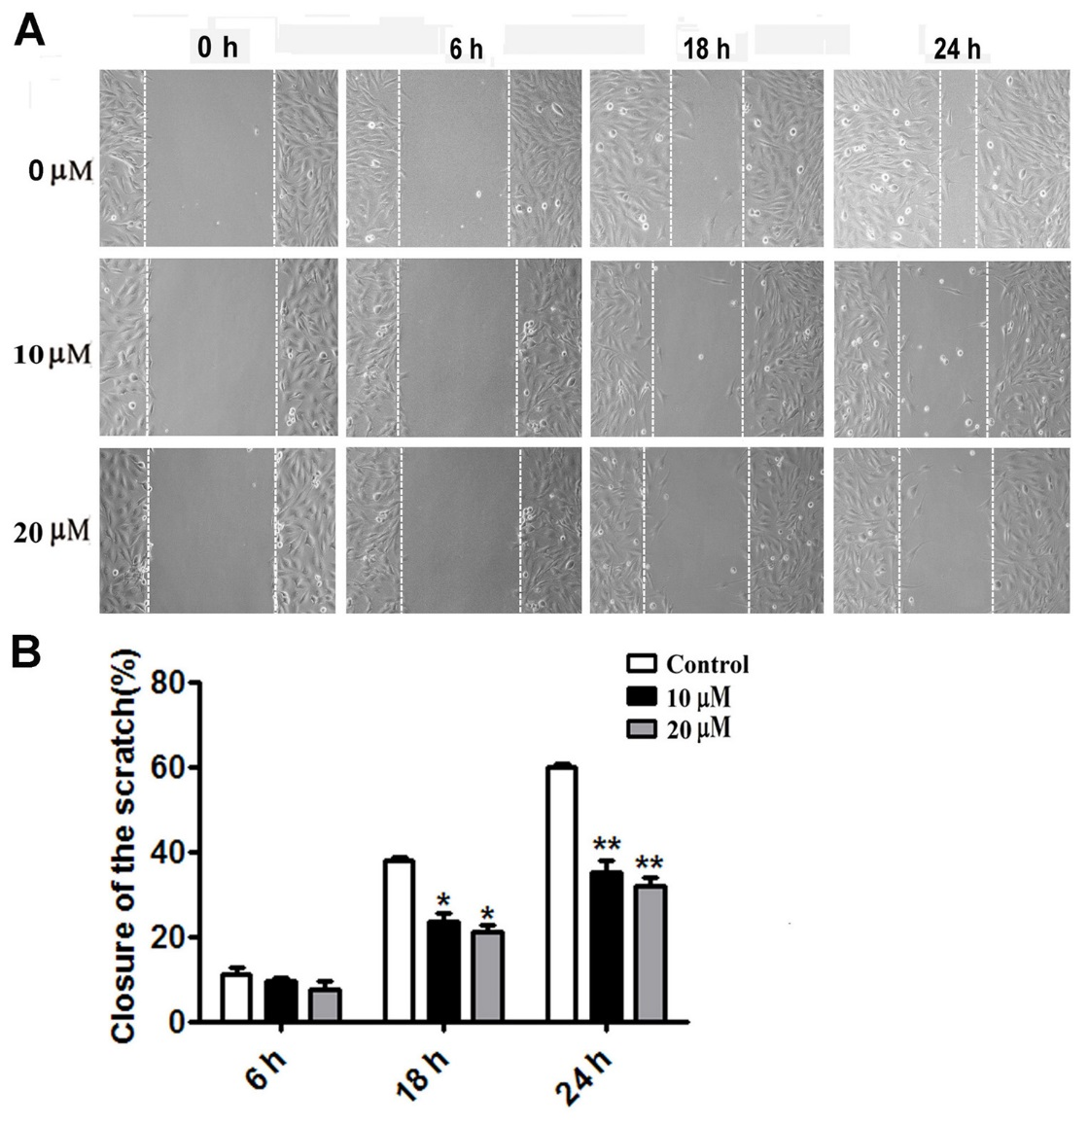
Figure S3. Nudol (1) suppressed migration of MG63 cells.
Notes: (A) Cells were treated with various doses of 1 for 0, 6, 18 and 24 h, and the migratory behavior was determined by wound-healing assay. (B) The wound distance of migration was calculated. Data were represented as mean ± SD (n = 3). *p < 0.05, **p < 0.01 compared to control cells.

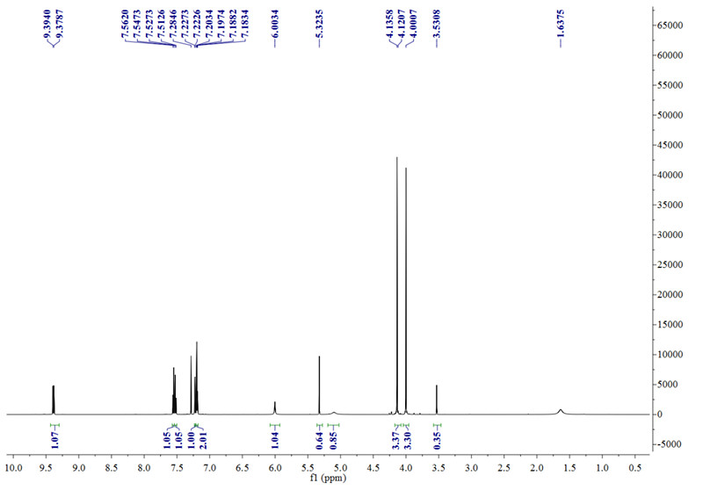
Fig. S4. ¹H NMR spectrum (600 MHz) of 1 in CDCl₃.

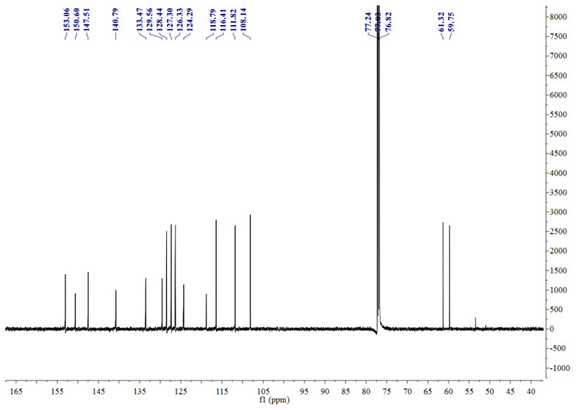
Fig. S5. ¹³C NMR spectrum (150 MHz) of 1 in CDCl₃.

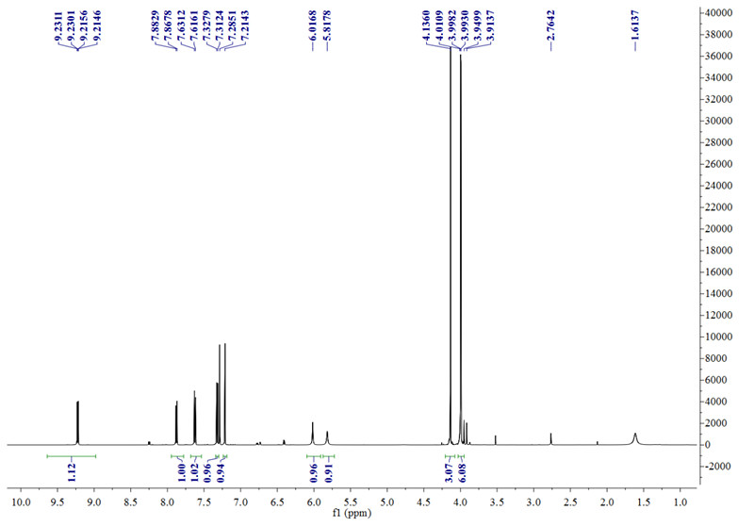
Fig. S6. ¹H NMR spectrum (600 MHz) of 2 in CDCl₃.

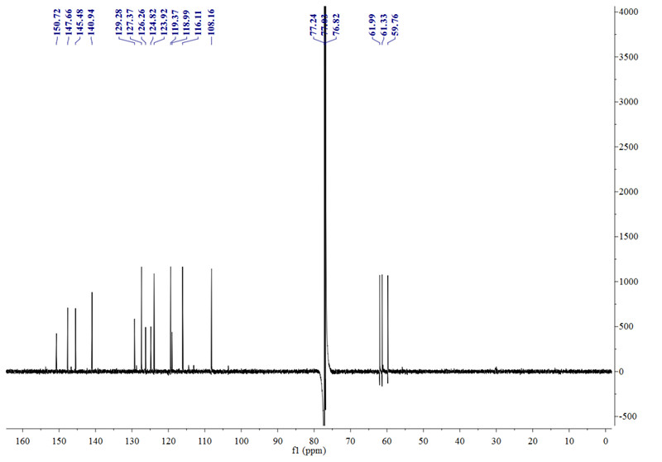
Fig. S7. ¹³C NMR spectrum (150 MHz) of 2 in CDCl₃.

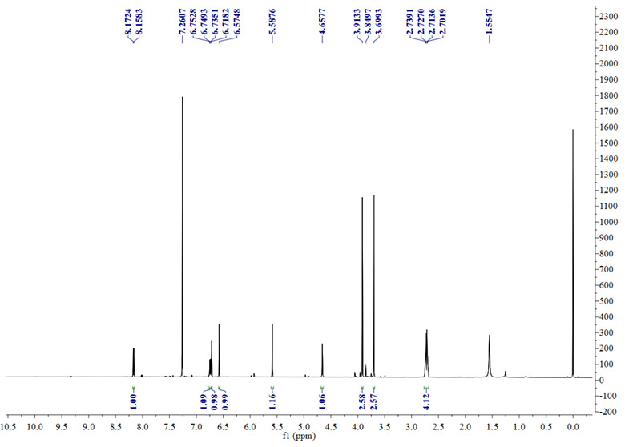
Fig. S8. ¹H NMR spectrum (600 MHz) of 3 in CDCl₃.

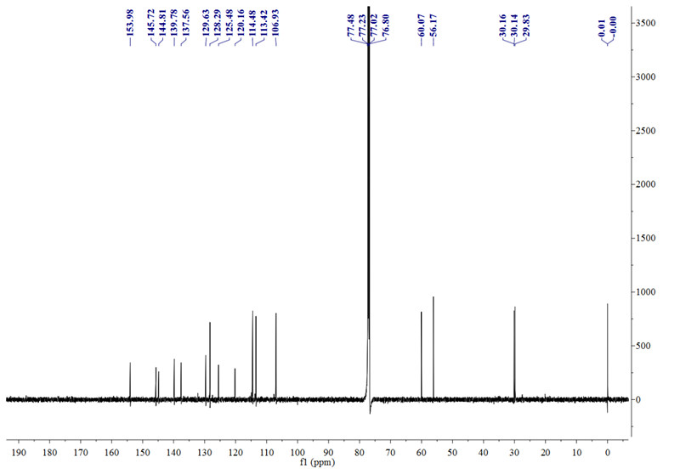
Fig. S9. ¹³C NMR spectrum (150 MHz) of 3 in CDCl₃.

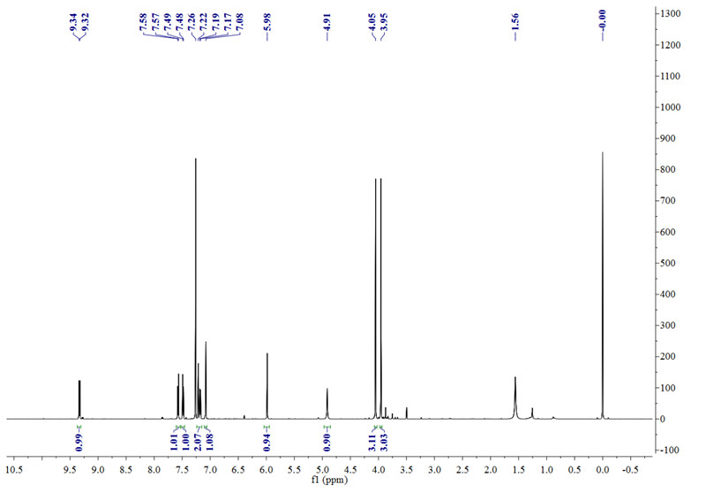
Fig. S10. ¹H NMR spectrum (600 MHz) of 4 in CDCl₃.

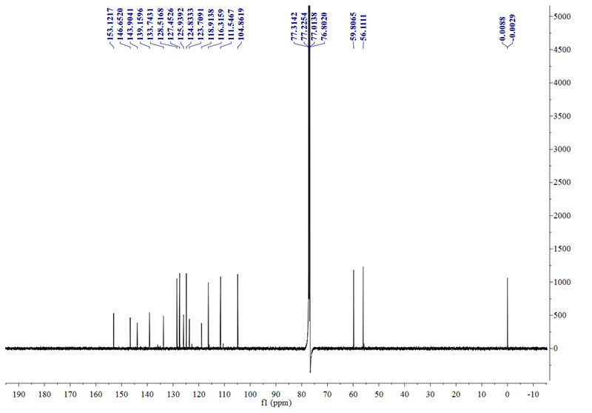
Fig. S11. ¹³C NMR spectrum (150 MHz) of 4 in CDCl₃.

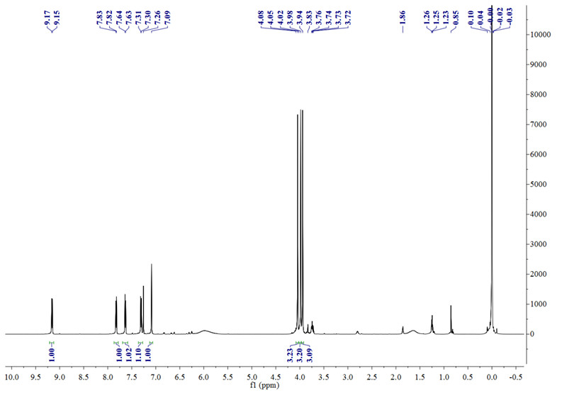
Fig. S12. ¹H NMR spectrum (600 MHz) of 5 in CDCl₃.

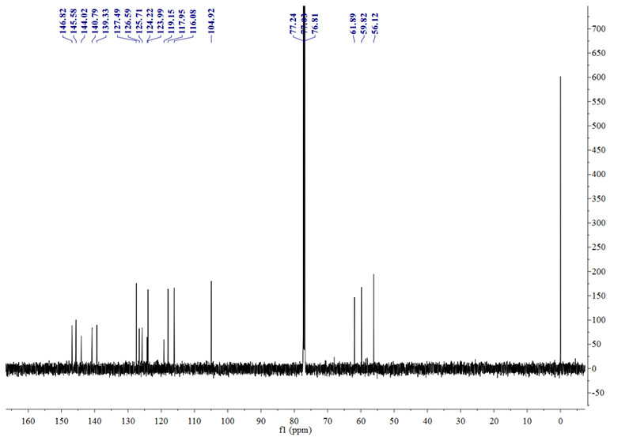
Fig. S13. ¹³C NMR spectrum (150 MHz) of 5 in CDCl₃.

