Supplementary material
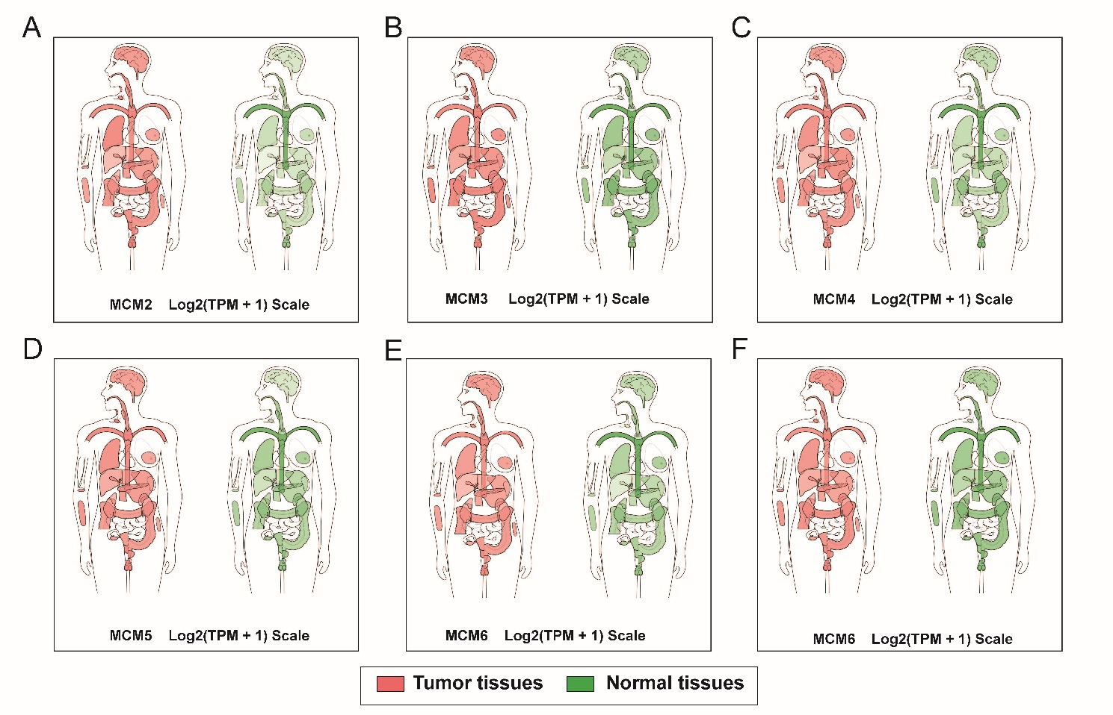
Figure S1. Expression distribution of MCM2–7 in human tumor tissue and adjacent normal tissues that carry out by GEPIA.
Notes: Interactive bodymap of MCM2 (A); MCM3 (B); MCM4 (C); MCM5 (D); MCM6 (E); MCM7 (F).
Abbreviations: MCM, minichromosome maintenance; GEPIA, Gene Expression Profiling Interactive Analysis.
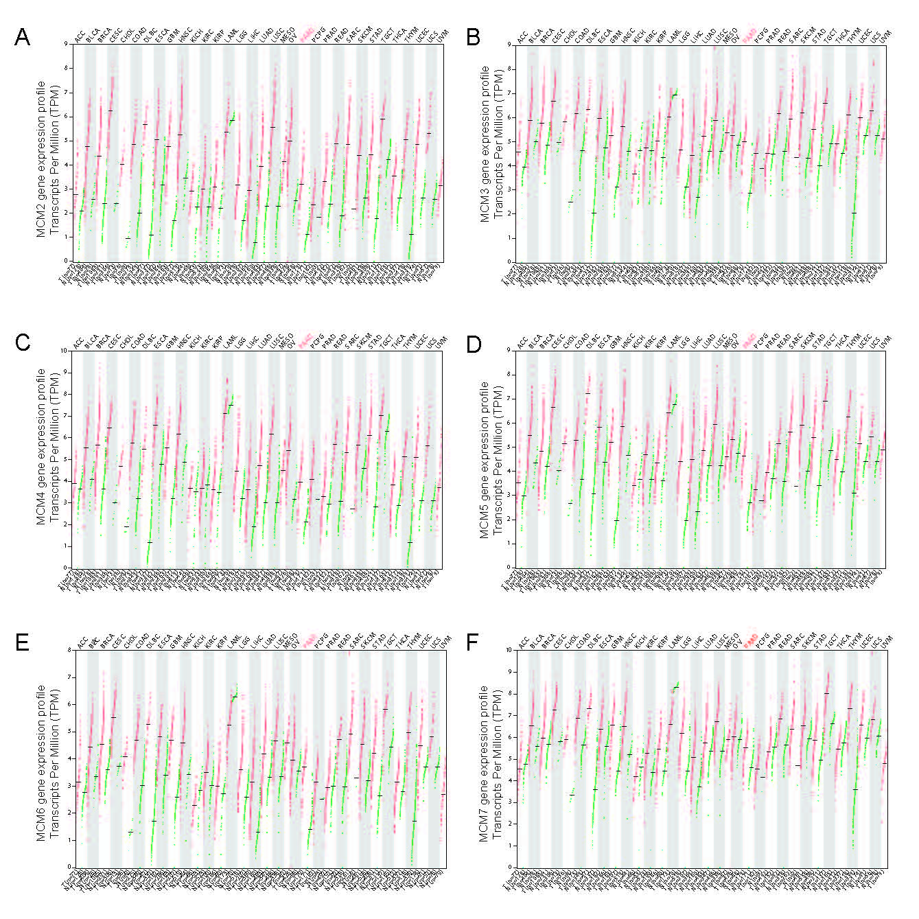
Figure S2. The MCM2–7 gene expression profile across all tumor samples and paired normal tissues (Dot plot).
Notes: Red dots represent tumor tissue, and green dots represent tumor tissue.
Abbreviations: MCM, minichromosome maintenance.
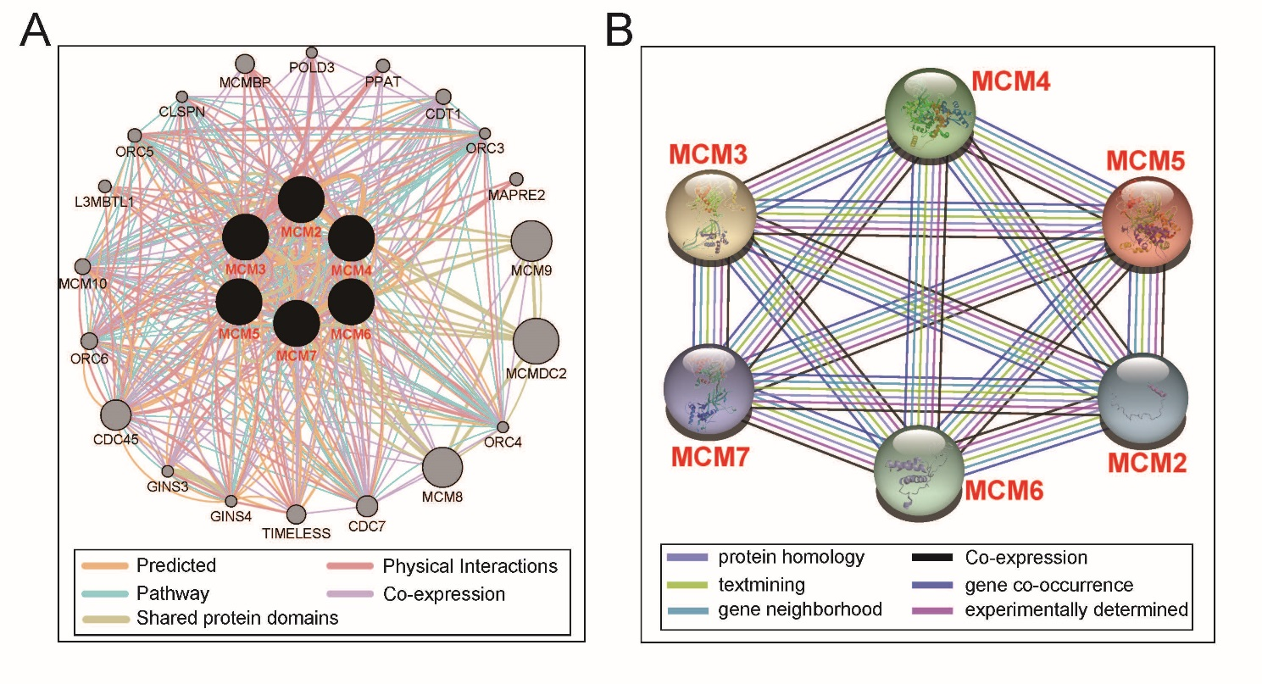
Figure S3. Protein-protein and gene-gene interaction networks.
Notes: (A) Protein–protein interaction networks; (B) GeneMANIA interaction networks.
Abbreviations: GeneMANIA, Gene Multiple Association Network Integration Algorithm.

