1. CHEMICAL CHARACTERIZATION OF FULLERENE NANOMATERIAL
1.1 MOLECULAR DOCKING AND MD SIMULATIONS
1.2 NMR SPECTRA
1.3 FT-IR SPECTRA
1.4 MASS SPECTROMETRY
1.5. DLS MEASUREMENTS
1.6 XPS SPECTROSCOPY
2. BIOLOGICAL STUDIES

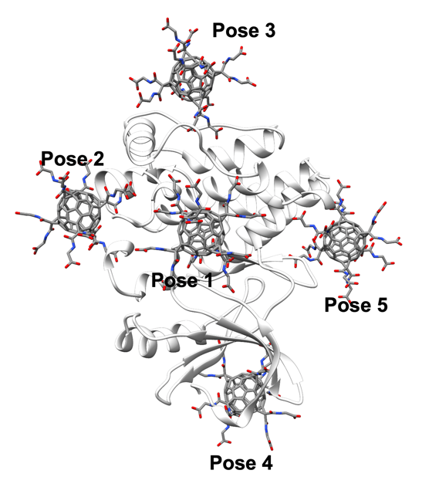

Figure S1 The possible binding site of HDGF in BTK, identified by docking.

¹H-NMR(d₁-CDCl₃, ppm, 500 MHz): 3.96(d, J= 5.2 Hz, 4H, -CH₂); 3.29(s, 2H, O=C-CH₂-C=O); 1.49(s, 9H, t-Bu).
¹³C-NMR(d₁-CDCl₃, ppm, 125 MHz): 168.59; 167.11; 82.46; 42.25; 42.15; 28.03

Figure S2
¹H-NMR spectrum of malonate 1.

Figure S3
¹³C-NMR spectrum of malonate (1).

¹H-NMR(d₁-CDCl₃, ppm, 500 MHz): 3.98(d, J= 5.2 Hz, 4H); 1.49(s, 9H, t-Bu).
¹³C-NMR(d₁-CDCl₃, ppm, 125 MHz):169.60(COOR); 168.64(COOR); 164.94(NH-C=O); 145.83(C₆₀-sp²); 145.73(C₆₀-sp²); 145.32(C₆₀-sp²); 145.17(C₆₀-sp²); 144.71(C₆₀-sp²); 144.52(C₆₀-sp²); 143.81(C₆₀-sp²); 142.98(C₆₀-sp²); 142.21(C₆₀-sp²); 142.20(C₆₀-sp²); 142.13(C₆₀-sp²); 142.11(C₆₀-sp²); 140.98(C₆₀-sp²); 140.95(C₆₀-sp²); 139.29(C₆₀-sp²); 82.43(C(CH₃)₃); 71.51(C₆₀-sp³); 42.15; 42.05; 29.66; 28.12 (C(CH₃)_{3.}

Figure S4
¹H-NMR spectrum of [60]fullerene monoadduct 2

Figure S5
¹³C-NMR spectrum of [60]fullerene monoadduct 2

¹³C-NMR(d₂-D₂O, ppm, 125 MHz): 174.5; 169.76; 145.23; 141.56; 71.63; 40.66

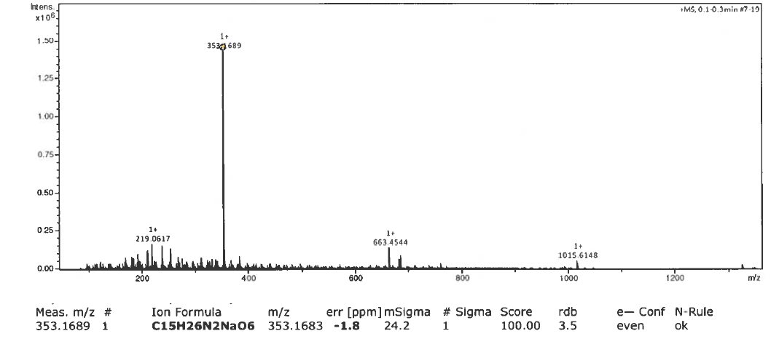
Figure S6
HRMS spectrum of malonate (1).

Figure S7
HRMS spectrum of fullerene monoadduct (2).

Figure S8
Spectrum of fullerene hexakisadduct (3)

Figure S9
A high-resolution XPS spectrum of O1s line of HDGF

Figure S10
DLS measurement of the fullerene nanomaterial HDGF at pH=3 (c=0.1 mg/mL)

Figure S11
DLS measurement of the fullerene nanomaterial HDGF at pH=6 (c=0.1 mg/mL)

Figure S12
DLS measurement of the fullerene nanomaterial HDGF at pH=9 (c=0.1 mg/mL)

Figure S13
DLS measurement of the fullerene nanomaterial HDGF in cellular medium containing FBS (c=0.1 mg/mL, day 0)

Figure S14
DLS measurement of the fullerene nanomaterial HDGF in cellular medium containing FBS (c=0.1 mg/mL, day 3)

Element | Atomic concentration  (at. %) | Assigned bond | Binding energy  (eV) | Contribution of individual chemical bonds for the given element  (%) | The approximate atomic concentration of individual chemical bond  (at. %)
C | 71.90 | Si–C | 282.6 | 3.91 | 2.8
C | 71.90 | C–C, C–H | 284.8 | 85.14 | 61.2
C | 71.90 | C–O, C–N, to –C–OH | 286.6 | 6.38 | 4.6
C | 71.90 | C=O | 288.0 | 4.56 | 3.3
N | 3.73 | Pyridinic N | 398.4 | 18.47 | 0.2
N | 3.73 | C–N, N–(C=O)– | 399.8 | 81.53 | 3.0
O | 20.32 | Atomic oxygen | 529.2 | 2.79 | 0.5
O | 20.32 | C=O, O=C–OH | 530.6 | 4.74 | 0.9
O | 20.32 | C–O, C–O–C, O–H, Si–O | 532.5 | 92.47 | 18.8
Si | 4.06 | Si–O | ~102.0 | 4.06 | 4.1

Table S1
Chemical composition, atomic concentration, and percentage contributions of chemical state for particular element obtained from the XPS measurements.

Gene | Forward primer (5’→3’) | Reverse primer (3’→5’)
BTK | ACAGATTCCGAGGAGAGGTGAGG | GGTCCTTCATCATATACAACCTGGAATGG
TLR8 | ACCACCTCAGTCCAGGGAAA | CGAACGCAACCACAGCATAA
NFAT | GATGCCAAGCACCAGCTTTC | TGTTGTGGTACAGGCCCAAG
ARID3A | AGCATTCGGATCAACAGCCA | CCGTATCTTCCGCCATCCTG
LC3 | CAGCATCCAACCAAAATCCC | CACTGACAATTTCATCCCGAAC
p62 | AGGACGGGGACTTGGTTG | GGCGGGAGATGTGGGTAC
HPRT1 | CAGCCCTGGCGTCGTGATTAGT | CCAGCAGGTCAGCAAAGAAT

Table S2
Sequences of primer pairs used in determining the mRNA expression of tested genes.

