Video Abstract to Accompany Submission of ‟Aripiprazole Lauroxil: Development and Evidence-Based Review of a Long-Acting Injectable Atypical Antipsychotic for the Treatment of Schizophrenia”
Video presenter: Leslie Citrome
Audio  Current Word Count: 260  Estimated Time: 2.0 min | No. Words | Potential Content for Development of Visual Elements
Hello, I’m Dr. Leslie Citrome, Clinical Professor of Psychiatry and Behavioral Sciences at New York Medical College in Valhalla, NY. My coauthors and I recently published this review of a long-acting injectable treatment for schizophrenia, aripiprazole lauroxil, also known by its brand name "ARISTADA." | 44 | [Manuscript title]  Aripiprazole Lauroxil: Development and Evidence-Based Review of a Long-Acting Injectable Atypical Antipsychotic for the Treatment of Schizophrenia  [Manuscript authors]  Leslie Citrome¹, Christoph U. Correll²⁻⁶, Andrew J. Cutler^{7,8}, Martin Dunbar⁹, Amber R. Hoberg¹⁰, Craig Hopkinson⁹, Gregory W. Mattingly¹¹, James A. McGrory⁹, Bhaskar Rege⁹, Peter J. Weiden¹², and David McDonnell¹³  ¹New York Medical College, Valhalla, NY, USA; ²Department of Psychiatry, The Zucker Hillside Hospital, Northwell Health, Glen Oaks, NY, USA; ³Department of Psychiatry and Molecular Medicine, Donald and Barbara Zucker School of Medicine at Hofstra/Northwell, Hempstead, NY, USA; ⁴Center for Psychiatric Neuroscience, The Feinstein Institute for Medical Research, Northwell Health, New Hyde Park, NY, USA; ⁵Department of Child and Adolescent Psychiatry, Charité Universitätsmedizin Berlin, Berlin, Germany; ⁶German Center for Mental Health (DZPG), partner site Berlin, Berlin, Germany; ⁷Department of Psychiatry, SUNY Upstate Medical University, Syracuse, NY, USA; ⁸Neuroscience Education Institute, Lakewood Ranch, FL, USA; ⁹Alkermes, Inc., Waltham, MA, USA; ¹⁰WellMed Medical Management, South Texas Medical Center, San Antonio, TX, USA; ¹¹Washington University School of Medicine, Midwest Research Group, St. Louis, MO, USA; ¹²Renaissance School of Medicine at Stony Brook University, Stony Brook, NY, USA; ¹³Alkermes Pharma Ireland Ltd, Dublin, Ireland
Aripiprazole is a second-generation antipsychotic approved in 2002 for the treatment of schizophrenia. In our review, we describe the development of the long-acting aripiprazole lauroxil formulation and review clinical trial results, summarizing its efficacy, safety, and flexibility for meeting patient needs. | 41
Aripiprazole lauroxil can be initiated in a single day with 2 injections—aripiprazole lauroxil and its initiation formulation—and 1 oral dose, thus avoiding an initial lengthy period of oral supplementation. Aripiprazole lauroxil can then be administered every month, every 6 weeks, or every 2 months, providing flexibility for personalized treatment. | 51 | Dr. Citrome will show 2 syringes (1 Initio and 1 AL maintenance dose) and 1 pill (30-mg oral aripiprazole) as he mentions them.  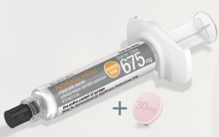  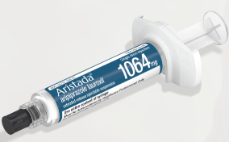
Available aripiprazole lauroxil dosages are equivalent to lower (10-mg), intermediate (15-mg), or higher (20-mg or more) daily doses of oral aripiprazole. | 21
Most patients derive clinical benefit from the intermediate dose, although some may require the lower or higher dose instead. | 19 | MS Figure 5B  Highlight red, green, and then set of 3 blue bars when ‘low,’ ‘high,’ and ‘intermediate,’ respectively, are mentioned.  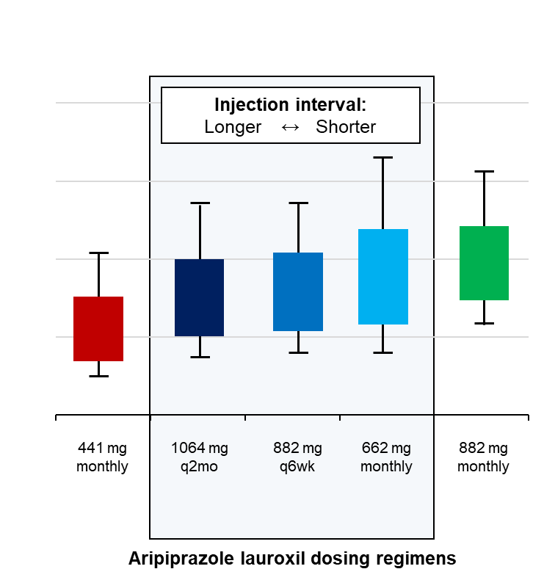
With aripiprazole lauroxil, intermediate dose levels can be delivered using a regimen with monthly, every-6-week, or every-2-month injection intervals, while the lower and higher dose exposures can be achieved using a monthly regimen. | 33 | MS Figure 5B  Focus on center box, highlighting right, center, and left blue bars when ‘monthly,’ ‘every 6 weeks,’ and ‘every 2 months,’ respectively, are mentioned.
Aripiprazole lauroxil has proven efficacy and safety in the treatment of schizophrenia in short-term and long-term studies, supporting its use in acute symptom treatment and maintenance therapy. | 27
Overall, this review describes the development and use of aripiprazole lauroxil to address the symptoms of schizophrenia, with treatment-initiation options personalized for individual patients. | 24 | MAST HEAD

