Supplementary Table 1. Contraceptive Method Attributes and Levels in a Discrete Choice Experiment Evaluating Contraceptive Decision-Making
Contraceptive Attribute (Shown to Participants) | Levels (Shown to Participants)
Chance of pregnancy, if using this method for one year* | - 1 of 100  - 4 of 100  - 7 of 100
Mode of administrationª | - HCP puts it in your uterus. It lasts several years.  - HCP puts it under the skin of your inner upper arm. It lasts several years.  - HCP gives you an injection every 3 months.  - HCP gives you a prescription. Method is used daily. Prescription refills needed.
Ability to get pregnant, if desired, after stopping this method^{b} | - Within a few days  - Within a few weeks  - May take several months
May increase the risk of blood clot, heart attack, or stroke^{c} | - 2 of 10,000  - 5 of 10,000  - 10 of 10,000
Per medical guidelines, this method can be used immediately after childbirth | - Yes  - No, you should delay starting for several weeks after giving birth
Per medical guidelines, can be used while breastfeeding immediately after childbirth and without impacting milk supply^{d} | - Yes  - No, you should delay starting for several weeks after giving birth
Percentage of women with absence of menstruation after continuous use for one year^{e} | - 1 of 100  - 10 of 100  - 25 of 100  - 50 of 100
Note: A pilot study was conducted to assess the suitability, comprehensiveness, and clarity of the attributes and their corresponding levels; in the full study, all participants completed a tutorial designed to familiarize them with the study procedures and improve internal validity, consistent with best practice guidelines. ª Levels were identified by targeted literature review including US package inserts; clinical consultation was sought. ^{b} Evidence on contraceptive use and return to fertility is mixed. Levels were pre-specified to understand this effect. ^{c} Levels defined according to USA FDA communication. ^{d} Based on medical eligibility criteria. ^{e} Based on ACOG medical management of menstrual suppression.
Abbreviations: HCP, healthcare provider.

Supplementary Table 2. Preference Weights and Trade-Offs Among Women in a Discrete Choice Experiment Evaluating Contraceptive Decision-Making: Subgroup Analysis by Age Group
 | 18–24 years (n = 106) |  |  | 25-34 years (n = 100) |  |  | 35-49 years (n = 101)
 | Preference weightsª | WTT^{b} | RI  Order^{c} | Preference weightsª | WTT^{b} | RI  Order^{c} | Preference weightsª | WTT^{b} | RI  Order^{c}
Effectiveness |  |  | 2 |  |  | 1 |  |  | 1
1 of 100 (Reference) | - | - |  | - | - |  | - | -
4 of 100 | −0.30^{d} | - |  | -0.33 ^{d} | - |  | −0.20 ^{d} | -
7 of 100 | −0.58 ^{d} | - |  | -0.55 ^{d} | - |  | −0.62 ^{d}
Cardiovascular Risk |  | 0.63 | 4 |  | 0.67 | 2 |  | 0.47 | 3
2 of 10,000 (Reference) | - | - |  |  |  |  | - | -
5 of 10,000 | −0.33 ^{d} | - |  | −0.23 |  |  | −0.07 | -
10 of 10,000 | −0.49 ^{d} | - |  | −0.49 ^{d} |  |  | -0.39 ^{d} | -
Immediate postpartum use |  |  | 7 |  |  | 5 |  |  | 6
No, should delay for several weeks (Reference) | - | - |  | - | - |  | - | -
Yes | 0.10 | 1.08 |  | 0.22 ^{d} | 2.43 |  | 0.16 ^{d} | 1.50
Breastfeeding after childbirth |  |  | 6 |  |  | 7 |  |  | 7
No, should delay for several weeks (Reference) | - | - |  | - | - |  | - | -
Yes | 0.11 | 1.11 |  | 0.01 | 0.05 |  | 0.06 | 0.57
Amenorrhea |  |  | 3 |  |  | 6 |  |  | 4
1 of 100 (Reference) | - | - |  | - |  |  | -
10 of 100 | −0.16 | −1.68 |  | 0.16 | 1.69 |  | 0.07 | 0.67
25 of 100 | −0.50 ^{d} | −5.23 |  | 0.06 | 0.66 |  | 0.13 | 1.23
50 of 100 | −0.05 | −0.56 |  | 0.09 | 0.98 |  | -0.11 | −1.09
Mode of administration |  |  | 1 |  |  | 3 |  |  | 2
HCP puts under skin of upper arm; lasts several  years. (Reference) | - | - |  | - | - |  | - | -
HCP puts in uterus; lasts several years. | −0.43 ^{d} | −4.45 |  | 0.26 ^{d} | 2.83 |  | 0.04 | 0.38
HCP gives an injection every 3 months. | −0.25 ^{d} | −2.58 |  | −0.11 | −1.20 |  | 0.30 ^{d} | 2.92
HCP gives a prescription; method used daily. Prescription refills needed. | 0.17 | 1.81 |  | 0.28 ^{d} | 3.10 |  | 0.40 ^{d} | 3.84
Return to fertility |  |  | 5 |  |  | 4 |  |  | 5
Within a few days (Reference) | - | - |  | - | - |  | - | -
Within a few weeks | −0.11 | −1.16 |  | −0.24 ^{d} | −2.65 |  | 0.06 | 0.57
May take several months | −0.11 | −1.11 |  | −0.32 ^{d} | −3.54 |  | -0.16 | −1.59

Note: ª Preference weights are from a conditional logistic model regressing preferences on the attribute’s levels of the treatment selected from each choice card. A negative coefficient is interpreted as that attribute level being less preferred relative to the reference category for that attribute, and the larger the magnitude of the negative coefficient the stronger the negative preference. For example, the results for effectiveness can be stated as: “Methods associated with a higher chance of pregnancy are less preferred than methods with a 1% chance of pregnancy”. Greater magnitudes reflect greater relative importance and thus stronger influence on choice. ^{b} WTT values were estimated using marginal utilities (continuous) or preference weights (categorical) for an attribute divided by the marginal utility for effectiveness. A positive coefficient reflects an individual’s willingness to trade-off a given attribute for lower effectiveness (ie, willingness to accept a less effective contraceptive method for the alternative attribute), while a negative coefficient indicates that individuals require a more effective contraceptive method to trade-off the attribute (ie, requiring a more effective contraceptive method to accept the alternative attribute). Coefficients represent the percentage points of effectiveness willing to be traded. Larger absolute percentage point values indicate larger estimated trade-offs with effectiveness for the displayed attribute-level comparison. ^{c} RI order refers to the ranking of items by relative importance (RI), where an order of 1 indicates the highest RI. ^{d} P < .05
Abbreviations: RI, Relative importance; WTT, willingness to trade-off.
Supplementary Table 3. Preference Weights and Trade-Offs Among Women in a Discrete Choice Experiment Evaluating Contraceptive Decision-Making: Subgroup Analysis by Body Weight
 | BMI < 25kg/m² (n = 146) |  |  | BMI ≥ 25kg/m² (n = 161)
 | Preference weightsª | WTT^{b} | RI  Order^{c} | Preference weightsª | WTT^{b} | RI  Order^{c}
Effectiveness |  |  | 1 |  |  | 1
1 of 100 (Reference) | - | - |  | - | -
4 of 100 | −0.26^{d} | - |  | −0.30 ^{d} | -
7 of 100 | −0.59 ^{d} | - |  | −0.55 ^{d} | -
Cardiovascular Risk |  | 0.65 | 2 |  | 0.52 | 2
2 of 10,000 (Reference) | - | - |  | - | -
5 of 10,000 | −0.05 | - |  | −0.33 ^{d} | -
10 of 10,000 | −0.52 ^{d} | - |  | −0.38 ^{d} | -
Immediate postpartum use |  |  | 6 |  |  | 4
No, should delay for several weeks (Reference) | - | - |  | - | -
Yes | 0.10 | 0.99 |  | 0.21 ^{d} | 2.27
Breastfeeding after childbirth |  |  | 7 |  |  | 7
No, should delay for several weeks (Reference) | - | - |  | - | -
Yes | −0.03 | -0.28 |  | 0.14 ^{d} | 1.51
Amenorrhea |  |  | 5 |  |  | 6
1 of 100 (Reference) | - | - |  | - | -
10 of 100 | −0.03 | -0.33 |  | 0.06 | 0.64
25 of 100 | −0.09 | -0.92 |  | −0.07 | −0.78
50 of 100 | 0.05 | 0.50 |  | −0.09 | −1.02
Mode of administration |  |  | 3 |  |  | 3
HCP puts under skin of upper arm; lasts several  years. (Reference) | - | - |  | - | -
HCP puts in uterus; lasts several years. | -0.01 | −0.05 |  | −0.08 | −0.92
HCP gives an injection every 3 months. | 0.06 | 0.56 |  | −0.08 | −0.87
HCP gives a prescription; method used daily. Prescription refills needed. | 0.36 ^{d} | 3.62 |  | 0.23 ^{d} | 2.50
Return to fertility |  |  | 4 |  |  | 5
Within a few days (Reference) | - | - |  | - | -
Within a few weeks | −0.12 | −1.24 |  | -0.05 | −0.58
May take several months | −0.21 ^{d} | −2.14 |  | -0.18 ^{d} | −1.90
Notes: ª Preference weights are from a conditional logistic model regressing preferences on the attribute’s levels of the treatment selected from each choice card. A negative coefficient is interpreted as that attribute level being less preferred relative to the reference category for that attribute, and the larger the magnitude of the negative coefficient the stronger the negative preference. For example, the results for effectiveness can be stated as: “Methods associated with a higher chance of pregnancy are less preferred than methods with a 1% chance of pregnancy”. Greater magnitudes reflect greater relative importance and thus stronger influence on choice. ^{b} WTT values were estimated using marginal utilities (continuous) or preference weights (categorical) for an attribute divided by the marginal utility for effectiveness. A positive coefficient reflects an individual’s willingness to trade-off a given attribute for lower effectiveness (ie, willingness to accept a less effective contraceptive method for the alternative attribute), while a negative coefficient indicates that individuals require a more effective contraceptive method to trade-off the attribute (ie, requiring a more effective contraceptive method to accept the alternative attribute). Coefficients represent the percentage points of effectiveness willing to be traded. Larger absolute percentage point values indicate larger estimated trade-offs with effectiveness for the displayed attribute-level comparison. ^{c} RI order refers to the ranking of items by relative importance (RI), where an order of 1 indicates the highest RI. ^{d} P < .05
Abbreviations: BMI, body mass index; HCP, healthcare provider; -, not applicable; RI, relative importance; WTT, willingness to-trade-off.

Supplementary Table 4. Preference Weights and Trade-Offs Among Women in a Discrete Choice Experiment Evaluating Contraceptive Decision-Making: Subgroup Analysis by Family Planning Status
 | Wants More Children (n = 190) |  |  | Does Not Want More Children (n = 117)
 | Preference weightsª | WTT^{b} | RI  Order^{c} | Preference weightsª | WTT^{b} | RI  Order^{c}
Effectiveness |  |  | 1 |  |  | 1
1 of 100 (Reference) | - | - |  | - | -
4 of 100 | −0.33^{d} | - |  | -0.21 ^{d} | -
7 of 100 | −0.49 ^{d} | - |  | -0.74 ^{d} | -
Cardiovascular Risk |  | 0.67 | 2 |  | 0.48 | 2
2 of 10,000 (Reference) | - | - |  | - | -
5 of 10,000 | -0.22 ^{d} | - |  | -0.19 | -
10 of 10,000 | -0.44 ^{d} | - |  | -0.47 ^{d} | -
Immediate postpartum use |  |  | 6 |  |  | 6
No, should delay for several weeks (Reference) | - | - |  | - | -
Yes | 0.13 ^{d} | 1.54 |  | 0.19 ^{d} | 1.56
Breastfeeding after childbirth |  |  | 7 |  |  | 5
No, should delay for several weeks (Reference) | - | - |  | - | -
Yes | −0.02 | −0.24 |  | 0.20 ^{d} | 1.61
Amenorrhea |  |  | 5 |  |  | 4
1 of 100 (Reference) | - | - |  | - | -
10 of 100 | −0.08 | -0.93 |  | 0.20 | 1.62
25 of 100 | −0.22 | -2.66 |  | 0.12 | 0.96
50 of 100 | −0.03 | -0.41 |  | 0.01 | 0.07
Mode of administration |  |  | 3 |  |  | 3
HCP puts under skin of upper arm; lasts several  years. (Reference) | - | - |  | - | -
HCP puts in uterus; lasts several years. | −0.18 ^{d} | −2.17 |  | 0.13 | 1.08
HCP gives an injection every 3 months. | −0.09 | −1.15 |  | 0.12 | 0.99
HCP gives a prescription; method used daily. Prescription refills needed. | 0.25 ^{d} | 3.03 |  | 0.35 ^{d} | 2.82
Return to fertility |  |  | 4 |  |  | 7
Within a few days (Reference) | - | - |  | - | -
Within a few weeks | −0.13 | −1.64 |  | 0.01 | 0.09
May take several months | −0.28 ^{d} | −3.43 |  | -0.03 | −0.27

Notes: ª Preference weights are from a conditional logistic model regressing preferences on the attribute’s levels of the treatment selected from each choice card. A negative coefficient is interpreted as that attribute level being less preferred relative to the reference category for that attribute, and the larger the magnitude of the negative coefficient the stronger the negative preference. For example, the results for effectiveness can be stated as: “Methods associated with a higher chance of pregnancy are less preferred than methods with a 1% chance of pregnancy”. Greater magnitudes reflect greater relative importance and thus stronger influence on choice. ^{b} WTT values were estimated using marginal utilities (continuous) or preference weights (categorical) for an attribute divided by the marginal utility for effectiveness. A positive coefficient reflects an individual’s willingness to trade-off a given attribute for lower effectiveness (ie, willingness to accept a less effective contraceptive method for the alternative attribute), while a negative coefficient indicates that individuals require a more effective contraceptive method to trade-off the attribute (ie, requiring a more effective contraceptive method to accept the alternative attribute). Coefficients represent the percentage points of effectiveness willing to be traded. Larger absolute percentage point values indicate larger estimated trade-offs with effectiveness for the displayed attribute-level comparison. ^{c} RI order refers to the ranking of items by relative importance (RI), where an order of 1 indicates the highest RI. ^{d} P < .05
Abbreviations: CI, confidence interval; HCP, healthcare provider; -, not applicable; RI, relative importance; WTT, willingness to-trade-off

Supplementary Figures
Supplementary Figure 1. Flow Diagram of Women Participant Recruitment and Inclusion
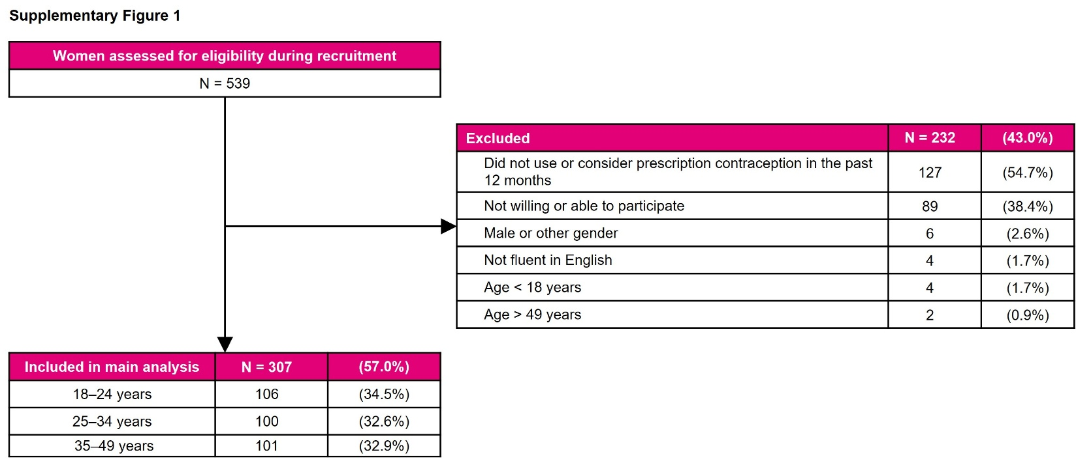

Supplementary Figure 2. Flow Diagram of Healthcare Provider Recruitment and Inclusion, Including Specialty Distribution
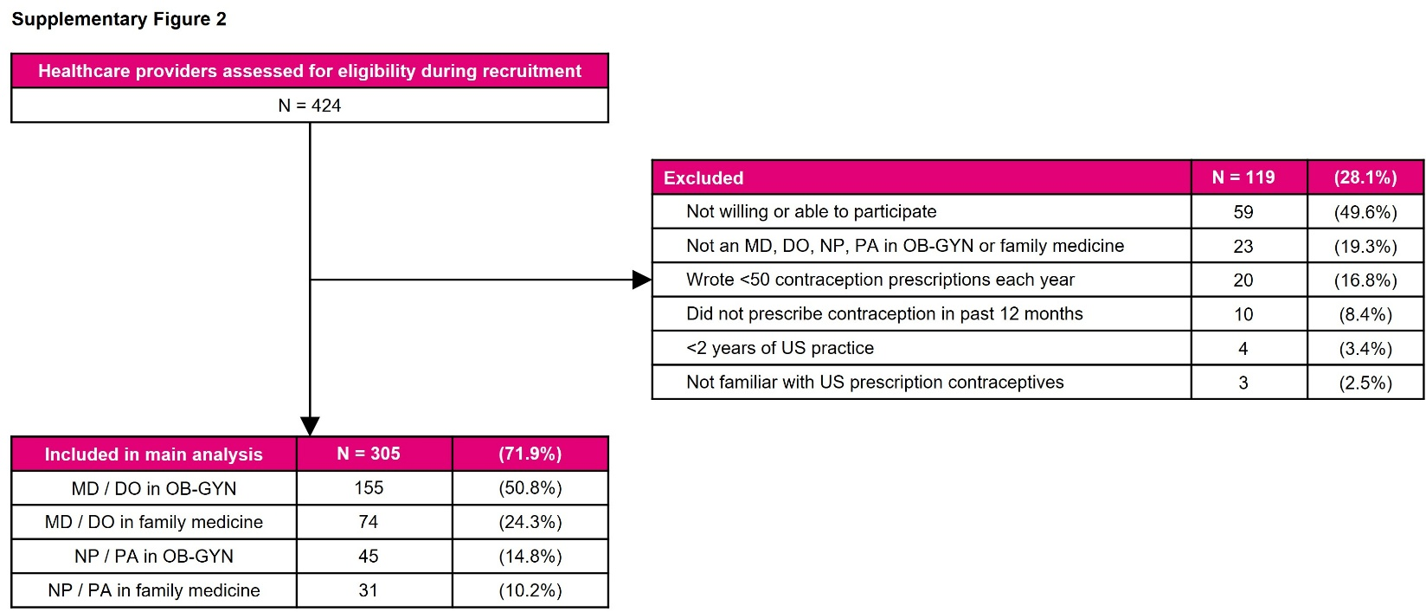

Abbreviations: DO, Doctor of Osteopathic Medicine; MD, Doctor of Medicine; NP, nurse practitioner; OB-GYN, obstetrics and gynecology; PA, physician assistant; US, United States.
Supplementary Figure 3. Example Choice Card in a Discrete Choice Experiment Evaluating Contraceptive Decision-Making (Levels Randomized Across Choice Cards)ª
Note: ª Each participant completed 12 choice cards per discrete choice experiment. Women completed one discrete choice experiment. Healthcare providers completed one discrete choice experiment per patient profile.
