Supplementary File
Supplementary Table 1. Epidemiology and health plan inputs
Epidemiology Inputs | Value | Source
Number of CML patients in US, 2021 | 69,533 | ¹
Proportion of CML with Ph+ | 95% | ²
Proportion of CML in 1L / 2L / 3L+ | 78% / 22% / 15% | ^{3,4} / ^{3,4} / ³
Proportion of CML Ph+ Aged <20 (Pediatric) | 1.5% | ¹
Proportion of CML Ph+ (Adult) | 98.5% | Calculated from pediatric proportion
Proportion of CML CP patients with the T315I mutation | 3.2% | ⁵
Payer Distribution Among Adult Patients with CML
Medicaid | 14.4% | ⁶
Commercial | 49.8% | ⁶
Medicare | 35.8% | ⁶
US Prevalence of CML by Payer (Cases Per 100,000)
Overall | 21.0 | ¹
Medicaid | 16.2 | ^{1,6,7}
Commercial | 16.0 | ^{1,6,7}
Medicare | 60.0 | ¹
US Prevalence of Adult Ph+ CML by Payer (Cases Per 100,000)
Overall | 19.7 | ^{1,4,8}
Medicaid | 15.1 | ^{1,4,6-8}
Commercial | 15.0 | ^{1,4,6-8}
Medicare | 57.0 | ^{1,4,8}
Health Plan Inputs | Value | Source
Annual OOP Maximum by Payer, 2024
Medicaid | $200 | ⁹
Commercial, Average | $4,101 | ¹⁰
Commercial, Highest | $9,450 | ¹¹
Medicare | $8,000 | ¹²
Annual OOP Maximum by Payer, 2025
Medicaid | $200 | Assumed same as 2024
Commercial, Average | $4,101 | Assumed same as 2024
Commercial, Highest | $9,200 | ¹¹
Medicare | $2,000 | ¹³
PPPY Medical Care Cost Under Commercial Payer (2024 USD)
1L CML | $49,030 | ¹⁴
2L CML | $70,391 | ¹⁴
3L+ CML | $129,889 | ¹⁵
Commercial Coinsurance Rate | 20% | ¹⁰
CML – Chronic Myeloid Leukemia; Ph+ – Philadelphia Chromosome-Positive; PPPY – Per Patient Per Year; OOP – Out-of-Pocket; US – United States; 1L – First-Line; 2L – Second-Line; 3L+ – Third-Line or Later

Supplementary Table 2. Price reduction required to each TKI to fall below 2025 annual OOP limits
Treatment | Below $2,000 (Medicare) | Below $4,101 (Average Commercial) | Below $9,200 (Highest Commercial)
Asciminib, 80mg QD | 99.3% | 98.5% | 96.6%
Asciminib, 200mg BID, T315I | 99.6% | 99.2% | 98.3%
Bosutinib | 99.3% | 98.5% | 96.6%
Dasatinib (Branded) | 99.1% | 98.2% | 95.9%
Dasatinib (Generic) | 95.8% | 91.4% | 80.8%
Dasatinib (Mark Cuban Cost Plus) | 36.3% | Below cap | Below cap
Imatinib (Branded) | 98.4% | 96.7% | 92.5%
Imatinib (Generic) | 65.0% | 28.2% | Below cap
Imatinib (Mark Cuban Cost Plus) | Below cap | Below cap | Below cap
Nilotinib (Branded) | 99.3% | 98.6% | 96.8%
Nilotinib (Generic) | 96.4% | 92.6% | 83.5%
Ponatinib | 99.3% | 98.6% | 96.8%
TKI – Tyrosine Kinase Inhibitor; OOP – Out-of-Pocket. Medicare refers to Medicare Part D coverage.

Supplementary Table 3. Sensitivity of the all-payer per member per month (PMPM) budget impact of later-generation TKIs relative to imatinib to variation in key model inputs, 2025

Treatment | Base Case | Imatinib priced at 100% generic* | Treatment WAC varied  (-20%, +20%) | Treatment priced as 100% generic
Asciminib | $4.23 | $4.51 | $3.31, $5.15 | --
Bosutinib | $4.07 | $4.34 | $3.18, $4.95 | --
Dasatinib | $0.82 | $1.10 | $0.59, $1.06 | $0.42
Nilotinib | $1.09 | $1.37 | $0.80, $1.38 | $0.54
Ponatinib | $0.76 | $0.81 | $0.59, $0.92 | --
*Generic imatinib calculated as the average WAC across generic products (18 products at 100mg, 17 products at 400mg).
TKI – Tyrosine Kinase Inhibitor; PMPM – Per Member Per Month.

Supplementary Figure 1. Expected per patient annual OOP cost for imatinib versus newer TKIs by payer type in 2024
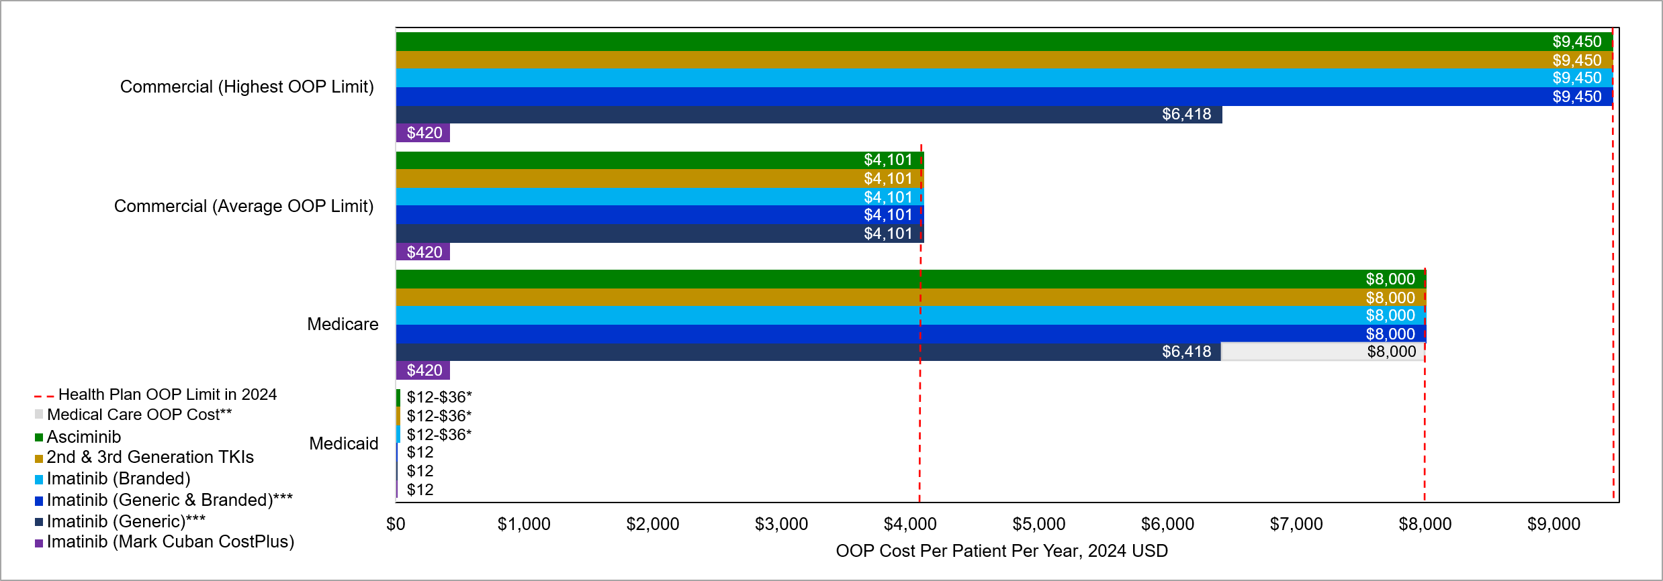
*Medicaid beneficiary copays for generic and preferred brands is $1 per prescription versus $3 per prescription for non-preferred brands. Thus, annual difference in OOP costs with newer TKIs vs. imatinib ranged $0-$24, depending on newer TKIs’ preferred status.
**Typical medical care OOP costs (2024 USD) under commercial plan range between $9,806/year in 1L to $25,978/year in 3L+.
***Generic & branded imatinib calculated as the average WAC across generic products (14 for 100mg, 13 for 400mg) and branded imatinib, weighted by relative market share of generic vs. branded; generic only imatinib calculated as the average WAC across generic products. Mark Cuban CostPlus imatinib represents the lowest possible retail pharmacy cost of imatinib.
TKI – Tyrosine Kinase Inhibitor; OOP – Out-of-Pocket. Medicare refers to Medicare Part D coverage.

Supplementary Figure 2. Difference in per member per month budget impact with newer TKIs vs. imatinib* by payer in 2024
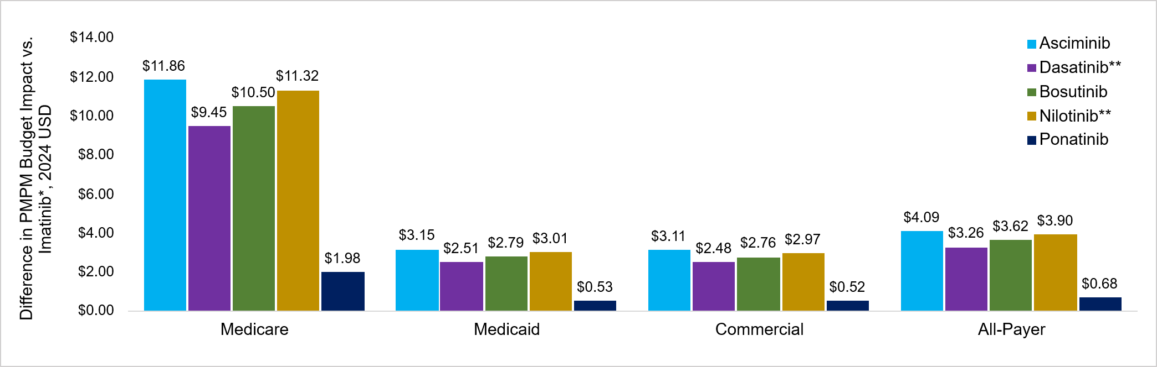
*Average of generic and branded products weighted by relative market share of generic vs. branded.
**Branded only products.
Calculation of PMPM budget impact for each TKI: (1) determine total US adult CML prevalence (overall and by payer), (2) apply the share of each indicated subgroup in CML (listed in Supplementary Table 1) to total adult CML prevalence to estimate prevalence of each subgroup, (3) sum prevalence across indicated subgroups to get total prevalence of indicated population, (4) apply annual per person TKI cost to indicated population prevalence to estimate PMPM budget impact. For overall and Medicare populations, total US adult CML prevalence was calculated using SEER data on total CML prevalence among all patients and among patients aged ≥65 years, with pediatric cases excluded. For Medicaid and Commercial populations, total US CML prevalence was estimated by multiplying overall number of CML patients in US from SEER by payer distribution among CML patients from literature, then dividing by total number of payer beneficiaries in US. Pediatric prevalence was excluded to obtain estimates among adults.
SEER -- Surveillance, Epidemiology, and End Results Program; PMPM – Per Member Per Month; TKI – Tyrosine Kinase Inhibitor.

Supplementary Figure 3. Difference in per member per month budget impact with newer TKIs vs. imatinib* by payer in 2025, with generic vs. branded breakout
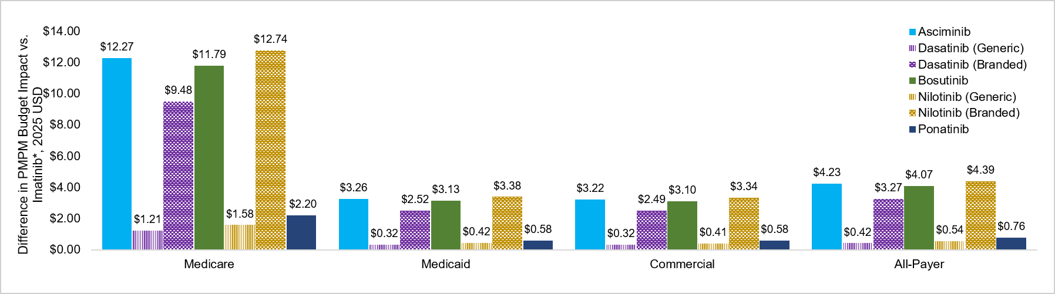
*Average of generic and branded products weighted by relative market share of generic vs. branded.
Calculation of PMPM budget impact for each TKI: (1) determine total US adult CML prevalence (overall and by payer), (2) apply the share of each indicated subgroup in CML (listed in Supplementary Table 1) to total adult CML prevalence to estimate prevalence of each subgroup, (3) sum prevalence across indicated subgroups to get total prevalence of indicated population, (4) apply annual per person TKI cost to indicated population prevalence to estimate PMPM budget impact. For overall and Medicare populations, total US adult CML prevalence was calculated using SEER data on total CML prevalence among all patients and among patients aged ≥65 years, with pediatric cases excluded. For Medicaid and Commercial populations, total US CML prevalence was estimated by multiplying overall number of CML patients in US from SEER by payer distribution among CML patients from literature, then dividing by total number of payer beneficiaries in US. Pediatric prevalence was excluded to obtain estimates among adults.
SEER -- Surveillance, Epidemiology, and End Results Program; PMPM – Per Member Per Month; TKI – Tyrosine Kinase Inhibitor.

Supplementary File References
1. SEER*Explorer: An interactive website for SEER cancer statistics [Internet]. Surveillance Research Program, National Cancer Institute;. https://seer.cancer.gov/statistics-network/explorer/
2. Huret JL. Complex translocations, simple variant translocations and Ph-negative cases in chronic myelogenous leukaemia. Hum Genet. Oct 1990;85(6):565-8. doi:10.1007/bf00193575
3. Bosi GR, Fogliatto LM, Costa TEV, et al. What happens to intolerant, relapsed or refractory chronic myeloid leukemia patients without access to clinical trials? Hematology, Transfusion and Cell Therapy. 2019;41(3):222-228.
4. Kota VK, Wei D, Yang D, et al. Treatment Patterns and Modifications of Tyrosine Kinase Inhibitors (TKI) Therapy in Early Lines in Patients with Chronic Myeloid Leukemia in Chronic Phase (CML-CP): Real-World Analysis from a Large Commercial Claims Database in the United States (US). Blood. 2023;142:5190.
5. Haddad FG, Sasaki K, Bidikian A, et al. Characteristics and outcomes of patients with chronic myeloid leukemia and T315I mutation treated in the pre‐and post‐ponatinib era. American journal of hematology. 2023;98(10):1619-1626.
6. Perry AM, Brunner AM, Zou T, et al. Association between insurance status at diagnosis and overall survival in chronic myeloid leukemia: a population‐based study. Cancer. 2017;123(13):2561-2569.
7. Katherine Keisler-Starkey LNB. Health Insurance Coverage in the United States: 2023. 2024. Accessed March 6, 2026. https://www2.census.gov/library/publications/2024/demo/p60-284.pdf
8. Huret J. Complex translocations, simple variant translocations and Ph-negative cases in chronic myelogenous leukaemia. Human genetics. 1990;85(6):565-568.
9. New York State Department of Health. Benefits and Coverage. https://member.emedny.org/pharmacy/benefits
10. KFF. 2023 Employer Health Benefits Survey. https://www.kff.org/report-section/ehbs-2023-section-7-employee-cost-sharing/
11. Health Insurance Marketplace. Out-of-pocket maximum/limit. https://www.healthcare.gov/glossary/out-of-pocket-maximum-limit/#:~:text=The%20out%2Dof%2Dpocket%20limit%20for%20Marketplace%20plans%20varies%2C,an%20individual%20and%20$18%2C400%20for%20a%20family.
12. Centers for Medicare & Medicaid Services. Lower out-of-pocket drug costs in 2024 and 2025. Accessed March 6, 2026. https://www.cms.gov/files/document/lower-out-pocket-drug-costs-2024-and-2025-article.pdf
13. Bisma A. Sayed KF, T. Anders Olsen, Kaavya Ashok, Sarah Schutz, Steven Sheingold, , Nancy De Lew BDS. Medicare Part D Enrollee Out-Of-Pocket Spending: Recent Trends and Projected Impacts of the Inflation Reduction Act. 2023. Accessed March 6, 2026. https://aspe.hhs.gov/sites/default/files/documents/1b652899fb99dd7e6e0edebbcc917cc8/aspe-part-d-oop.pdf
14. McGarry LJ, Chen YJ, Divino V, et al. Increasing economic burden of tyrosine kinase inhibitor treatment failure by line of therapy in chronic myeloid leukemia. Curr Med Res Opin. 2016;32(2):289-299.
15. Atallah EL, Maegawa R, Latremouille-Viau D, et al. Chronic Myeloid Leukemia: Part I—Real-World Treatment Patterns, Healthcare Resource Utilization, and Associated Costs in Later Lines of Therapy in the United States. Journal of Health Economics and Outcomes Research. 2022;9(2):19.

