Supplementary Method S1. Available cardiovascular disease-related descriptors
Descriptor | Category | n (%)
Arrhythmia type | None | 312 (56.4)
Arrhythmia type | Atrial fibrillation only | 194 (35.1)
Arrhythmia type | Atrial flutter only | 9 (1.6)
Arrhythmia type | Atrial premature beat | 11 (2.0)
Arrhythmia type | Premature ventricular contraction only | 10 (1.8)
Arrhythmia type | Other/multiple/unspecified | 17 (3.1)
Main admission presentation | chest tightness | 161 (29.1)
Main admission presentation | palpitations | 76 (13.7)
Main admission presentation | dyspnea | 71 (12.8)
Main admission presentation | chest tightness;dyspnea | 64 (11.6)
Main admission presentation | chest pain | 52 (9.4)
Main admission presentation | chest tightness;palpitations | 18 (3.3)
Main admission presentation | edema | 15 (2.7)
Main admission presentation | gastrointestinal symptoms | 15 (2.7)
Main admission presentation | Other/rare/missing | 81 (14.6)

Supplementary Method S2. Missing-data patterns before imputation
Variable | Missing n | Missing %
Sex | 0 | 0.0
Age | 0 | 0.0
BMI | 1 | 0.2
NYHA functional class | 1 | 0.2
LVEF | 0 | 0.0
NT-proBNP | 0 | 0.0
Troponin | 0 | 0.0
Creatinine | 0 | 0.0
Hemoglobin | 0 | 0.0
Total protein | 0 | 0.0
Creatinine clearance | 0 | 0.0
Uric acid | 0 | 0.0
CRP | 8 | 1.4
Serum sodium | 0 | 0.0
Serum potassium | 1 | 0.2
Admission Barthel Index | 0 | 0.0
Hypertension | 0 | 0.0
Diabetes mellitus | 0 | 0.0
Smoking status | 1 | 0.2
Drinking status | 0 | 0.0
Disease duration | 15 | 2.7
Thyroxine | 1 | 0.2
Glycated albumin | 0 | 0.0
Serum chloride | 0 | 0.0
Blood glucose | 0 | 0.0
Triglycerides | 0 | 0.0
Total cholesterol | 0 | 0.0
LDL-C | 0 | 0.0
HDL-C | 0 | 0.0

Supplementary File S1. Detailed preprocessing procedures, model development workflow, hyperparameter settings, and evaluation methods
Section | Item | Details
Overall workflow | Outcome-specific modelling | Analyses were performed separately for 1-week functional recovery and 90-day readmission. Patients with available outcome information were included in the corresponding outcome-specific modelling dataset.
Overall workflow | Data split | For each outcome-specific dataset, patients were randomly divided into a training cohort and a test cohort at a ratio of 7:3 using a fixed random seed of 52.
Overall workflow | Training cohort | The training cohort was used for variable selection, missing-value imputation parameter estimation, dummy-variable construction, near-zero variance filtering, model training, and hyperparameter tuning.
Overall workflow | Test cohort | The test cohort was used for independent model evaluation. Preprocessing parameters derived from the training cohort were applied to the test cohort.
Outcome definition | 1-week functional recovery | Functional recovery was defined according to the Barthel Index assessed 1 week after discharge. Patients with a score of 85 or higher were classified as having functional recovery; those with a score below 85 were classified as not having functional recovery.
Outcome definition | 90-day readmission | Readmission was defined as any recorded readmission occurring within 90 days after discharge. The interval between discharge and readmission was calculated using discharge and readmission dates.
Candidate predictors | Predictor source | Candidate predictors were restricted to baseline or admission-related variables, including demographic characteristics, comorbidities, cardiac function indicators, laboratory measurements, and admission functional assessment.
Candidate predictors | Leakage control | Variables directly related to outcome definition or post-discharge information were excluded, including discharge date, readmission date, time to readmission, discharge Barthel Index score, 1-week post-discharge Barthel Index score, and outcome variables.
Candidate predictors | Demographic characteristics | Sex, age, body mass index.
Candidate predictors | Comorbidities and history | Hypertension, diabetes mellitus, smoking, drinking, disease duration.
Candidate predictors | Cardiac function indicators | New York Heart Association functional class, left ventricular ejection fraction, N-terminal pro-B-type natriuretic peptide, troponin.
Candidate predictors | Functional assessment | Admission Barthel Index score.
Candidate predictors | Renal and metabolic indicators | Creatinine, creatinine clearance, uric acid, blood glucose, glycated albumin.
Candidate predictors | Electrolytes | Serum sodium, serum potassium.
Candidate predictors | Inflammatory and hematologic indicators | C-reactive protein, haemoglobin.
Candidate predictors | Nutrition and lipid indicators | Total protein, triglycerides, total cholesterol, low-density lipoprotein cholesterol, high-density lipoprotein cholesterol.
Candidate predictors | Other laboratory indicators | Thyroxine, serum chloride.
Data preprocessing | Missing continuous predictors | Continuous predictors with missing values were imputed using the median value calculated from the training cohort. The same median values were applied to the test cohort.
Data preprocessing | Missing categorical predictors | Categorical predictors with missing values were imputed using the most frequent category in the training cohort. The same imputation rule was applied to the test cohort.
Data preprocessing | Categorical predictors | Categorical predictors were transformed into dummy variables based on the training cohort, and the same dummy-variable structure was applied to the test cohort.
Data preprocessing | Variable name standardization | Variable names were standardized to ensure compatibility with machine learning algorithms.
Data preprocessing | Near-zero variance filtering | Near-zero variance dummy variables were identified in the training cohort and removed before model fitting. The same retained predictor structure was applied to the test cohort.
Data preprocessing | Class balancing | Synthetic minority oversampling technique was not used in the final analysis.
Variable selection | Method | Least absolute shrinkage and selection operator regression was used for candidate variable selection.
Variable selection | Dataset | Variable selection was performed in the training cohort.
Variable selection | Model family | Binomial regression was used for binary outcomes.
Variable selection | Cross-validation | The penalty parameter was selected using 10-fold cross-validation.
Variable selection | Penalty parameter | The lambda.1se criterion was used to obtain a parsimonious predictor set.
Variable selection | Selection rule | Predictors with non-zero coefficients were retained for subsequent model development.
Variable selection | Fallback strategy | If no predictor was retained, the full baseline predictor set was used for modelling.
Model development | Candidate algorithms | Ten candidate algorithms were trained and compared: logistic regression, support vector machine, neural network, K-nearest neighbours, decision tree, random forest, gradient boosting machine, light gradient boosting machine, extreme gradient boosting, and naïve Bayes.
Model development | Cross-validation | For caret-based models, repeated cross-validation was performed using 5-fold cross-validation repeated 5 times.
Model development | Optimization metric | The area under the receiver operating characteristic curve was used as the primary optimization metric during model tuning.
Model development | Prediction target | Predicted probabilities for the positive outcome class were generated for both the training and test cohorts.
Hyperparameters | Logistic regression | No additional tuning grid was used.
Hyperparameters | Support vector machine | sigma: 0.001, 0.005, 0.01; C: 0.05, 0.1, 0.5, 1. Predictors were centred and scaled.
Hyperparameters | Neural network | size: 3, 5, 6; decay: 0.1, 0.3, 0.6. Predictors were centred and scaled; maximum number of weights was set to 10,000; maximum iterations were set to 1,000.
Hyperparameters | K-nearest neighbours | kmax: 5, 7, 9, 12, 15; distance: 1; kernel: optimal, rectangular, triangular. Predictors were centred and scaled.
Hyperparameters | Decision tree | cp: 0.001, 0.005, 0.01, 0.03, 0.05.
Hyperparameters | Random forest | mtry was selected from floor(sqrt[p]), floor(p/3), and floor(p/2), where p represents the number of predictors.
Hyperparameters | Gradient boosting machine | n.trees: 50, 100, 150; interaction.depth: 1, 2, 3; shrinkage: 0.03, 0.05, 0.1; n.minobsinnode: 10.
Hyperparameters | Naïve Bayes | fL: 0; usekernel: true or false; adjust: 1 or 1.5.
Hyperparameters | Extreme gradient boosting | objective: binary:logistic; eval_metric: auc; max_depth: 2; eta: 0.03; subsample: 0.8; colsample_bytree: 0.8; min_child_weight: 3; gamma: 0; scale_pos_weight: ratio of negative to positive cases; nrounds: 120.
Hyperparameters | Light gradient boosting machine | objective: binary; metric: auc; learning_rate: 0.03; num_leaves: 15; feature_fraction: 0.8; bagging_fraction: 0.8; bagging_freq: 1; nrounds: 300.
Model evaluation | Discrimination | Discrimination was assessed using the area under the receiver operating characteristic curve with 95% confidence intervals. Receiver operating characteristic curves were plotted for all candidate models.
Model evaluation | Precision–recall analysis | Precision–recall curves were generated, and the area under the precision–recall curve was calculated to assess predictive performance, particularly in the presence of class imbalance.
Model evaluation | Classification metrics | Accuracy, sensitivity, specificity, positive predictive value, negative predictive value, and F1 score were calculated using a probability threshold of 0.5.
Model evaluation | Optimal threshold | The optimal threshold was determined using the Youden index, and the corresponding sensitivity, specificity, positive predictive value, negative predictive value, F1 score, and accuracy were reported.
Model evaluation | Calibration | Calibration was evaluated using calibration curves, Brier score, calibration intercept, and calibration slope. Calibration curves compared the mean predicted probability with the observed event rate.
Model evaluation | Clinical usefulness | Decision curve analysis was used to estimate net benefit across threshold probabilities from 0.01 to 0.99.
Model evaluation | Confusion matrix | Confusion matrices were generated for each model in the training and test cohorts.
Model interpretation | Method | Model interpretation was performed using Shapley additive explanations.
Model interpretation | Extreme gradient boosting | Shapley values were calculated directly from the fitted extreme gradient boosting model.
Model interpretation | Random forest | Approximate Shapley values were estimated using a Monte Carlo-based approach.
Model interpretation | Random forest explanation parameters | The number of simulations was set to 50, and up to 150 training samples were used for approximate Shapley additive explanation estimation.
Model interpretation | Global importance | Global predictor importance was summarized using the mean absolute Shapley value for each predictor.
Model interpretation | Visualization | Shapley additive explanation importance bar plots, beeswarm plots, and dependence plots were generated.
Web-based calculator | Platform | A Shiny-based web application was developed.
Web-based calculator | Prediction tasks | The calculator provided individualized predicted probabilities for 1-week functional recovery and 90-day readmission.
Web-based calculator | Input | Users entered patient-level predictor values through an interactive interface.
Web-based calculator | Output | The application generated predicted probabilities for the positive outcome class.
Web-based calculator | Preprocessing | The calculator used the same preprocessing workflow as model development, including missing-value handling, dummy-variable transformation, and alignment with model input variables.
Web-based calculator | Interpretation display | The calculator displayed global Shapley additive explanation outputs, including variable importance plots, beeswarm plots, and dependence plots.
Software | Statistical software | All analyses were performed using R software.
Software | R packages | caret, pROC, glmnet, randomForest, xgboost, gbm, e1071, nnet, kknn, klaR, rpart, lightgbm, fastshap, ggplot2, dplyr, tableone, and shiny.

Supplementary Table S1. Candidate predictors and feature-selection results for model development
Endpoint | Feature-selection result | Predictors used for final modelling
1-week functional recovery | LASSO retained five predictors | NYHA functional class; serum creatinine; serum sodium; admission Barthel Index score; serum chloride
90-day readmission | Penalized coefficient output retained only the intercept | Full baseline predictor set: sex, age, BMI, NYHA functional class, LVEF, NT-proBNP, troponin, serum creatinine, hemoglobin, total protein, creatinine clearance, uric acid, CRP, serum sodium, serum potassium, admission Barthel Index score, hypertension, diabetes mellitus, smoking status, drinking status, disease duration, thyroxine, glycated albumin, serum chloride, blood glucose, triglycerides, total cholesterol, LDL-C, and HDL-C

Supplementary Table S2. Preprocessing and feature-selection details for 90-day readmission modelling
Item | Details
Near-zero variance dummy variables removed | NYHA.II.III; NYHA.III.IV
LASSO non-zero coefficients retained | Intercept = 0.108992
Interpretation | Only the intercept was retained by LASSO for this endpoint; therefore, the fallback modelling strategy used the full baseline predictor set, as specified in the preprocessing workflow.

Supplementary Table S3. Training-cohort performance of machine learning models for predicting 1-week functional recovery
Model | AUC (95% CI) | PR-AUC | Brier score | Accuracy (%) | Sensitivity (%) | Specificity (%) | PPV (%) | NPV (%) | F1 score (%)
Logistic regression | 0.926 (0.902-0.951) | 0.961 | 0.106 | 84.3 | 89.7 | 74.1 | 86.6 | 79.4 | 88.2
Support vector machine | 0.927 (0.902-0.951) | 0.961 | 0.105 | 84.5 | 89.7 | 74.8 | 87.0 | 79.5 | 88.3
Neural network | 0.947 (0.927-0.967) | 0.971 | 0.088 | 86.1 | 91.3 | 76.3 | 87.8 | 82.4 | 89.5
K-nearest neighbours | 0.993 (0.989-0.998) | 0.997 | 0.043 | 94.8 | 97.6 | 89.6 | 94.6 | 95.3 | 96.1
Random forest | 1.000 (1.000-1.000) | 1.000 | 0.015 | 100.0 | 100.0 | 100.0 | 100.0 | 100.0 | 100.0
Gradient boosting machine | 0.956 (0.938-0.974) | 0.976 | 0.083 | 88.1 | 92.9 | 79.3 | 89.4 | 85.6 | 91.1
Naive Bayes | 0.929 (0.905-0.953) | 0.963 | 0.110 | 84.0 | 93.7 | 65.9 | 83.7 | 84.8 | 88.4
Decision tree | 0.947 (0.924-0.970) | 0.966 | 0.076 | 90.2 | 90.9 | 88.9 | 93.9 | 83.9 | 92.4
XGBoost | 0.950 (0.931-0.970) | 0.973 | 0.098 | 86.6 | 85.8 | 88.1 | 93.1 | 76.8 | 89.3
LightGBM | 1.000 (1.000-1.000) | 1.000 | 0.014 | 99.0 | 99.2 | 98.5 | 99.2 | 98.5 | 99.2

Supplementary Table S4. Testing-cohort optimal-threshold performance based on the Youden index for 1-week functional recovery
Model | Optimal threshold | Sensitivity (%) | Specificity (%) | PPV (%) | NPV (%) | F1 score (%) | Accuracy (%) | PR-AUC
Logistic regression | 0.845 | 63.9 | 87.7 | 90.8 | 56.2 | 75.0 | 72.1 | 0.915
Support vector machine | 0.707 | 74.1 | 73.7 | 84.2 | 60.0 | 78.8 | 73.9 | 0.907
Neural network | 0.552 | 79.6 | 71.9 | 84.3 | 65.1 | 81.9 | 77.0 | 0.912
K-nearest neighbours | 0.514 | 84.3 | 68.4 | 83.5 | 69.6 | 83.9 | 78.8 | 0.838
Random forest | 0.616 | 82.4 | 77.2 | 87.3 | 69.8 | 84.8 | 80.6 | 0.921
Gradient boosting machine | 0.812 | 68.5 | 87.7 | 91.4 | 59.5 | 78.3 | 75.2 | 0.917
Naive Bayes | 0.509 | 88.0 | 59.6 | 80.5 | 72.3 | 84.1 | 78.2 | 0.902
Decision tree | 0.829 | 74.1 | 82.5 | 88.9 | 62.7 | 80.8 | 77.0 | 0.899
XGBoost | 0.512 | 75.9 | 80.7 | 88.2 | 63.9 | 81.6 | 77.6 | 0.919
LightGBM | 0.750 | 81.5 | 77.2 | 87.1 | 68.8 | 84.2 | 80.0 | 0.903

Supplementary Table S5. Training-cohort performance of machine learning models for predicting 90-day readmission
Model | AUC (95% CI) | PR-AUC | Brier score | Accuracy (%) | Sensitivity (%) | Specificity (%) | PPV (%) | NPV (%) | F1 score (%)
Logistic regression | 0.780 (0.708-0.852) | 0.317 | 0.086 | 89.2 | 2.4 | 99.7 | 50.0 | 89.4 | 4.5
Support vector machine | 0.980 (0.955-1.000) | 0.888 | 0.082 | 89.7 | 4.8 | 100.0 | 100.0 | 89.6 | 9.1
Neural network | 1.000 (1.000-1.000) | 1.000 | 0.007 | 99.7 | 100.0 | 99.7 | 97.7 | 100.0 | 98.8
K-nearest neighbours | 0.993 (0.987-0.999) | 0.942 | 0.037 | 95.6 | 69.0 | 98.8 | 87.9 | 96.3 | 77.3
Random forest | 1.000 (1.000-1.000) | 1.000 | 0.016 | 100.0 | 100.0 | 100.0 | 100.0 | 100.0 | 100.0
Gradient boosting machine | 0.992 (0.986-0.999) | 0.936 | 0.031 | 95.6 | 66.7 | 99.1 | 90.3 | 96.1 | 76.7
Naive Bayes | 0.903 (0.865-0.940) | 0.534 | 0.091 | 90.5 | 16.7 | 99.4 | 77.8 | 90.8 | 27.5
Decision tree | 0.678 (0.593-0.764) | 0.338 | 0.086 | 89.7 | 21.4 | 98.0 | 56.2 | 91.1 | 31.0
XGBoost | 0.958 (0.938-0.977) | 0.719 | 0.116 | 87.1 | 95.2 | 86.1 | 45.5 | 99.3 | 61.5
LightGBM | 1.000 (1.000-1.000) | 1.000 | 0.004 | 100.0 | 100.0 | 100.0 | 100.0 | 100.0 | 100.0

Supplementary Table S6. Testing-cohort optimal-threshold performance based on the Youden index for 90-day readmission
Model | Optimal threshold | Sensitivity (%) | Specificity (%) | PPV (%) | NPV (%) | F1 score (%) | Accuracy (%) | PR-AUC
Logistic regression | 0.218 | 22.2 | 85.7 | 16.0 | 90.0 | 18.6 | 78.8 | 0.129
Support vector machine | 0.124 | 33.3 | 87.1 | 24.0 | 91.4 | 27.9 | 81.2 | 0.284
Neural network | 0.124 | 38.9 | 82.3 | 21.2 | 91.7 | 27.5 | 77.6 | 0.246
K-nearest neighbours | 0.312 | 38.9 | 85.7 | 25.0 | 92.0 | 30.4 | 80.6 | 0.374
Random forest | 0.142 | 50.0 | 76.2 | 20.5 | 92.6 | 29.0 | 73.3 | 0.364
Gradient boosting machine | 0.153 | 44.4 | 84.4 | 25.8 | 92.5 | 32.7 | 80.0 | 0.313
Naive Bayes | 0.003 | 44.4 | 73.5 | 17.0 | 91.5 | 24.6 | 70.3 | 0.167
Decision tree | 0.106 | 55.6 | 65.3 | 16.4 | 92.3 | 25.3 | 64.2 | 0.183
XGBoost | 0.548 | 38.9 | 82.3 | 21.2 | 91.7 | 27.5 | 77.6 | 0.280
LightGBM | 0.224 | 27.8 | 95.9 | 45.5 | 91.6 | 34.5 | 88.5 | 0.333

Supplementary Table S7. Testing-cohort calibration intercept and calibration slope for 1-week functional recovery models
Model | Calibration intercept | Calibration slope
Logistic regression | 0.216 | 0.594
Support vector machine | 0.198 | 0.575
Neural network | 0.244 | 0.614
K-nearest neighbours | 0.362 | 0.141
Random forest | 0.207 | 0.616
Gradient boosting machine | 0.079 | 0.832
Naive Bayes | 0.133 | 0.439
Decision tree | 0.594 | 0.268
XGBoost | 0.539 | 0.937
LightGBM | 0.147 | 0.423

Supplementary Table S8. Testing-cohort calibration intercept and calibration slope for 90-day readmission models
Model | Calibration intercept | Calibration slope
Logistic regression | -2.402 | -0.094
Support vector machine | 2.004 | 1.953
Neural network | -1.731 | 0.092
K-nearest neighbours | -2.141 | -0.009
Random forest | -0.768 | 0.684
Gradient boosting machine | -1.143 | 0.349
Naive Bayes | -1.815 | 0.039
Decision tree | -0.981 | 0.511
XGBoost | -1.859 | 0.419
LightGBM | -0.862 | 0.323

Supplementary Table S9. Top predictors identified by SHAP analysis for the final models
Endpoint | Final model | Top SHAP-ranked predictors
1-week functional recovery | XGBoost | Admission Barthel Index score; serum sodium; serum chloride; NYHA class IV; serum creatinine
90-day readmission | Random forest | Serum creatinine; LDL-C; total cholesterol; CRP; creatinine clearance

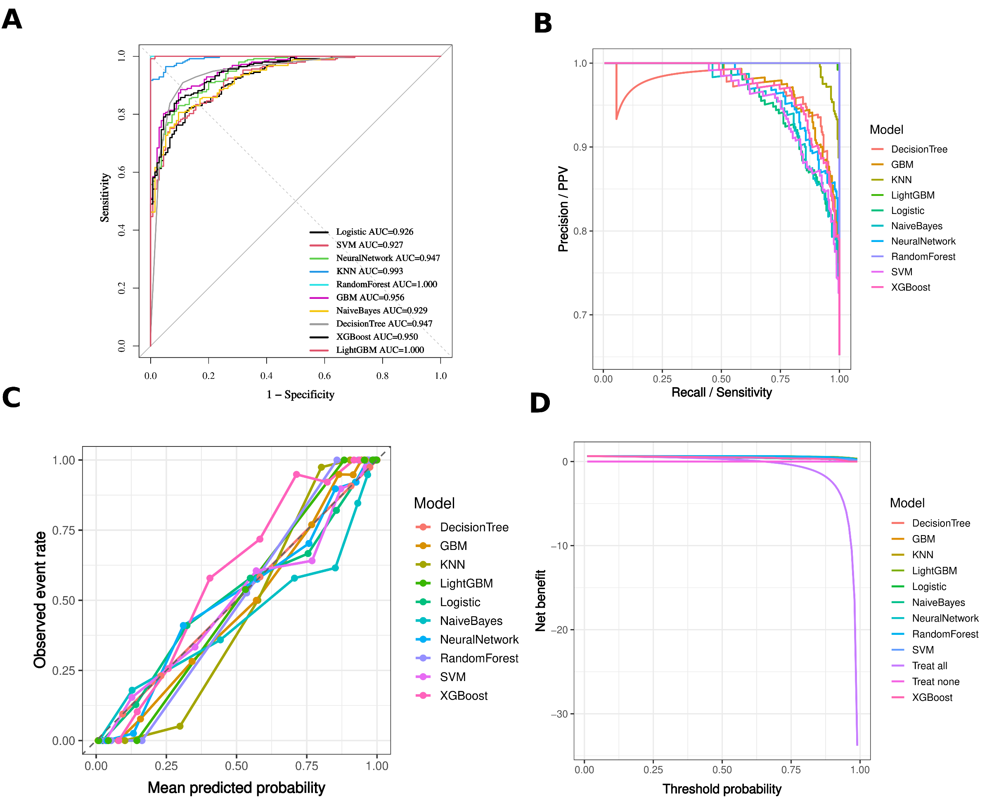
Supplementary Figure S1. Training-cohort curves for 1-week functional recovery.
(A) ROC curve. (B) Precision-recall curve. (C) Calibration curve. (D) Decision curve analysis.
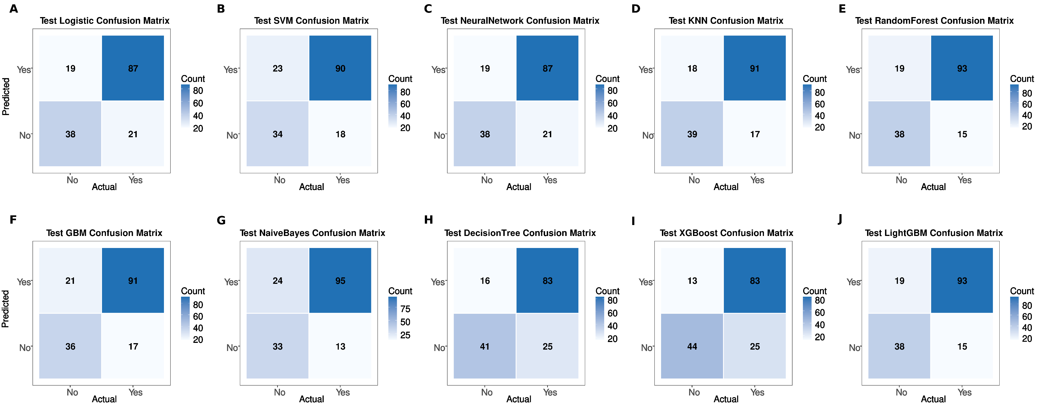
Supplementary Figure S2. Testing-cohort confusion matrices for 1-week functional recovery.
Figures A-J show confusion matrices for the 10 candidate algorithms.

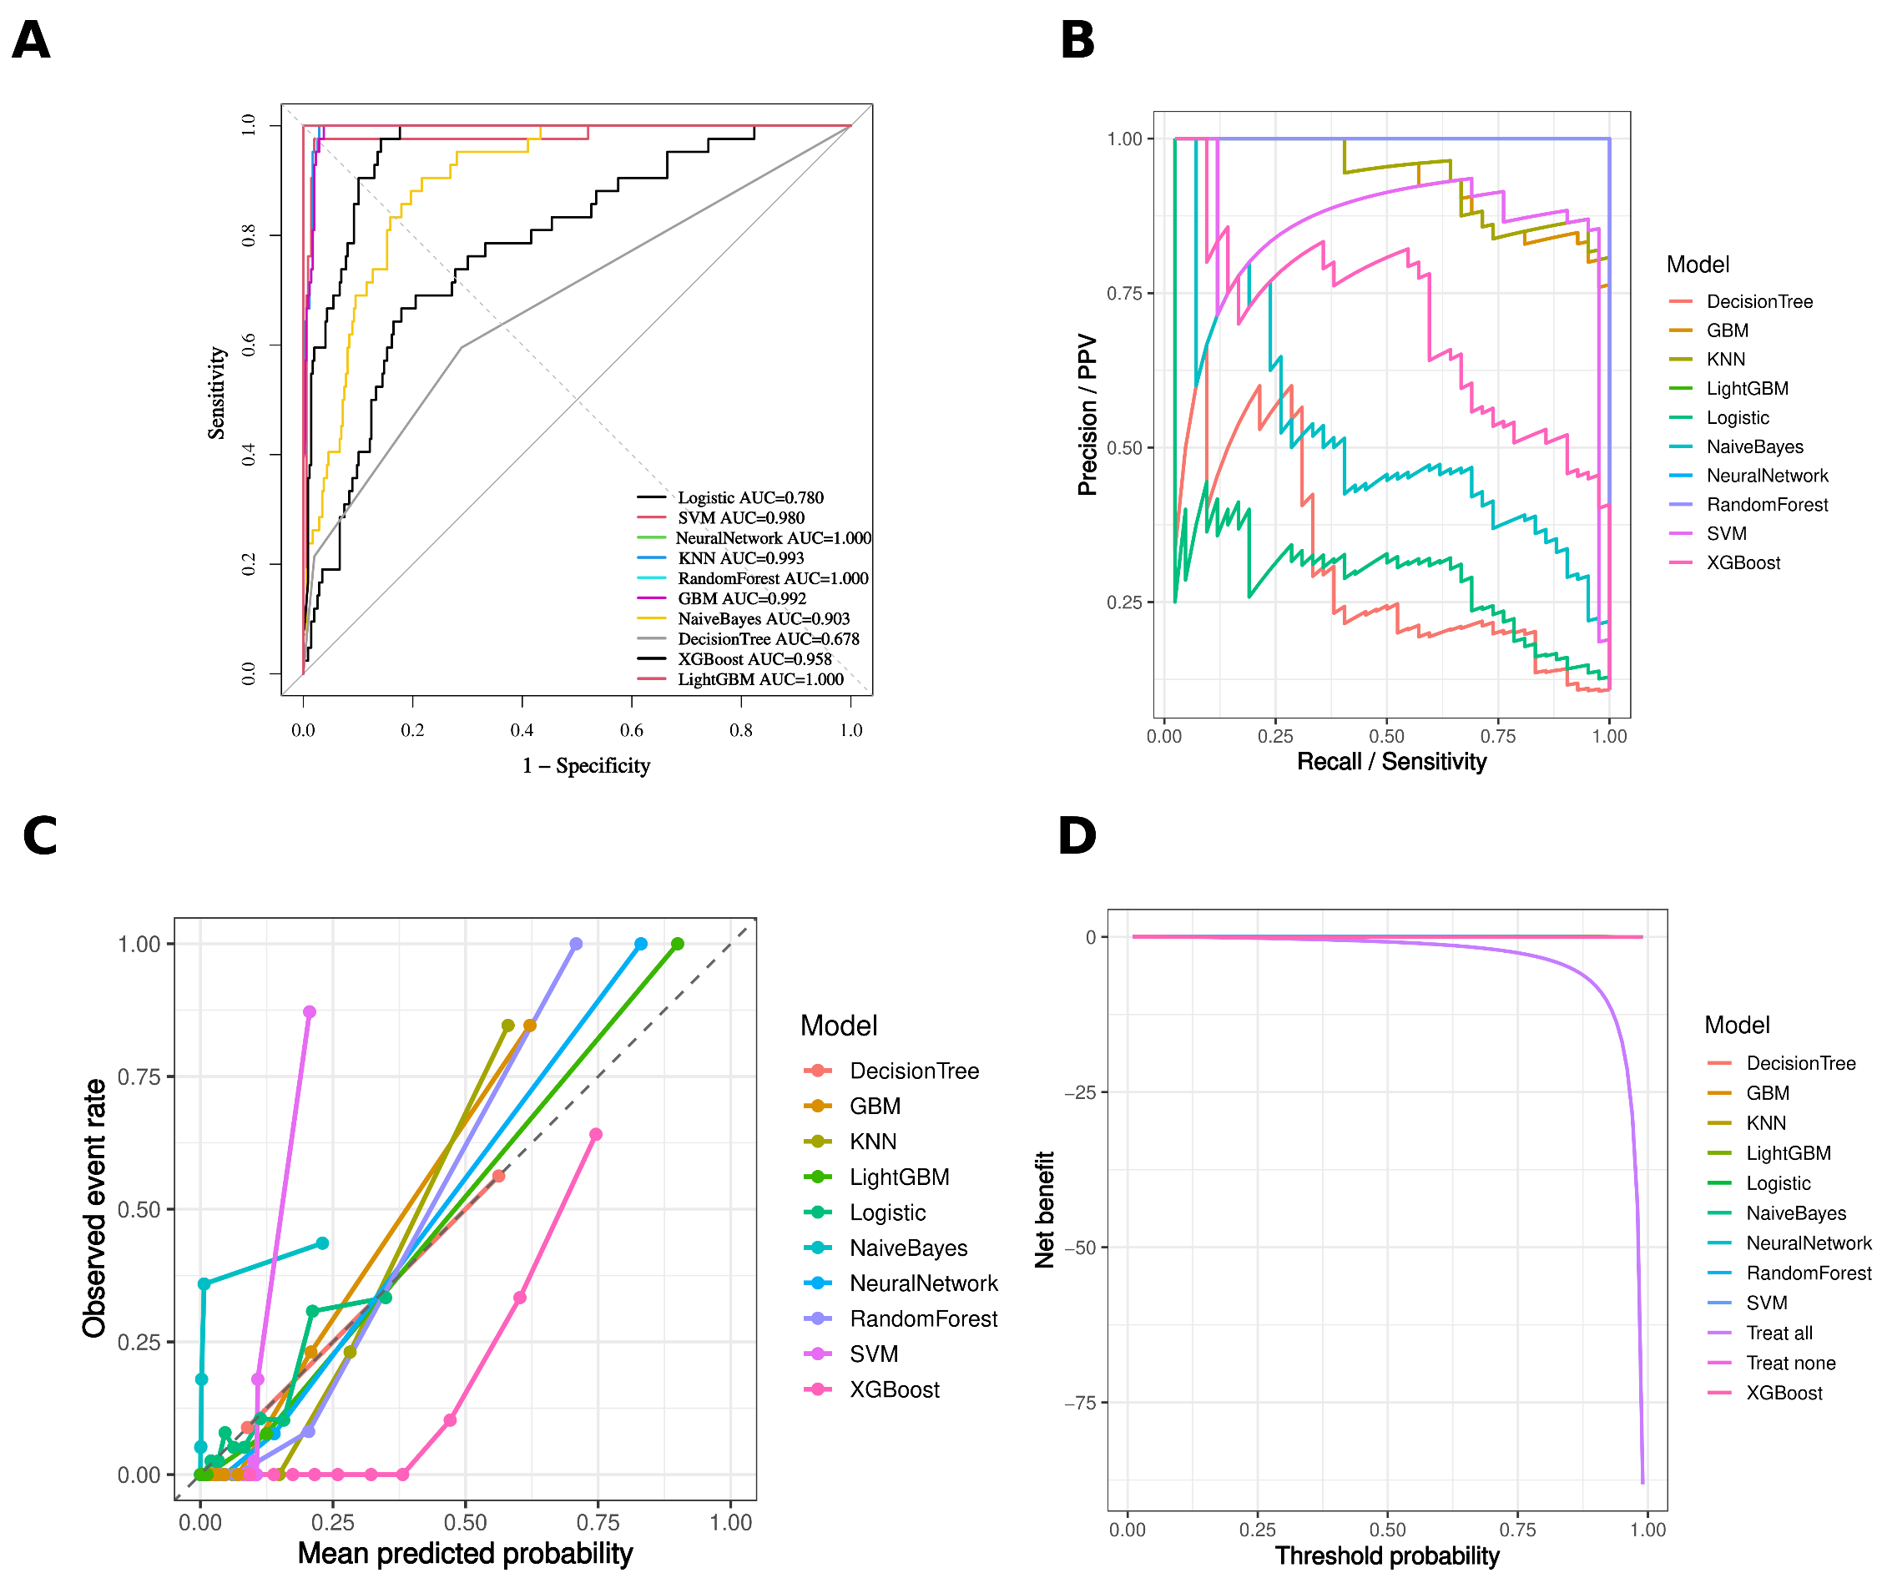
Supplementary Figure S3. Training-cohort curves for 90-day readmission.
(A) ROC curve. (B) Precision-recall curve. (C) Calibration curve. (D) Decision curve analysis.

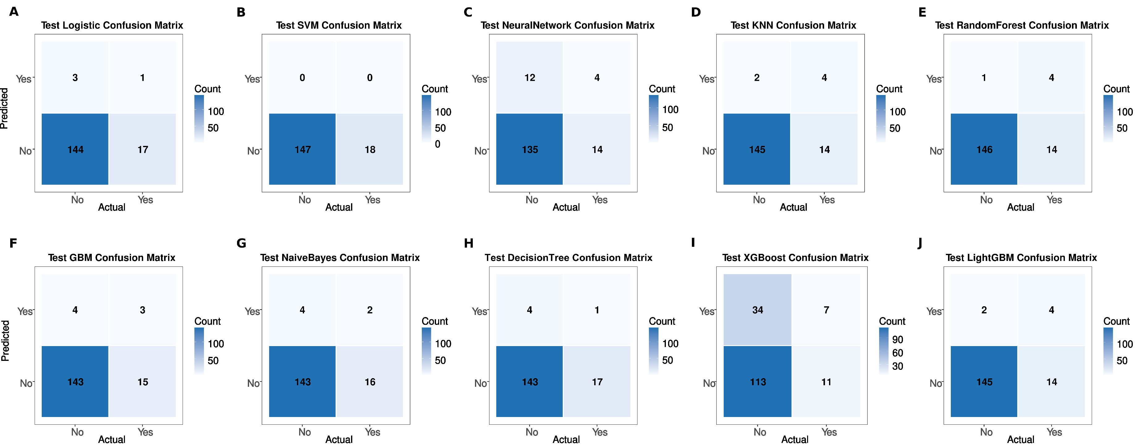
Supplementary Figure S4. Testing-cohort confusion matrices for 90-day readmission.
Figures A-J show confusion matrices for the 10 candidate algorithms.

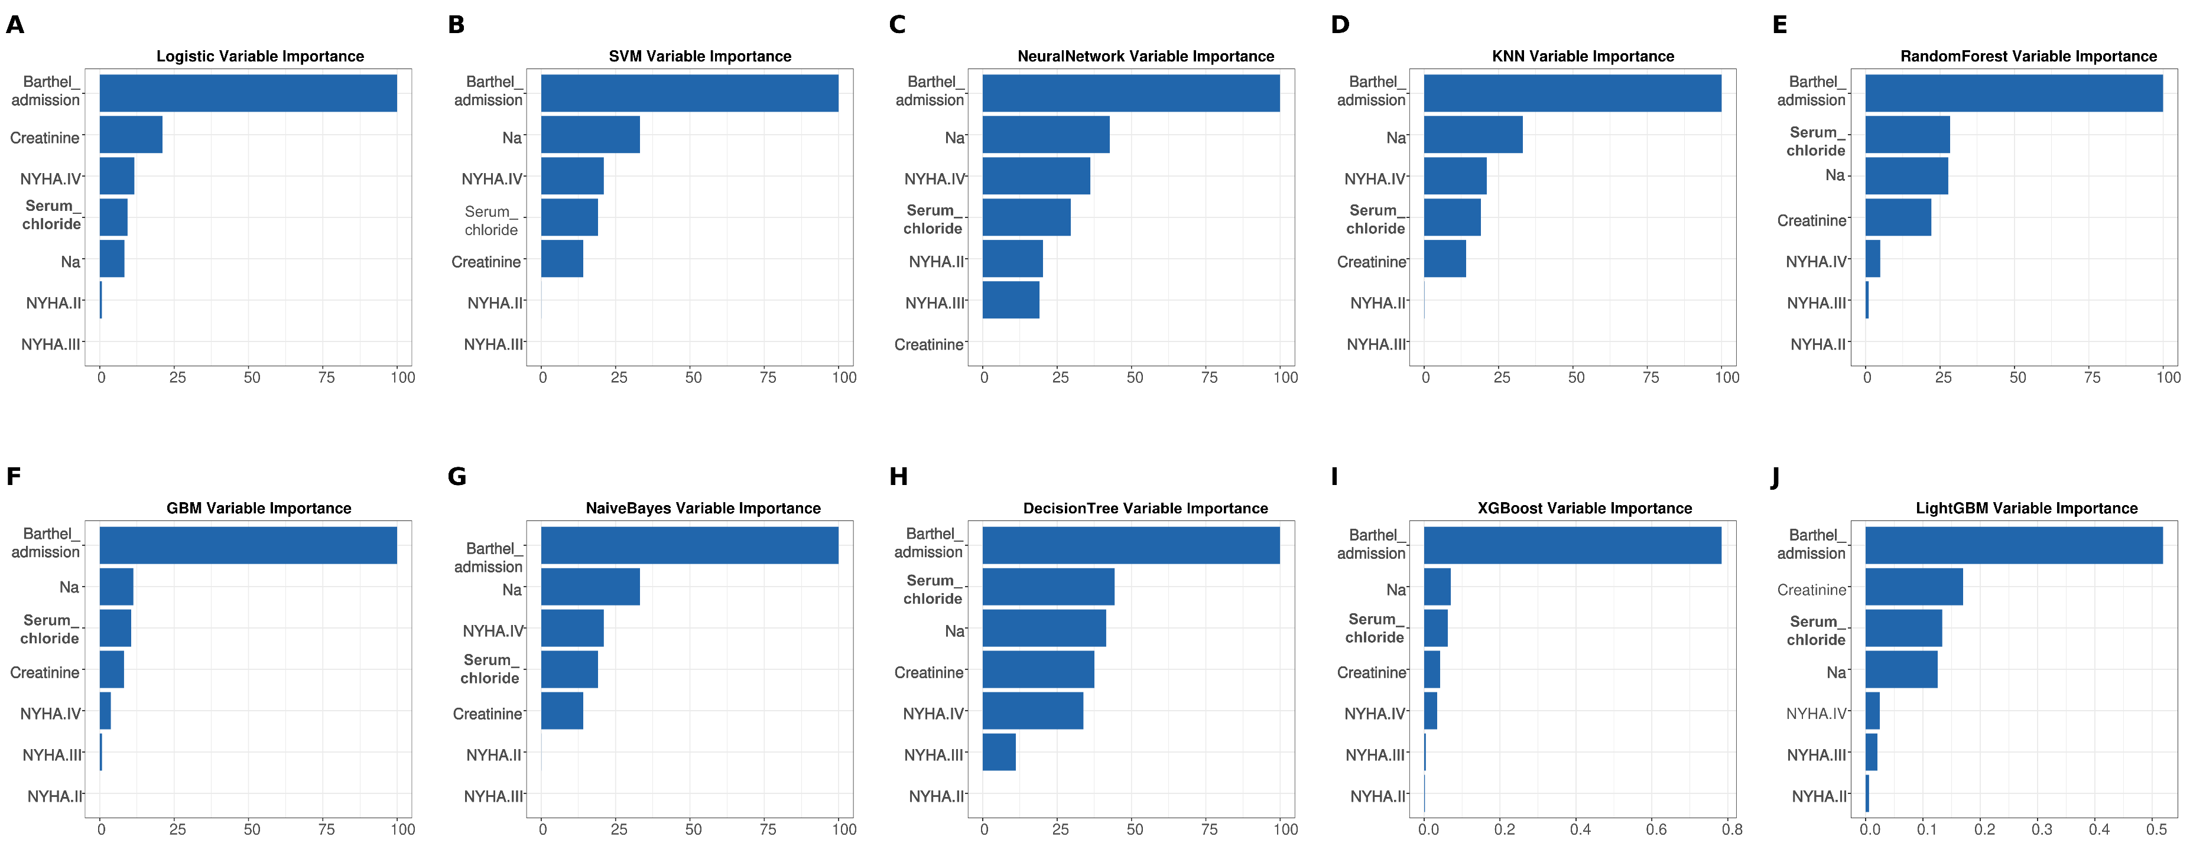
Supplementary Figure S5. Model-specific importance plots for 1-week functional recovery.
Figures A-J show model-specific importance plots for the 10 candidate algorithms.

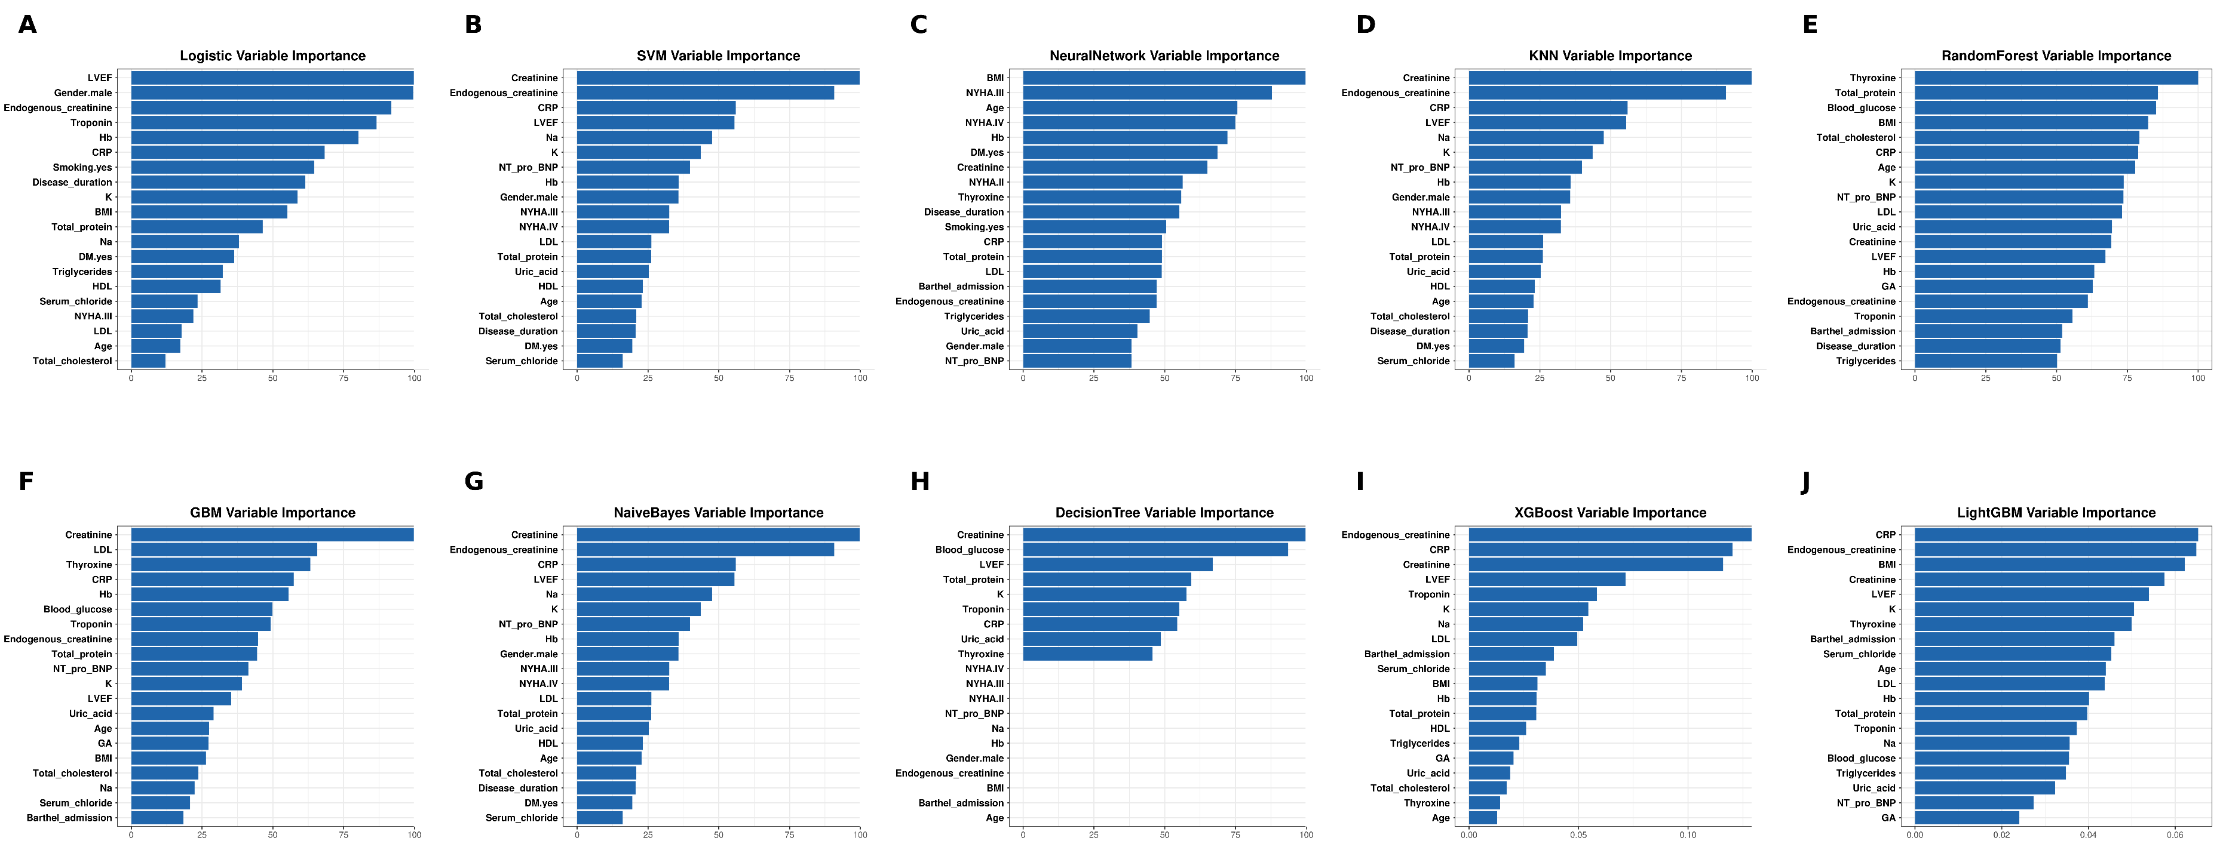
Supplementary Figure S6. Model-specific importance plots for 90-day readmission.
Figures A-J show model-specific importance plots for the 10 candidate algorithms.

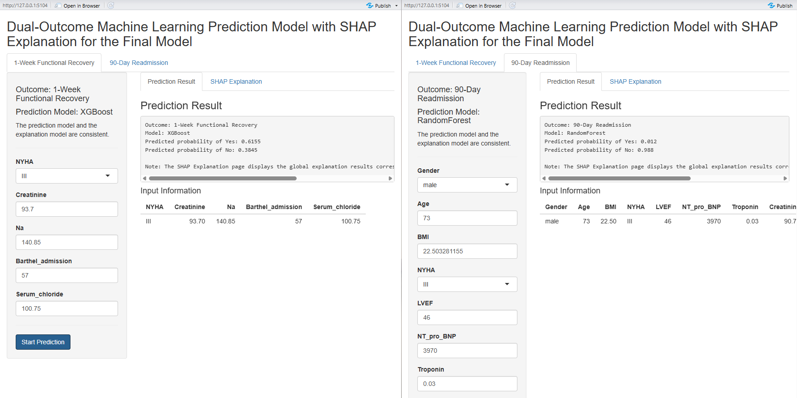
Supplementary Figure S7. Web-based risk calculator.
The Shiny-based calculator provides individualized predictions for 1-week functional recovery and 90-day readmission, with SHAP-based interpretation outputs. The figure shows the local Shiny prototype interface used for individualized probability estimation and SHAP-based interpretation during model development.

