Supplementary Material
Metabolic Dysfunction Outweighs Inflammatory Burden in Association with Hyperuricemia: A Cross-Sectional Study in a Large Health Examination Cohort

Supplementary Tables
Supplementary Table S1. Comparison of participants included in and excluded from the TyG analysis
Variable | Included in TyG analysis (n = 4,193) | Excluded from TyG analysis (n = 4,240) | P value
Age, years | 47.05 ± 14.60 | 58.76 ± 15.87 | <0.001
Male, n (%) | 2369 (56.5%) | 2393 (56.4%) | 0.973
Uric acid, µmol/L | 339.07 ± 84.84 | 334.53 ± 79.09 | 0.011
Hyperuricemia, n (%) | 781 (18.6%) | 710 (16.7%) | 0.025
NHR | 41.02 ± 11.45 | 42.05 ± 12.75 | <0.001
Neutrophil proportion, % | 54.28 ± 8.01 | 54.81 ± 8.39 | 0.003
HDL cholesterol, mmol/L | 1.39 ± 0.32 | 1.38 ± 0.33 | 0.168
Alanine aminotransferase, U/L | 23.90 ± 18.63 | 22.95 ± 16.94 | 0.014
Aspartate aminotransferase, U/L | 22.70 ± 8.94 | 23.35 ± 9.11 | 0.001
Creatinine, µmol/L | 71.05 ± 15.30 | 70.92 ± 17.35 | 0.712
Blood urea nitrogen, mmol/L | 5.10 ± 1.27 | 5.64 ± 1.58 | <0.001
White blood cell count, ×10⁹/L | 6.13 ± 1.55 | 6.18 ± 1.61 | 0.144
Hemoglobin, g/L | 144.81 ± 14.88 | 144.97 ± 14.86 | 0.617
Platelet count, ×10⁹/L | 246.81 ± 59.23 | 236.37 ± 59.54 | <0.001
Total cholesterol, mmol/L | 5.07 ± 0.99 | 5.13 ± 1.13 | 0.008
HbA1c, % | 5.74 ± 0.35 | 6.27 ± 1.03 | <0.001
LDL cholesterol, mmol/L | 3.17 ± 0.74 | 3.15 ± 0.90 | 0.560

Supplementary Table S2. Sex- and age-stratified associations of NHR and TyG with hyperuricemia
Exposure | Stratifier | Group | n | HUA cases | OR (95% CI) | P value | P for interaction
NHR, per 1-SD | Sex | Male | 4517 | 980 | 1.11 (1.03-1.20) | 0.008 | <0.001
NHR, per 1-SD | Sex | Female | 3442 | 418 | 1.40 (1.22-1.60) | <0.001 | <0.001
NHR, per 1-SD | Age | <60 years | 4299 | 820 | 1.17 (1.06-1.29) | 0.001 | 0.002
NHR, per 1-SD | Age | ≥60 years | 3660 | 578 | 1.15 (1.05-1.27) | 0.004 | 0.002
TyG, per 1-SD | Sex | Male | 2369 | 616 | 1.49 (1.34-1.66) | <0.001 | <0.001
TyG, per 1-SD | Sex | Female | 1824 | 165 | 2.04 (1.66-2.52) | <0.001 | <0.001
TyG, per 1-SD | Age | <60 years | 3138 | 611 | 1.53 (1.37-1.71) | <0.001 | 0.230
TyG, per 1-SD | Age | ≥60 years | 1055 | 170 | 1.93 (1.58-2.36) | <0.001 | 0.230

Supplementary Table S3. Sensitivity analysis using eGFR category
Exposure | Sensitivity model with eGFR category OR (95% CI) | P value
NHR, per 1-SD | 1.16 (1.08-1.23) | <0.001
TyG, per 1-SD | 1.59 (1.45-1.75) | <0.001

Supplementary Figures
Supplementary Figure S1. Sex-stratified restricted cubic spline analysis of the association between NHR and hyperuricemia.
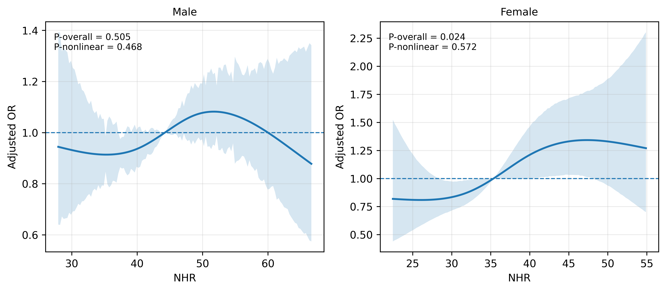

Supplementary Figure S2. Sex-stratified restricted cubic spline analysis of the association between TyG index and hyperuricemia.
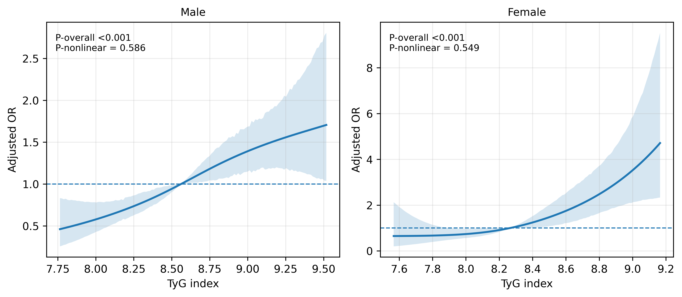

Supplementary Figure S3. Age-stratified restricted cubic spline analysis of the association between NHR and hyperuricemia.
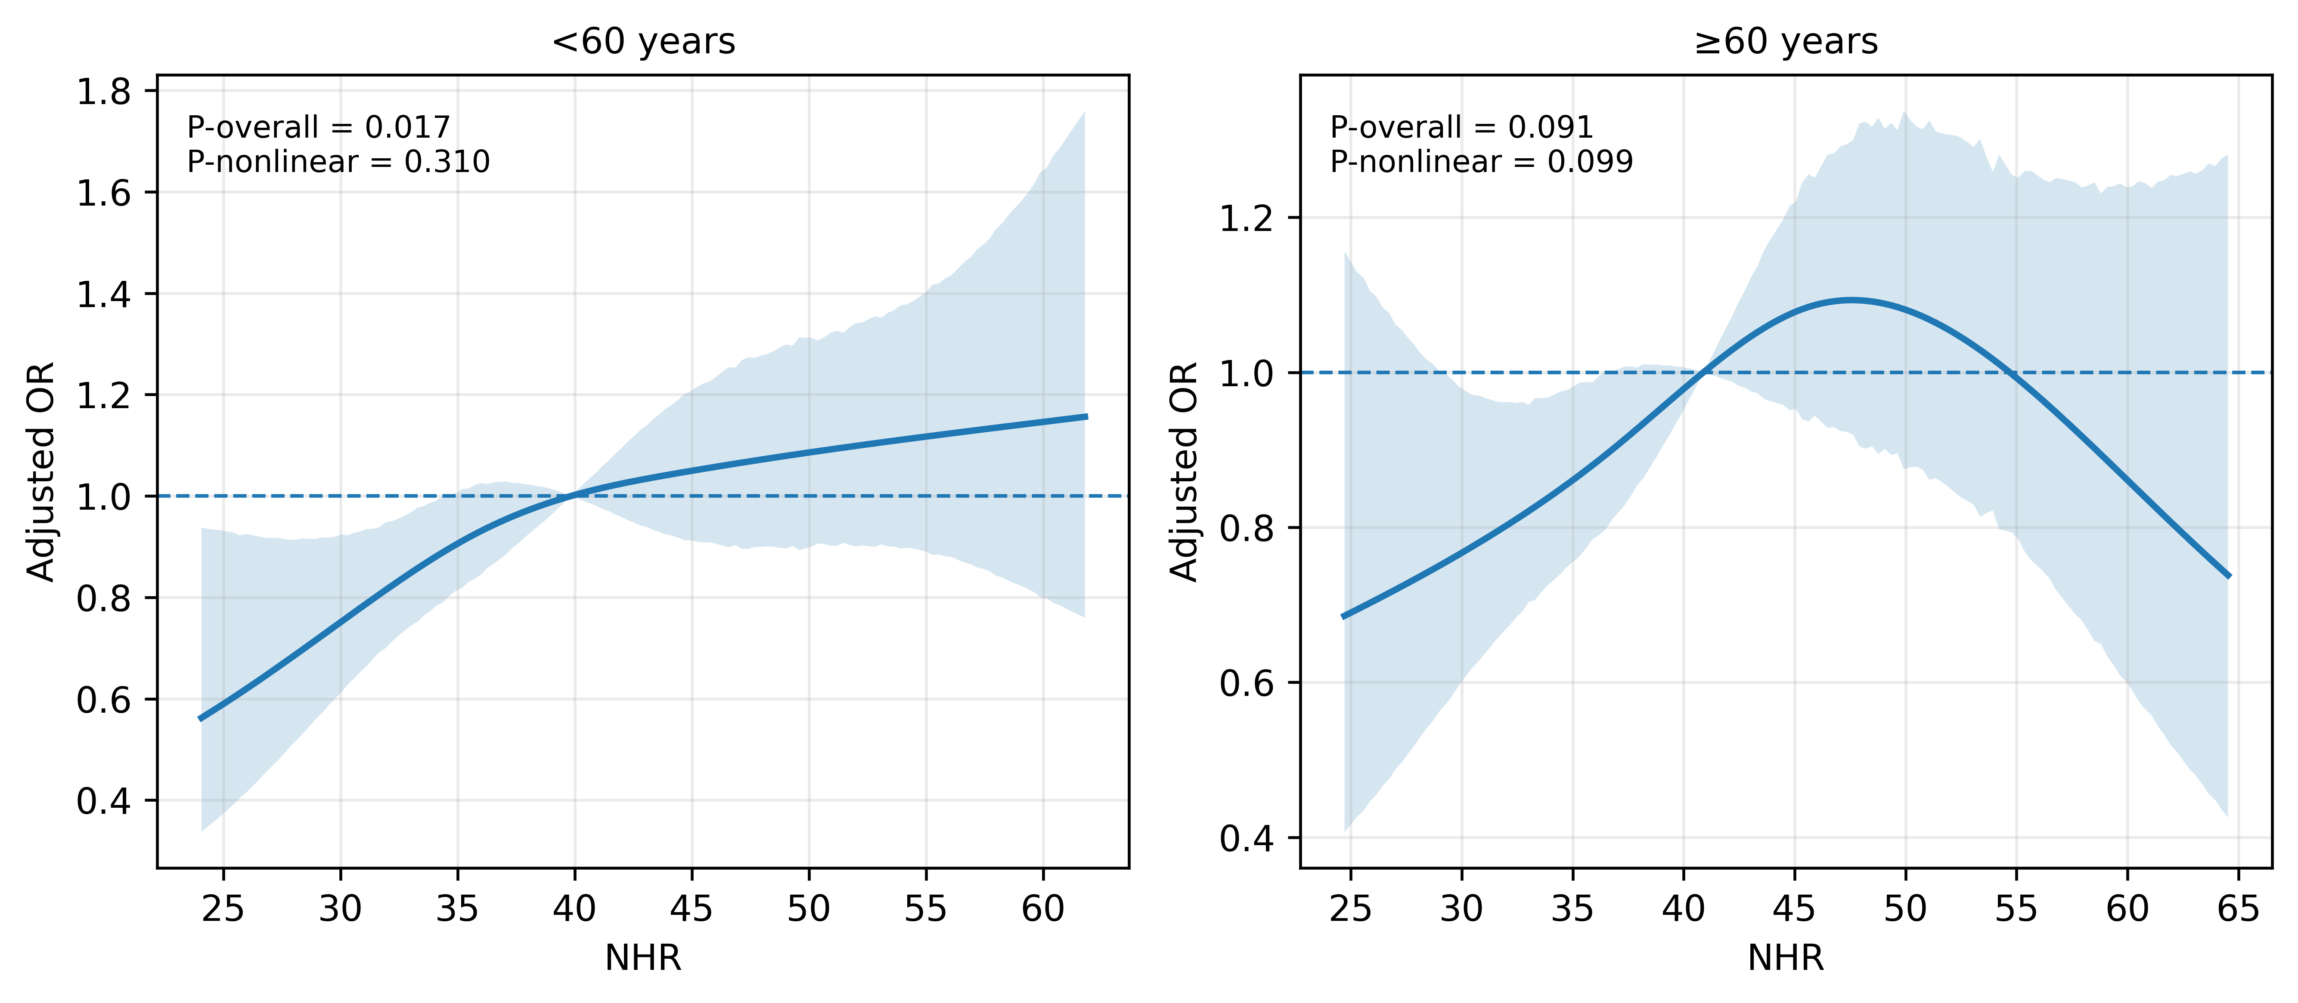

Supplementary Figure S4. Age-stratified restricted cubic spline analysis of the association between TyG index and hyperuricemia.
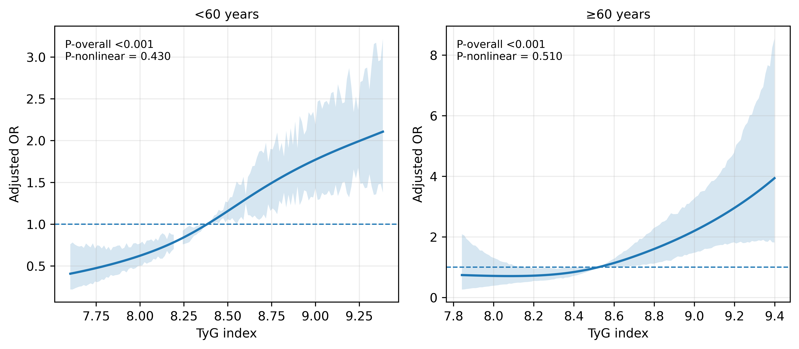

Supplementary Figure Legends
Supplementary Figure S1. Sex-stratified restricted cubic spline analysis of the association between NHR and hyperuricemia.
Restricted cubic spline curves for NHR were fitted separately in men and women. Analyses were conducted in the NHR analysis cohort (n = 7,959). Models were adjusted for age, alanine aminotransferase, aspartate aminotransferase, creatinine, blood urea nitrogen, white blood cell count, hemoglobin, and platelet count.
Supplementary Figure S2. Sex-stratified restricted cubic spline analysis of the association between TyG index and hyperuricemia.
Restricted cubic spline curves for TyG were fitted separately in men and women. Analyses were conducted in the metabolic subcohort with complete triglyceride and fasting glucose data (n = 4,193). Models were adjusted for age, alanine aminotransferase, aspartate aminotransferase, creatinine, blood urea nitrogen, white blood cell count, hemoglobin, and platelet count.
Supplementary Figure S3. Age-stratified restricted cubic spline analysis of the association between NHR and hyperuricemia.
Restricted cubic spline curves for NHR were fitted separately in participants aged <60 and ≥60 years. Analyses were conducted in the NHR analysis cohort (n = 7,959). Models were adjusted for age, sex, alanine aminotransferase, aspartate aminotransferase, creatinine, blood urea nitrogen, white blood cell count, hemoglobin, and platelet count.
Supplementary Figure S4. Age-stratified restricted cubic spline analysis of the association between TyG index and hyperuricemia.
Restricted cubic spline curves for TyG were fitted separately in participants aged <60 and ≥60 years. Analyses were conducted in the metabolic subcohort with complete triglyceride and fasting glucose data (n = 4,193). Models were adjusted for age, sex, alanine aminotransferase, aspartate aminotransferase, creatinine, blood urea nitrogen, white blood cell count, hemoglobin, and platelet count.

