Supplementary Table 1. Excluded variables with missing rate >30%
Excluded Variables | Missing Rate (%)
LDL-C (mmol/L) | 36.08
HDL-C (mmol/L) | 36.17
hs-cTnI (ng/mL) | 55.24
CK-MB (U/L) | 87.16
Myoglobin (ng/mL) | 34.73
FBG (mmol/L) | 55.61
HbA1c (%) | 77.18
eGFR (mL/min/1.73m²) | 84.13
Cystatin C (mg/L) | 73.11
LDH (U/L) | 78.36
GGT (U/L) | 43.79
TBA (μmol/L) | 55.16
Mg (mmol/L) | 44.17
Abbreviations: LDL-C, low-density lipoprotein cholesterol; HDL-C, high-density lipoprotein cholesterol; hs-cTnI, high-sensitivity cardiac troponin I; CK-MB, creatine kinase-MB; FBG, fasting blood glucose; HbA1c, glycated hemoglobin; eGFR, estimated glomerular filtration rate; LDH, lactate dehydrogenase; GGT, gamma-glutamyl transferase; TBA, total bile acid; Mg, magnesium.

Supplementary Table 2. Imputation results for variables with missing rate below 30% in the training set
Variables | Before interpolation | After interpolation | P value
Pulse rate (beats/min) | 88 (77, 100) | 88 (77, 100) | 0.939
SBP (mmHg) | 131 (120, 143) | 131 (120, 143) | 0.945
DBP (mmHg) | 78 (70, 87) | 78 (70, 87) | 0.792
TC (mmol/L) | 3.98 (3.33, 4.67) | 3.98 (3.32, 4.67) | 0.803
TG (mmol/L) | 0.95 (0.72, 1.3) | 0.94 (0.72, 1.29) | 0.412
PT (s) | 13.2 (12.5, 14) | 13.1 (12.5, 14) | 0.851
FIB (g/L) | 3.88 (3.12, 4.97) | 3.88 (3.12, 4.97) | 0.984
D-D (mg/L) | 0.36 (0.22, 0.67) | 0.36 (0.22, 0.67) | 0.898
PLT count (×10^9/L) | 194 (153, 245) | 194 (153, 245) | 0.898
WBC count (×10^9/L) | 7.3 (5.6, 9.6) | 7.3 (5.6, 9.7) | 0.538
NEUT count (×10^9/L) | 5.36 (3.82, 7.83) | 5.38 (3.85, 7.82) | 0.713
LYM count (×10^9/L) | 1 (0.69, 1.4) | 1.01 (0.69, 1.42) | 0.225
MONO count (×10^9/L) | 0.47 (0.35, 0.64) | 0.47 (0.35, 0.64) | 0.522
CRP (mg/L) | 5.62 (1.26, 23.2) | 5.32 (1.1, 21.79) | 0.028
BUN (mmol/L) | 2.46 (1.92, 3.17) | 2.46 (1.92, 3.17) | 0.998
CREA (μmol/L) | 69 (58, 85) | 69 (58, 85) | 0.894
UA (μmol/L) | 324 (259, 398) | 324 (259, 398) | 0.980
DBIL (μmol/L) | 4.13 (3, 5.9) | 4.1 (3, 5.9) | 0.923
ALB (g/L) | 38.54 (35.58, 41.26) | 38.57 (35.59, 41.27) | 0.856
PAB (mg/L) | 177.58 (129.54, 222.6) | 177.42 (129.24, 222.37) | 0.759
K⁺ (mmol/L) | 3.82 (3.5, 4.14) | 3.82 (3.5, 4.14) | 0.603
P (mmol/L) | 1.06 (0.91, 1.21) | 1.06 (0.9, 1.2) | 0.182
Na⁺ (mmol/L) | 140 (137, 142) | 140 (137, 142) | 0.859
Ca²⁺ (mmol/L) | 2.21 (2.11, 2.3) | 2.21 (2.12, 2.3) | 0.296
Abbreviations: SBP, systolic blood pressure; DBP, diastolic blood pressure; TC, total cholesterol; TG, triglycerides; PT, prothrombin time; FIB, fibrinogen; D-D, D-dimer; PLT, platelet; WBC, white blood cell; NEUT, neutrophil; LYM, lymphocyte; MONO, monocyte; CRP, C-reactive protein; BUN, blood urea nitrogen; CREA, creatinine; UA, uric acid; DBIL, direct bilirubin; ALB, albumin; PAB, prealbumin; K⁺, potassium; P, phosphorus; Na⁺, sodium; Ca²⁺, calcium.

Supplementary Table 3. Imputation results for variables with missing rate below 30% in the validation set
Variables | Before interpolation | After interpolation | P value
Pulse rate (beats/min) | 87 (77, 100) | 87 (77, 100) | 0.971
SBP (mmHg) | 130 (120, 142) | 130 (120, 142) | 0.899
DBP (mmHg) | 78 (70, 86) | 78 (70, 86) | 0.932
TC (mmol/L) | 4.01 (3.36, 4.67) | 4 (3.35, 4.66) | 0.748
TG (mmol/L) | 0.94 (0.72, 1.29) | 0.94 (0.72, 1.29) | 0.901
PT (s) | 13.1 (12.5, 13.9) | 13.1 (12.5, 13.9) | 0.940
FIB (g/L) | 3.88 (3.12, 4.97) | 3.89 (3.13, 4.97) | 0.702
D-D (mg/L) | 0.35 (0.21, 0.64) | 0.35 (0.2, 0.63) | 0.280
PLT count (×10^9/L) | 192 (153, 241) | 193 (153, 241) | 0.841
WBC count (×10^9/L) | 7.3 (5.6, 9.7) | 7.3 (5.6, 9.7) | 0.925
NEUT count (×10^9/L) | 5.38 (3.86, 7.81) | 5.37 (3.85, 7.82) | 0.975
LYM count (×10^9/L) | 1.02 (0.7, 1.42) | 1.02 (0.7, 1.42) | 0.866
MONO count (×10^9/L) | 0.47 (0.35, 0.64) | 0.47 (0.35, 0.64) | 0.951
CRP (mg/L) | 5.24 (1.11, 21.07) | 5.04 (0.89, 19.79) | 0.132
BUN (mmol/L) | 2.5 (1.92, 3.21) | 2.5 (1.92, 3.17) | 0.747
CREA (μmol/L) | 70 (58, 85) | 70 (58, 85) | 0.986
UA (μmol/L) | 325 (261, 395) | 325 (260, 395) | 0.923
DBIL (μmol/L) | 4.1 (3, 5.8) | 4.1 (3, 5.8) | 0.772
ALB (g/L) | 38.49 (35.7, 41.24) | 38.49 (35.7, 41.24) | 0.932
PAB (mg/L) | 181.13 (133.56, 228.25) | 181.44 (133.59, 228.44) | 0.916
K⁺ (mmol/L) | 3.81 (3.5, 4.14) | 3.82 (3.5, 4.14) | 0.667
P (mmol/L) | 1.05 (0.91, 1.2) | 1.05 (0.9, 1.2) | 0.574
Na⁺ (mmol/L) | 140 (137.6, 142) | 140 (137.7, 142) | 0.858
Ca²⁺ (mmol/L) | 2.21 (2.11, 2.3) | 2.21 (2.11, 2.3) | 0.561
Abbreviations: SBP, systolic blood pressure; DBP, diastolic blood pressure; TC, total cholesterol; TG, triglycerides; PT, prothrombin time; FIB, fibrinogen; D-D, D-dimer; PLT, platelet; WBC, white blood cell; NEUT, neutrophil; LYM, lymphocyte; MONO, monocyte; CRP, C-reactive protein; BUN, blood urea nitrogen; CREA, creatinine; UA, uric acid; DBIL, direct bilirubin; ALB, albumin; PAB, prealbumin; K⁺, potassium; P, phosphorus; Na⁺, sodium; Ca²⁺, calcium.

Supplementary Table 4. Variance inflation factor (VIF) and tolerance for all candidate variables prior to LASSO regression
Variables | VIF (before) | Tolerance (before) | VIF (after) | Tolerance (after)
Age (years) | 1.259 | 0.794 | 1.258 | 0.795
Gender | 1.702 | 0.588 | 1.701 | 0.588
Marital status | 1.033 | 0.968 | 1.033 | 0.968
Smoking history | 1.704 | 0.587 | 1.704 | 0.587
Drinking history | 1.176 | 0.850 | 1.176 | 0.850
Surgical history | 1.010 | 0.990 | 1.010 | 0.990
Hypertension | 1.222 | 0.818 | 1.222 | 0.818
Diabetes | 1.086 | 0.921 | 1.085 | 0.922
Chronic gastritis | 1.024 | 0.977 | 1.024 | 0.977
Hypokalemia | 1.271 | 0.787 | 1.271 | 0.787
Pulse rate (beats/min) | 1.227 | 0.815 | 1.226 | 0.816
SBP (mmHg) | 1.937 | 0.516 | 1.937 | 0.516
DBP (mmHg) | 1.801 | 0.555 | 1.800 | 0.556
TC (mmol/L) | 1.417 | 0.706 | 1.419 | 0.705
TG (mmol/L) | 1.285 | 0.778 | 1.302 | 0.768
PT (s) | 1.116 | 0.896 | 1.115 | 0.897
FIB (g/L) | 1.828 | 0.547 | 1.826 | 0.548
D-D (mg/L) | 1.109 | 0.902 | 1.106 | 0.904
PLT count (×10^9/L) | 1.244 | 0.804 | 1.243 | 0.804
WBC count (×10^9/L) | 52.453 | 0.019 | — (excluded) | —
NEUT count (×10^9/L) | 28.378 | 0.035 | 1.608 | 0.622
LYM count (×10^9/L) | 20.872 | 0.048 | 1.105 | 0.905
MONO count (×10^9/L) | 1.884 | 0.531 | 1.357 | 0.737
CRP (mg/L) | 1.694 | 0.590 | 1.693 | 0.591
BUN (mmol/L) | 2.251 | 0.444 | 2.250 | 0.445
CREA (μmol/L) | 1.869 | 0.535 | 1.869 | 0.535
UA (μmol/L) | 1.378 | 0.726 | 1.378 | 0.726
DBIL (μmol/L) | 1.055 | 0.948 | 1.055 | 0.947
ALB (g/L) | 1.836 | 0.545 | 1.835 | 0.545
PAB (mg/L) | 2.194 | 0.456 | 2.190 | 0.457
K⁺ (mmol/L) | 1.521 | 0.657 | 1.520 | 0.658
P (mmol/L) | 1.372 | 0.729 | 1.371 | 0.729
Na⁺ (mmol/L) | 1.146 | 0.873 | 1.145 | 0.874
Ca²⁺ (mmol/L) | 1.404 | 0.712 | 1.404 | 0.712
Abbreviations: VIF, variance inflation factor; SBP, systolic blood pressure; DBP, diastolic blood pressure; TC, total cholesterol; TG, triglycerides; PT, prothrombin time; FIB, fibrinogen; D-D, D-dimer; PLT, platelet; WBC, white blood cell; NEUT, neutrophil; LYM, lymphocyte; MONO, monocyte; CRP, C-reactive protein; BUN, blood urea nitrogen; CREA, creatinine; UA, uric acid; DBIL, direct bilirubin; ALB, albumin; PAB, prealbumin; K⁺, potassium; P, phosphorus; Na⁺, sodium; Ca²⁺, calcium.

Supplementary Table 5. Optimal hyperparameters of the XGBoost model
Hyperparameter | Optimal value
n_estimators | 500
max_depth | 7
min_child_weight | 5
learning_rate | 0.01
subsample | 0.8
colsample_bytree | 1.0
gamma | 0.2
random_state | 42
reg_lambda | 0.2

Supplementary Table 6. Sensitivity analysis comparing complete-case analysis versus imputed datasets
Setting | Model | Complete-Case AUC | Imputed AUC | Difference
Training set | XGBoost | 0.862 | 0.871 | -0.009
 | KNN | 0.736 | 0.741 | -0.005
 | GBDT | 0.845 | 0.857 | -0.012
 | ANN | 0.741 | 0.750 | -0.009
 | RF | 0.755 | 0.773 | -0.018
 | LR | 0.735 | 0.737 | -0.002
 | DT | 0.714 | 0.721 | -0.007
 | SVM | 0.779 | 0.789 | -0.010
 | LightGBM | 0.782 | 0.803 | -0.021
Validation set | XGBoost | 0.734 | 0.743 | -0.009
 | KNN | 0.725 | 0.730 | -0.005
 | GBDT | 0.729 | 0.741 | -0.012
 | ANN | 0.728 | 0.736 | -0.008
 | RF | 0.736 | 0.738 | -0.002
 | LR | 0.733 | 0.736 | -0.003
 | DT | 0.695 | 0.708 | -0.013
 | SVM | 0.731 | 0.734 | -0.003
 | LightGBM | 0.734 | 0.740 | -0.006
Abbreviations: AUC, area under the ROC curve; XGBoost, extreme Gradient Boosting; KNN, K-nearest Neighbors; GBDT, gradient boosting decision tree; ANN, artificial neural network; RF, random forest; LR, logistic regression; DT, decision tree; SVM, support vector machine; LightGBM, light gradient boosting machine.

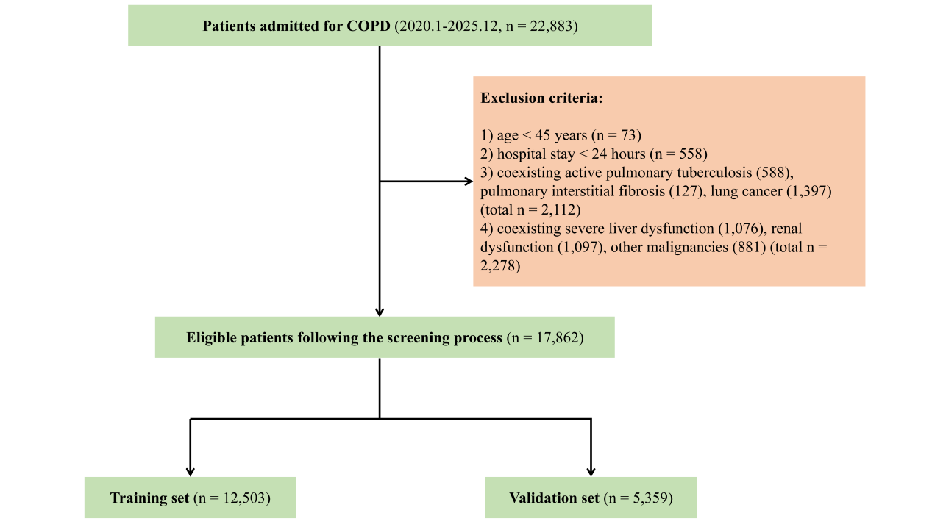
Supplementary Figure 1. Patient selection and data partitioning workflow

