Supplementary Materials
Supplementary Table S1a: Demographic information of Mammary Hyperplasia patients
Clinical and demographic characteristics of five mammary hyperplasia patients, including Sample Id, Age ,Clinical Features.
Sample Id | Age | Clinical Features
40480 | 37 | Mammary hyperplasia with focal ductal epithelial hyperplasia showing cribriform pattern and partial apocrine metaplasia.
39302 | 43 | Mammary hyperplasia with fibroadenoma formation and focal ductal epithelial hyperplasia.
39282 | 41 | Mammary hyperplasia with intraductal papilloma formation.
39262 | 37 | Mammary hyperplasia, stromal hyperplasia, hyalinization, and focal glandular hyperplasia.
39202 | 46 | Mammary hyperplasia

Supplementary Table S1b:Demographic information of Breast Cancer patients
Clinical and demographic characteristics of five mammary Breast Cancer patients, including Sample Id, Age ,Tumor Type, Tumor Type,Clinical Features.
Sample Id | Age | Tumor Type | Tumor Type | Clinical Features
37659 | 43 | Invasive breast cancer | Grade 2 | No tumor at base resection margin, no tumor in nipple, no axillary metastasis.
37136 | 53 | Invasive breast cancer | Grade 2 | No tumor at base resection margin, no tumor in nipple, no axillary metastasis.
38293 | 43 | Invasive breast cancer | Grade 2 | No tumor at base resection margin, tumor in subcutaneous nipple, axillary metastasis.
38642 | 59 | Invasive breast cancer | Grade 2 | No tumor at base resection margin, no tumor in nipple, axillary metastasis.
36564 | 48 | Invasive breast cancer | Grade 2 | No definite nerve invasion, tumor thrombus in blood vessels.

Supplementary Table S2: Instrumental variables (8 SNPs, P < 5 × 10⁻⁶) for Seipin on Breast Cancer (ieu-a-1135) in mendelian randomization analysis
Eight single nucleotide polymorphisms (SNPs) selected as instrumental variables (IVs) at the genome-wide significance threshold of P < 5 × 10⁻⁶ for the association between Seipin (exposure, eqtl-a-ENSG00000168000) and breast cancer (outcome, ieu-a-1135) in the two-sample Mendelian randomization analysis.
SNPs | CHR | POS | EA | OA | EAF | BETA | SE | P | F-STATISTICS
rs112251597 | 11 | 62767952 | A | G | 0.026 | -0.435 | 0.037 | 0.000 | 136.689
rs117991865 | 11 | 62416859 | A | G | 0.014 | -0.271 | 0.050 | 0.000 | 28.913
rs12272560 | 11 | 62684777 | A | G | 0.039 | -0.350 | 0.031 | 0.000 | 130.357
rs12418135 | 11 | 62556703 | T | G | 0.018 | -0.275 | 0.045 | 0.000 | 38.142
rs148248716 | 11 | 62451457 | T | C | 0.027 | 1.204 | 0.036 | 0.000 | 1142.114
rs78265569 | 1 | 2146165 | A | C | 0.073 | 0.106 | 0.023 | 0.000 | 21.392
rs79678172 | 11 | 62609779 | A | G | 0.024 | 0.507 | 0.039 | 0.000 | 172.723
rs826415 | 1 | 118153977 | G | T | 0.308 | 0.065 | 0.013 | 0.000 | 25.492
Abbreviations: CHR, chromosome; POS, position; EA, effect allele; OA, other allele; EAF, effect allele frequency; BETA, beta coefficient; SE, standard error, F-STATISTICS, F-statistic indicating instrument strength. Note: For P values with small magnitudes, three decimal places are reserved.

Supplementary Table S3: Sensitivity analysis of the association between Seipin and Breast Cancer
Results of sensitivity analyses evaluating the robustness of the Mendelian randomization estimate for the causal effect of Seipin (eqtl-a-ENSG00000168000) on breast cancer (ieu-a-1135). Heterogeneity was assessed using Cochran’s Q test (P > 0.05 indicates no significant heterogeneity across IVs). Horizontal pleiotropy was evaluated via the MR-Egger intercept test (P > 0.05 indicates no directional pleiotropy). MR-PRESSO global test was performed to detect outlying variants (P > 0.05 indicates no significant pleiotropy). All P-values are non-significant, supporting the validity of the MR assumptions.
Exposure (Seipin) | Outcome (breast cancer) | Heterogeneity (Cochran's Q) | Heterogeneity p-value | Pleiotropy_test (Egger_intercept) | Pleiotropy p-value | MR-PRESSO (RSSobs) | MR-PRESSO p-value
eqtl-a-ENSG00000168000 | ieu-a-1135 | 3.962 | 0.682 | -0.007 | 0.663 | 6.045 | 0.759

Supplementary Table S4: Immunohistochemistry grading of Seipin expression in Breast Cancer and Mammary Hyperplasia patient samples
Immunohistochemistry (IHC) grading of Seipin protein expression in breast cancer and mammary hyperplasia tissue samples. For each sample, cells were classified by staining intensity grade (1+, weak; 2+, moderate; 3+, strong). Mean Intensity represents the average cellular mask brightness for each grade. Count indicates the number of cells in each grade category; Percent shows the proportion of cells per grade.
Sample | Sample ID | Grade | Mean Intensity | Count | Percent
Breast  Cancer  Patients | 38642 | 1+ | 12.803 | 933 | 73.35%
Breast  Cancer  Patients | 38642 | 2+ | 20.755 | 333 | 26.18%
Breast  Cancer  Patients | 38642 | 3+ | 30.906 | 3 | 0.24%
Breast  Cancer  Patients | 37136 | 1+ | 10.114 | 548 | 55.92%
Breast  Cancer  Patients | 37136 | 2+ | 23.745 | 175 | 17.86%
Breast  Cancer  Patients | 37136 | 3+ | 40.27 | 254 | 25.92%
Breast  Cancer  Patients | 38293 | 1+ | 6.506 | 985 | 70.97%
Breast  Cancer  Patients | 38293 | 2+ | 23.072 | 382 | 27.52%
Breast  Cancer  Patients | 38293 | 3+ | 32.793 | 21 | 1.51%
Breast  Cancer  Patients | 36564 | 1+ | 13.913 | 886 | 47.56%
Breast  Cancer  Patients | 36564 | 2+ | 22.163 | 870 | 46.70%
Breast  Cancer  Patients | 36564 | 3+ | 36.789 | 107 | 5.74%
Breast  Cancer  Patients | 37659 | 1+ | 9.631 | 652 | 58.01%
Breast  Cancer  Patients | 37659 | 2+ | 24.056 | 280 | 24.91%
Breast  Cancer  Patients | 37659 | 3+ | 35.885 | 191 | 16.99%
Mammary Hyperplasia Patients | 39302 | 1+ | 9.062 | 568 | 35.66%
Mammary Hyperplasia Patients | 39302 | 2+ | 25.635 | 278 | 17.45%
Mammary Hyperplasia Patients | 39302 | 3+ | 38.919 | 740 | 46.45%
Mammary Hyperplasia Patients | 40480 | 1+ | 12.047 | 201 | 14.75%
Mammary Hyperplasia Patients | 40480 | 2+ | 23.498 | 156 | 11.45%
Mammary Hyperplasia Patients | 40480 | 3+ | 55.004 | 1005 | 73.73%
Mammary Hyperplasia Patients | 39202 | 1+ | 12.67 | 101 | 7.77%
Mammary Hyperplasia Patients | 39202 | 2+ | 22.785 | 96 | 7.38%
Mammary Hyperplasia Patients | 39202 | 3+ | 64.766 | 1101 | 84.69%
Mammary Hyperplasia Patients | 39262 | 1+ | 12.925 | 421 | 27.00%
Mammary Hyperplasia Patients | 39262 | 2+ | 24.651 | 375 | 24.05%
Mammary Hyperplasia Patients | 39262 | 3+ | 40.035 | 763 | 48.94%
Mammary Hyperplasia Patients | 39282 | 1+ | 12.489 | 217 | 16.69%
Mammary Hyperplasia Patients | 39282 | 2+ | 23.74 | 176 | 13.54%
Mammary Hyperplasia Patients | 39282 | 3+ | 54.56 | 900 | 69.23%

Supplementary Figure S1: Immunohistochemical negative control staining of mammary hyperplasia tissues

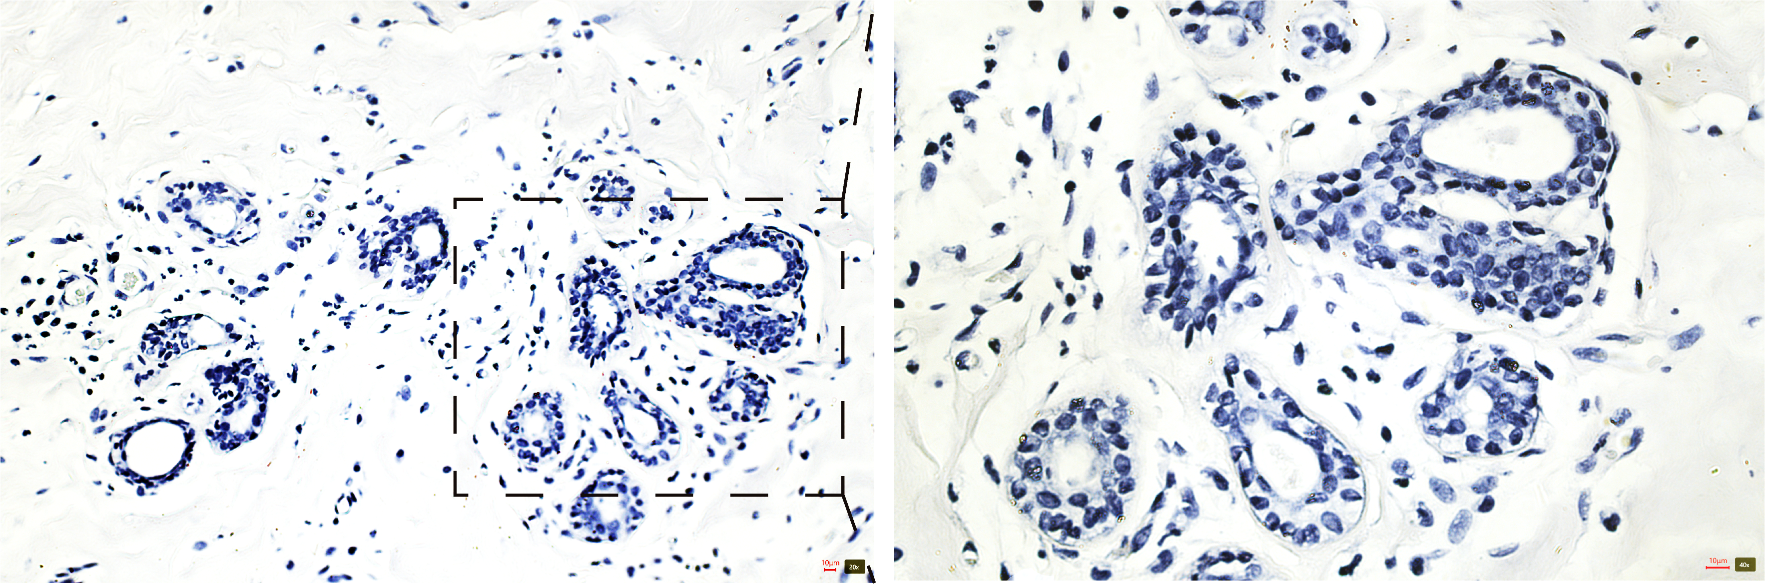
Figure S1. Immunohistochemical negative control staining of mammary hyperplasia tissues.
Negative controls were prepared by omission of the primary antibody. The left panel is captured
at 100× original magnification, and the right panel at 200× original magnification. Scale bars correspond to 10 μm.

