Supplementary File 1 Representative Examination Question Example
Question: A 53-year-old female with a history of hypertension presents to the emergency department with 3 hours of severe, substernal chest pressure accompanied by a choking sensation in the throat. Her vital signs are BP 112/65 mmHg, HR 59 bpm, RR 20/min, O₂sat 96% on room air. The 12-lead ECG is shown below. What is the most likely diagnosis?
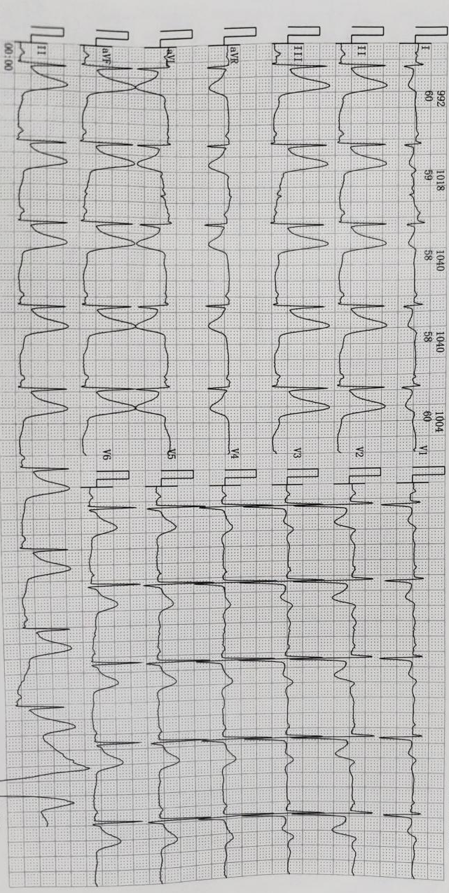
A. Acute pericarditis
B. Inferior ST-elevation myocardial infarction (STEMI)
C. Early repolarization variant
D. Left ventricular hypertrophy with strain pattern

Correct Answer: B. Inferior ST-elevation myocardial infarction (STEMI)
ABCD Classification: Category A (Common Emergency)

Supplementary File 2. Descriptive Raw Accuracy for Categories C and D by Training Year
Group | Category C, % (SD) | Category D, % (SD)
PGY-1 | 48.9 (20.1) | 44.7 (19.5)
PGY-2 | 60.0 (17.3) | 55.6 (16.9)
PGY-3 | 65.5 (15.8) | 72.2 (14.7)
Total | 58.1 (18.9) | 57.5 (21.0)
Note: These accuracy values are descriptive only and are not adjusted for item difficulty, discrimination, or guessing parameters. They cannot be interpreted as valid indicators of resident competency in rare ECG patterns. No statistical tests comparing categories or training years were performed on these data, as such comparisons would be methodologically unsupported in the absence of item calibration.
Content of Categories C and D
For transparency, the ECG findings included in Categories C and D are listed below. These were classified through the expert consensus process described in the main manuscript.
- Category C (Rare Emergencies): Patterns representing life-threatening but infrequently encountered conditions. Examples: Brugada pattern, arrhythmogenic right ventricular cardiomyopathy, hyperkalemia-related ECG changes. These require prompt recognition for emergency management but are uncommon in general internal medicine practice.
- Category D (Rare Non-Emergencies): Patterns that are both infrequent and non-urgent. Examples: left posterior fascicular block, dextrocardia, certain electrolyte abnormality patterns. These do not typically require immediate intervention and are often encountered in specialist consultation.
Item-Level Observation (Reported Solely for Completeness)
Among uncalibrated items in Categories C and D, the lowest descriptive raw accuracy values were observed for Brugada pattern (Category C: 32.2%, 51/158) and left posterior fascicular block (Category D: 29.6%, 47/158). These values reflect a confound of trainee ability and intrinsic item challenge; they should not be interpreted as evidence of knowledge gaps in these specific diagnoses, as the items may have been inherently more difficult. This observation is reported for completeness and may inform hypotheses for future calibrated research.
Implications for Future Research
As stated in the main manuscript, future studies should employ formal psychometric models (e.g., Rasch analysis, Item Response Theory) to calibrate all examination items across the ABCD framework. Once calibrated, Category C and D performance can be meaningfully integrated into the competency assessment. Until then, the data in this file should be regarded solely as documentation of content coverage.
Reference to Main Manuscript
Please refer to the Methods section ("Assessment Tool and Content") and the Limitations section of the main manuscript for a detailed discussion of the two-tiered analytical approach and the interpretive constraints surrounding Categories C and D.

Supplementary Figure 1. Category A Performance Across Multiple Educational Thresholds by Training Year

Supplementary Figure 2. Distribution of Category A Scores by Training Year

