Table S1. Carbapenemase-producing, and biofilm-forming capacity of P. aeruginosa and percentages of their OXA genes related to antibiotics resistance pattern
Biofilm | Carbapenemase-producing strains |  | Antibiotic resistant profiles |  |  |  |  |  |  |  |  |  |  |  |  |  |  |  | p. value
Biofilm | KPC | MBL | C  (n = 0) | CEF  (n = 19) | PIP  (n = 11) | GEN  (n = 41) | AMK  (n = 39) | NOR  (n = 84) | CIP  (n = 89) | CAZ  (n = 21) | CTX  (n = 49) | IMI  (n = 51) | MER  (n = 49) | ERT  (n = 52) | FOX  (n = 92) | CFX  (n = 14) | MDR  (n = 84) | XDR  (n = 39) | p. value
Biofilm | POS  (n = 52) | POS  (n = 47)
Biofilm forming (n = 69, 63.3%) | 52  (100%) | 47  (100%) | 0  (0%) | 19  (100%) | 11  (100%) | 41  (100%) | 39  (100%) | 69  (82.1%) | 69  (77.5%) | 21  (100%) | 49  (100%) | 51  (100%) | 49  (100%) | 52  (100%) | 69  (75%) | 14  (100%) | 69  (82.1%) | 30  (100%) | 0.036
non-biofilm forming (n = 40, 36.6%) | 0  (0%) | 0  (0%) | 0  (0%) | 0  (0%) | 0  (0%) | 0  (0%) | 0  (0%) | 15  (17.7%) | 15  (22.4%) | 0  (0%) | 0  (0%) | 0  (0%) | 0  (0%) | 37  (37%) | 69  (25%) | 0  (0%) | 15  (17.7%) | 0  (0%) | 0.071
OXA genes
blaOXA-145  (n = 18, 18%) | 14  (26.9%) | 18  (38.2%) | 0  (0%) | 18  (94.7%) | 11  (100%) | 2  (4.8%) | 18  (46.1%) | 18  (23.8%) | 18  (22.4%) | 10  (47.6%) | 18  (36.7%) | 18  (35.2%) | 18  (36.7%) | 18  (34.4%) | 18  (19.5%) | 14  (100%) | 18  (23.8%) | 18  (46.1%) | 0.049
blaOXA-161  (n = 24, 24%) | 22  (42.3%) | 24  (51.1%) | 0  (0%) | 19  (100%) | 3  (27.7%) | 4  (9.7%) | 24  (61.5%) | 24  (28.5%) | 24  (26.9%) | 20  (95.2%) | 24  (28.5%) | 24  (47.0%) | 24  (48.9%) | 24  (46.1%) | 24  (26.0%) | 14  (100%) | 24  (28.5%) | 24  (61.5%) | 0.035
blaOXA-224  (n = 20, 22%) | 10  (19.2%) | 20  (42.5%) | 0  (0%) | 19  (100%) | 11  (100%) | 2  (4.8%) | 20  (51.2%) | 20  (48.8%) | 20  (22.4%) | 20  (95.2%) | 20  (48.8%) | 20  (39.2%) | 20  (40.8%) | 20  (38.4%) | 20  (21.7%) | 14  (100%) | 20  (48.8%) | 20  (51.2%) | 0.029
blaOXA-539  (n = 29, 29%) | 16  (30.7%) | 29  (61.7%) | 0  (0%) | 19  (100%) | 11  (100%) | 9  (21.9%) | 29  (74.3%) | 11  (13.1%) | 11  (12.3%) | 21  (100%) | 29  (59.1%) | 29  (56.8%) | 29  (59.1%) | 29  (55.7%) | 29  (31.5%) | 14  (100%) | 11  (13.1%) | 29  (74.3%) | 0.006
blaOXA-675  (n = 7, 7%) | 2  (3.8%) | 7  (14.8%) | 0  (0%) | 7  (9.1%) | 1  (21.1%) | 0  (0%) | 7  (17.9%) | 7  (8.3%) | 7  (7.8%) | 7  (33.3%) | 7  (14.2%) | 7  (13.7%) | 7  (14.2%) | 7  (13.4%) | 7  (7.6%) | 7  (50%) | 7  (8.3%) | 7  (17.9%) | 0.910
blaOXA-848  (n = 19, 19%) | 11  (21.1%) | 19  (40.4%) | 0  (0%) | 19  (100%) | 2  (18.1%) | 1  (2.4%) | 19  (48.7%) | 19  (22.6%) | 19  (21.3%) | 19  (90.4%) | 19  (38.7%) | 19  (37.2%) | 19  (38.7%) | 19  (36.5%) | 19  (20.6%) | 14  (100%) | 19  (22.6%) | 19  (48.7%) | 0.055

PIP: Piperacillin; GEN: Gentamycin; AMK: Amikacin; CIP: Ciprofloxacin; CAZ: Ceftazidime; CTX: Ceftriaxone; IMI: Imipenem; MER: Meropenem; ERT: Ertapenem; FOX: Cefoxitin; CFX: Cefazolin; CPE: Cefepime; MDR: multiple drug resistance; XDR: extensively drug-resistant;

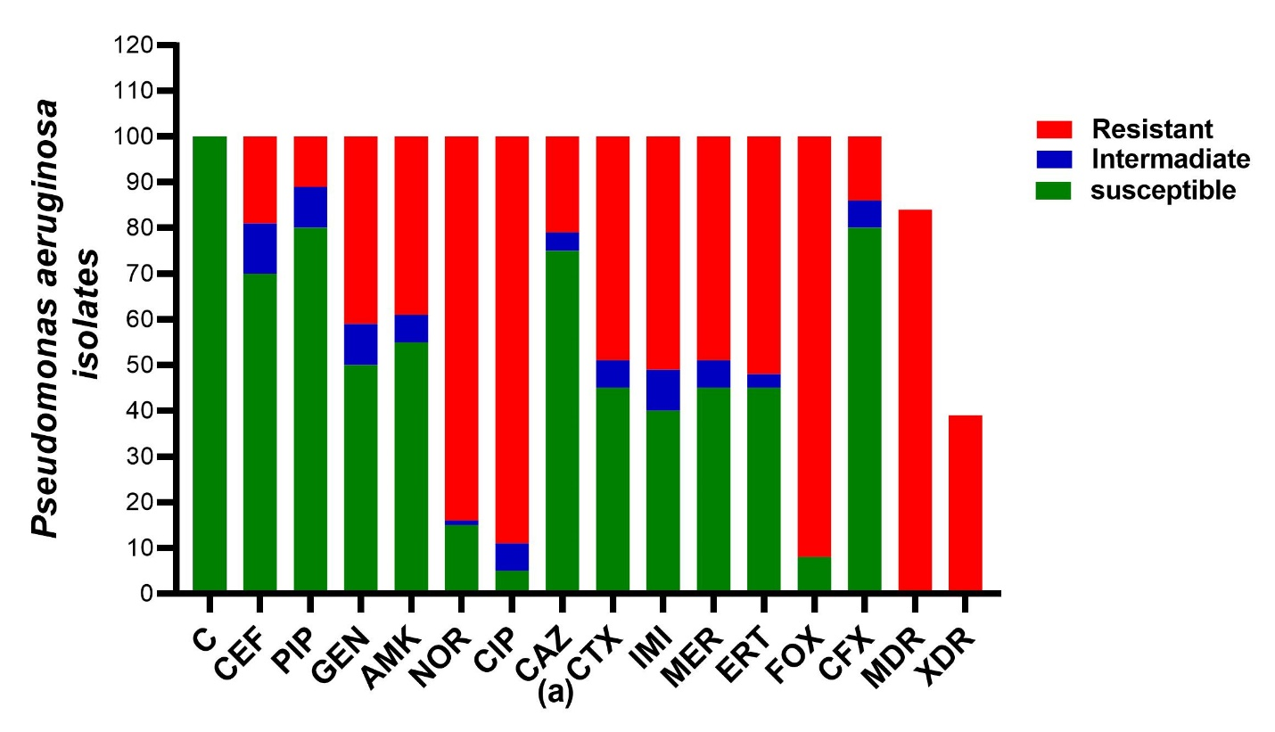

Figure S1. Antibiotic resistance pattern in clinical isolates of P. aeruginosa. PIP: Piperacillin; GEN: Gentamycin; AMK: Amikacin; CIP: Ciprofloxacin; CAZ: Ceftazidime; CTX: Ceftriaxone; IMI: Imipenem; MER: Meropenem; ERT: Ertapenem; FOX: Cefoxitin; CFX: Cefazolin; CPE: Cefepime; MDR: multiple drug resistance; XDR: extensively drug-resistant.

