Supplementary Table S1. Non-zero edge weights of the estimated network.
Node 1 | Node 2 | Weight | Absolute weight | Direction
FoP-SF | FoP-PH | 0.663 | 0.663 | Positive
SM-Diet | COP-Face | 0.264 | 0.264 | Positive
COP-Yield | COP-Avoid | 0.233 | 0.233 | Positive
COP-Avoid | COP-Face | 0.226 | 0.226 | Positive
SM-Abnormal | COP-Face | 0.176 | 0.176 | Positive
SM-Tech | COP-Face | 0.166 | 0.166 | Positive
SM-Monitor | COP-Yield | -0.165 | 0.165 | Negative
SM-Emotion | SM-Tech | 0.147 | 0.147 | Positive
SM-Emotion | COP-Face | 0.132 | 0.132 | Positive
SM-Emotion | FoP-PH | -0.130 | 0.130 | Negative
SM-Monitor | FoP-PH | -0.123 | 0.123 | Negative
SM-Diet | COP-Avoid | -0.122 | 0.122 | Negative
SM-Abnormal | SM-Tech | 0.106 | 0.106 | Positive
SM-Diet | FoP-SF | -0.100 | 0.100 | Negative
SM-Monitor | COP-Face | 0.099 | 0.099 | Positive
SM-Diet | SM-Tech | 0.092 | 0.092 | Positive
COP-Yield | COP-Face | -0.086 | 0.086 | Negative
SM-Tech | COP-Avoid | -0.086 | 0.086 | Negative
SM-Abnormal | FoP-PH | -0.086 | 0.086 | Negative
SM-Diet | FoP-PH | -0.086 | 0.086 | Negative
SM-Abnormal | COP-Yield | -0.085 | 0.085 | Negative
SM-Tech | COP-Yield | -0.084 | 0.084 | Negative
SM-Emotion | COP-Yield | -0.084 | 0.084 | Negative
SM-Emotion | SM-Abnormal | 0.083 | 0.083 | Positive
SM-Monitor | FoP-SF | -0.075 | 0.075 | Negative
COP-Face | FoP-SF | -0.072 | 0.072 | Negative
SM-Monitor | SM-Diet | 0.067 | 0.067 | Positive
SM-Tech | FoP-PH | -0.065 | 0.065 | Negative
SM-Emotion | SM-Monitor | 0.055 | 0.055 | Positive
SM-Monitor | SM-Tech | 0.053 | 0.053 | Positive
SM-Abnormal | FoP-SF | -0.049 | 0.049 | Negative
SM-Tech | FoP-SF | -0.045 | 0.045 | Negative
SM-Monitor | SM-Abnormal | 0.040 | 0.040 | Positive
COP-Avoid | FoP-SF | 0.038 | 0.038 | Positive
SM-Emotion | COP-Avoid | -0.037 | 0.037 | Negative
COP-Yield | FoP-SF | 0.034 | 0.034 | Positive
COP-Avoid | FoP-PH | 0.031 | 0.031 | Positive
SM-Emotion | FoP-SF | -0.009 | 0.009 | Negative
Note. Edges are regularized partial correlations estimated using EBICglasso. Absolute weight indicates the absolute value of the edge weight.

Supplementary Table S2. Centrality and bridge centrality indices.
Node | Full name | Community | Strength | Strength z | Expected influence | Expected influence z | Bridge strength | Bridge strength z | Bridge expected influence | Bridge expected influence z
COP-Face | Coping style: confrontation | Coping styles | 1.220 | 1.635 | 0.904 | 2.283 | 0.908 | 2.566 | 0.764 | 2.597
FoP-PH | Fear of progression: physical health | Fear of progression | 1.183 | 1.470 | 0.205 | -0.060 | 0.520 | 0.196 | -0.458 | -1.024
FoP-SF | Fear of progression: social/family | Fear of progression | 1.085 | 1.025 | 0.385 | 0.542 | 0.422 | -0.405 | -0.279 | -0.492
SM-Tech | Self-management: technique management | Self-management | 0.843 | -0.069 | 0.283 | 0.202 | 0.445 | -0.260 | -0.114 | -0.005
COP-Avoid | Coping style: avoidance | Coping styles | 0.772 | -0.389 | 0.283 | 0.201 | 0.313 | -1.067 | -0.176 | -0.187
COP-Yield | Coping style: resignation | Coping styles | 0.770 | -0.396 | -0.237 | -1.543 | 0.451 | -0.226 | -0.384 | -0.803
SM-Diet | Self-management: diet management | Self-management | 0.731 | -0.575 | 0.115 | -0.363 | 0.572 | 0.513 | -0.044 | 0.203
SM-Emotion | Self-management: emotion management | Self-management | 0.676 | -0.822 | 0.157 | -0.222 | 0.392 | -0.589 | -0.127 | -0.045
SM-Monitor | Self-management: complication monitoring | Self-management | 0.676 | -0.824 | -0.049 | -0.913 | 0.461 | -0.164 | -0.264 | -0.448
SM-Abnormal | Self-management: abnormal situation handling | Self-management | 0.625 | -1.056 | 0.185 | -0.127 | 0.395 | -0.564 | -0.044 | 0.203
Note. Centrality and bridge centrality z-scores were standardized across nodes. Bridge expected influence refers to one-step bridge expected influence.

Supplementary Table S3. Non-zero edge weights of the Spearman sensitivity network.
Node 1 | Node 2 | Spearman-based weight | Absolute weight | Direction
FoP-SF | FoP-PH | 0.657 | 0.657 | Positive
SM-Diet | COP-Face | 0.238 | 0.238 | Positive
COP-Yield | COP-Avoid | 0.221 | 0.221 | Positive
COP-Avoid | COP-Face | 0.213 | 0.213 | Positive
SM-Abnormal | COP-Face | 0.176 | 0.176 | Positive
SM-Emotion | SM-Tech | 0.166 | 0.166 | Positive
SM-Tech | COP-Face | 0.156 | 0.156 | Positive
SM-Monitor | FoP-PH | -0.144 | 0.144 | Negative
SM-Emotion | COP-Face | 0.139 | 0.139 | Positive
SM-Monitor | COP-Yield | -0.134 | 0.134 | Negative
SM-Diet | SM-Tech | 0.118 | 0.118 | Positive
SM-Abnormal | SM-Tech | 0.118 | 0.118 | Positive
SM-Emotion | FoP-PH | -0.116 | 0.116 | Negative
SM-Abnormal | FoP-PH | -0.112 | 0.112 | Negative
SM-Diet | COP-Avoid | -0.109 | 0.109 | Negative
SM-Diet | FoP-SF | -0.105 | 0.105 | Negative
SM-Abnormal | COP-Yield | -0.100 | 0.100 | Negative
SM-Monitor | COP-Face | 0.097 | 0.097 | Positive
COP-Yield | COP-Face | -0.092 | 0.092 | Negative
SM-Emotion | SM-Abnormal | 0.090 | 0.090 | Positive
SM-Diet | FoP-PH | -0.086 | 0.086 | Negative
SM-Monitor | FoP-SF | -0.086 | 0.086 | Negative
SM-Emotion | COP-Yield | -0.083 | 0.083 | Negative
SM-Tech | COP-Yield | -0.077 | 0.077 | Negative
SM-Tech | FoP-SF | -0.075 | 0.075 | Negative
SM-Tech | COP-Avoid | -0.073 | 0.073 | Negative
SM-Emotion | SM-Monitor | 0.072 | 0.072 | Positive
SM-Monitor | SM-Diet | 0.058 | 0.058 | Positive
COP-Face | FoP-SF | -0.052 | 0.052 | Negative
SM-Tech | FoP-PH | -0.049 | 0.049 | Negative
COP-Avoid | FoP-SF | 0.049 | 0.049 | Positive
COP-Yield | FoP-SF | 0.037 | 0.037 | Positive
COP-Avoid | FoP-PH | 0.032 | 0.032 | Positive
SM-Monitor | SM-Tech | 0.027 | 0.027 | Positive
SM-Monitor | SM-Abnormal | 0.024 | 0.024 | Positive
SM-Emotion | COP-Avoid | -0.020 | 0.020 | Negative
SM-Abnormal | FoP-SF | -0.013 | 0.013 | Negative
SM-Emotion | FoP-SF | -0.012 | 0.012 | Negative
Note. The Spearman sensitivity network was estimated using the same EBICglasso procedure and tuning parameter as the primary network.
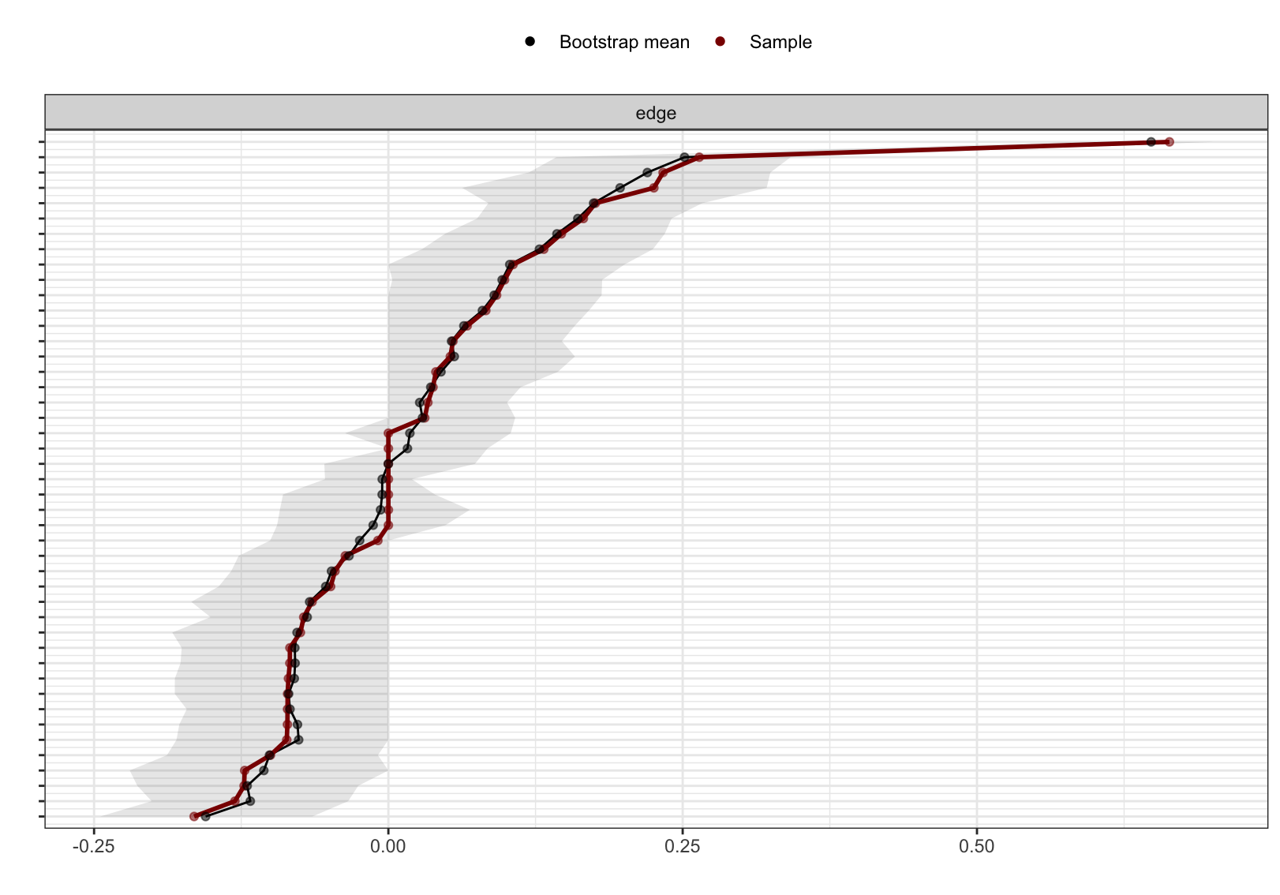
Supplementary Figure S1. Bootstrapped confidence intervals for edge weights. Nonparametric bootstrap results for edge-weight accuracy are shown. Red points indicate edge weights estimated from the original sample, black points indicate bootstrap mean edge weights, and grey areas indicate 95% bootstrap confidence intervals. Edges are ordered by the original sample estimates.

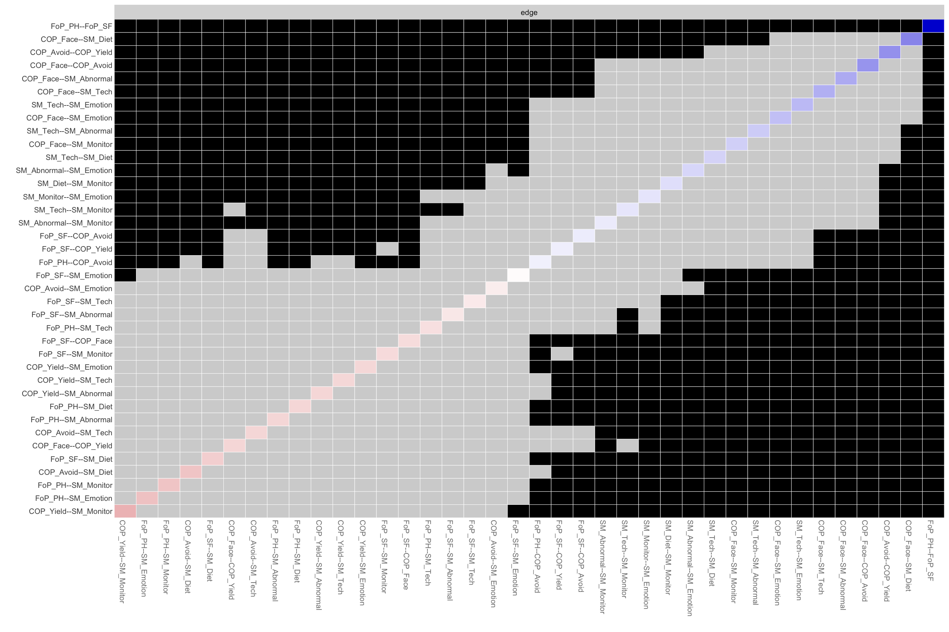
Supplementary Figure S2. Bootstrapped edge-weight difference test. The plot shows pairwise difference tests between edge weights based on nonparametric bootstrapping. Black squares indicate statistically significant differences between two edge weights, whereas grey squares indicate non-significant differences. Edge labels are ordered according to the estimated edge weights.

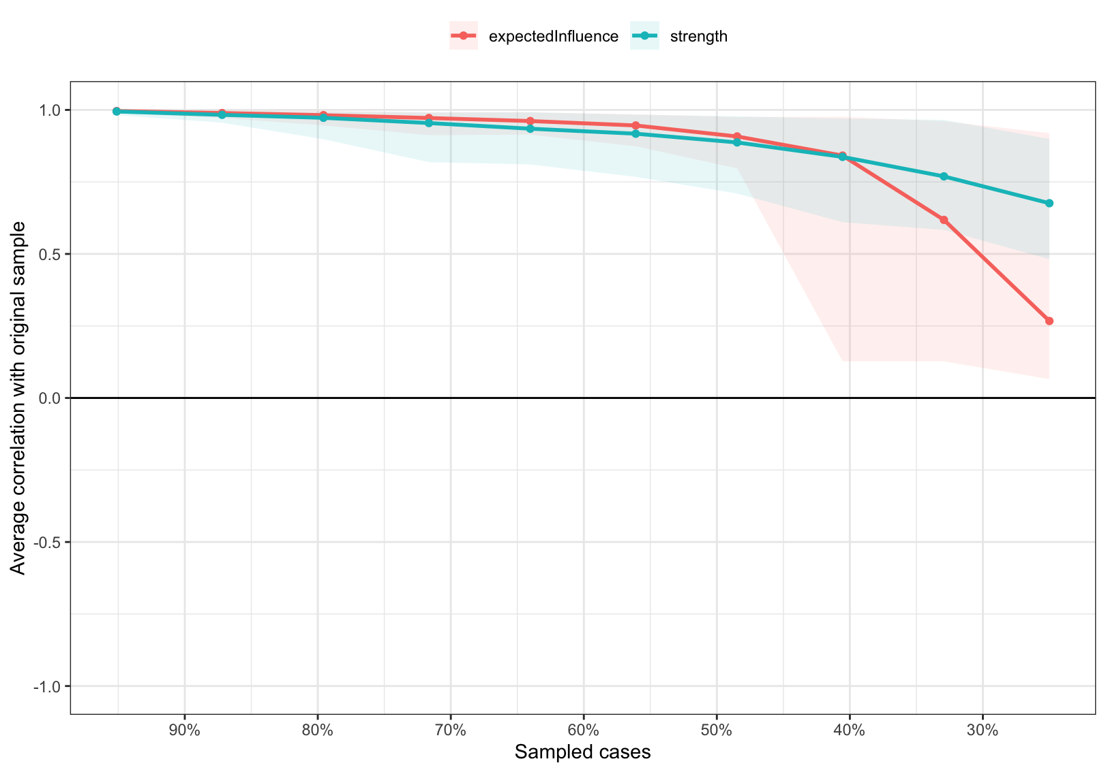
Supplementary Figure S3. Case-dropping bootstrap stability of centrality indices. The plot shows the average correlation between centrality estimates from subsamples and those from the original sample across different proportions of retained cases. Shaded areas indicate the 95% confidence intervals. Strength and expected influence were evaluated using case-dropping bootstrap procedures.

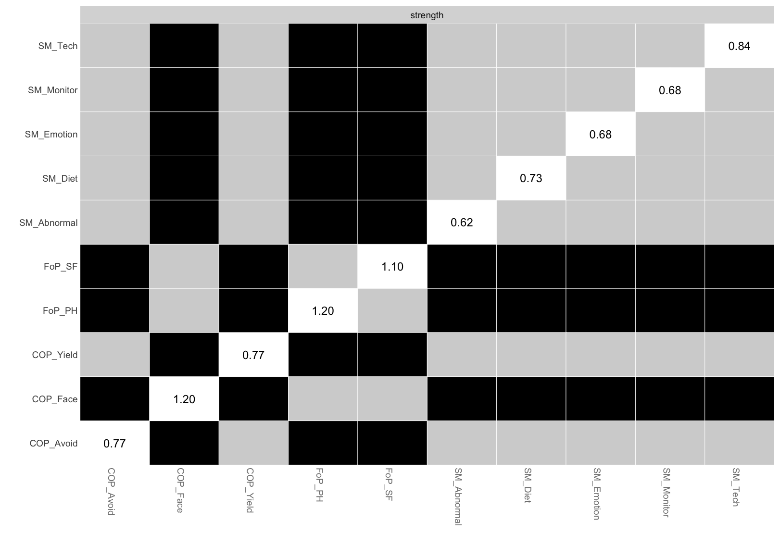
Supplementary Figure S4. Bootstrapped difference test for strength. The plot shows pairwise difference tests for node strength based on nonparametric bootstrapping. Black squares indicate statistically significant differences between two nodes, whereas grey squares indicate non-significant differences.

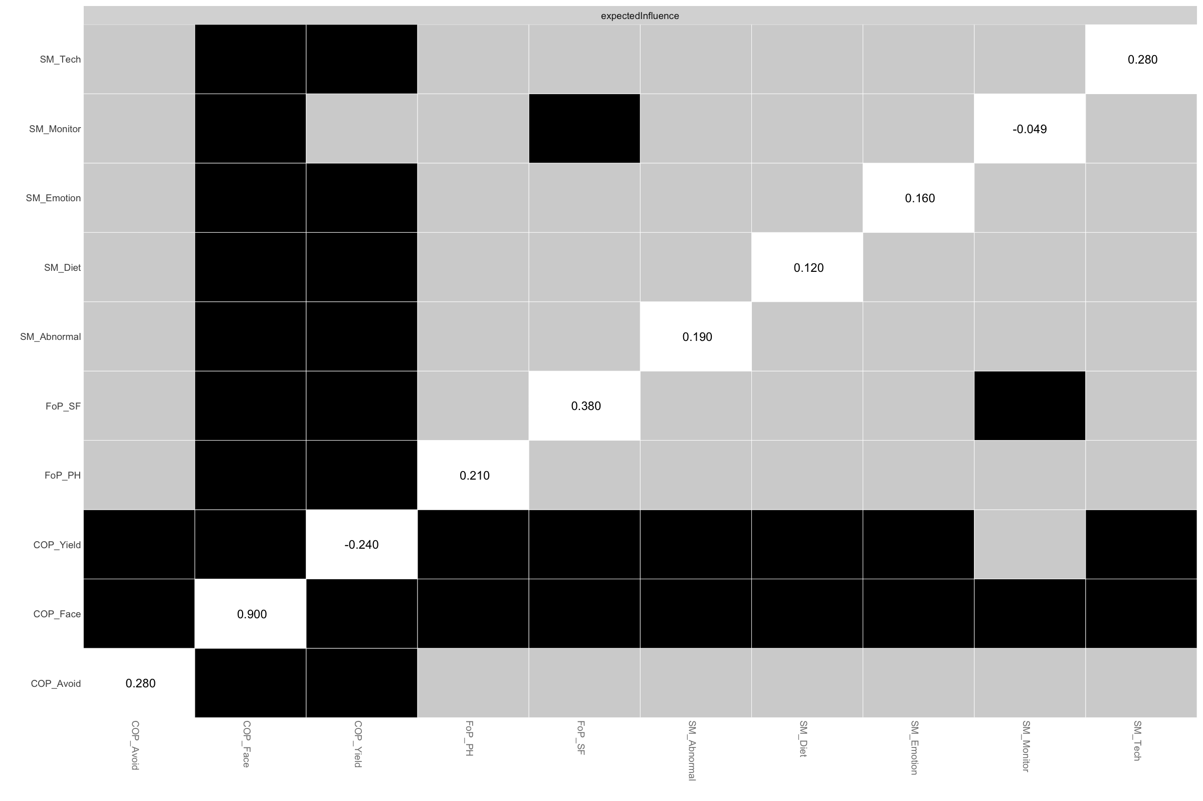
Supplementary Figure S5. Bootstrapped difference test for expected influence. The plot shows pairwise difference tests for node expected influence based on nonparametric bootstrapping. Black squares indicate statistically significant differences between two nodes, whereas grey squares indicate non-significant differences.

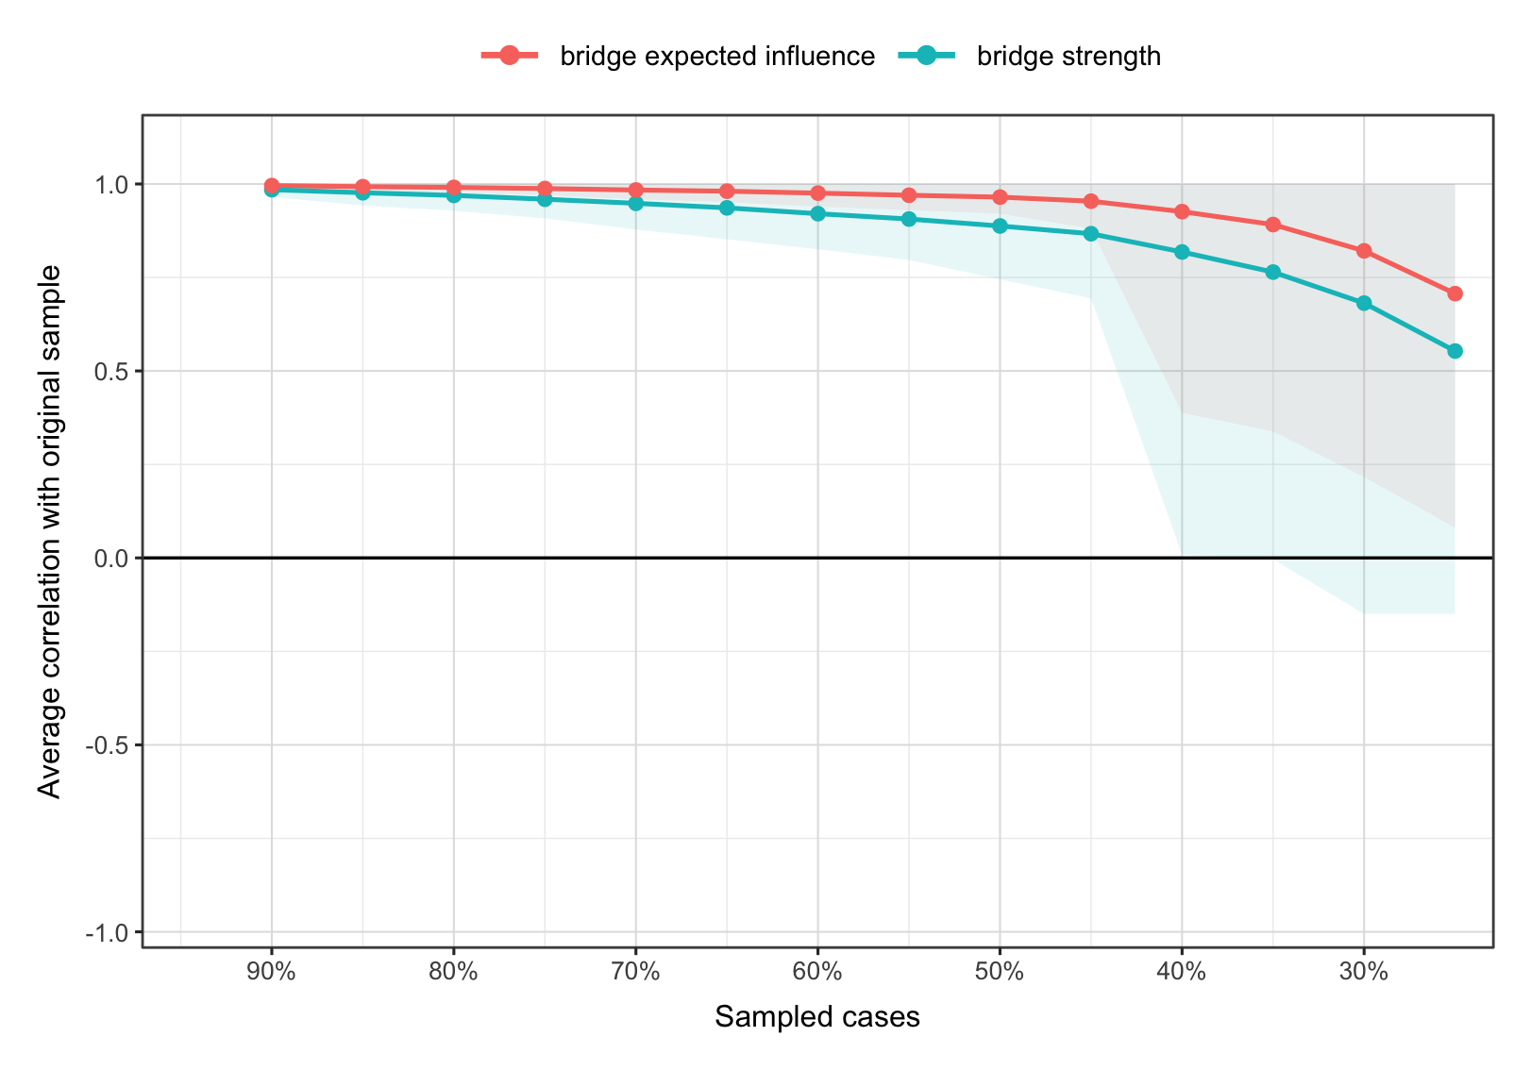
Supplementary Figure S6. Case-dropping bootstrap stability of bridge centrality indices. The plot shows the average correlation between bridge centrality estimates from subsamples and those from the original sample across different proportions of retained cases. Shaded areas indicate the 95% confidence intervals. Bridge strength and bridge expected influence were evaluated using case-dropping bootstrap procedures.

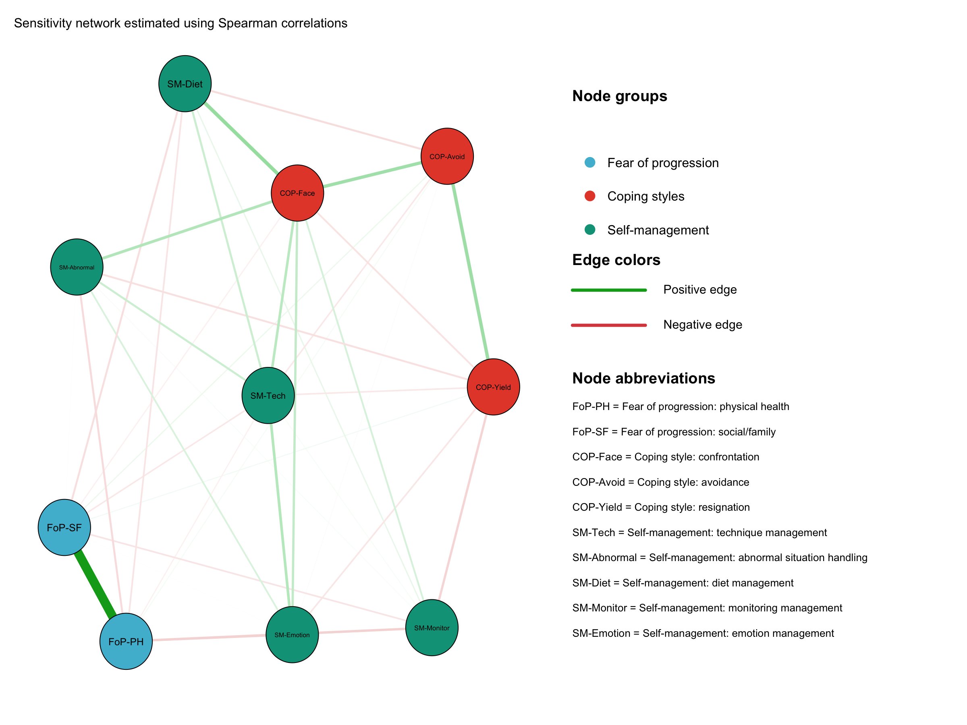
Supplementary Figure S7. Sensitivity network estimated using Spearman correlations. The network was re-estimated using Spearman correlations while retaining the same EBICglasso procedure and tuning parameter. Green edges indicate positive regularized partial correlations, red edges indicate negative regularized partial correlations, and thicker edges represent stronger associations. Node abbreviations are defined in Figure 2.

