Supplementary Material
Effect of Remdesivir on Mortality in Mechanically Ventilated COVID-19 Patients: A Target Trial Emulation Using Inverse Probability of Treatment Weighting
Yan-Ru Wang, Hong-Jie Jhou, Po-Huang Chen, Te-Yu Lin
Infection and Drug Resistance (Manuscript ID 620121)
Table of Contents
Supplementary Tables
Table S1. Target Trial Emulation Protocol
Table S2. Propensity Score Model Specification
Table S3. Complete Standardized Mean Difference Table
Table S4. IPTW Weight Distribution
Table S5. Co-interventions and Complications Before and After S-IPTW Weighting
Table S6. Sensitivity Analyses for the Association Between Remdesivir and Outcomes

Supplementary Figures
Figure S1. Target Trial Emulation Time Framework
Figure S2. Propensity Score Distribution by Treatment Group
Figure S3. Love Plot of Covariate Balance Before and After S-IPTW Weighting
Figure S4. Cumulative Incidence Functions for Competing-Risks Analysis (MV Duration)

Table S1. Target Trial Emulation Protocol
Target trial emulation framework used in this study. The observational emulation column details how each component was operationalized using real-world data.
Component | Target Trial | Observational Emulation
Eligibility Criteria | Adults ≥18 years with laboratory-confirmed COVID-19 requiring endotracheal intubation within 7 days of diagnosis | Same criteria applied to retrospective cohort at TSGH (Jan 2021 - Mar 2024), N=163
Treatment Strategies | Remdesivir (≥3 consecutive days) vs. No remdesivir | Same definition based on medical records; Remdesivir N=117, Control N=46
Assignment Procedure | Random assignment at time of COVID-19 diagnosis | S-IPTW to emulate randomization using 15 baseline covariates; Max |SMD| = 0.148
Treatment Assignment Window | Treatment initiated within 3 days of diagnosis (Grace period) | Same: Remdesivir must be started within Day 0-3 of diagnosis
Follow-up Period | From randomization (time zero) to death or administrative censoring | From COVID-19 diagnosis (time zero) to death or May 1, 2025
Primary Outcomes | All-cause mortality, 90-day mortality | Same outcomes ascertained from electronic health records
Secondary Outcome | Mechanical ventilation duration | Same: Time on MV with death as event
Causal Contrast | Per-protocol effect | Per-protocol effect estimated via IPTW
Statistical Analysis | Intention-to-treat Cox proportional hazards regression | S-IPTW weighted Cox regression with robust standard errors
Abbreviations: MV, mechanical ventilation; S-IPTW, stabilized inverse probability of treatment weighting; SMD, standardized mean difference; TSGH, Tri-Service General Hospital.

Table S2. Propensity Score Model Specification
Details of the 15 variables included in the propensity score model, categorized by type (demographics, comorbidity index, individual comorbidities, complete blood count, renal function, inflammation) with rationale for inclusion.
Variable | Category | Rationale for Inclusion
Age | Demographics | Key demographic confounder affecting both treatment decision and mortality
Gender | Demographics | Key demographic confounder
Charlson Comorbidity Index | Comorbidity Index | Summary measure of overall comorbidity burden; strongly associated with mortality
Heart failure | Comorbidity | Residual imbalance after CCI adjustment; affects prognosis
Diabetes mellitus | Comorbidity | Residual imbalance after CCI adjustment; common comorbidity
Hypertension | Comorbidity | Common comorbidity affecting treatment decisions
Chronic kidney disease | Comorbidity | Key factor in remdesivir prescribing due to renal clearance concerns
Hyperlipidemia | Comorbidity | Metabolic comorbidity; proxy for cardiovascular risk
Hemoglobin | CBC | Marker of overall health status and disease severity
Platelet count | CBC | Marker of bone marrow function and sepsis severity
ANC | CBC | Absolute neutrophil count; infection and inflammation marker
ALC | CBC | Absolute lymphocyte count; immune status in COVID-19
BUN | Renal Function | Renal function marker; key for remdesivir dosing decisions
Creatinine | Renal Function | Creatinine clearance affects remdesivir eligibility
CRP | Inflammation | Inflammatory marker reflecting COVID-19 disease severity
Abbreviations: ALC, absolute lymphocyte count; ANC, absolute neutrophil count; BUN, blood urea nitrogen; CRP, C-reactive protein.

Table S3. Complete Standardized Mean Difference Table
Balance assessment for all covariates before and after S-IPTW weighting. Balanced defined as |SMD| ≤ 0.1 (optimal) or |SMD| ≤ 0.2 (acceptable). Variables included in the propensity score model are indicated.
Variable | SMD (Unadjusted) | SMD (S-IPTW) | In PS Model | Balanced (|SMD|≤0.1)
AGE | -0.275 | -0.064 | Yes | Yes
GENDER (Male) | 0.093 | -0.025 | Yes | Yes
Charlson Comorbidity Index | -0.439 | -0.027 | Yes | Yes
Stroke | -0.020 | 0.148 | No | No
Coronary artery disease | -0.128 | 0.062 | No | Yes
Heart failure | -0.069 | 0.0995 | Yes | Yes
Diabetes mellitus | -0.314 | -0.038 | Yes | Yes
Hypertension | -0.191 | 0.015 | Yes | Yes
Chronic kidney disease | -0.599 | -0.069 | Yes | Yes
Hyperlipidemia | -0.145 | 0.026 | Yes | Yes
COPD | -0.032 | -0.129 | No | No
WBC | 0.008 | 0.087 | No | Yes
Hemoglobin | 0.190 | -0.018 | Yes | Yes
Platelet count | 0.156 | 0.080 | Yes | Yes
Neutrophil(%) | 0.014 | 0.124 | No | No
Lymphocyte(%) | -0.049 | -0.050 | No | Yes
ANC | 0.012 | 0.107 | Yes | No
ALC | 0.002 | -0.028 | Yes | Yes
NLR | 0.032 | 0.101 | No | No
BUN | -0.716 | -0.064 | Yes | Yes
Creatinine | -0.496 | -0.033 | Yes | Yes
AST | 0.061 | 0.1004 | No | No
ALT | -0.004 | 0.056 | No | Yes
Total bilirubin | 0.044 | 0.124 | No | No
CRP | 0.016 | 0.141 | Yes | No
Pro-BNP | -0.471 | -0.140 | No | No
Abbreviations: ALC, absolute lymphocyte count; ALT, alanine aminotransferase; ANC, absolute neutrophil count; AST, aspartate aminotransferase; BUN, blood urea nitrogen; COPD, chronic obstructive pulmonary disease; CRP, C-reactive protein; NLR, neutrophil-to-lymphocyte ratio; Pro-BNP, pro-B-type natriuretic peptide; PS, propensity score; S-IPTW, stabilized inverse probability of treatment weighting; SMD, standardized mean difference; WBC, white blood cell count.

Table S4. IPTW Weight Distribution
Distribution statistics (minimum, percentiles, median, mean, maximum, standard deviation) for raw IPTW, truncated IPTW, raw S-IPTW, truncated S-IPTW, and overlap weights. Truncation performed at 1st and 99th percentiles. Primary analysis used S-IPTW (truncated) weights.
Weight Type | Min | P5 | P25 | Median | Mean | P75 | P95 | Max | SD
IPTW (raw) | 1.064 | 1.082 | 1.175 | 1.354 | 1.939 | 2.002 | 5.111 | 7.612 | 1.376
IPTW (truncated) | 1.066 | 1.082 | 1.175 | 1.354 | 1.935 | 2.002 | 5.111 | 7.282 | 1.360
S-IPTW (raw) | 0.309 | 0.479 | 0.801 | 0.886 | 0.982 | 1.074 | 1.828 | 2.474 | 0.386
S-IPTW (truncated) | 0.382 | 0.479 | 0.801 | 0.886 | 0.981 | 1.074 | 1.828 | 2.206 | 0.377
Overlap Weight | 0.060 | 0.076 | 0.149 | 0.261 | 0.341 | 0.500 | 0.804 | 0.869 | 0.233
Abbreviations: S-IPTW, stabilized inverse probability of treatment weighting; SD, standard deviation.

Table S5. Co-interventions and Complications Before and After S-IPTW Weighting
Variable | Remdesivir, % (unweighted / weighted) | Control, %  (unweighted / weighted) | SMD (unweighted) | SMD (weighted)
Corticosteroid | 99.1 / 98.2 | 97.8 / 98.9 | +0.108 | -0.058
Tocilizumab | 53.0 / 51.5 | 39.1 / 32.7 | +0.281 | +0.388
Vasopressor | 77.8 / 80.0 | 71.7 / 65.0 | +0.139 | +0.339
ECMO | 6.8 / 6.4 | 2.2 / 1.1 | +0.226 | +0.284
Co-infection at admission (<48 h) | 28.2 / 27.5 | 19.6 / 15.0 | +0.204 | +0.309
Secondary bacterial infection | 86.3 / 86.2 | 80.4 / 84.3 | +0.159 | +0.053
Secondary fungal infection | 28.2 / 28.9 | 32.6 / 33.0 | -0.096 | -0.088
Invasive aspergillosis | 27.4 / 28.2 | 32.6 / 33.0 | -0.115 | -0.104
Values are percentages before / after stabilized inverse probability of treatment weighting (S-IPTW); Co-interventions and complications were administered after time zero and may lie on the causal pathway between treatment and outcome; they were therefore not included in the propensity score model and are presented descriptively. Co-infection at admission and secondary bacterial infection were defined by the concurrent presence of compatible symptoms, radiographic change, and microbiological evidence. Secondary fungal infection was predominantly invasive pulmonary aspergillosis; two patients had candidemia.
Abbreviations: ECMO, extracorporeal membrane oxygenation, SMD, standardized mean difference.

Table S6. Sensitivity Analyses for the Association Between Remdesivir and Outcomes
Analysis | Overall mortality,  HR (95% CI) | 90-day mortality,  HR (95% CI) | MV duration,  HR (95% CI)
Main analysis (S-IPTW weighted) | 2.52 (1.24-5.15) | 2.09 (0.97-4.48) | 2.79 (1.37-5.68)
Excluding ECMO users (n=154) | 2.68 (1.27-5.62) | 2.01 (0.93-4.37) | 3.02 (1.43-6.38)
PS additionally adjusted for admission co-infection and recent prior hospitalization | 2.62 (1.28-5.37) | 2.16 (1.00-4.66) | 3.06 (1.47-6.36)
Excluding patients with admission co-infection (n=121) | 2.71 (1.24-5.88) | 2.28 (0.99-5.26) | 2.65 (1.22-5.77)
Vital status re-verified against the National Health Insurance death registry | 2.98 (1.44-6.16) | 2.39 (1.12-5.11) | 3.22 (1.56-6.63)
All hazard ratios (HR) are from stabilized inverse probability of treatment weighted Cox models with robust standard errors. The main analysis and the exclude-ECMO analysis are the prespecified analyses reported in the main text. Admission co-infection and recent prior hospitalization are baseline-level factors and were added to the propensity score model as a sensitivity analysis; other co-interventions, being post-baseline, were not. In the re-verification analysis, vital status was confirmed against the National Health Insurance death registry and chart review, reclassifying four patients.
Abbreviations: CI, confidence interval; ECMO, extracorporeal membrane oxygenation; MV, mechanical ventilation; PS, propensity score; S-IPTW, stabilized inverse probability of treatment weighting.

Supplementary Figures
Figure S1. Target Trial Emulation Time Framework.
Schematic illustration of the target trial emulation design. Time zero is defined as the date of COVID-19 diagnosis (Day 0), with both treatment arms starting follow-up at this common time point. The treatment assignment window (green box) spans Day 0-3, during which remdesivir must be initiated for patients in the treatment group. The eligibility window (blue box) requires intubation within 7 days of diagnosis. The control group (orange bar) is defined as patients who did not receive remdesivir during their entire hospitalization, not merely those with delayed treatment.
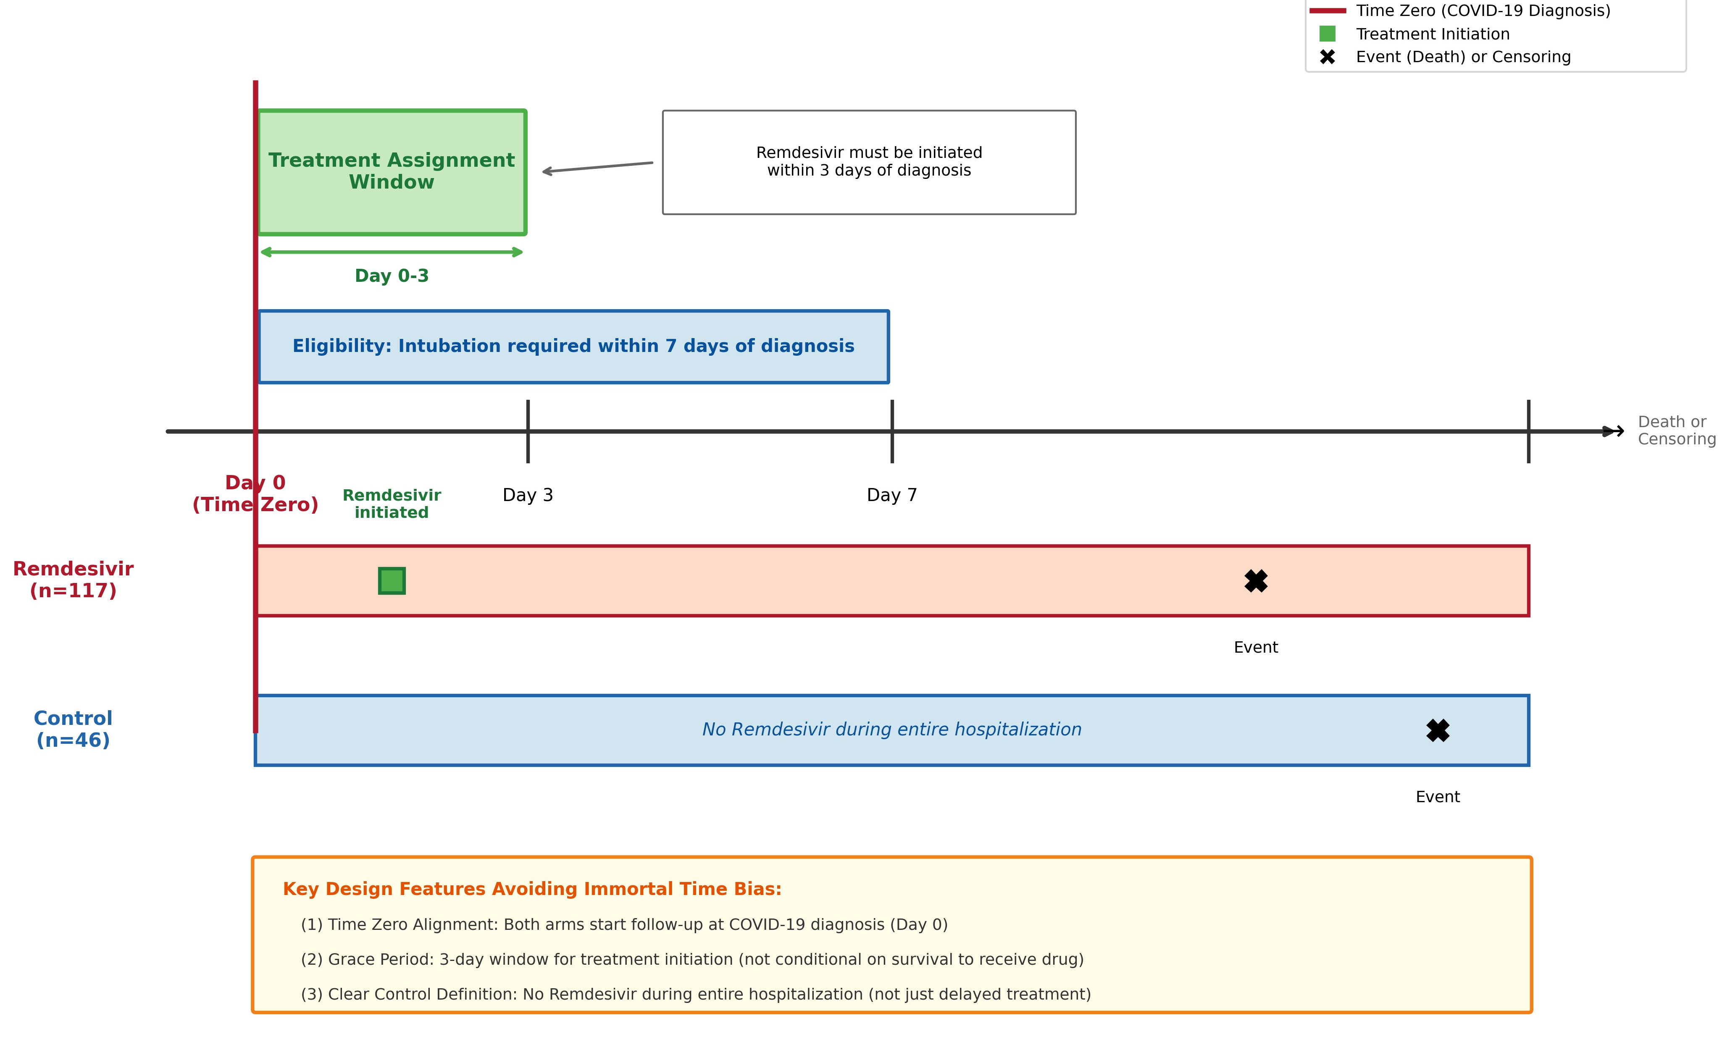
Abbreviations: ETT, endotracheal tube.

Figure S2. Propensity Score Distribution by Treatment Group.
Overlapping histograms showing the distribution of propensity scores for the remdesivir group (red, n=117) and control group (blue, n=46). The vertical dotted lines indicate the overlap region boundaries (0.290 to 0.869). The substantial overlap between the two distributions supports the positivity assumption and indicates that patients with similar baseline characteristics exist in both treatment groups, enabling valid causal inference through inverse probability weighting.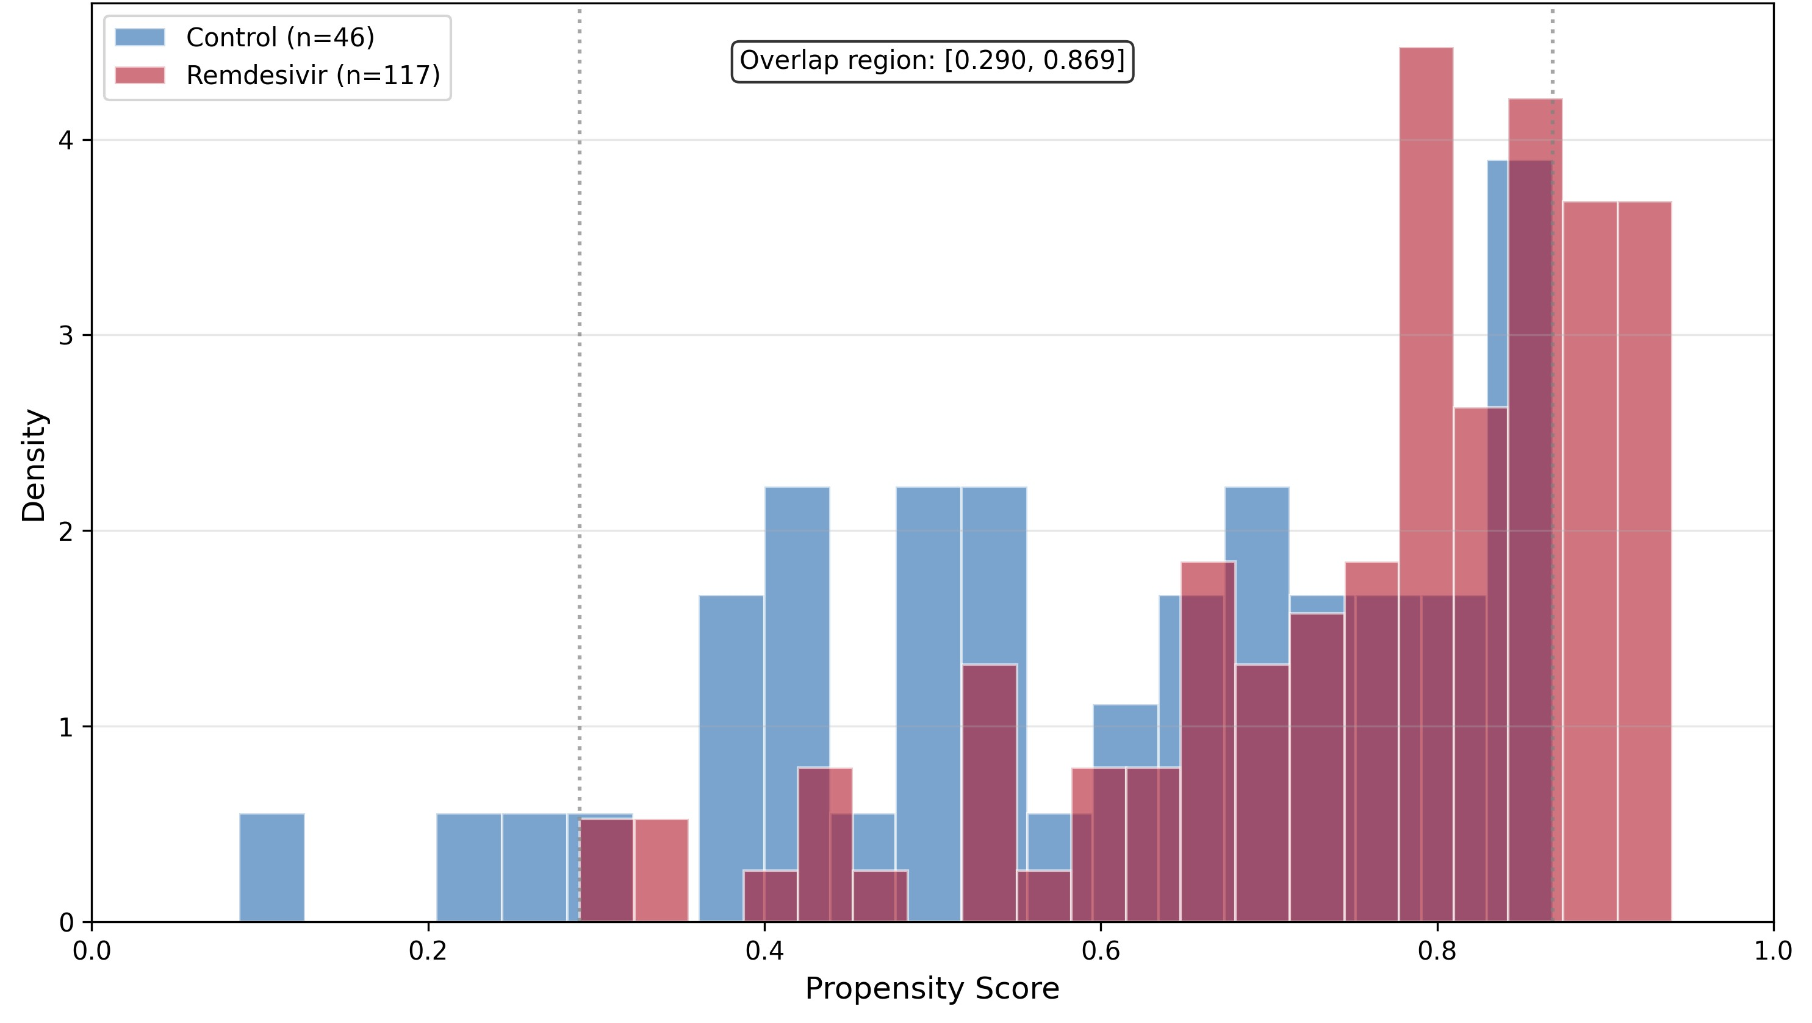
Abbreviations: PS, propensity score.

Figure S3. Love Plot of Covariate Balance Before and After S-IPTW Weighting.
Absolute standardized mean differences (SMDs) for all baseline covariates before (red circles) and after (blue squares) stabilized inverse probability of treatment weighting (S-IPTW). The vertical orange dashed line denotes the optimal balance threshold (|SMD| = 0.1), and the vertical red dashed line denotes the acceptable balance threshold (|SMD| = 0.2). Before weighting, substantial imbalances were observed for blood urea nitrogen (SMD = 0.72), chronic kidney disease (SMD = 0.60), creatinine (SMD = 0.50), and pro-BNP (SMD = 0.47). After S-IPTW weighting, all covariates achieved |SMD| < 0.2, with the maximum |SMD| of 0.148 observed for stroke, indicating adequate covariate balance.
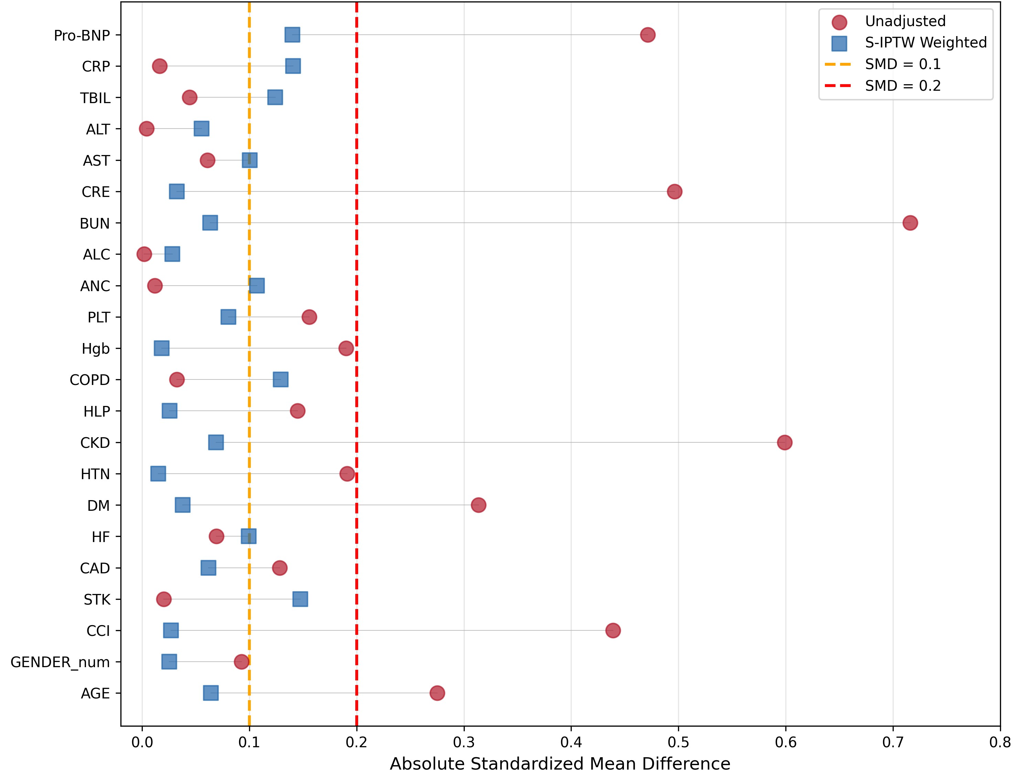
Abbreviations: ALC, absolute lymphocyte count; ANC, absolute neutrophil count; ALT, alanine aminotransferase; AST, aspartate aminotransferase; BUN, blood urea nitrogen; CAD, coronary artery disease; CCI, Charlson Comorbidity Index; CKD, chronic kidney disease; COPD, chronic obstructive pulmonary disease; CRE, creatinine; CRP, C-reactive protein; DM, diabetes mellitus; HF, heart failure; Hgb, hemoglobin; HLP, hyperlipidemia; HTN, hypertension; PLT, platelet; Pro-BNP, pro-B-type natriuretic peptide; S-IPTW, stabilized inverse probability of treatment weighting; SMD, standardized mean difference; STK, stroke; TBIL, total bilirubin.

Figure S4. Cumulative Incidence Functions for Competing-Risks Analysis (MV Duration).
Cumulative incidence functions (CIF) for death during mechanical ventilation (Panel A) and successful extubation as a competing event (Panel B), stratified by treatment group using S-IPTW weights. In Panel A, the cumulative incidence of death during mechanical ventilation was substantially higher in the remdesivir group (red, 41 events) compared to the control group (blue, 12 events) throughout the follow-up period. In Panel B, the cumulative incidence of successful extubation was lower in the remdesivir group (76 events) compared to the control group (34 events). These competing risk analyses account for the fact that successful extubation precludes the observation of death during mechanical ventilation, providing a more accurate estimation of the treatment effect on MV duration than standard Kaplan-Meier analysis.
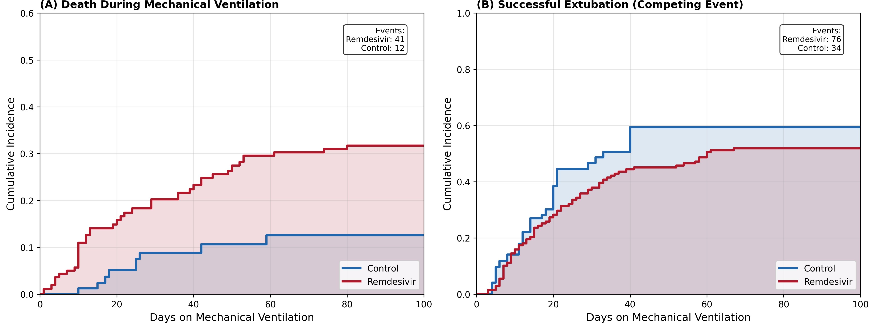
Abbreviations: MV, mechanical ventilation; S-IPTW, stabilized inverse probability of treatment weighting.

