Supplementary Figure 1: Structure of Diosmin.

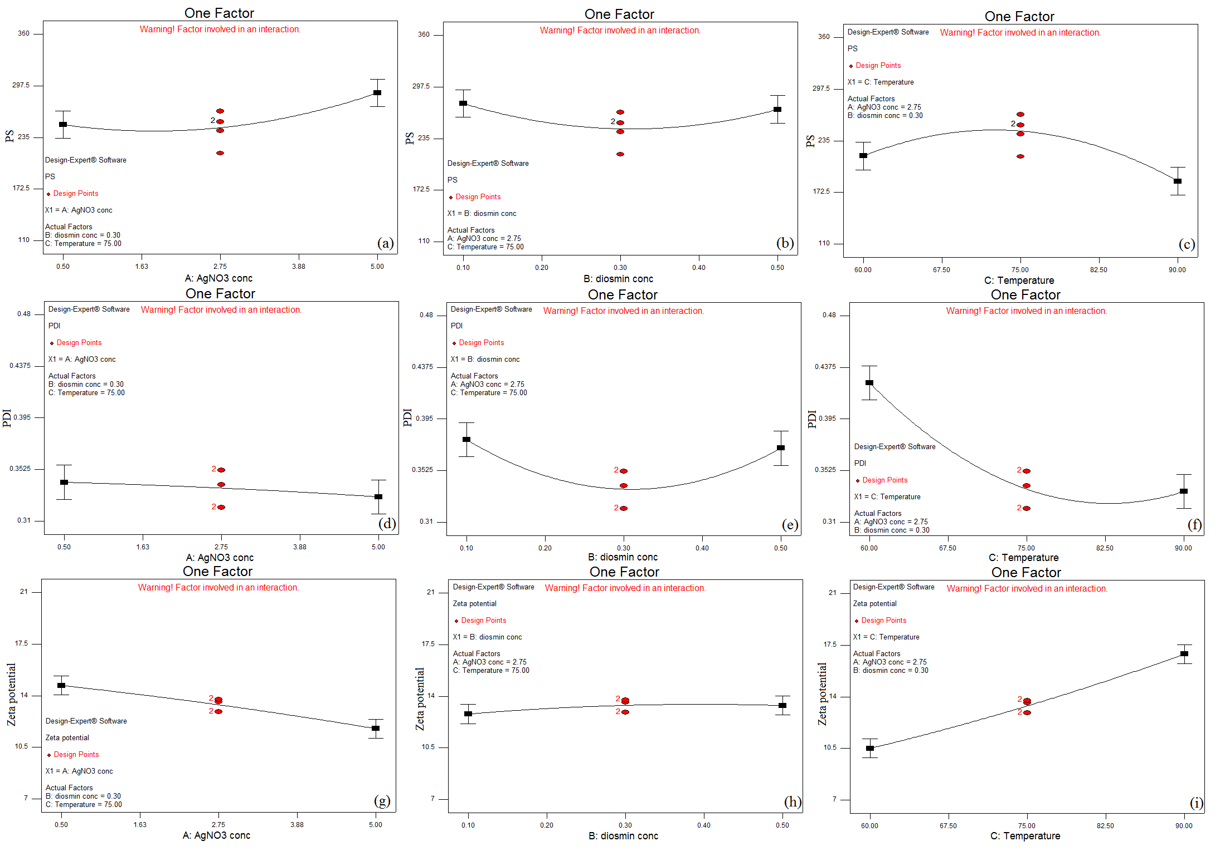
Supplementary Figure 2: One factor effect of the three design critical material attributes namely, A: AgNO₃ concentration, B: Diosmin concentration and C: Temperature on the critical quality attributes namely, PS (a, b, and c), PDI (d, e, and f) and ZP (g, h, and i) of Diosmin-loaded AgNPs.

Supplementary Table 1: Significance of CMA effects and interactions on PS, PDI, and ZP of Diosmin-loaded AgNPs
Factor | CQA | Sum of squares | Df | Mean square | F value | P value  Prob>F | Significance (P<0.05)
Model | PS | 46425 | 7 | 6632.22 | 13.56 | 0.0004 | Significant
Model | PDI | 0.042 | 7 | 4.708E-003 | 24.20 | 0.0002 | Significant
Model | ZP | 200.45 | 9 | 22.27 | 54.04 | 0.0002 | Significant
A  (AgNO3 concentration)  (mM) | PS | 2964.50 | 1 | 2964.50 | 10.77 | 0.0135 | Significant
A  (AgNO3 concentration)  (mM) | PDI | 2.880E-004 | 1 | 2.88E-005 | 1.48 | 0.2631 | Non-significant
A  (AgNO3 concentration)  (mM) | ZP | 17.17 | 1 | 17.17 | 41.66 | 0.0003 | Significant
B  (Diosmin concentration)  (mM) | PS | 103.68 | 1 | 103.68 | 0.38 | 0.5588 | Non-significant
B  (Diosmin concentration)  (mM) | PDI | 9.800E-005 | 1 | 9.800E-005 | 0.50 | 0.5008 | Non-significant
B  (Diosmin concentration)  (mM) | ZP | 0.66 | 1 | 0.66 | 1.60 | 0.2458 | Non-significant
C  (Temperature)  (°C) | PS | 1860.50 | 1 | 1860.50 | 6.76 | 0.0354 | Significant
C  (Temperature)  (°C) | PDI | 0.016 | 1 | 0.016 | 82.35 | <0.0001 | Significant
C  (Temperature)  (°C) | ZP | 82.05 | 1 | 82.05 | 199.07 | <0.0001 | Significant
AB | PS | 8372.25 | 1 | 8372.25 | 30.41 | 0.0009 | Significant
AB | PDI | 9.120E-003 | 1 | 9.120E-003 | 46.88 | 0.0002 | Significant
AB | ZP | 60.06 | 1 | 60.06 | 145.73 | <0.0001 | Significant
AC | PS | 22022.56 | 1 | 11011.56 | 45.04 | <0.0001 | Significant
AC | PDI | 2.256E-003 | 1 | 2.256E-003 | 11.60 | 0.0114 | Significant
AC | ZP | 22.00 | 1 | 22.00 | 53.37 | 0.0002 | Significant
BC | PS | 265.69 | 1 | 265.69 | 0.97 | 0.3586 | Non-significant
BC | PDI | 2.402E-004 | 1 | 2.402E-004 | 1.23 | 0.3032 | Non-significant
BC | ZP | 17.64 | 1 | 17.64 | 42.80 | 0.0003 | Significant
A2 | PS | 2208.04 | 1 | 2208.04 | 8.02 | 0.0253 | Significant
A2 | PDI | 6.318E-006 | 1 | 6.318E-006 | 0.032 | 0.8621 | Non-significant
A2 | ZP | 0.10 | 1 | 0.10 | 0.25 | 0.6355 | Non-significant
B2 | PS | 3080.85 | 1 | 3080.85 | 11.19 | 0.0123 | Significant
B2 | PDI | 5.850E-003 | 1 | 5.850E-003 | 30.07 | 0.0009 | Significant
B2 | ZP | 0.38 | 1 | 0.38 | 0.92 | 0.3696 | Non-significant
C2 | PS | 8716.84 | 1 | 8716.84 | 31.66 | 0.0008 | Significant
C2 | PDI | 7.704E-003 | 1 | 7.704E-003 | 39.60 | 0.0004 | Significant
C2 | ZP | 0.43 | 1 | 0.43 | 1.05 | 0.3404 | Non-significant
Residual | PS | 1927.22 | 7 | 275.32
Residual | PDI | 1.362E-003 | 7 | 1.945E-004
Residual | ZP | 2.89 | 7 | 0.41
Lack of fit | PS | 441.54 | 3 | 147.18 | 0.40 | 0.7635 | Non-significant
Lack of fit | PDI | 3.910E-004 | 3 | 1.303E-004 | 0.54 | 0.6816 | Non-significant
Lack of fit | ZP | 2.10 | 3 | 0.70 | 3.58 | 0.1249 | Non-significant
Pure Error | PS | 1485.68 | 4 | 371.42
Pure Error | PDI | 9.708E-004 | 4 | 2.427E-004
Pure Error | ZP | 0.78 | 4 | 0.20
Cor Total | PS | 50826.51 | 16
Cor Total | PDI | 0.044 | 16
Cor Total | ZP | 203.33 | 16

