Supplementary Tables
Supplementary Table 1. AKI Risk with a Univariate Analysis.
Variables | OR (95% CI) | B | p-Value
Age | 1.001 (0.995–1.008) | 0.001 | 0.672
Gender | 0.827 (0.669–1.022) | –0.190 | 0.827
Diabetes Mellitus | 0.764 (0.558–1.045) | –0.270 | 0.092
Hyperuricemia | 1.387 (1.041–1.847) | 0.327 | 0.025
Cardiac Dysfunction | 1.583 (1.245–2.014) | 0.460 | < 0.001
Malignant Solid Tumor | 0.744 (0.590–0.939) | –0.295 | 0.013
Critically ill | 1.694 (1.377–2.082) | 0.527 | < 0.001
Hypoalbuminemia | 1.031 (0.840–1.265) | 0.030 | 0.771
eGFR | 0.994 (0.991–0.998) | –0.006 | 0.001
Length of vancomycin therapy | 1.235 (1.085–1.406) | 0.211 | 0.001
CUTOFF 15.935 | 2.378 (1.940–2.914) | 0.866 | < 0.001
Vasopressors | 1.576 (1.173–2.119) | 0.455 | 0.003
Loop Diuretics | 1.333 (1.088–1.633) | 0.288 | 0.005
Contrast Media | 2.954 (1.571–5.553) | 1.083 | 0.001
Cephalosporin Antibiotics | 1.584 (1.257–1.996) | 0.460 | < 0.001
Piperacillin-Tazobactam | 1.526 (1.003–2.322) | 0.423 | 0.049
PPI | 1.193 (0.970–1.466) | 0.176 | 0.094
Tacrolimus | 2.088 (1.223–3.565) | 0.736 | 0.007
Supplementary Table 2. Clinically actionable framework for VA-AKI risk stratification
Risk domain | Variable | Clinical implication
Exposure-related | Trough ≥15.9 mg/L | Consider closer TDM review and renal monitoring
Co-medication-related | PTZ / contrast / cephalosporins | Reassess need, timing, and cumulative nephrotoxic burden
Treatment course | Duration ≥14 days | Intensify ongoing surveillance
Patient vulnerability | Critical illness / eGFR<90 / cardiac dysfunction | Start early and more frequent monitoring

Supplementary Figures
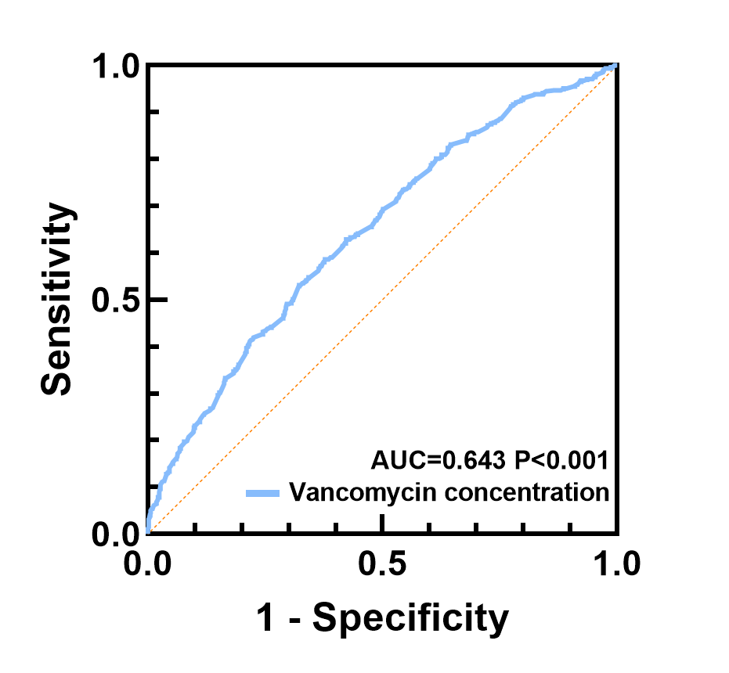
Supplementary Fig. 1. ROC Curve Analysis of Vancomycin Trough Concentration for VA-AKI Prediction.
Legend: The ROC curve demonstrated the predictive performance of the first vancomycin trough concentration for VA-AKI development. The area under the curve (AUC) was 0.643 (95% CI: 0.615–0.670, P < 0.001). The optimal cutoff value determined by Youden's index was 15.935 mg/L.
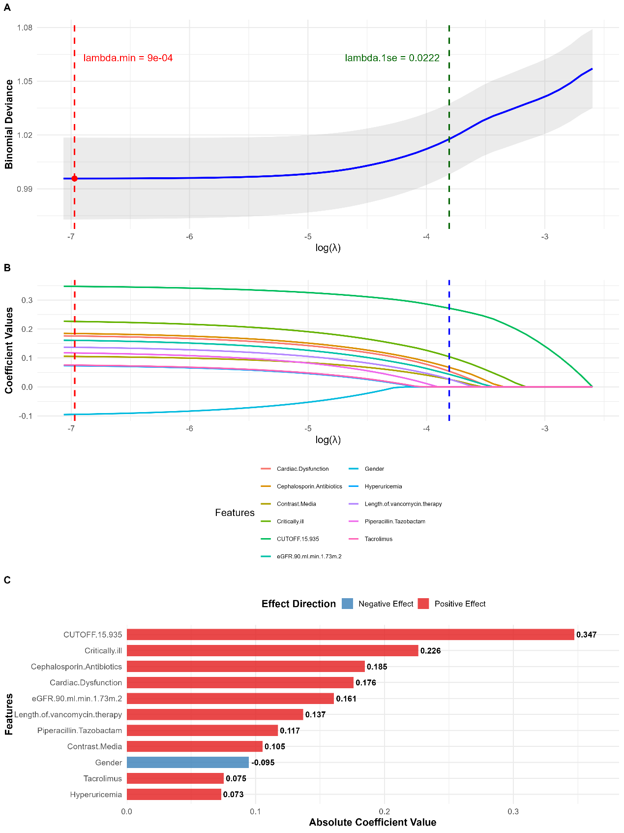
Supplementary Fig. 2. Feature selection and coefficient paths in LASSO regression.
Legend: The figure illustrates the LASSO regression analysis used for feature selection and model validation. (A) LASSO coefficient paths: The trajectories of regression coefficients for all candidate variables as a function of the L1 regularization parameter (λ). Each colored line represents a specific predictor variable. As λ increases (moving left to right on the x-axis), coefficients are progressively shrunk toward zero, with less important variables being eliminated first. Variables that maintain non-zero coefficients across a wide range of λ values demonstrate greater robustness and predictive importance for VA-AKI. (B) Cross-validation curve: The plot illustrates the mean cross-validated deviance (or prediction error) as a function of log(λ), determined by 10-fold cross-validation. The vertical dashed lines indicate λ.min (the value that minimizes the cross-validation error) and λ.1se (the largest λ value within one standard error of the minimum). The optimal model was selected using λ.min to balance model complexity and predictive performance. (C) Key variables identified by LASSO regression—including vancomycin trough concentration ≥ 15.935 mg/L, treatment duration ≥ 14 days, critical illness, cardiac dysfunction, and concomitant nephrotoxic medications (cephalosporins, piperacillin-tazobactam, contrast media)—exhibited consistent non-zero coefficients, validating the variable selection from the backward stepwise logistic regression model and confirming their independent association with VA-AKI risk.

