Supplementary Table S1. Standardized Mean Differences Before and After IPTW
Variable | SmPCNL  (n = 78) | VmPCNL  (n = 58) | SMD  (Unweighted) | SMD  (IPTW)
Age (years), mean ± SD | 59.2 ± 6.3 | 60.0 ± 6.2 | 0.13 | 0.04
Male sex, n (%) | 37 (47.4) | 32 (55.2) | 0.16 | 0.05
BMI (kg/m²), mean ± SD | 26.0 ± 5.5 | 25.8 ± 4.9 | 0.04 | 0.02
ASA ≥ III, n (%) | 23 (29.5) | 22 (37.9) | 0.18 | 0.07
Diabetes mellitus, n (%) | 6 (7.7) | 6 (10.3) | 0.09 | 0.03
Hypertension, n (%) | 7 (9.0) | 6 (10.3) | 0.04 | 0.02
Dyslipidemia, n (%) | 6 (7.7) | 6 (10.3) | 0.09 | 0.03
History of UTI, n (%) | 9 (11.5) | 3 (5.2) | 0.23 | 0.08
Positive urine culture, n (%) | 13 (16.7) | 6 (10.3) | 0.19 | 0.06
Previous stone surgery, n (%) | 6 (7.7) | 6 (10.3) | 0.09 | 0.03
GSS ≥ III, n (%) | 28 (35.9) | 24 (41.4) | 0.11 | 0.04
Stone volume (mm³), mean ± SD | 2640 ± 951 | 2788 ± 856 | 0.16 | 0.05
Stone density (HU), mean ± SD | 955 ± 300 | 990 ± 385 | 0.10 | 0.04
Multiple stones, n (%) | 9 (11.5) | 8 (13.8) | 0.07 | 0.02
Hydronephrosis, n (%) | 30 (38.5) | 23 (39.7) | 0.02 | 0.01
Preoperative eGFR (mL/min/1.73 m²), mean ± SD | 88.5 ± 14.2 | 88.2 ± 18.1 | 0.02 | 0.01
Note: SMD = standardized mean difference; IPTW = inverse probability of treatment weighting; SD = standard deviation. An SMD < 0.1 was considered indicative of adequate covariate balance. The propensity score was estimated using preoperative covariates only.

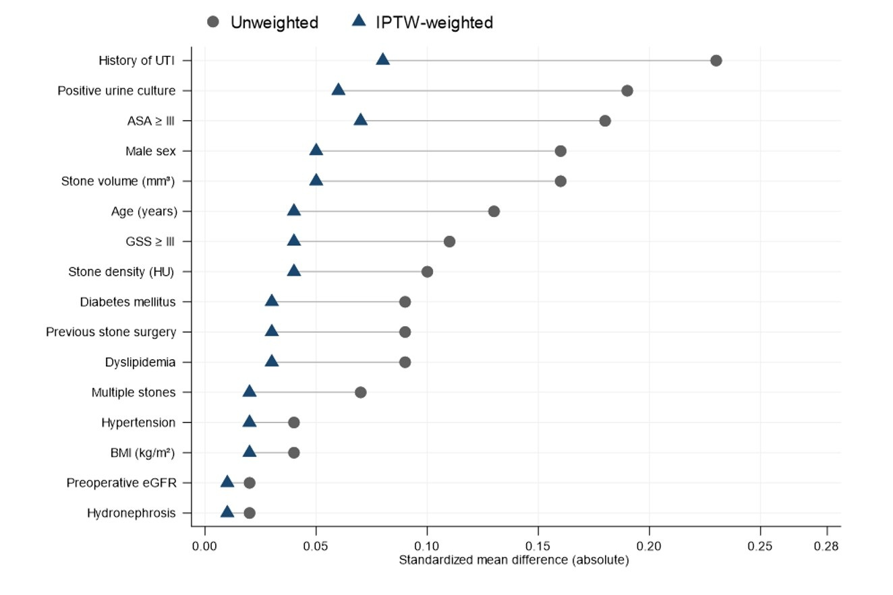
Supplementary Figure S1. Love plot of standardized mean differences (SMDs) for baseline covariates before and after inverse probability of treatment weighting (IPTW). Each covariate is represented by paired points showing the absolute SMD in the unweighted cohort (gray circles) and after IPTW (blue triangles), connected by a horizontal line to illustrate the change in balance. Covariates are ordered by decreasing unweighted SMD. An SMD < 0.1 was considered indicative of adequate covariate balance. After IPTW, all standardized mean differences fell below 0.1, indicating successful covariate balance between the standard mini-percutaneous nephrolithotomy (SmPCNL) and vacuum-assisted mini-percutaneous nephrolithotomy (VmPCNL) groups.
Abbreviations: ASA = American Society of Anesthesiologists; BMI = body mass index; eGFR = estimated glomerular filtration rate; GSS = Guy’s stone score; HU = Hounsfield unit; IPTW = inverse probability of treatment weighting; SMD = standardized mean difference; UTI = urinary tract infection.

