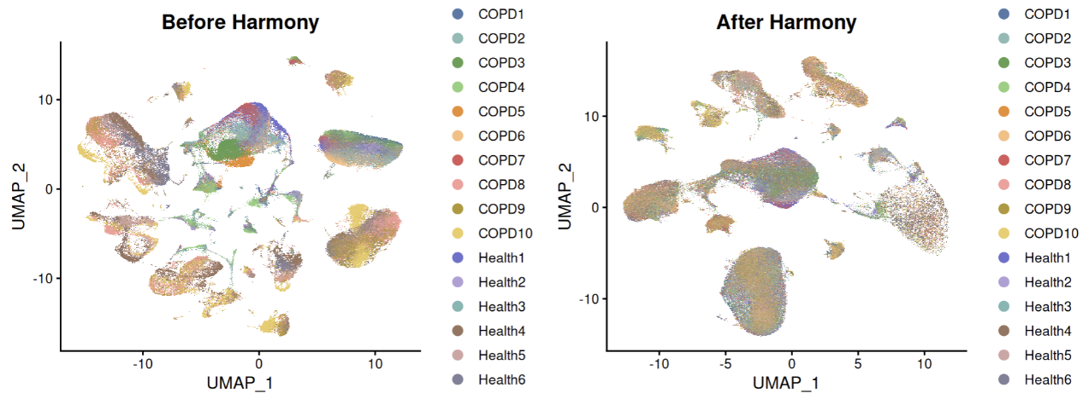
Figure S1. UMAP visualization before and after Harmony correction. UMAP plots showing single cell transcriptomic profiles before and after Harmony correction. Cells are colored by individual sample identity.

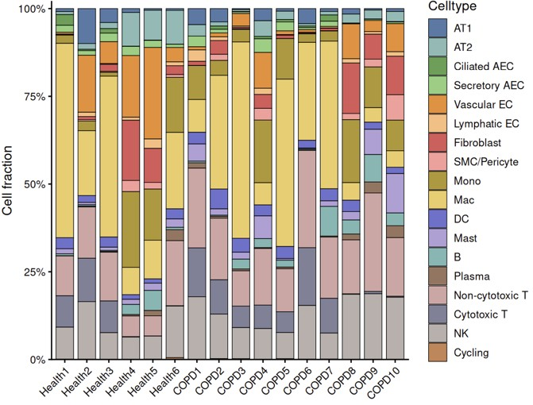
Figure S2. Sample-level distribution of major lung cell populations in healthy controls and COPD. Stacked bar plot displaying the relative proportions of major cell types across individual lung samples from healthy controls and COPD patients. Each column corresponds to one sample, and the colored segments indicate the fractions of annotated cell populations.

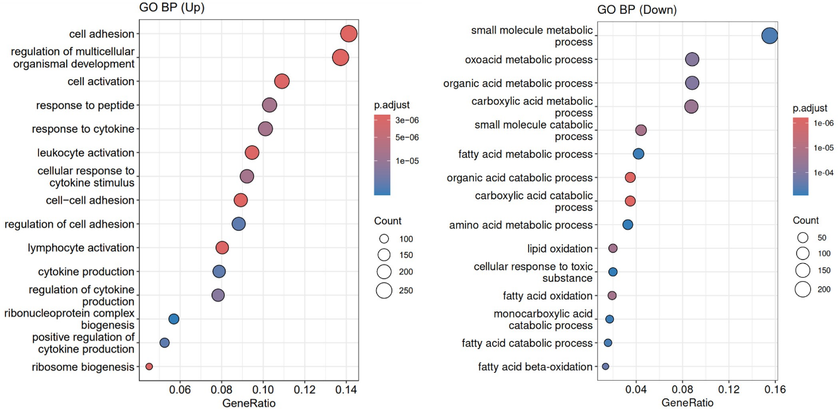
Figure S3. GO biological process enrichment analysis of upregulated and downregulated genes in COPD fibroblasts. GO BP enrichment analysis of upregulated(left) and downregulated(right) genes in COPD fibroblasts relative to healthy controls. Dot size indicates gene count, dot color indicates adjusted P value, and the x-axis shows the gene ratio.

Supplementary Table 1. Demographic and clinical characteristics of the included subjects.
COPD, chronic obstructive pulmonary disease; NA, not available; FEV1, forced expiratory volume in 1 second; FVC, forced vital capacity; ICS, inhaled corticosteroid; OCS, oral corticosteroids.

