Tivozanib versus Sorafenib as Subsequent-Line Therapy for Advanced Renal Cell Carcinoma: A Cost-Effectiveness Analysis from a U.S. Healthcare Perspective
Xiaoyu Zhang^{1†}, Ruming Liu^{2†}, Yani Hu^{1†}, Jiaxi Ye³, Mingdong Yang¹, Junjun Xu¹, Houci Yang¹, Xiaomin Yang¹, Zhiheng Xu¹, Haibin Dai^{1*}, Huimin Xu^{1*}
¹ Department of Pharmacy, The Second Affiliated Hospital, Zhejiang University School of Medicine, Hangzhou, China
² Department of Clinical Pharmacy, The First Affiliated Hospital of Kunming Medical University, Kunming, China
³ School of Pharmaceutical Sciences, Wenzhou Medical University, Wenzhou, China
†Xiaoyu Zhang, Ruming Liu and Yani Hu, contributed equally to this work as co-first authors.
*Haibin Dai and Huimin Xu contributed equally to this work as co-corresponding authors.
*Correspondence: Huimin Xu, Department of Pharmacy, The Second Affiliated Hospital, Zhejiang University School of Medicine, No. 88 Jiefang Road, Shangcheng District, Hangzhou, Zhejiang, 310009, People’s Republic of China, Email xuhuimin78@zju.edu.cn; Haibin Dai, Department of Pharmacy, The Second Affiliated Hospital, Zhejiang University School of Medicine, No. 88 Jiefang Road, Shangcheng District, Hangzhou, Zhejiang, 310009, People’s Republic of China, Email haibindai@zju.edu.cn
Supplementary Materials
Table S1. CHEERS Checklist (2022)
Topic | No. | Item | Reported?
Title and abstract
Title | 1 | Identify the study as an economic evaluation and specify the interventions being compared. | Yes
Abstract | 2 | Provide a structured summary that highlights context, key methods, results, and alternative analyses. | Yes
Introduction
Background and objectives | 3 | Give the context for the study, the study question, and its practical relevance for decision making in policy or practice. | Yes
Methods
Health economic analysis plan | 4 | Indicate whether a health economic analysis plan was developed and where available. | Yes
Study population | 5 | Describe characteristics of the study population (such as age range, demographics, socioeconomic, or clinical characteristics). | Yes
Setting and location | 6 | Provide relevant contextual information that may influence findings. | Yes
Comparators | 7 | Describe the interventions or strategies being compared and why chosen. | Yes
Perspective | 8 | State the perspective(s) adopted by the study and why chosen. | Yes
Time horizon | 9 | State the time horizon for the study and why appropriate. | Yes
Discount rate | 10 | Report the discount rate(s) and reason chosen. | Yes
Selection of outcomes | 11 | Describe what outcomes were used as the measure(s) of benefit(s) and harm(s). | Yes
Measurement of outcomes | 12 | Describe how outcomes used to capture benefit(s) and harm(s) were measured. | Yes
Valuation of outcomes | 13 | Describe the population and methods used to measure and value outcomes. | Yes
Measurement and valuation of resources and costs | 14 | Describe how costs were valued. | Yes
Currency, price date, and conversion | 15 | Report the dates of the estimated resource quantities and unit costs, plus the currency and year of conversion. | Yes
Rationale and description of model | 16 | If modelling is used, describe in detail and why used. Report if the model is publicly available and where it can be accessed. | Yes
Analytics and assumptions | 17 | Describe any methods for analysing or statistically transforming data, any extrapolation methods, and approaches for validating any model used. | Yes
Characterising heterogeneity | 18 | Describe any methods used for estimating how the results of the study vary for subgroups. | Yes
Characterising distributional effects | 19 | Describe how impacts are distributed across different individuals or adjustments made to reflect priority populations. | Yes
Characterising uncertainty | 20 | Describe methods to characterise any sources of uncertainty in the analysis. | Yes
Approach to engagement with patients and others affected by the study | 21 | Describe any approaches to engage patients or service recipients, the general public, communities, or stakeholders (such as clinicians or payers) in the design of the study. | Not applicable
Results
Study parameters | 22 | Report all analytic inputs (such as values, ranges, references) including uncertainty or distributional assumptions. | Yes
Summary of main results | 23 | Report the mean values for the main categories of costs and outcomes of interest and summarise them in the most appropriate overall measure. | Yes
Effect of uncertainty | 24 | Describe how uncertainty about analytic judgments, inputs, or projections affect findings. Report the effect of choice of discount rate and time horizon, if applicable. | Yes
Effect of engagement with patients and others affected by the study | 25 | Report on any difference patient/service recipient, general public, community, or stakeholder involvement made to the approach or findings of the study | Not applicable
Discussion
Study findings, limitations, generalisability, and current knowledge | 26 | Report key findings, limitations, ethical or equity considerations not captured, and how these could affect patients, policy, or practice. | Yes
Other relevant information
Source of funding | 27 | Describe how the study was funded and any role of the funder in the identification, design, conduct, and reporting of the analysis | Yes
Conflicts of interest | 28 | Report authors conflicts of interest according to journal or International Committee of Medical Journal Editors requirements. | Yes
From: Husereau, D., Drummond, M., Augustovski, F., de Bekker-Grob, E., Briggs, A. H., Carswell, C., et al. (2022). Consolidated health economic evaluation reporting standards 2022 (CHEERS 2022) statement: Updated reporting guidance for health economic evaluations. MDM Policy Pract. 7(1), 23814683211061097. doi:10.1177/2381468321106109
Table S2 Summary of the statistical goodness-of-fit of Kaplan Meier survival curves.
Distribution | AIC in tivozanib | BIC in tivozanib | AIC in sorafenib | BIC in sorafenib
PFS curve
Exponential | 811.3039 | 814.4686 | 716.6637 | 719.8285
Weibull | 813.3034 | 819.633 | 699.7159 | 706.0454
Gamma | 812.3513 | 818.6809 | 690.5313 | 696.8608
Generalized Gamma | 781.5972 | 791.0915 | 674.4151 | 683.9095
Gompertz | 804.7518 | 811.0814 | 716.5697 | 722.8993
Log-normal | 785.961 | 792.29 | 674.402 | 680.731
Log-logistic | 789.2582 | 795.5877 | 678.0438 | 684.3734
OS curve
Exponential | 950.6354 | 953.8002 | 972.4392 | 975.604
Weibull | 951.0369 | 957.3664 | 971.4095 | 977.7391
Gamma | 949.4945 | 955.8241 | 970.1107 | 976.4403
Generalized Gamma | 941.5654 | 951.0598 | 966.5954 | 976.0898
Gompertz | 952.2417 | 958.5713 | 974.2195 | 980.5491
Log-normal | 939.665 | 945.994 | 964.604 | 970.934
Log-logistic | 941.2374 | 947.5669 | 966.4419 | 972.7715

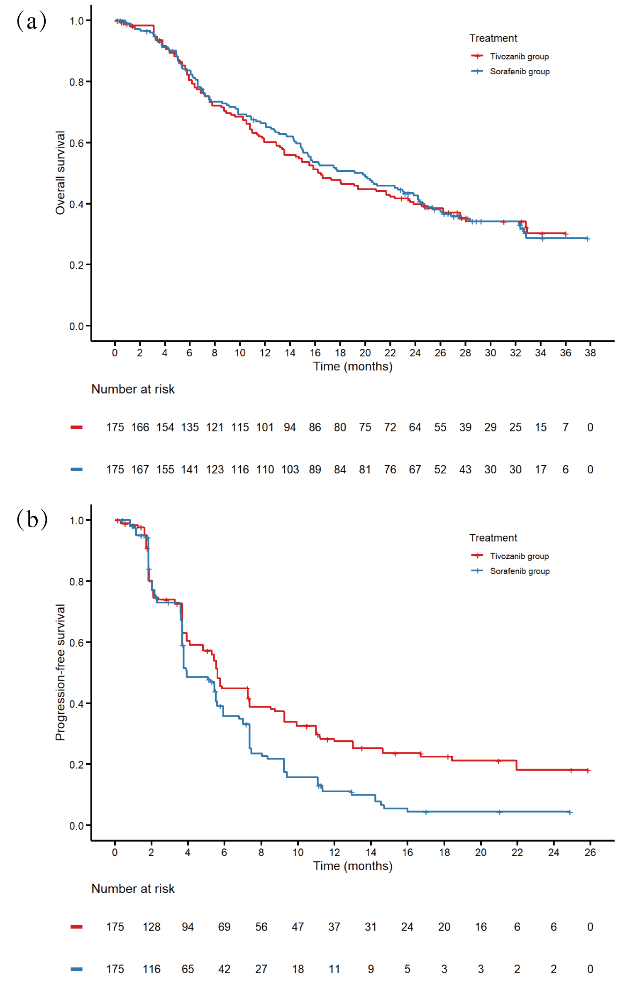
Figure S1 Reconstruction of Kaplan Meier survival curve. Overall survival curve(a), progression-free survival curve (b).
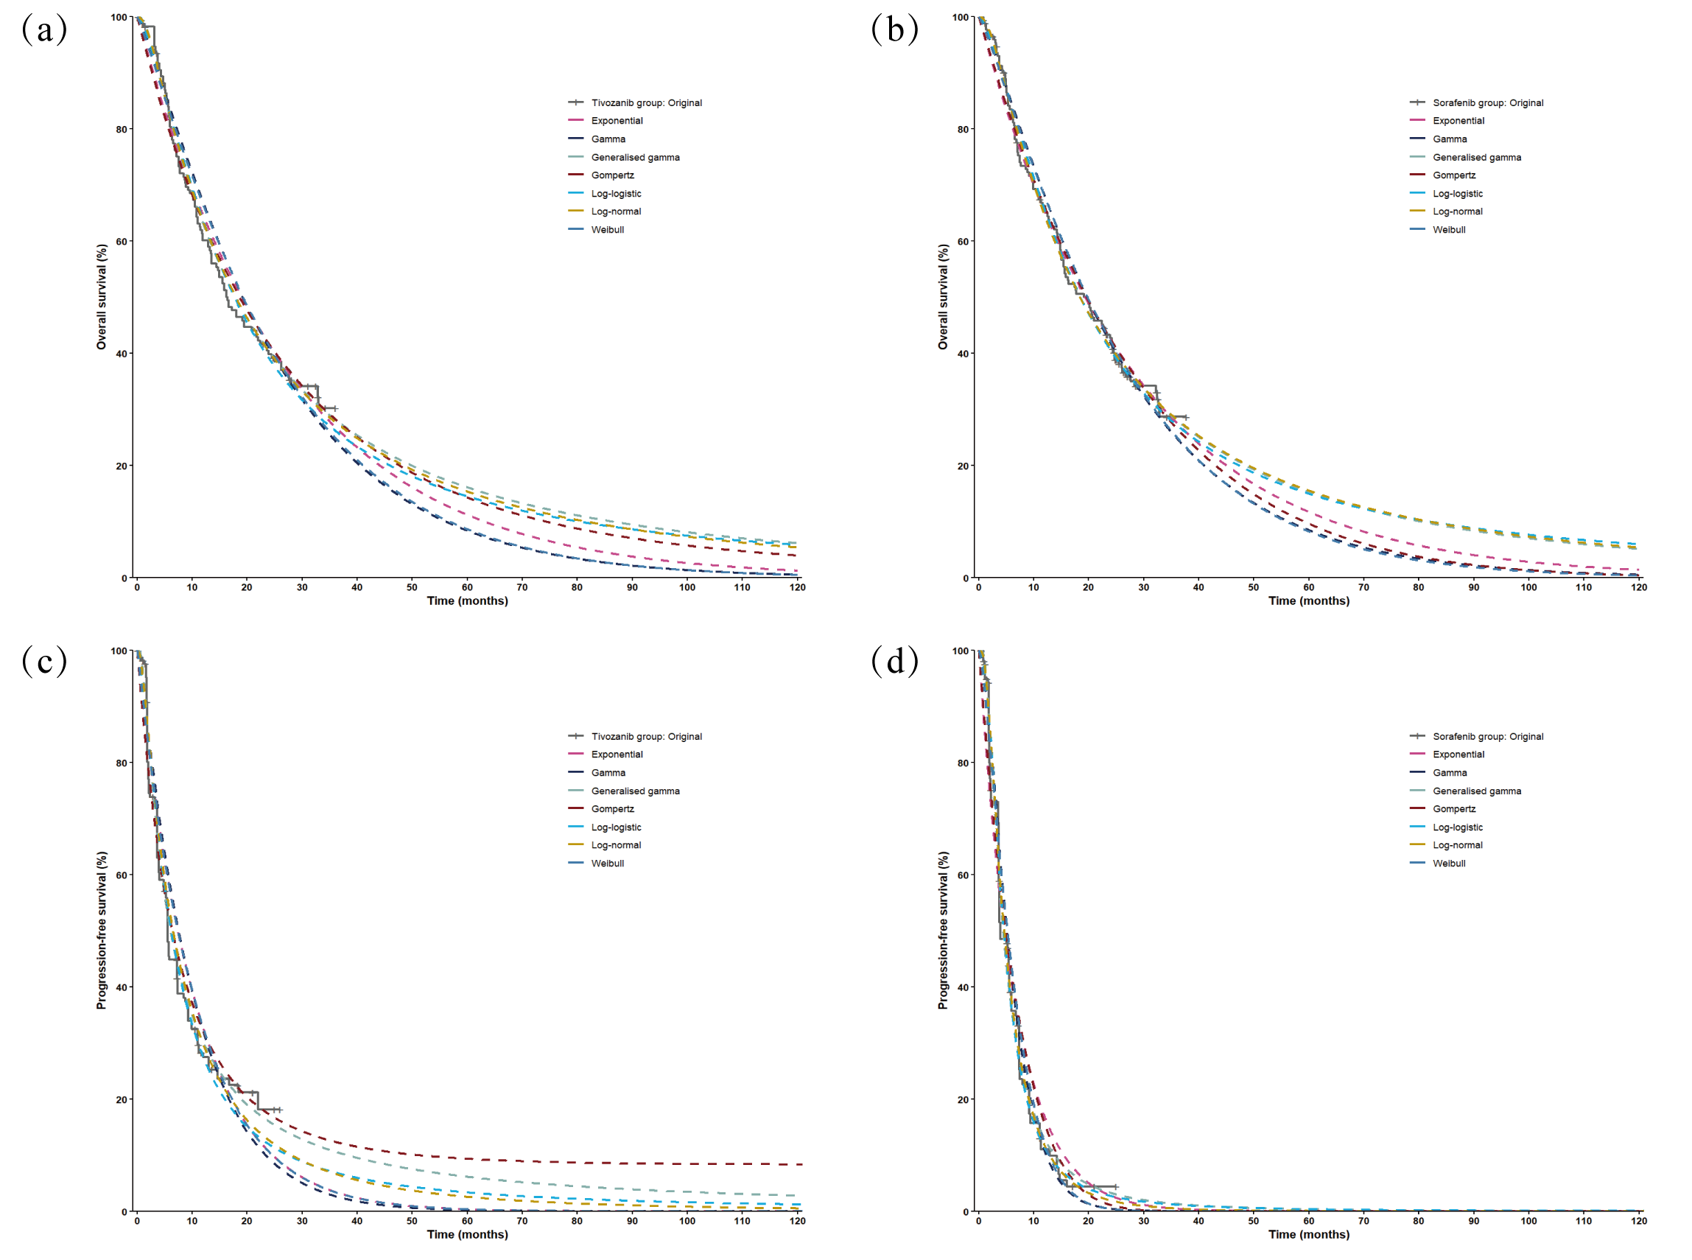
Figure S2 Fitting and extrapolation of Kaplan Meier survival curve. The results of tivozanib OS curve (a); the results of sorafenib OS curve (b); the results of tivozanib PFS curve (c); the results of sorafenib PFS curve (d). Abbreviations: OS: overall survival; PFS: progression-free survival.

