Supporting Information

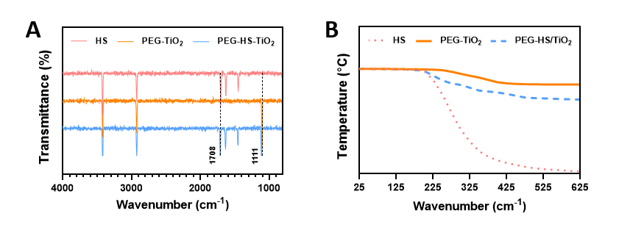
Figure S1. Direct evidence of HS integration and loading quantification. (A) FTIR spectra of pure HS, PEG-TiO₂, and PEG-HS/TiO₂. (B) TGA thermograms of pure HS, PEG-TiO₂, and PEG-HS/TiO₂.

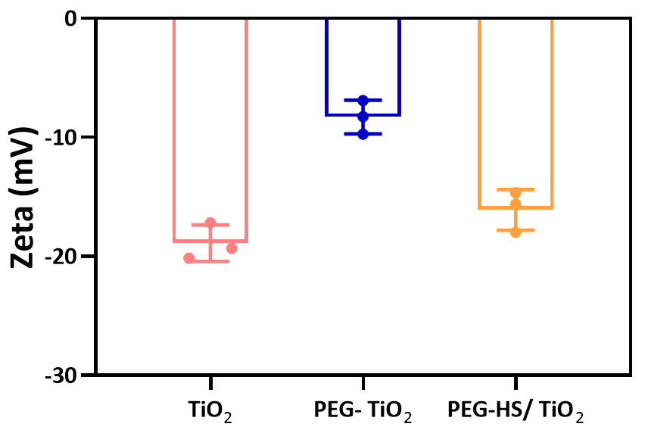
Figure S2. Zeta potentials of TiO₂, PEG-TiO₂, and PEG-HS/TiO₂. Measurements were performed in deionized water (pH 7.4) at 25 °C. Data are presented as mean ± SD (n = 3).

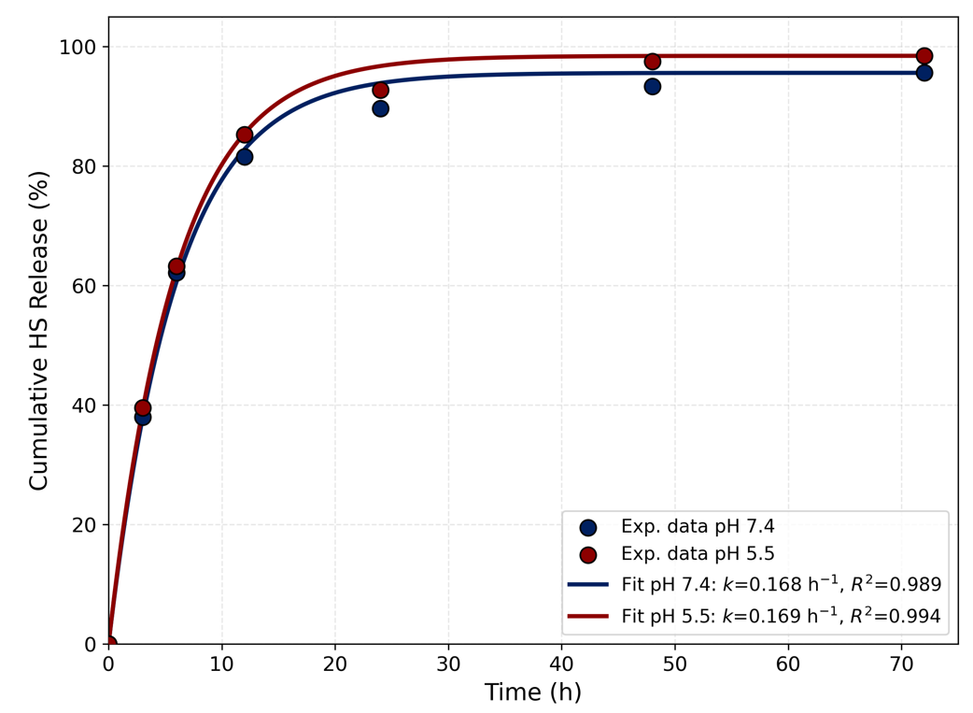
Figure S3. Release kinetics and first-order fitting of HS from PEG-HS/TiO₂. Cumulative release profiles of HS at pH 7.4 (left) and pH 5.5 (right) over 72 h. Symbols represent experimental data (mean ± SD, n = 3). Solid lines represent first-order kinetic fitting. The release rate constants (k) and correlation coefficients (R²) are indicated.

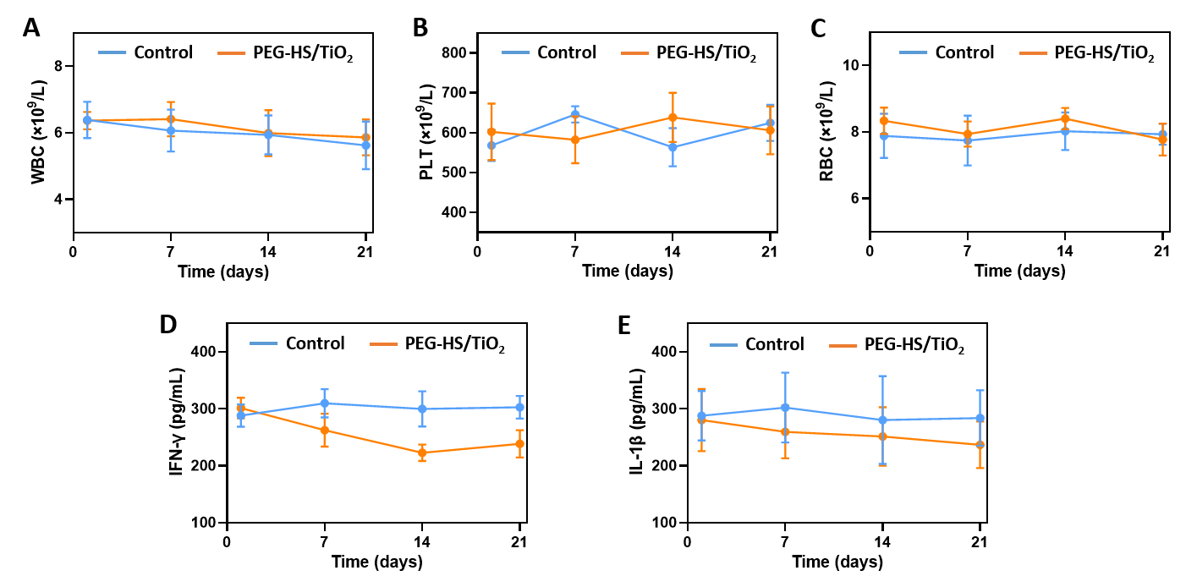
Figure S4. In vivo biosafety assessment: peripheral blood parameters and systemic inflammatory cytokines. (A–C) RBC, WBC, PLT counts at days 0, 7, 14, 21. (D–E) Serum IFN-γ and IL-1β levels at days 0, 7, 14, 21. Data are presented as mean ± SD, n=5.

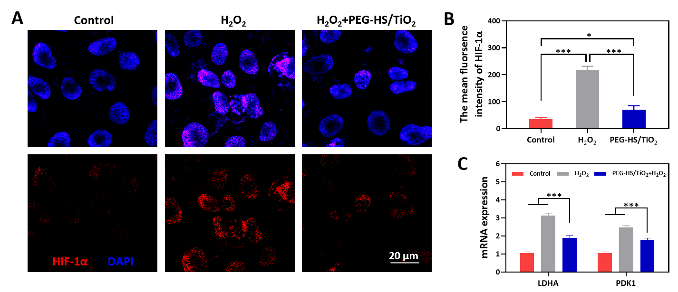
Figure S5. PEG‑HS/TiO₂ inhibits H₂O₂‑induced HIF‑1α nuclear translocation and downregulates HIF‑1α target gene expression in macrophages. (A–B) Representative immunofluorescence images of HIF‑1α (red) and DAPI (blue) in RAW264.7 macrophages treated with PBS, H₂O₂, or H₂O₂ + PEG‑HS/TiO₂ (100 μg/mL) for 24 h. (C) qPCR analysis of HIF‑1α downstream target genes LDHA and PDK1. Data are presented as mean ± SD (n = 3 independent biological replicates). *p < 0.05 and ***p < 0.001.

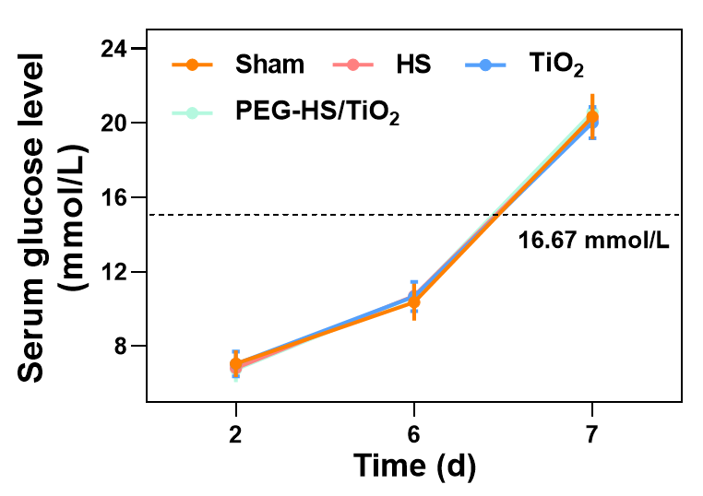
Figure S6. Changes in serum glucose levels of the mice subjected to different treatments at various times after STZ treatment. Data are presented as mean ± SD, n=3.

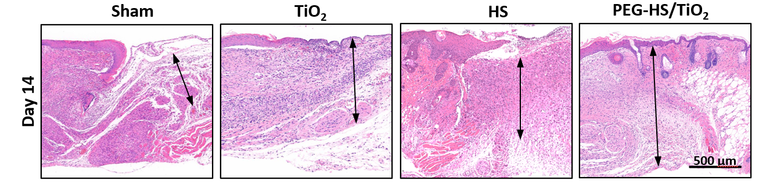
Figure S7. Representative images of HE staining on day 14. The areas between arrows indicate the dermal region.

