Figure S1: A representative image of agar well diffusion assay showing the antibacterial activity of the nanobiotic against MDR bacteria under four different conditions: (1) Control (commercial antibiotic disc), (2) Antibiotic alone, (3) Empty liposome, and (4) Nanobiotic. Clear zone of inhibition in the 4th well indicates the antibacterial effect. Zone diameters were measured in millimeters; [a]TE-nanobiotic; [b]CHL-nanobiotic; [c]NA-nanobiotic
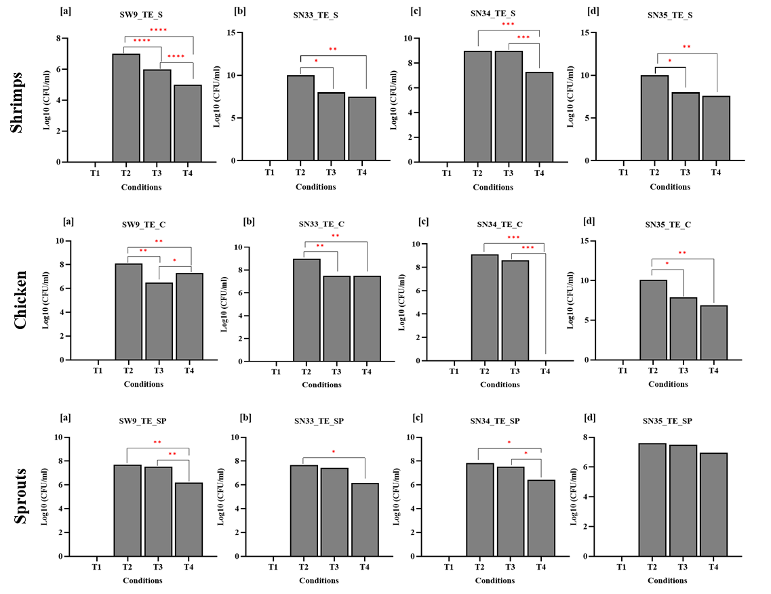

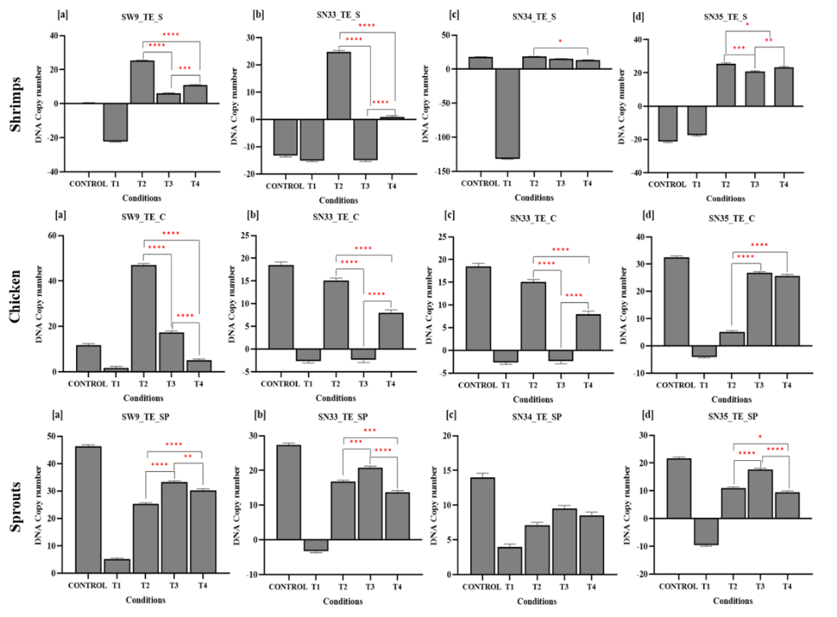
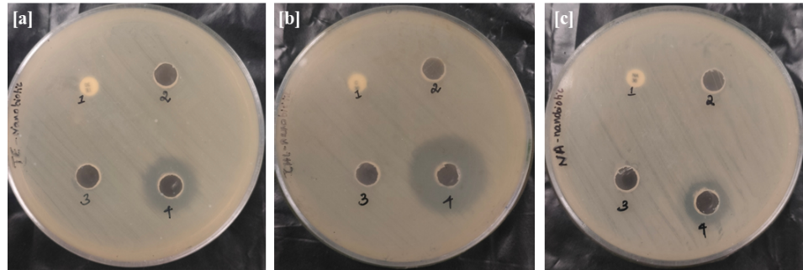
Figure S3: Graphical representation of Spiking assay of different NTS strains for CHL-nanobiotic on shrimps, chicken and sprouts; (a) SW9 (b) SN34 (c) SN35 Graphical representation of the bacterial count (log₁₀ CFU/mL) obtained from the food spiking assay under different treatment conditions: (T1) sterile food matrices, (T2) 0.6 OD bacterial culture, (T3) bacteria and plain antibiotic at MIC level, and (T4) CHL-nanobiotic. The results indicate the antibacterial effectiveness of each treatment in reducing viable bacterial counts in spiked food samples. Data are presented as mean ± SD from three independent experiments. Statistical significance between groups was determined using one-way ANOVA followed by Tukey’s post hoc test (p < 0.05). *- p < 0.05; **- p < 0.01; ***- p < 0.001.
Figure S4: Bar graph showing DNA copy number variation of NTS strains recovered from the food spiking assay for shrimps, chicken and sprouts under different treatment conditions: (T1) sterile food matrices, (T2) 0.6 OD bacterial culture, (T3) bacteria and plain antibiotic at MIC level, and (T4) TE-nanobiotic. DNA copy numbers were quantified using qPCR for invA gene. Data are presented as mean ± SD from three independent experiments. Statistical significance between groups was determined using one-way ANOVA followed by Tukey’s post hoc test (p < 0.05). *- p < 0.05; **- p < 0.01; ***- p < 0.001.
Figure S2: Graphical representation of Spiking assay of different NTS strains for TE-nanobiotic on shrimps, chicken and sprouts; (a) SW9 (b) SN33 (c) SN34 (d) SN35 Graphical representation of the bacterial count (log₁₀ CFU/mL) obtained from the food spiking assay under different treatment conditions: (T1) sterile food matrices, (T2) 0.6 OD bacterial culture, (T3) bacteria and plain antibiotic at MIC level, and (T4) TE-nanobiotic. The results indicate the antibacterial effectiveness of each treatment in reducing viable bacterial counts in spiked food samples. Data are presented as mean ± SD from three independent experiments. Statistical significance between groups was determined using one-way ANOVA followed by Tukey’s post hoc test (p < 0.05); *- p < 0.05; **- p < 0.01; ***- p < 0.001

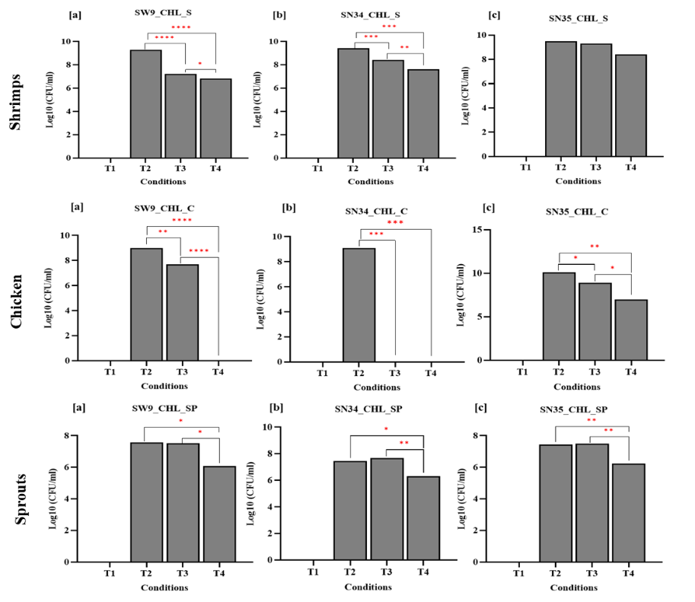

Figure S3: Graphical representation of Spiking assay of different NTS strains for CHL-nanobiotic on shrimps, chicken and sprouts; (a) SW9 (b) SN34 (c) SN35 Graphical representation of the bacterial count (log₁₀ CFU/mL) obtained from the food spiking assay under different treatment conditions: (T1) sterile food matrices, (T2) 0.6 OD bacterial culture, (T3) bacteria and plain antibiotic at MIC level, and (T4) CHL-nanobiotic. The results indicate the antibacterial effectiveness of each treatment in reducing viable bacterial counts in spiked food samples. Data are presented as mean ± SD from three independent experiments. Statistical significance between groups was determined using one-way ANOVA followed by Tukey’s post hoc test (p < 0.05). *- p < 0.05; **- p < 0.01; ***- p < 0.001.

Figure S4: Bar graph showing DNA copy number variation of NTS strains recovered from the food spiking assay for shrimps, chicken and sprouts under different treatment conditions: (T1) sterile food matrices, (T2) 0.6 OD bacterial culture, (T3) bacteria and plain antibiotic at MIC level, and (T4) TE-nanobiotic. DNA copy numbers were quantified using qPCR for invA gene. Data are presented as mean ± SD from three independent experiments. Statistical significance between groups was determined using one-way ANOVA followed by Tukey’s post hoc test (p < 0.05). *- p < 0.05; **- p < 0.01; ***- p < 0.001.

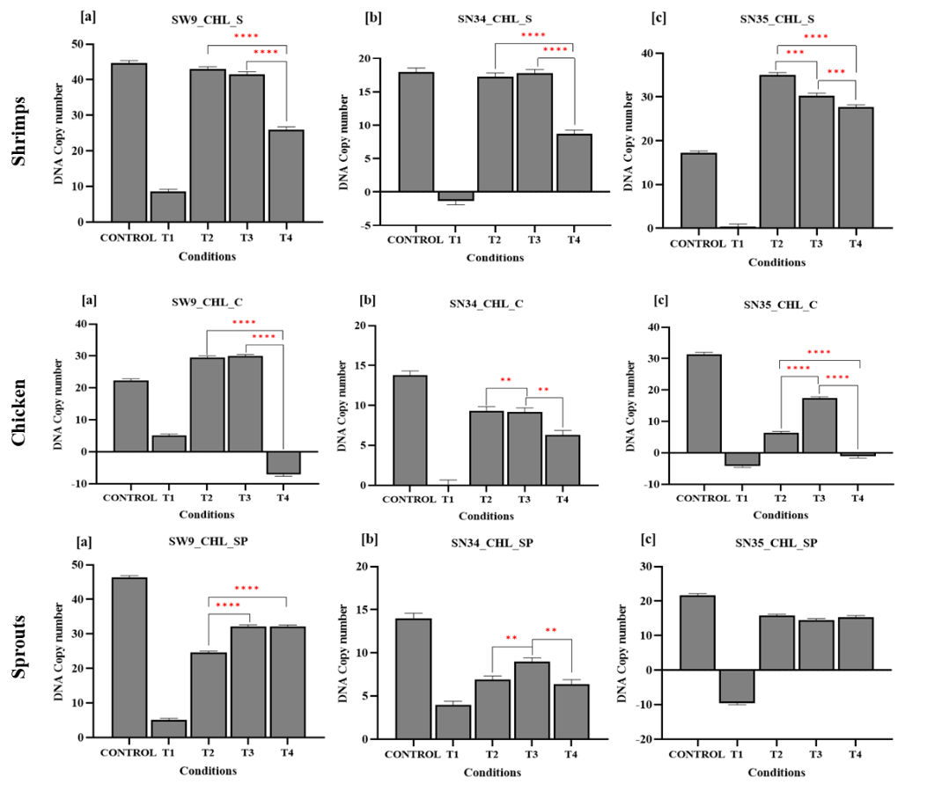

Figure S5: Bar graph showing DNA copy number variation of NTS strains recovered from the food spiking assay for shrimps, chicken and sprouts under different treatment conditions: (T1) sterile food matrices, (T2) 0.6 OD bacterial culture, (T3) bacteria and plain antibiotic at MIC level, and (T4) CHL-nanobiotic. DNA copy numbers were quantified using qPCR for invA gene. Data are presented as mean ± SD from three independent experiments. Statistical significance between groups was determined using one-way ANOVA followed by Tukey’s post hoc test (p < 0.05). *- p < 0.05; **- p < 0.01; ***- p < 0.001.
Table S1: Characterization of antibiotic encapsulated liposomes (nanobiotics)
DLS | Z- average (nm) | PDI | Zeta potential (mv)
Empty liposome | 124.2±3.22 | 0.345±0.01 | -31.3±1.57
TE nanobiotic | 132.7±3.043 | 0.434±0.01 | -51.1±1.27
CHL nanobiotic | 153.4±2.94 | 0.387±0.02 | -58.3±1.50
NA nanobiotic | 186.1±2.53 | 0.41±0.06 | -51.1±0.92

DLS-Dynamic Light Scattering; TE-Tetracycline; CHL-Chloramphenicol; NA-Nalidixic acid; PDI-Polydispersity Index

Table S2: MBC determination of nanobiotics
Nanobiotics | Isolate | No. of bacteria -Free antibiotic (log₁₀CFU/ml) | No. of bacteria – Nanobiotic (log₁₀CFU/ml)
TE | J269 | 4 | <1.0
TE | J186 | 2.568202 | <1.0
TE | J180 | <1.0 | <1.0
TE | KP22 | 3.09659 | <1.0
TE | KP33 | 4.6478 | <1.0
TE | KP03 | <1.0 | <1.0
CHL | J274 | <1.0 | <1.0
CHL | J111 | <1.0 | <1.0
CHL | KP30 | 2.012 | <1.0
CHL | KP39 | 3.0 | <1.0
NA | J110 | 3 | <1.0
NA | J103 | <1.0 | <1.0
NA | KP42 | 3.845098 | <1.0
NA | KP49 | <1.0 | <1.0

Table S3: Primer used for the confirmation of Salmonella spp:
Gene | Primers sequence | Amplicon  size | Annealing | Reference
invA | F: ACAGTGCTCGTTTACGACCTGAAT  R: AGACGACTGGTACTGATCGATAAT | 284 | 64◦C | (17)

