Supplementary materials
Supplementary Figure S1 Flowchart of Patient Selection
Supplementary Table S1 Operational Definitions of Selected Study Variables
Supplementary Table S2 Missingness of Variables with Missing Data in the Full Cohort
Supplementary Table S3 Item Importance Ratings and Coefficients of Variation in the First Round of Expert Consultation
Supplementary Table S4 Item Importance Ratings and Coefficients of Variation in the Second Round of Expert Consultation
Supplementary Table S5 Variables with Non-Zero Coefficients Selected by LASSO Regression
Supplementary Table S6 Pairwise Comparison of AUCs among the Three Models Using the DeLong Test

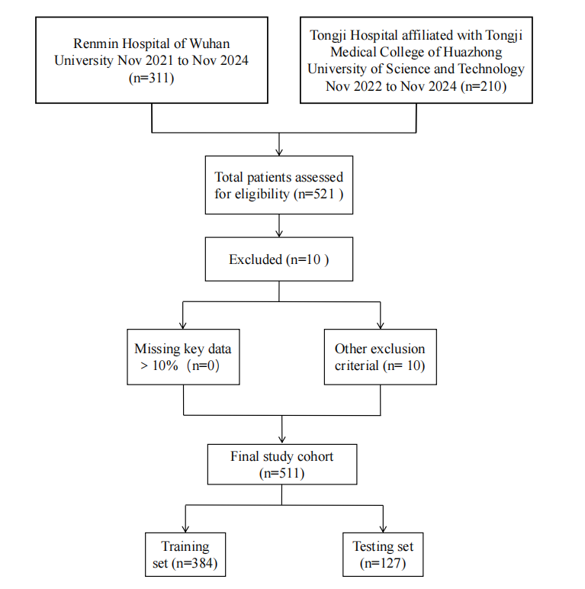
Supplementary Figure S1 Flowchart of Patient Selection

Supplementary Table S1 Operational Definitions of Selected Study Variables
Variable | Operational definition
Shock | Defined as persistent systolic blood pressure <90 mmHg and/or the requirement for vasoactive agents to maintain hemodynamic stability, with or without evidence of end-organ hypoperfusion.
Cardiac tamponade | Defined as pericardial effusion or hemopericardium causing hemodynamic compromise. The diagnosis was based on clinical manifestations (e.g., hypotension, tachycardia) together with imaging evidence such as echocardiographic signs of right atrial or right ventricular compression or inferior vena cava dilatation.
Limb ischemia | Defined as an acute reduction in limb perfusion that may threaten limb viability. The diagnosis was based on clinical manifestations (e.g., pain, pallor, pulselessness, sensory deficit, or motor dysfunction) and/or imaging findings indicating restricted blood flow or vascular occlusion.
Cerebral hypoperfusion | Defined as newly developed neurological deficits and/or impaired consciousness, with imaging evidence suggestive of reduced cerebral blood flow or supra-aortic branch malperfusion when available.
Pulmonary complications | Defined as a composite endpoint including newly developed postoperative pulmonary edema, atelectasis, or pulmonary infection (pneumonia), all of which were absent preoperatively. Pulmonary edema was diagnosed based on imaging findings (e.g., chest radiography or CT suggesting pulmonary edema) together with compatible clinical respiratory deterioration. Atelectasis was diagnosed based on postoperative imaging showing lobar or segmental collapse or reduced lung aeration. Pulmonary infection (pneumonia) was diagnosed based on new pulmonary infiltrates on imaging together with clinical evidence of infection. To reduce temporal ambiguity, only pulmonary complications occurring before delayed extubation were included in the analysis.
Acute lung injury | Defined in reference to contemporary ARDS-related criteria. In patients with sufficient data, adjudication included acute onset (usually within 1 week of a known clinical insult), bilateral pulmonary infiltrates/opacities on chest imaging not fully explained by pleural effusions, atelectasis, or nodules, respiratory failure not fully explained by cardiogenic pulmonary edema or fluid overload, and impaired oxygenation (e.g., PaO₂/FiO₂ ≤300 mmHg). Patients with postoperative acute hypoxemia and clinical or radiological evidence of lung injury who did not fully meet strict ARDS criteria, or in whom some required elements were unavailable, were still included in this category for analysis.

Supplementary Table S2 Missingness of Variables with Missing Data in the Full Cohort
Variable | Missing (n) | Missing (%)
BMI (kg/m²) | 21 | 4.110
Onset-to-surgery time(hour) | 1 | 0.196
White blood cell count (×10⁹/L) | 1 | 0.196
Platelet count (×10⁹/L) | 1 | 0.196
Serum creatinine(µmol/L) | 3 | 0.587
CPB time(min) | 7 | 1.370
Ascending aortic cross-clamp time(min) | 10 | 1.957
Serum albumin(g/L) | 1 | 0.196
Peak serum creatinine(µmol/L) | 1 | 0.196
Lactate at end of surgery(mmol/L) | 1 | 0.196
Interleukin-6(pg/mL) | 135 | 26.419
Intraoperative fluid balance(mL) | 157 | 30.724

Supplementary Table S3 Item Importance Ratings and Coefficients of Variation in the First Round of Expert Consultation
Variable | Mean | Standard deviation | Coefficient of variation
Baseline characteristics
Age | 4.67 | 0.49 | 0.10
Body mass index | 3.60 | 0.83 | 0.23
Sex | 4.60 | 0.51 | 0.11
Smoking history | 4.73 | 0.46 | 0.10
Preoperative variables
Onset-to-surgery time | 4.27 | 0.88 | 0.21
White blood cell count | 4.13 | 0.99 | 0.24
Platelet count | 3.93 | 0.80 | 0.20
Blood lactate | 4.60 | 0.63 | 0.14
Blood glucose | 3.40 | 0.99 | 0.29
D-dimer | 3.33 | 1.23 | 0.37
Cardiac troponin I | 3.47 | 1.46 | 0.42
Interleukin-6 | 3.80 | 0.862 | 0.23
Shock | 4.93 | 0.26 | 0.05
Cerebral hypoperfusion | 4.87 | 0.35 | 0.07
Cardiac tamponade | 4.93 | 0.26 | 0.05
Limb ischemia | 4.53 | 0.52 | 0.11
Preoperative analgesic use | 3.87 | 1.25 | 0.32
Intraoperative variables
Cardiopulmonary bypass time | 4.73 | 0.46 | 0.10
Deep hypothermic circulatory arrest | 4.80 | 0.41 | 0.09
Ascending aortic cross-clamp time | 4.67 | 0.72 | 0.16
Blood transfusion volume | 4.33 | 0.72 | 0.17
Red blood cell transfusion volume | 4.40 | 0.63 | 0.14
Ascending aortic diameter | 3.67 | 1.11 | 0.30
Concomitant coronary artery bypass grafting | 4.60 | 0.51 | 0.11
Concomitant other cardiac surgery | 4.53 | 0.52 | 0.11
Postoperative variables
Serum albumin | 3.67 | 0.82 | 0.22
Serum creatinine | 4.00 | 0.85 | 0.21
Plasma transfusion | 4.20 | 0.78 | 0.18
Platelet transfusion | 4.27 | 0.59 | 0.14
Stroke | 4.93 | 0.26 | 0.05
Lactate at end of surgery | 4.27 | 0.96 | 0.23

Supplementary Table S4 Item Importance Ratings and Coefficients of Variation in the Second Round of Expert Consultation
Variable | Mean | Standard deviation | Coefficient of variation
Baseline characteristics
Age | 4.53 | 0.52 | 0.11
Body mass index | 3.60 | 0.83 | 0.23
Sex | 4.53 | 0.52 | 0.11
Smoking history | 4.87 | 0.35 | 0.07
Chronic obstructive pulmonary disease comorbidity | 5.00 | 0.00 | 0.00
Preoperative variables
Onset-to-surgery time | 4.20 | 0.94 | 0.22
White blood cell count | 4.00 | 0.93 | 0.23
Platelet count | 3.87 | 0.92 | 0.24
Blood lactate | 4.60 | 0.51 | 0.11
Interleukin-6 | 3.80 | 0.86 | 0.23
Shock | 4.87 | 0.35 | 0.07
Cerebral hypoperfusion | 4.80 | 0.56 | 0.12
Cardiac tamponade | 4.87 | 0.35 | 0.07
Limb ischemia | 4.53 | 0.64 | 0.14
Serum albumin | 4.07 | 0.80 | 0.20
Intraoperative variables
Cardiopulmonary bypass time | 4.80 | 0.41 | 0.09
Deep hypothermic circulatory arrest | 4.73 | 0.46 | 0.10
Ascending aortic cross-clamp time | 4.60 | 0.74 | 0.16
Blood transfusion volume | 4.40 | 0.63 | 0.14
ntraoperative fluid input and output | 4.20 | 1.01 | 0.24
Concomitant coronary artery bypass grafting | 4.60 | 0.63 | 0.14
Concomitant other cardiac surgery | 4.60 | 0.51 | 0.11
Postoperative variables
Serum albumin | 4.00 | 0.66 | 0.16
Peak serum creatinine | 4.07 | 0.80 | 0.20
Plasma transfusion | 4.40 | 0.74 | 0.17
Platelet transfusion | 4.27 | 0.70 | 0.16
Stroke | 4.80 | 0.56 | 0.12
Lactate at end of surgery | 4.27 | 0.80 | 0.19
Acute lung injury | 4.93 | 0.26 | 0.05
Pulmonary complications | 4.93 | 0.26 | 0.05

Supplementary Table S5 Variables with Non-Zero Coefficients Selected by LASSO Regression
Variable | Coefficient
preoperative blood lactate (mmol/L) | 0.0318911315
CPB time (min) | 0.0024623979
peak postoperative serum creatinine (µmol/L) | 0.0016264450
postoperative plasma transfusion (mL) | 0.0007163904
lactate at the end of surgery (mmol/L) | 0.0222939682
pulmonary complications | 0.3932615242

Supplementary Table S6 Pairwise Comparison of AUCs among the Three Models Using the DeLong Test
Comparison | AUC of model 1 | AUC of model 2 | AUC difference | Z statistic | P
XGBoost vs. SVM | 0.784 | 0.820 | -0.0352 | -1.26 | 0.207
XGBoost vs. Logistic regression | 0.784 | 0.805 | -0.0210 | -0.663 | 0.507
SVM vs. Logistic regression | 0.820 | 0.805 | 0.0142 | 1.60 | 0.111

