Supplemental Material 1 – Search strategy

Pubmed
("Lidocaine"[Mesh] OR lidocaine[Title/Abstract])
AND
("Thoracic Surgery, Video-Assisted"[Mesh] OR (("video-assisted thoracic surgery" OR "video-assisted thoracoscopic surgery" OR VATS)[Title/Abstract]))

Web of Science
TS=("lidocaine")
AND
TS=("video-assisted thoracic surgery" OR "video-assisted thoracoscopic surgery" OR "VATS")

Embase
(lidocaine: ab,ti)
AND
(video assisted thoracoscopic surgery/ OR ('video assisted thoracic surgery' OR 'video-assisted thoracoscopic surgery' OR vats): ab,ti)

Cochrane
(MeSH descriptor: [Lidocaine] explode all trees OR lidocaine:ti,ab)
AND
(MeSH descriptor: [Thoracic Surgery, Video-Assisted] explode all trees OR ("video assisted thoracic surgery" OR "video assisted thoracoscopic surgery" OR VATS):ti,ab)

CNKI
SU=('Lidocaine')
AND
SU=('video-assisted thoracic surgery' OR 'thoracoscopic surgery' OR 'VATS')

WANFANG
Subject:("Lidocaine")
AND
Subject:("video-assisted thoracic surgery" OR "thoracoscopic surgery" OR "VATS")

SinoMed
"Lidocaine"[Common Fields] OR "Lidocaine"[Subject Headings]
AND
"video-assisted thoracic surgery"[Common Fields] OR "Thoracic Surgery, Video-Assisted"[Subject Headings]
Supplemental Table 1. Leave-one-out sensitivity analysis of primary outcomes in included studies.
Study | Intravenous lidocaine  No. of patients | Placebo  No. of patients | Random effects,  MD (95% CI) | I² (%) | P-value
Pain scores (at rest) at 6-8 h
Omitting Cui, 2011²⁴ | 270 | 261 | -0.63 (-1.26, 0.00) | 96.2% | 0.05
Omitting Wang, 2015²⁶ | 260 | 251 | -0.76 (-1.41, -0.11) | 96.3% | 0.02
Omitting Yao, 2021³⁰ | 249 | 240 | -0.78 (-1.42, -0.14) | 96.1% | 0.02
Omitting Zheng, 2021³¹ | 262 | 256 | -0.51 (-1.08, 0.06) | 95.6% | 0.08
Omitting Xie, 2023³⁴ | 255 | 246 | -0.48 (-1.01, 0.06) | 88.4% | 0.08
Omitting Ren, 2025³⁷ | 245 | 238 | -0.79 (-1.42, -0.16) | 96.0% | 0.01
Omitting Zhu, 2025³⁸ | 244 | 237 | -0.63 (-1.29, 0.04) | 95.9% | 0.06
Omitting Zhang, 2025³⁶ | 245 | 238 | -0.78 (-1.42, -0.13) | 96.3% | 0.02
Pain scores (at rest) at 24 h
Omitting Cui, 2011²⁴ | 325 | 314 | -0.48 (-0.87, -0.10) | 89.1% | 0.01
Omitting Wang, 2015²⁶ | 315 | 304 | -0.54 (-0.95, -0.13) | 89.2% | 0.01
Omitting Yao, 2021³⁰ | 304 | 293 | -0.55 (-0.96, -0.15) | 87.0% | <0.01
Omitting Hou, 2021²⁸ | 315 | 304 | -0.51 (-0.92, -0.10) | 89.1% | 0.01
Omitting Zheng, 2021³¹ | 317 | 309 | -0.42 (-0.80, -0.05) | 87.8% | 0.03
Omitting Fan, 2022³² | 300 | 289 | -0.27 (-0.49, -0.05) | 56.3% | 0.02
Omitting Ren, 2023³³ | 312 | 301 | -0.44 (-0.82, -0.06) | 88.5% | 0.02
Omitting Hojski,2024³⁵ | 317 | 310 | -0.54 (-0.93, -0.15) | 89.2% | 0.01
Omitting Ren, 2025³⁷ | 300 | 291 | -0.55 (-0.95, -0.15) | 89.2% | 0.01
Omitting Zhang, 2025³⁶ | 300 | 291 | -0.56 (-0.96, -0.17) | 88.9% | 0.01
Pain scores (at rest) at 48 h
Omitting Cui, 2011²⁴ | 325 | 314 | -0.31 (-0.53, -0.09) | 64.9% | 0.01
Omitting Wang, 2015²⁶ | 315 | 304 | -0.36 (-0.63, -0.09) | 66.7% | 0.01
Omitting Hou, 2021²⁸ | 315 | 304 | -0.38 (-0.59, -0.17) | 60.7% | <0.01
Omitting Yao, 2021³⁰ | 304 | 293 | -0.38 (-0.65, -0.10) | 65.3% | 0.01
Omitting Zheng, 2021³¹ | 317 | 309 | -0.21 (-0.28, -0.14) | 16.3% | < 0.01
Omitting Fan, 2022³² | 300 | 289 | -0.34 (-0.60, -0.08) | 66.1% | 0.01
Omitting Ren, 2023³³ | 312 | 301 | -0.31 (-0.54, -0.09) | 65.1% | 0.01
Omitting Hojski, 2024³⁵ | 317 | 310 | -0.37 (-0.61, -0.13) | 66.1% | <0.01
Omitting Ren, 2025³⁷ | 300 | 291 | -0.37 (-0.64, -0.10) | 67.2% | 0.01
Omitting Zhang, 2025³⁶ | 300 | 291 | -0.36 (-0.63, -0.09) | 66.9% | 0.01
Pain scores (during activity) at 6-8 h
Omitting Cui, 2010²³ | 255 | 245 | -0.77 (-1.40, -0.14) | 96.7% | 0.02
Omitting Cui, 2011²⁴ | 255 | 245 | -0.73 (-1.31, -0.14) | 96.6% | 0.01
Omitting Wang, 2015²⁶ | 245 | 235 | -0.41 (-0.72, -0.09) | 60.5% | 0.01
Omitting Yao, 2021³⁰ | 234 | 224 | -0.93 (-1.54, -0.32) | 94.8% | <0.01
Omitting Hojski, 2024³⁵ | 247 | 241 | -0.83 (-1.46, -0.20) | 96.7% | 0.01
Omitting Ren, 2025³⁷ | 230 | 222 | -0.89 (-1.53, -0.26) | 96.7% | 0.01
Omitting Zhu, 2025³⁸ | 229 | 221 | -0.79 (-1.44, -0.15) | 96.6% | 0.02
Omitting Zhang, 2025³⁶ | 230 | 222 | -0.92 (-1.54, -0.31) | 96.6% | <0.01
Pain scores (during activity) at 24 h
Omitting Cui, 2011²⁴ | 222 | 218 | -0.76 (-1.24, -0.28) | 93.1% | <0.01
Omitting Wang, 2015²⁶ | 212 | 208 | -0.69 (-1.19, -0.20) | 75.6% | 0.01
Omitting Yao, 2021³⁰ | 201 | 197 | -0.92 (-1.40, -0.43) | 85.3% | <0.01
Omitting Ren, 2023³³ | 209 | 205 | -0.62 (-1.00, -0.24) | 91.9% | <0.01
Omitting Hojski, 2024³⁵ | 214 | 210 | -0.79 (-1.31, -0.26) | 93.1% | <0.01
Omitting Ren, 2025³⁷ | 197 | 195 | -0.88 (-1.42, -0.35) | 93.2% | <0.01
Omitting Zhang, 2025³⁶ | 197 | 195 | -0.88 (-1.42, -0.34) | 93.2% | <0.01
Pain scores (during activity) at 48 h
Omitting Cui, 2011²⁴ | 222 | 218 | -0.29 (-0.50, -0.09) | 62.5% | 0.01
Omitting Wang, 2015²⁶ | 212 | 208 | -0.41 (-0.68, -0.15) | 69.0% | <0.01
Omitting Yao, 2021³⁰ | 201 | 197 | -0.42 (-0.67, -0.17) | 41.6% | <0.01
Omitting Ren, 2023³³ | 209 | 205 | -0.33 (-0.56, -0.11) | 68.6% | <0.01
Omitting Hojski, 2024³⁵ | 214 | 210 | -0.29 (-0.49, -0.08) | 60.5% | 0.01
Omitting Ren, 2025³⁷ | 197 | 195 | -0.35 (-0.63, -0.07) | 64.1% | 0.01
Omitting Zhang, 2025³⁶ | 197 | 195 | -0.30 (-0.54, -0.06) | 54.1% | 0.02

Supplemental Table 2. GRADE evidence of primary outcomes and clinically important secondary outcomes in included studies.
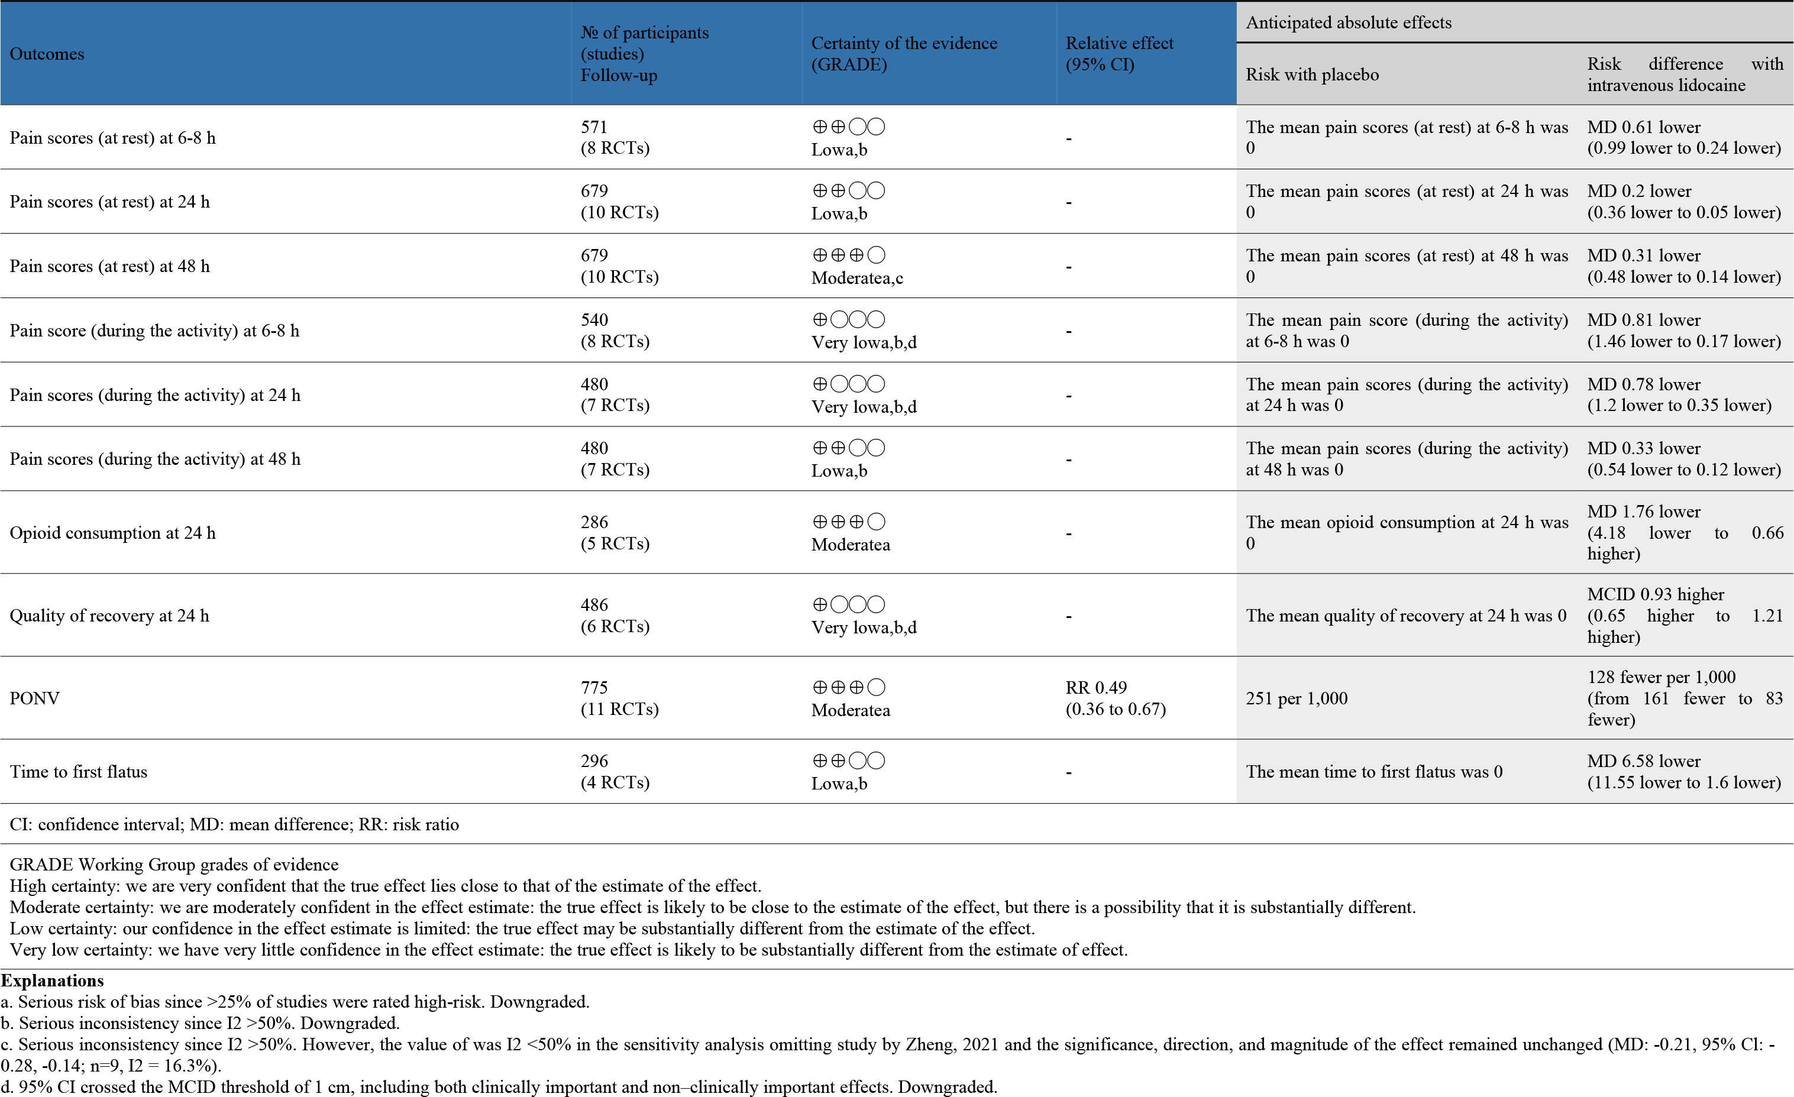

Supplemental Figure 1. The risk of bias of the included studies.
(A) Risk of bias graph: review authors’ judgements for included studies.
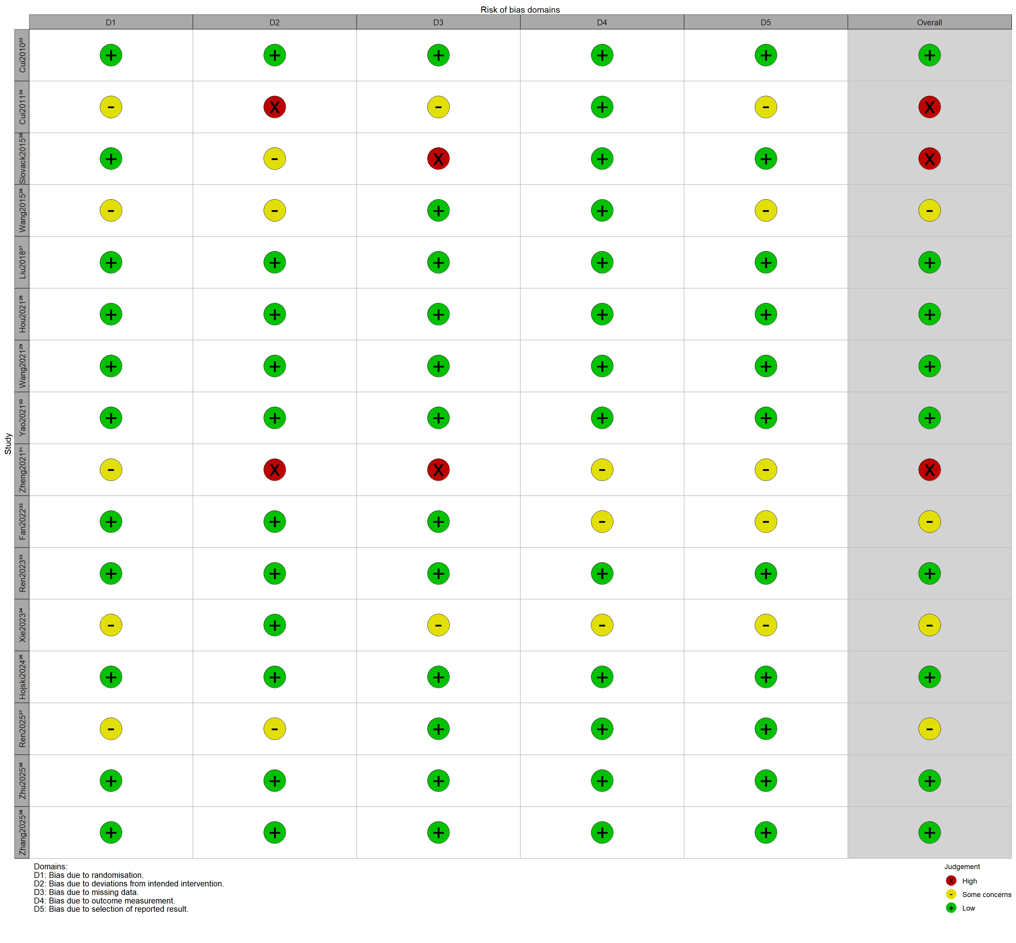
(B) Risk of bias summary: review authors’ judgements presented as percentage across included studies.

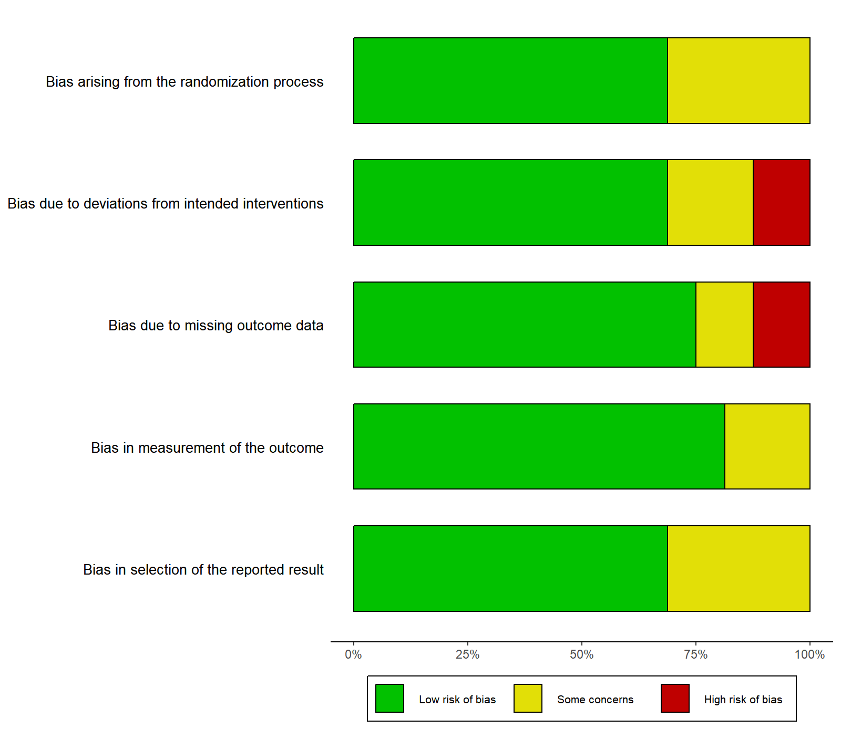
Supplemental Figure 2. Forest plot of the effect of perioperative intravenous lidocaine on quality of recovery after video-assisted thoracic surgery.
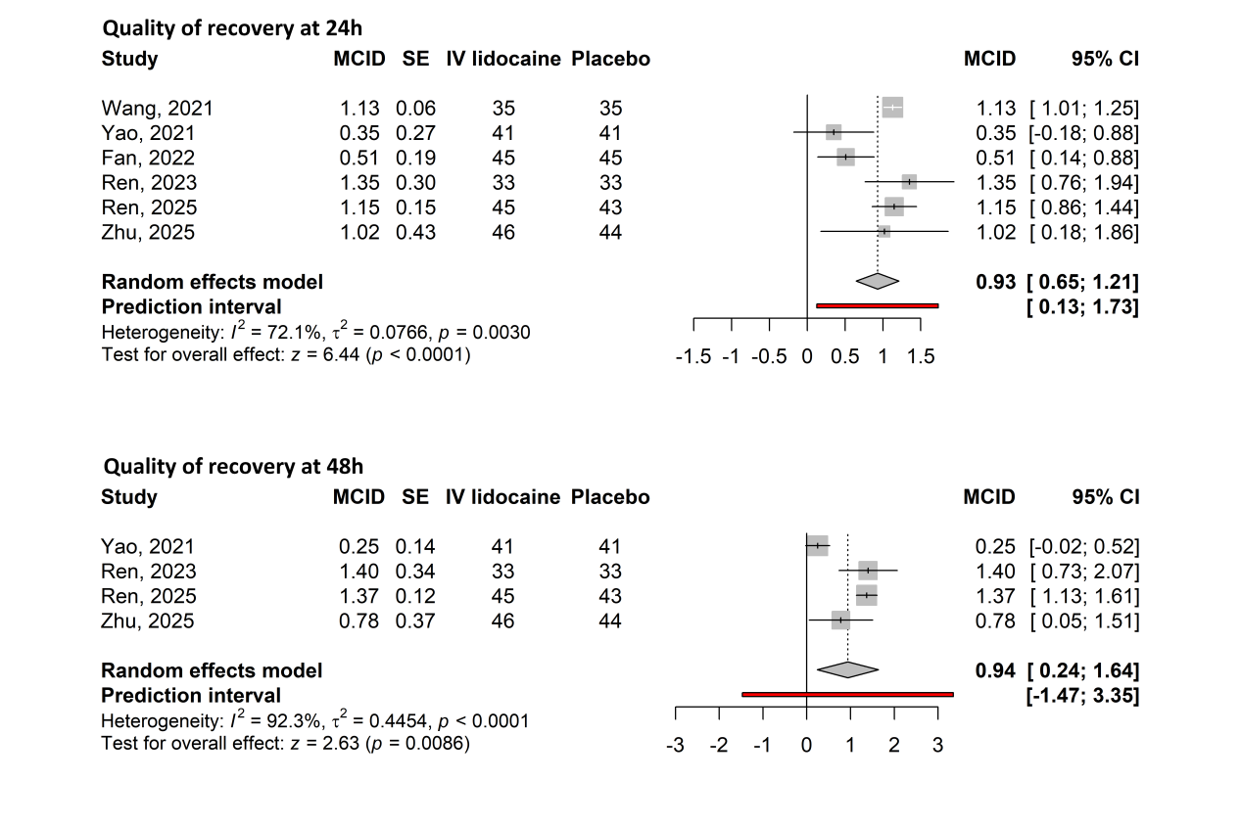

Supplemental Figure 3. Forest plot of the effect of perioperative intravenous lidocaine on postoperative nausea and vomiting (PONV) after video-assisted thoracic surgery.

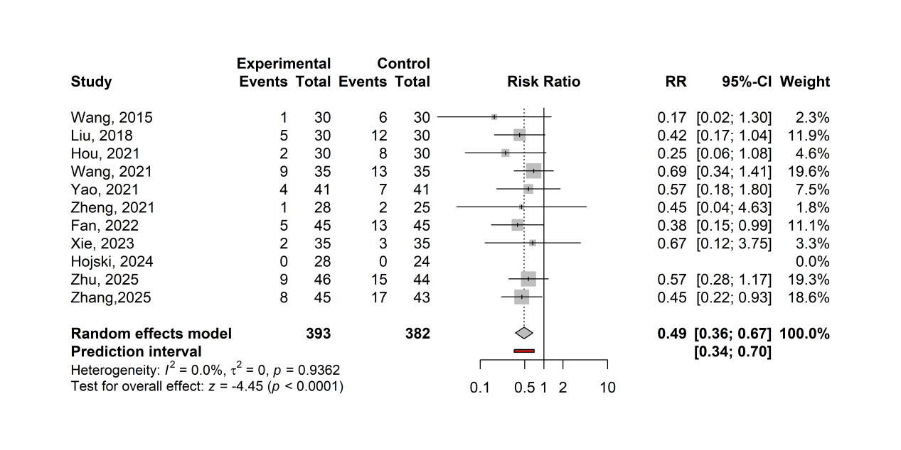

Supplemental Figure 4. Forest plot of the effect of perioperative intravenous lidocaine on gastrointestinal function recovery after video-assisted thoracic surgery.
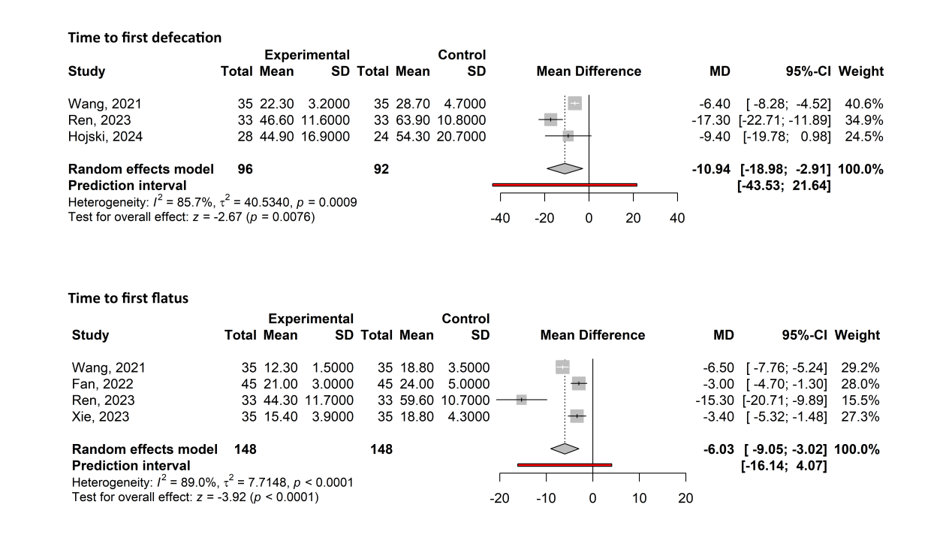
Supplemental Figure 5. Forest plot of the effect of perioperative intravenous lidocaine on postoperative pulmonary complications after video-assisted thoracic surgery.
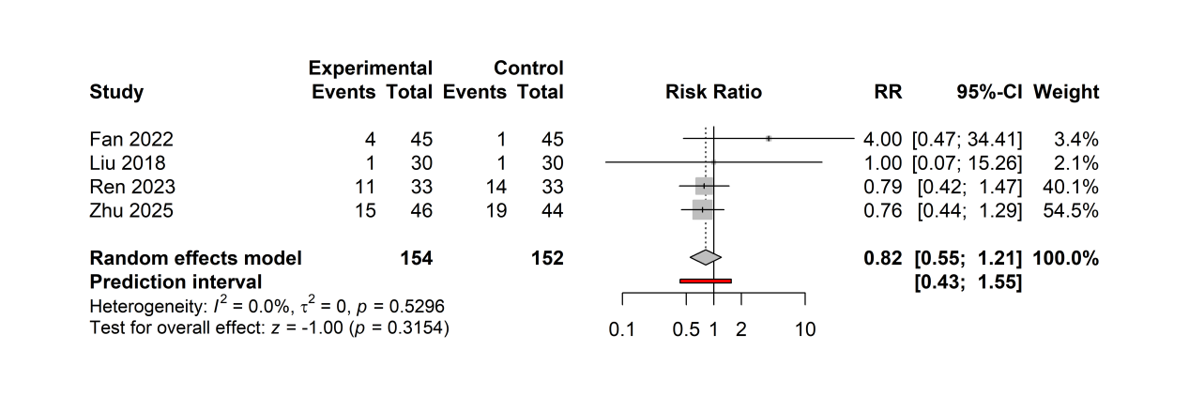
Supplemental Figure 6. Forest plot of the effect of perioperative intravenous lidocaine on postoperative arrhythmias after video-assisted thoracic surgery.
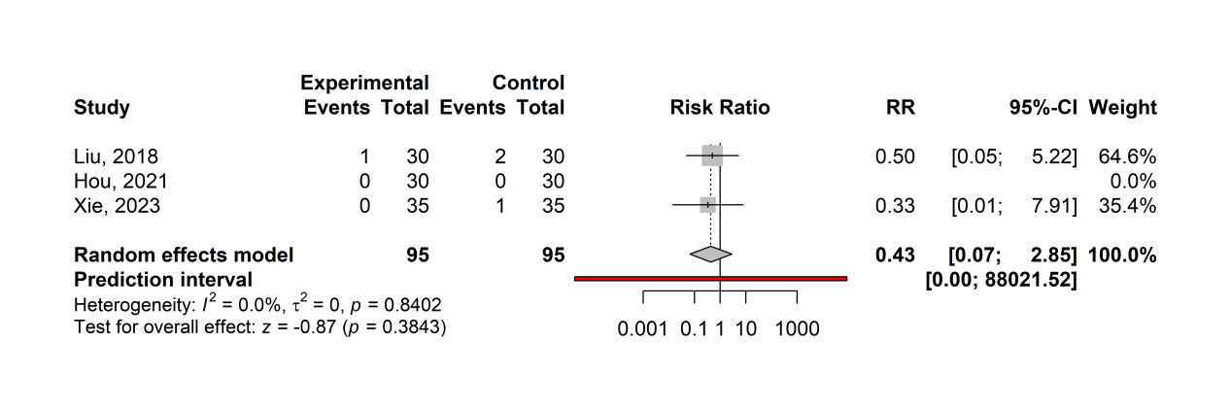

Supplemental Figure 7. Forest plot of the effect of perioperative intravenous lidocaine on postoperative dizziness after video-assisted thoracic surgery.
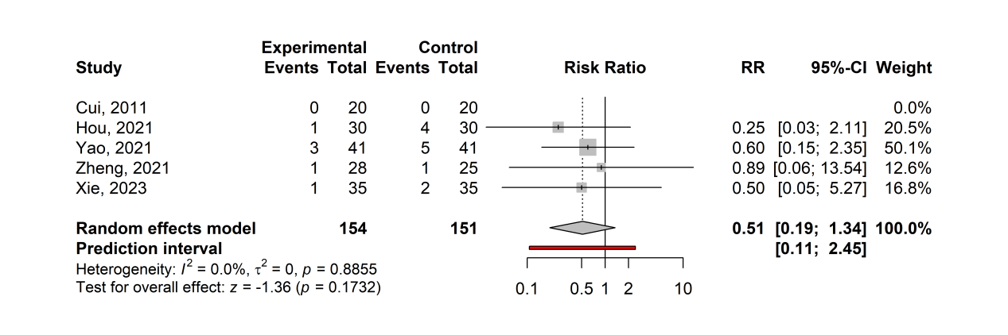
Supplemental Figure 8. Forest plot of the effect of perioperative intravenous lidocaine on length of hospitalization after video-assisted thoracic surgery.

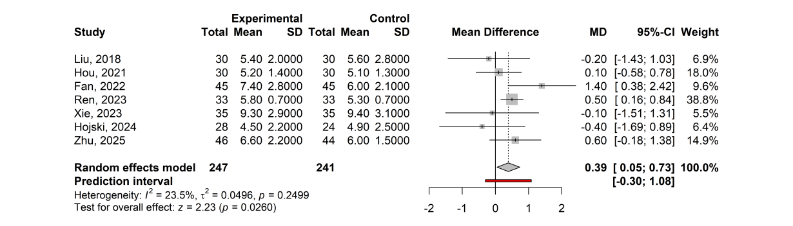
Supplemental Figure 9. Forest plot for the subgroup analysis of pain scores (at rest) at 24 h by anesthesia methods.
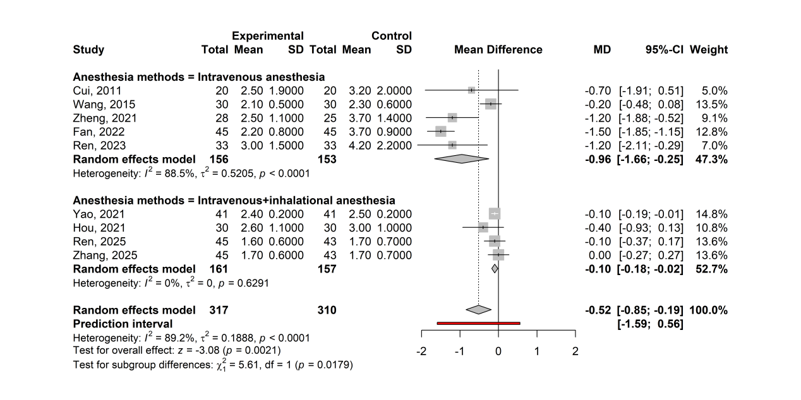
Supplemental Figure 10. Forest plot for the subgroup analysis of pain scores (during activity) at 24 h by anesthesia methods.
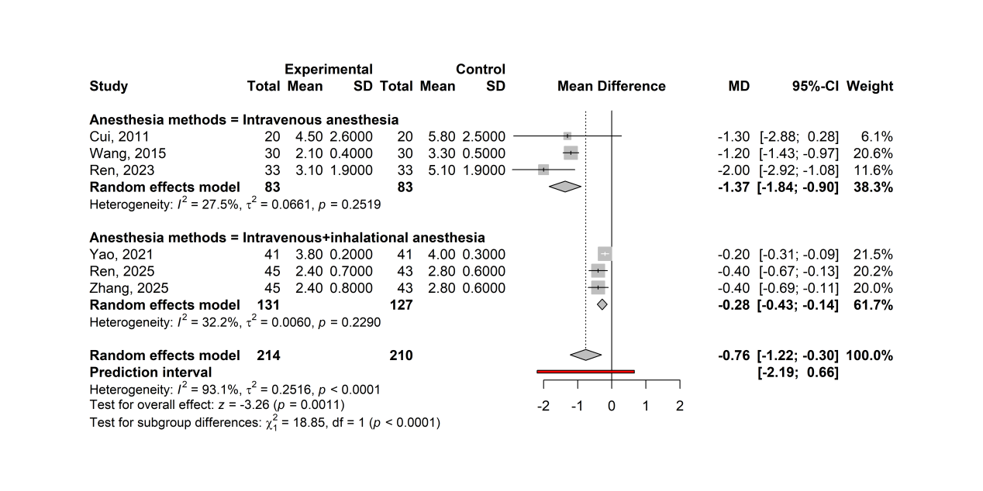
Supplemental Figure 11. Forest plot for the subgroup analysis of pain scores (at rest) at 24 h by lidocaine infusion duration.
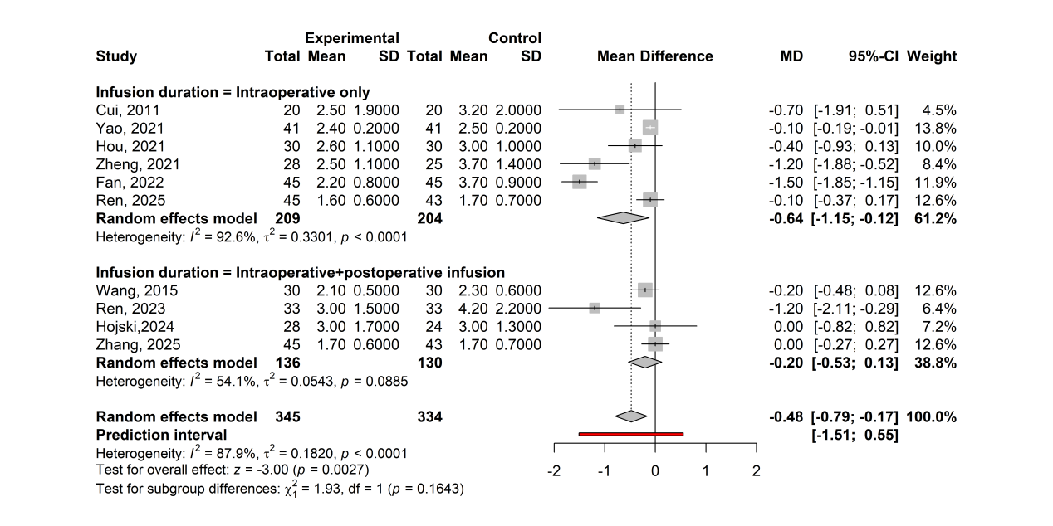
Supplemental Figure 12. Forest plot for the subgroup analysis of pain scores (during activity) at 24 h by lidocaine infusion duration.
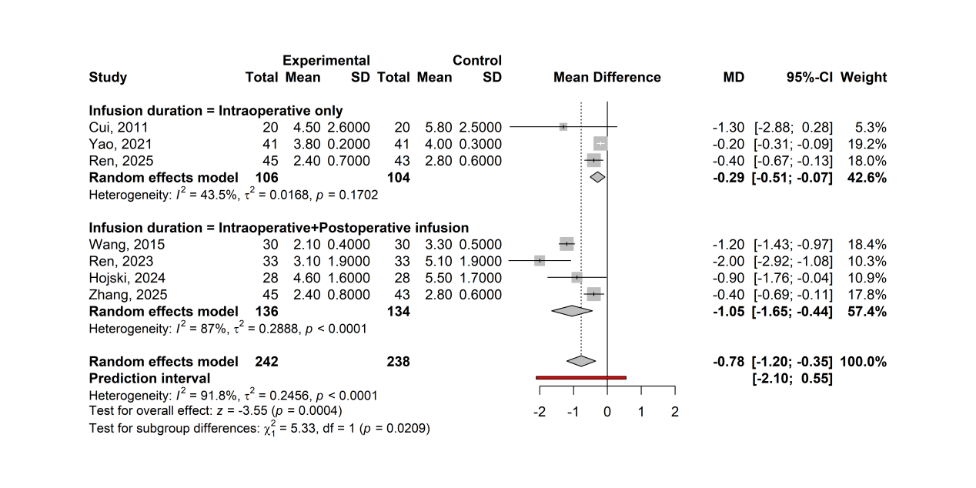

Supplemental Figure 13. Funnel plot for the primary outcomes in included studies.
(A) Pain score (at rest) at 6-8 h; (B) Pain score (at rest) at 24 h; (C) Pain score (at rest) at 48 h; (D) Pain score (during activity) at 6-8 h; (E) Pain score (during activity) at 24 h; (F) Pain score (during activity) at 48 h.
