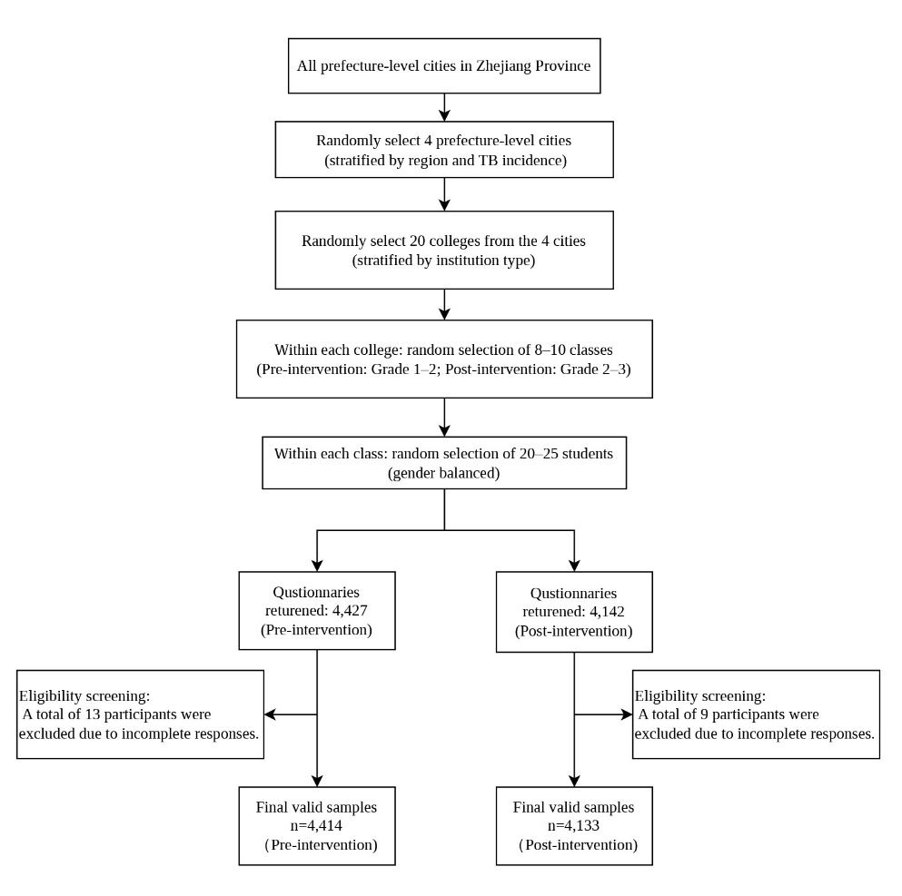

Figure S1. Participant selection flow diagram.

Table S1. Key knowledge of TB
Question | Key Knowledge
Q1: What is TB? | TB is a chronic communicable disease that seriously harms people's health for a long time.
Q2: How is TB transmitted? | TB spreads mainly through the respiratory tract and everyone can be infected.
Q3: What are the suspicious symptoms of TB? | TB should be suspected if a cough or expectoration persists for more than two weeks and should be treated in designated TB hospitals immediately.
Q4: If you suspect that you have TB, what should you do? | Go to local TB designated medical institutions for testing, treatment and management.
Q5: Is TB curable? | Standardize the whole-course treatment, the vast majority of TB patients can be cured, but also to avoid infecting others.
Q6: While at school, when you develop suspicious symptoms of TB or are diagnosed with TB, what should you do? | After showing suspicious symptoms of TB or being diagnosed as a TB patient, the student should take the initiative to report to the school, do not conceal his/her disease condition, and do not attend classes with illness.
Q7: What practice is beneficial in preventing the spread of TB? | Develop the habit of frequently opening windows for ventilation. Do not spit everywhere, cover your mouth and nose when coughing and sneezing, and wear a mask to reduce the spread of TB.
Q8: Which lifestyle habit will improve your immunity? | Ensure ample sleep, reasonable diet, strengthen physical exercise, build up resistance to disease.

Table S2. Pre- and post-intervention participants' responses to core information items on TB control in schools.
TB core information | Pre-intervention survey (n,%) | Post-intervention survey (n,%) | χ² | P-value
Q1: What is TB? |  |  | 0.713 | 0.870
Acute communicable disease | 1390 (31.5) | 1270 (30.7)
Acute non-communicable diseases | 345 (7.8) | 318 (7.7)
Chronic communicable diseases | 2251 (51.0) | 2138 (51.7)
Chronic non-communicable diseases | 428 (9.7) | 407 (9.8)
Q2: How is TB transmitted? |  |  | 6.284 | 0.099
No idea | 272 (6.2) | 206 (5.0)
Through respiratory tract transmission | 4003 (90.7) | 3790 (91.7)
Through digestive tract transmission | 78 (1.8) | 83 (2.0)
Through blood-borne transmission | 61 (1.4) | 54 (1.3)
Q3: What are the suspicious symptoms of TB? |  |  | 23.918 | <0.001
No idea | 235 (5.3) | 134 (3.2)
Abdominal pain and diarrhea | 25 (0.6) | 24 (0.6)
Cough and sneeze | 131 (3.0) | 107 (2.6)
Cough, sputum for more than 2 weeks or sputum with blood | 4023 (91.1) | 3868 (93.6)
Q4: If you suspect that you have TB, what should you do? |  |  | 16.679 | 0.001
No idea | 131 (3.0) | 74 (1.8)
Visit local TB designated medical institutions | 4248 (96.2) | 4008 (97.0)
Visit a private clinic | 18 (0.4) | 28 (0.7)
Buy your own medicine | 17 (0.4) | 23 (0.6)
Q5: Is TB curable? |  |  | 9.509 | 0.023
No idea | 611 (13.8) | 506 (12.2)
Most of them can be cured | 3341 (75.7) | 3233 (78.2)
All of them can be cured | 273 (6.2) | 250 (6.0)
Incurable | 189 (4.3) | 144 (3.5)
Q6: While at school, when you develop suspicious symptoms of TB or are diagnosed with TB, what should you do? |  |  | 20.592 | <0.001
Take lessons while in therapy | 27 (0.6) | 23 (0.6)
Immediate hospitalization | 659 (14.9) | 518 (12.5)
Observation without treatment if symptoms are not severe | 43 (1.0) | 75 (1.8)
Take the initiative to report to the school and do not conceal your illness or bring it to class | 3685 (83.5) | 3517 (85.1)
Q7: What practice is beneficial in preventing the spread of TB? |  |  | 9.140 | 0.027
Not drinking raw water | 392 (8.9) | 332 (8.0)
No littering | 100 (2.3) | 79 (1.9)
Regular diet | 562 (12.7) | 464 (11.2)
Open windows regularly for ventilation | 3360 (76.1) | 3258 (78.8)
Q8: Which lifestyle habit will improve your immunity? |  |  | 20.850 | <0.001
Stay up late, overeat and exercise occasionally | 44 (1.0) | 49 (1.2)
Stay up late, irregular diet, lack of exercise | 98 (2.2) | 84 (2.0)
Wear a mask, eat a balanced diet and exercise consistently | 379 (8.6) | 251 (6.1)
Keep early hours, balanced diet and consistent exercise | 3893 (88.2) | 3749 (90.7)

Table S3. Awareness of core information items on TB control among participants with different characteristics pre- and post-intervention.
Characteristics | Q1, n (%) |  | Q2, n (%) |  | Q3, n (%) |  | Q4, n (%) |  | Q5, n (%) |  | Q6, n (%) |  | Q7, n (%) |  | Q8, n (%)
Characteristics | Pre | Post | Pre | Post | Pre | Post | Pre | Post | Pre | Post | Pre | Post | Pre | Post | Pre | Post
Sex
Male | 1116 (48.9) | 936 (50.3) | 2038 (89.3) | 1689 (90.9) | 2017 (88.4) | 1720 (92.5) | 2151 (94.3) | 1786 (96.1) | 1653 (72.4) | 1421 (76.4) | 1834 (80.4) | 1541 (82.9) | 1738 (76.2) | 1506 (81.0) | 1953 (85.6) | 1645 (88.5)
Female | 1135 (53.2) | 1202 (52.9) | 1965 (92.2) | 2101 (92.4) | 2006 (94.1) | 2148 (94.5) | 2097 (98.4) | 2222 (97.7) | 1688 (79.2) | 1812 (79.7) | 1851 (86.8) | 1976 (86.9) | 1622 (76.1) | 1752 (77.0) | 1940 (91.0) | 2104 (92.5)
Area residence
Urban | 853 (54.6) | 794 (54.0) | 1424 (91.2) | 1353 (92.0) | 1442 (92.3) | 1385 (94.2) | 1506 (96.4) | 1411 (95.9) | 1206 (77.2) | 1157 (78.7) | 1319 (84.4) | 1235 (84.0) | 1227 (78.6) | 1155 (78.5) | 1371 (87.8) | 1338 (91.0)
Rural | 1398 (49.0) | 1344 (50.5) | 2579 (90.4) | 2437 (91.5) | 2581 (90.5) | 2483 (93.3) | 2742 (96.1) | 2597 (97.6) | 2135 (74.9) | 2076 (78.0) | 2366 (83.0) | 2282 (85.7) | 2133 (74.8) | 2103 (79.0) | 2522 (88.4) | 2411 (90.6)
Origin of the students
Zhejiang Province | 1578 (50.0) | 1480 (51.5) | 2883 (91.3) | 2678 (93.3) | 2883 (91.3) | 2713 (94.5) | 3030 (96.0) | 2816 (98.1) | 2417 (76.6) | 2298 (80.0) | 2645 (83.8) | 2457 (85.6) | 2418 (76.6) | 2313 (80.6) | 2782 (88.1) | 2609 (90.9)
Others | 673 (53.5) | 658 (52.1) | 1120 (89.1) | 1112 (88.1) | 1140 (90.7) | 1155 (91.5) | 1218 (96.9) | 1192 (94.5) | 924 (73.5) | 935 (74.1) | 1040 (82.7) | 1060 (84.0) | 942 (74.9) | 945 (74.9) | 1111 (88.4) | 1140 (90.3)
Grade ª
Low | 1173 (49.3) | 1574 (50.7) | 2172 (91.3) | 2828 (91.1) | 2164 (91.0) | 2885 (92.9) | 2295 (96.5) | 3008 (96.9) | 1810 (76.1) | 2436 (78.5) | 1998 (84.0) | 2623 (84.5) | 1800 (75.7) | 2415 (77.8) | 2110 (88.7) | 2799 (90.1)
High | 1078 (52.9) | 564 (54.9) | 1831 (89.9) | 962 (93.6) | 1859 (91.3) | 983 (95.6) | 1953 (95.9) | 1000 (97.3) | 1531 (75.2) | 797 (77.5) | 1687 (82.9) | 894 (87.0) | 1560 (76.6) | 843 (82.0) | 1783 (87.6) | 950 (92.4)
Major
Humanity Social Sciences | 691 (50.5) | 629 (45.3) | 1230 (90.0) | 1252 (90.1) | 1246 (91.1) | 1266 (91.1) | 1322 (96.7) | 1336 (96.1) | 1038 (75.9) | 1049 (75.5) | 1129 (82.6) | 1142 (82.2) | 1028 (75.2) | 1049 (75.5) | 1201 (87.9) | 1247 (89.7)
Science and Engineering | 979 (49.2) | 808 (53.1) | 1786 (89.8) | 1390 (91.4) | 1784 (89.4) | 1438 (94.5) | 1898 (95.4) | 1489 (97.9) | 1467 (73.8) | 1190 (78.2) | 1619 (81.4) | 1305 (85.8) | 1481 (74.5) | 1223 (80.4) | 1736 (87.3) | 1391 (91.5)
Medicine | 386 (57.2) | 460 (64.1) | 638 (94.5) | 703 (97.9) | 637 (94.4) | 711 (99.0) | 658 (97.5) | 717 (99.9) | 548 (81.2) | 641 (89.3) | 604 (89.5) | 661 (92.1) | 558 (82.7) | 619 (86.2) | 611 (90.5) | 667 (92.9)
Art | 195 (50.9) | 241 (47.8) | 349 (91.1) | 445 (88.3) | 356 (93.0) | 453 (89.9) | 370 (96.6) | 466 (92.5) | 288 (75.2) | 353 (70.0) | 333 (86.9) | 409 (81.2) | 293 (76.5) | 367 (72.8) | 345 (90.1) | 444 (88.1)
Monthly living expenses (RMB)
≤500 | 30 (41.7) | 30 (50.8) | 58 (80.6) | 51 (86.4) | 56 (77.8) | 49 (83.1) | 62 (86.1) | 53 (89.8) | 44 (61.1) | 41 (69.5) | 50 (69.4) | 43 (72.9) | 47 (65.3) | 32 (54.2) | 54 (75.0) | 46 (78.0)
501~1000 | 162 (50.9) | 144 (54.3) | 283 (89.0) | 242 (91.3) | 284 (89.3) | 249 (94.0) | 301 (94.7) | 255 (96.2) | 231 (72.6) | 211 (79.6) | 264 (83.0) | 227 )85.7) | 241 (75.8) | 203 (76.6) | 274 (86.2) | 232 (87.5)
1001~1500 | 688 (50.8) | 640 (54.8) | 1221 (90.2) | 1082 (92.7) | 1244 (91.9) | 1109 (95.0) | 1315 (97.2) | 1140 (97.7) | 1033 (76.3) | 918 (78.7) | 1131 (83.6) | 1005 (86.1) | 1042 (77.0) | 936 (80.2) | 1205 (89.1) | 1065 (91.3)
1501~2000 | 904 (51.6) | 911 (51.9) | 1623 (92.6) | 1603 (91.4) | 1614 (92.1) | 1650 (94.1) | 1703 (97.2) | 1714 (97.7) | 1341 (76.5) | 1382 (78.8) | 1474 (84.1) | 1508 (86.0) | 1347 (76.9) | 1384 (78.9) | 1560 (89.0) | 1616 (92.1)
>2000 | 467 (50.8) | 413 (46.5) | 818 (89.0) | 812 (91.4) | 825 (89.8) | 811 (91.3) | 867 (94.3) | 846 (95.3) | 692 (75.3) | 681 (76.7) | 766 (83.4) | 734 (82.7) | 683 (74.3) | 703 (79.2) | 800 (87.1) | 790 (89.0)
Have you ever received health education of TB?
Yes | 1766 (51.9) | 1734 (52.1) | 3183 (93.5) | 3121 (93.8) | 3158 (92.8) | 3172 (95.3) | 3317 (97.4) | 3257 (97.9) | 2706 (79.5) | 2723 (81.8) | 2843 (83.5) | 2853 (85.7) | 2653 (77.9) | 2673 (80.3) | 3009 (88.4) | 3033 (91.1)
No | 485 (48.0) | 404 (50.2) | 820 (81.2) | 669 (83.1) | 865 (85.6) | 696 (86.5) | 931 (92.2) | 751 (93.3) | 635 (62.9) | 510 (63.4) | 842 (83.4) | 664 (82.5) | 707 (70.0) | 585 (72.7) | 884 (87.5) | 716 (88.9)
Have you ever had contact with a TB patient?
Yes | 120 (60.9) | 112 (55.4) | 184 (93.4) | 185 (91.6) | 186 (94.4) | 188 (93.1) | 194 (98.5) | 193 (95.5) | 174 (88.3) | 164 (81.2) | 171 (86.8) | 176 (87.1) | 169 (85.8) | 166 (82.2) | 185 (93.9) | 196 (92.1)
No | 1693 (49.6) | 1527 (51.2) | 3119 (91.3) | 2748 (92.2) | 3120 (91.4) | 2804 (94.1) | 3296 (96.5) | 2904 (97.4) | 2607 (76.3) | 2368 (79.5) | 2841 (83.2) | 2530 (84.9) | 2599 (76.1) | 2337 (78.4) | 3016 (88.3) | 2695 (90.4)
No idea | 438 (54.6) | 499 (52.5) | 700 (87.3) | 857 (90.1) | 717 (89.4) | 876 (92.1) | 758 (94.5) | 911 (95.8) | 560 (69.8) | 701 (73.7) | 673 (83.9) | 811 (85.3) | 592 (73.8) | 755 (79.4) | 692 (86.3) | 868 (91.3)
ª The baseline survey sampled first- and second-year undergraduate students enrolled in 2022, while the follow-up intervention survey targeted second- and third-year undergraduates enrolled in 2023.

