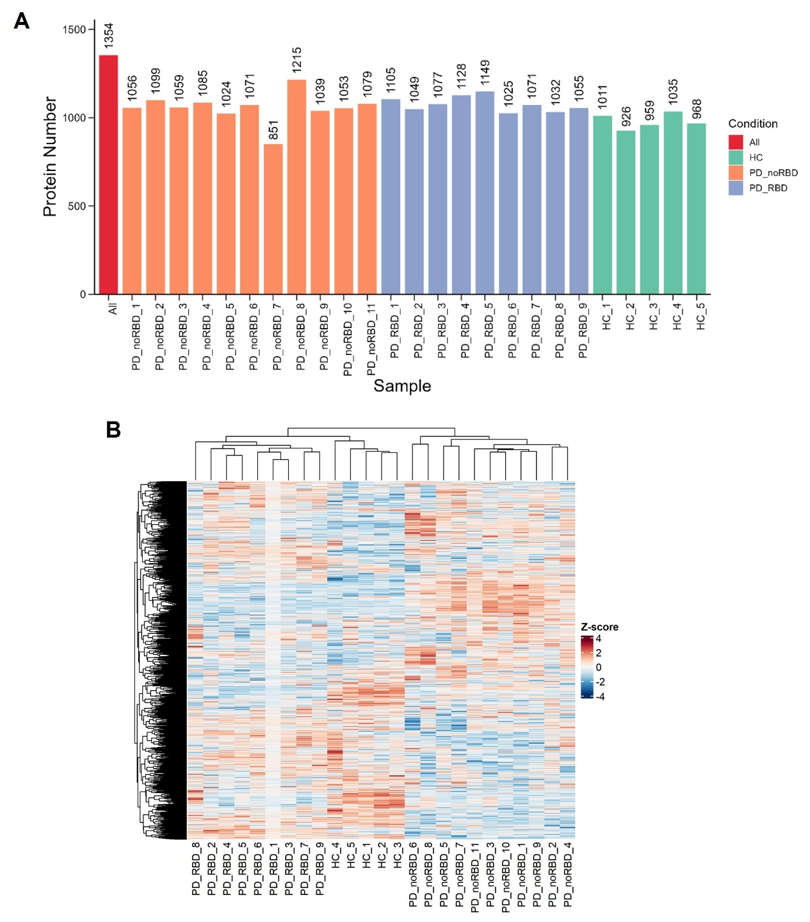
Figure S1 Statistics and Heatmap for general protein identification. (A) the total number statistics in each subject. (B) Hierarchical clustering heatmap represents hierarchical clustering of samples based on gene expression data. Rows correspond to genes, and columns represent individual samples, with the color scale indicating Z-scores. Red indicates higher expression, while blue indicates lower expression. The clustering reveals patterns of similarity among the samples, with samples from the same condition (HC, PD-noRBD, PD-RBD) clustering together.
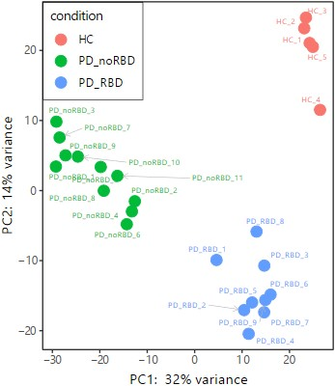
Figure S2 PCA plot for three groups. Principal component analysis (PCA) was performed to visualize the relationships among different sample conditions. The first principal component (PC1), explaining 32% of the variance, is plotted on the x-axis, while the second principal component (PC2), explaining 14% of the variance, is plotted on the y-axis. Each point represents a sample, colored according to its condition: red for HC, green for PD-noRBD, and blue for PD-RBD. The plot demonstrates clear separations between the different conditions, with samples from each group clustering distinctly.
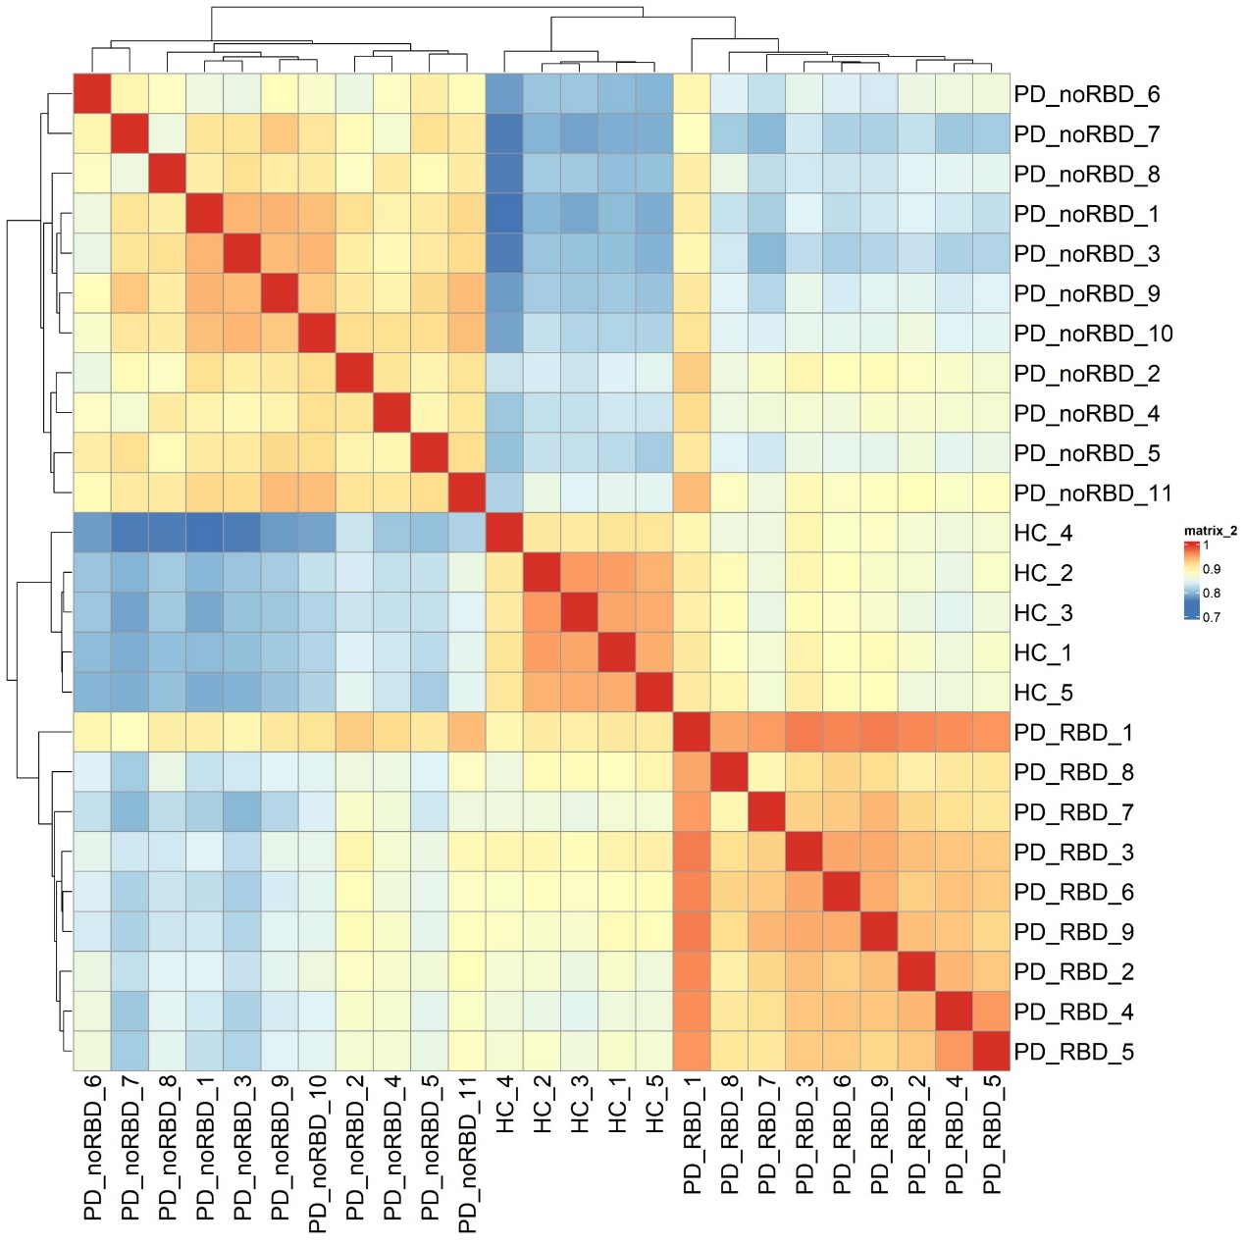
Figure S3 Sample Correlation Analysis. This heatmap shows the correlation between samples, with color intensity reflecting the strength of correlation (from -1 to 1). Red indicates strong positive correlation, and blue indicates strong negative correlation. The clustering reveals patterns of similarity within and between sample groups (HC, PD-noRBD, PD-RBD).
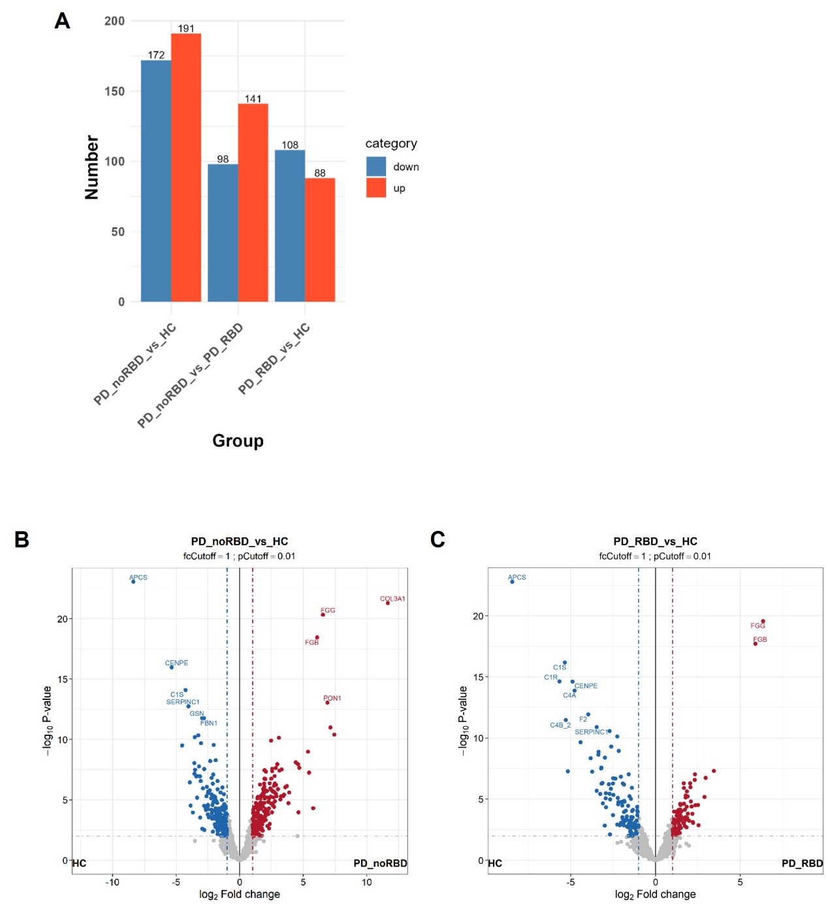
Figure S4 Differential Protein Expression. (A) bar plot shows the number of upregulated (red) and downregulated (blue) proteins in three comparison groups: PD-noRBD vs PD-RBD, PD-noRBD vs HC, and PD-RBD vs HC. (B) volcano plot shows the log2 fold change (x-axis) versus the -log10 p-value (y-axis) for proteins in the PD-noRBD vs HC. (C) volcano plot shows the log2 fold change (x-axis) versus the -log10 p-value (y-axis) for proteins in the PD-RBD vs HC
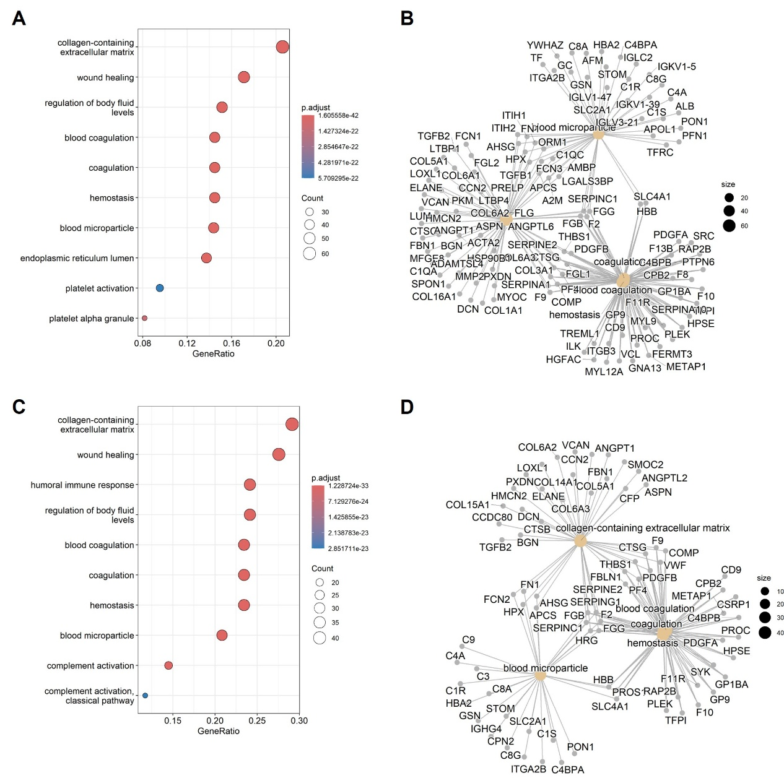
Figure S5 Over-Representation Analysis (ORA) of Differential Genes (GO Terms). (A) show bubble plots and (B) show GCN for the enrichment of different biological terms for differentially expressed genes in the PD-noRBD vs HC group. (C) and (D) display similar analyses for the PD-RBD vs HC group. The size of the bubbles corresponds to the number of genes annotated to each term, and the color represents the adjusted p-value (p.adj), with red indicating stronger significance. In GCN, node size reflecting gene count.
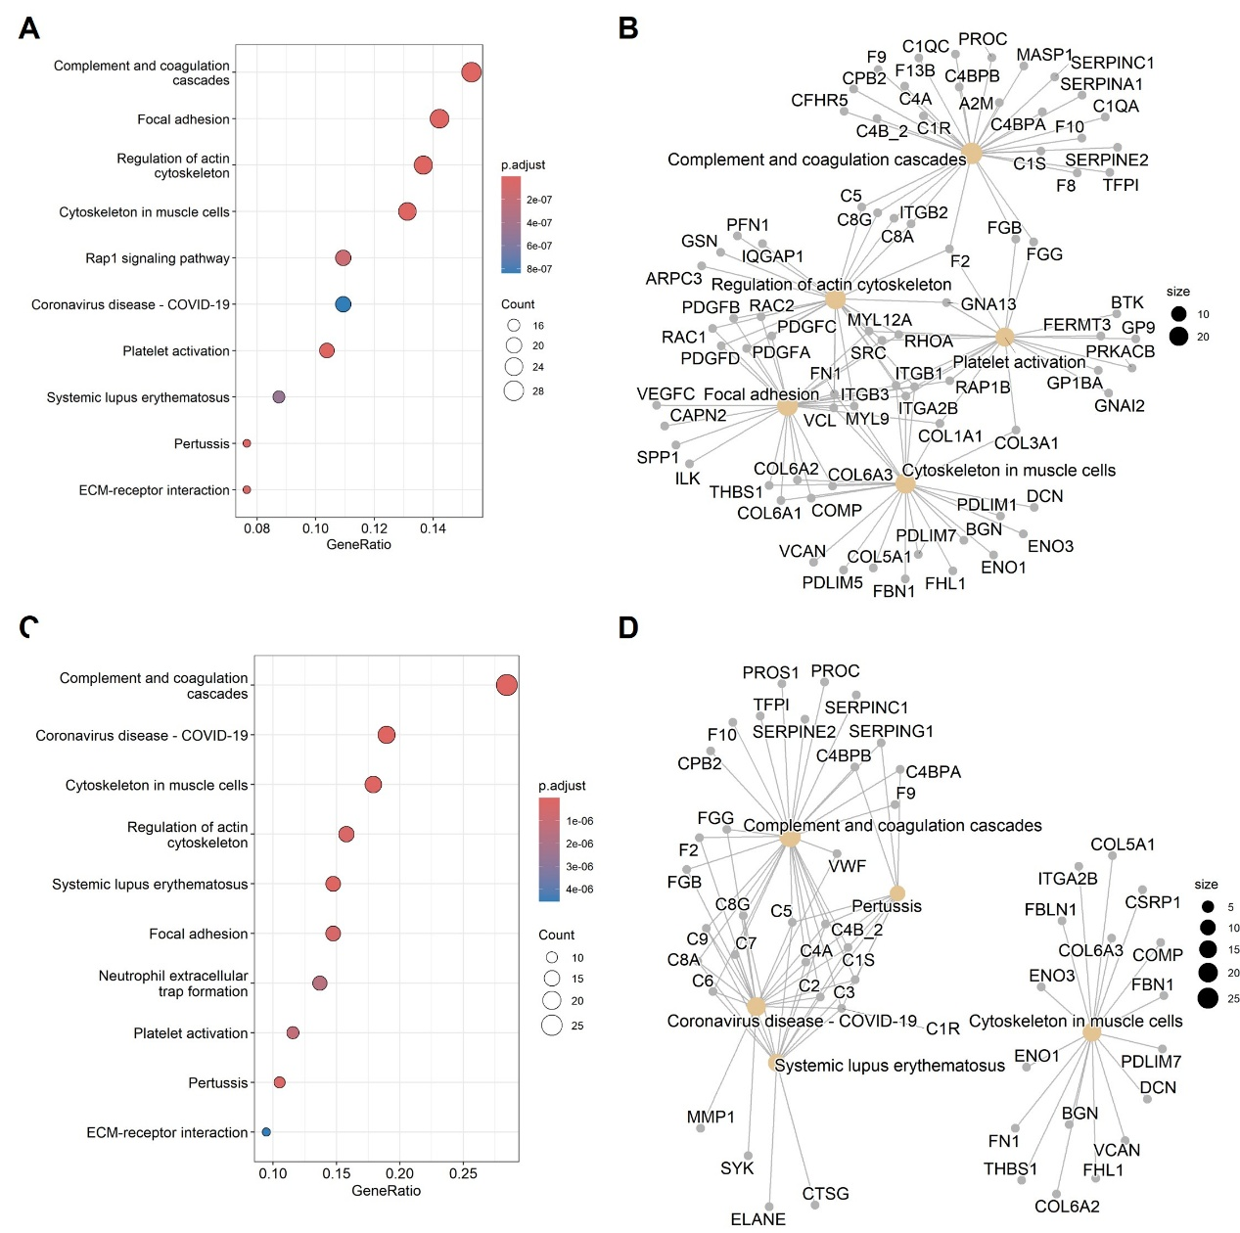
Figure S6 Over-Representation Analysis (ORA) of Differential Genes (KEGG Pathways). (A) show bubble plots and (B) show GCN for the enrichment of different KEGG pathways for differentially expressed genes in the PD-noRBD vs HC group. (C) and (D) display similar analyses for the PD-RBD vs HC group. The size of the bubbles corresponds to the number of genes annotated to each pathway, and the color represents the adjusted p-value (p.adj), with red indicating stronger significance. In GCN, node size reflecting gene count.
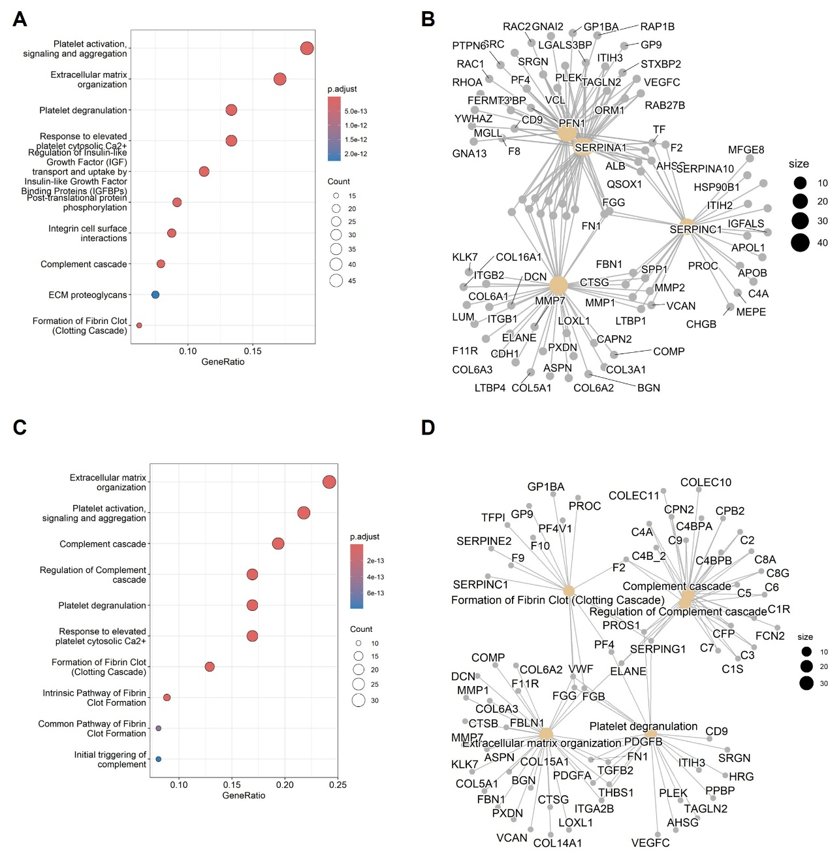
Figure S7. Over-Representation Analysis (ORA) of Differential Genes (REACTOME Pathways). (A) show bubble plots and (B) show GCN for the enrichment of different REACTOME pathways for differentially expressed genes in the PD-noRBD vs HC group. (B) and (D) display similar analyses for the PD-RBD vs HC group. The size of the bubbles corresponds to the number of genes annotated to each pathway, and the color represents the adjusted p-value (p.adj), with red indicating stronger significance. In GCN, node size reflecting gene count.
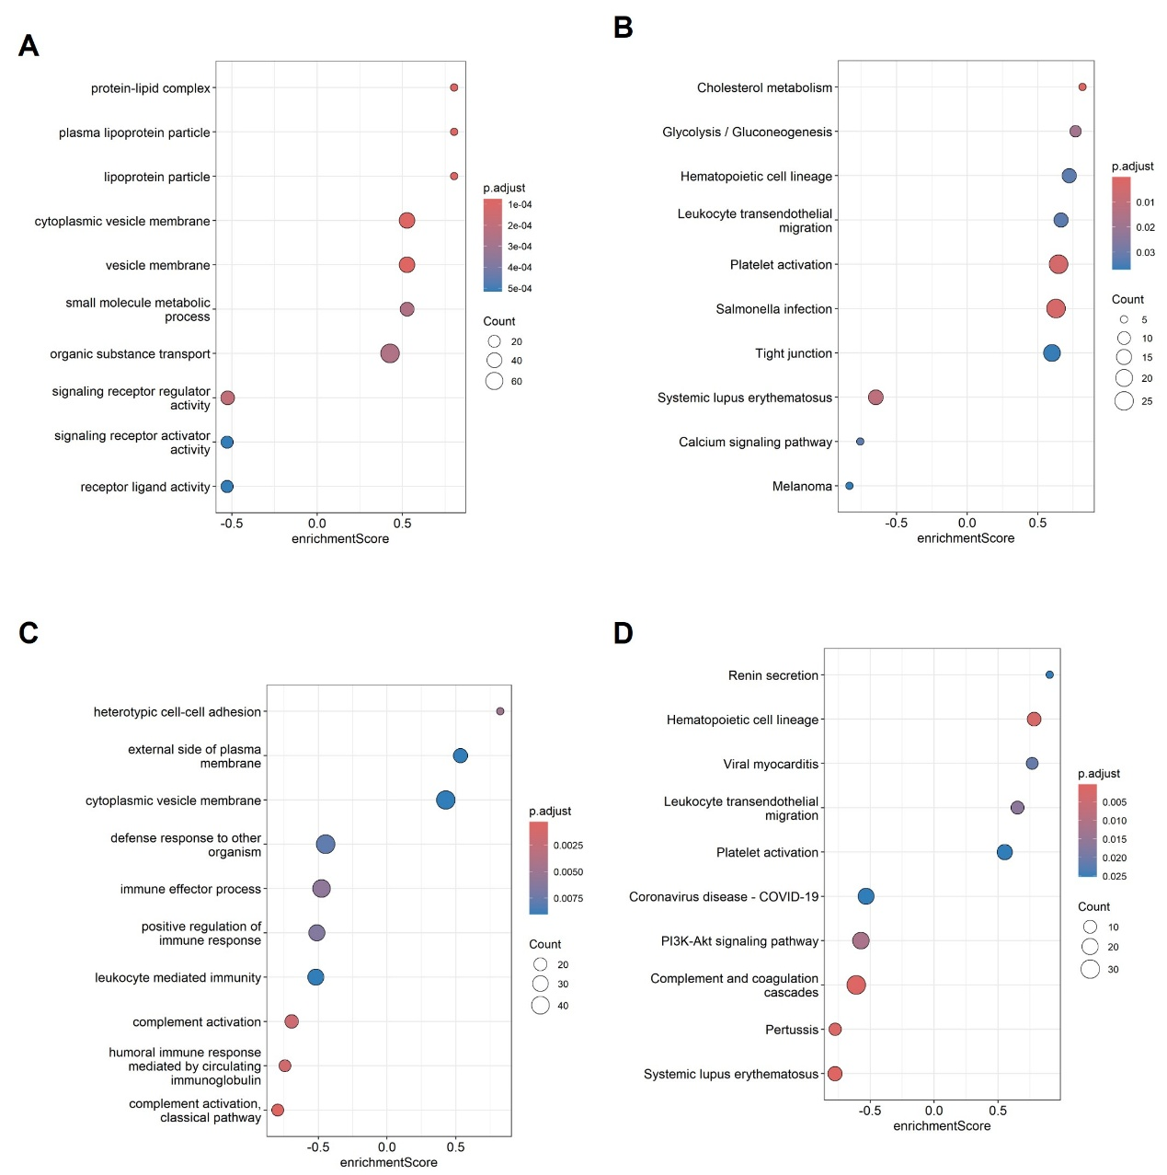
Figure S8 Gene Set Enrichment Analysis (GSEA) of Differentially Expressed Proteins. (A) and (B) show GSEA results for Gene Ontology (GO) terms in the PD-noRBD vs HC group, while (C) and (D) display the same for KEGG pathways in the PD-RBD vs HC group. The x-axis represents the Enrichment Score (ES), and the y-axis corresponds to different biological terms (GO or KEGG pathways). The size of the bubbles reflects the number of proteins enriched in each term, and the color indicates the adjusted p-value (p.adj), with red indicating stronger significance.
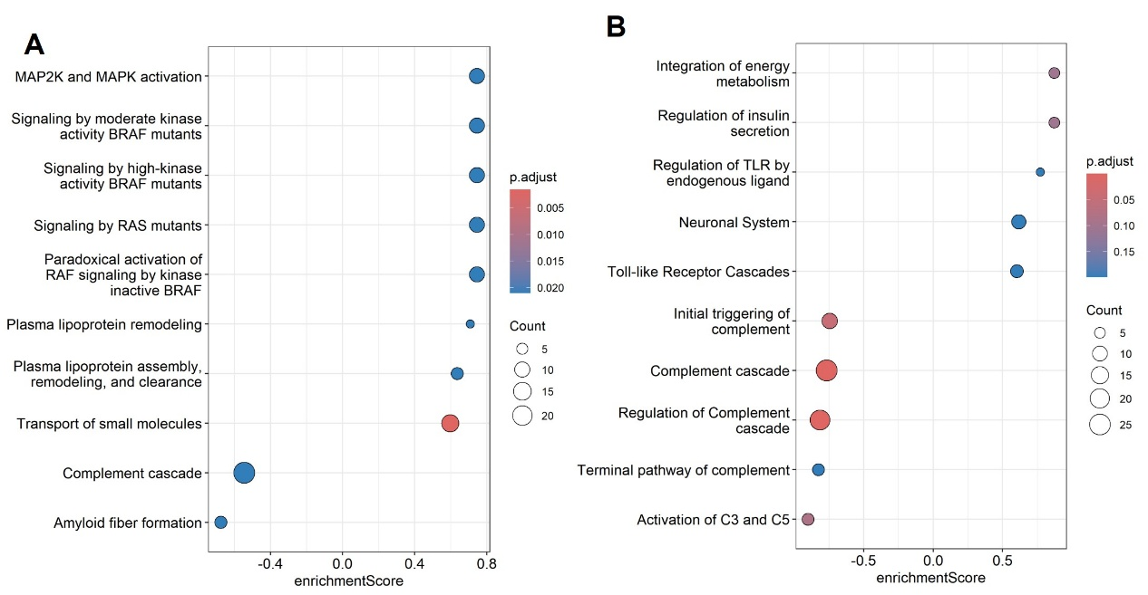
Figure S9 Gene Set Enrichment Analysis (GSEA) of Differentially Expressed Proteins (REACTOME Pathways). (A) shows GSEA results for REACTOME pathways in the PD-noRBD vs HC group, and (B) displays the same for the PD-RBD vs HC group.
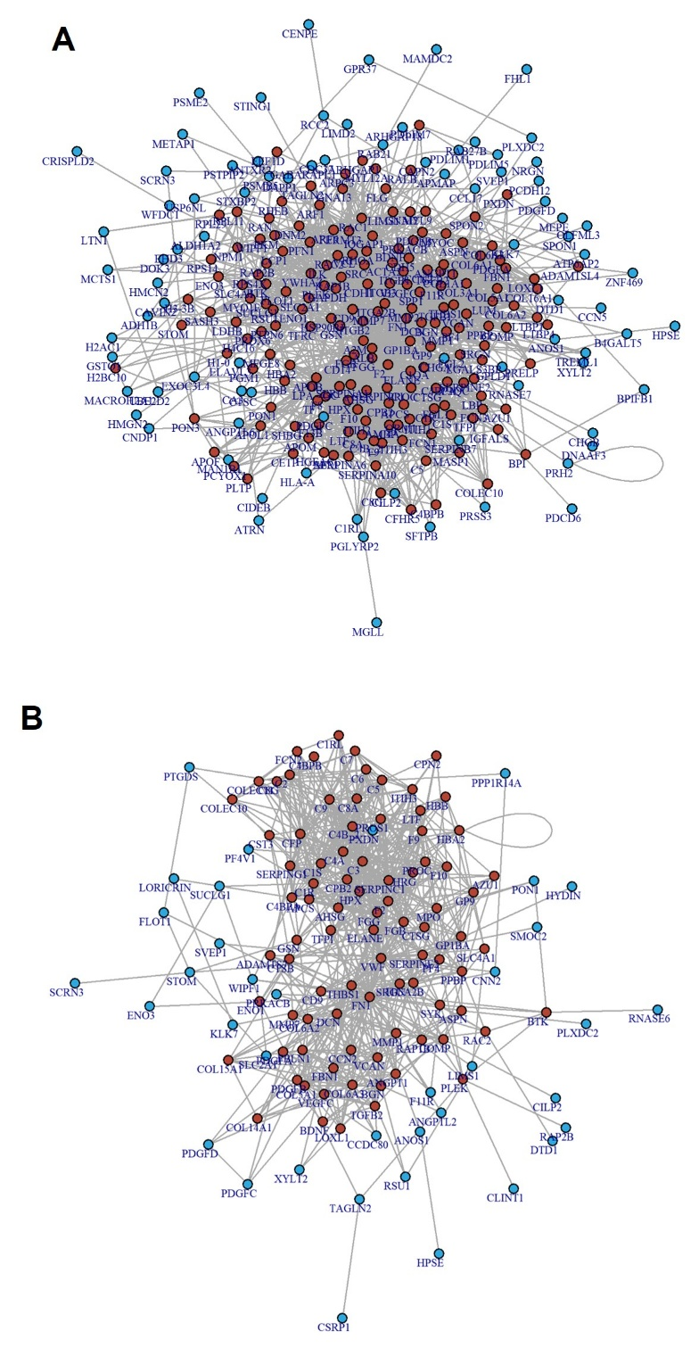
Figure S10 Protein-Protein Interaction (PPI) Networks. (A) shows the PPI network for differentially expressed proteins in the PD-noRBD vs HC group, and (B) shows the PPI network for the PD-RBD vs HC group. Nodes represent proteins, and edges indicate interactions. Red nodes indicate significant proteins, while blue nodes represent others.
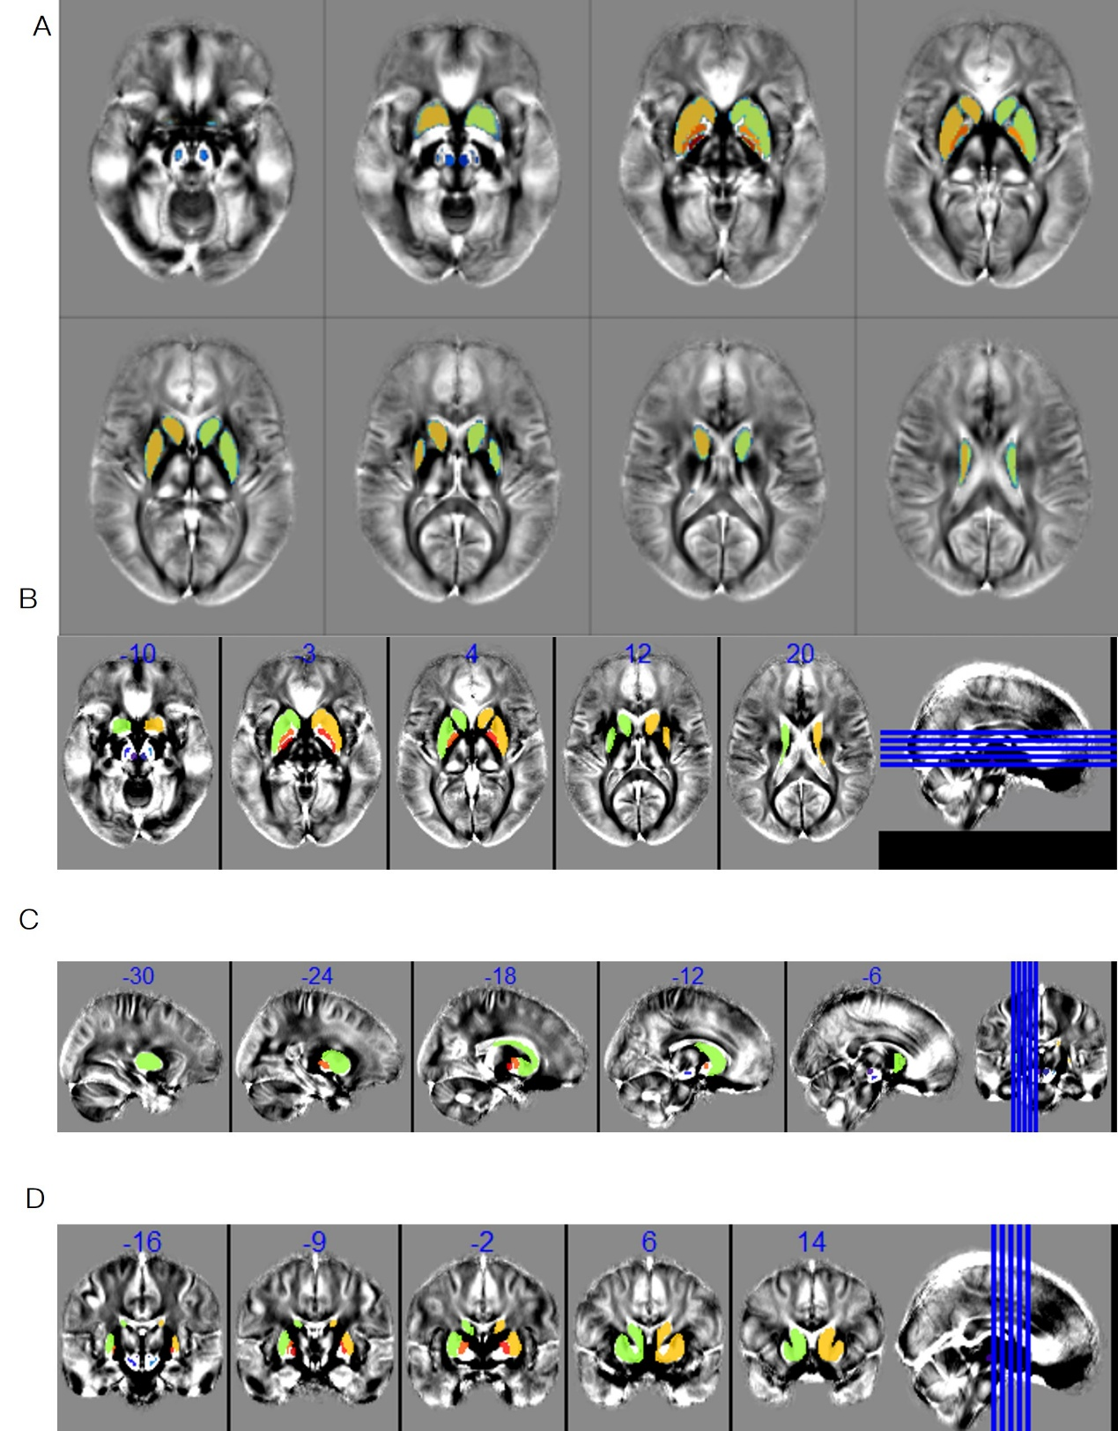
Figure S11 Representative QSM measurement image. Representative QSM images from a Parkinson’s disease patient are shown to illustrate the acquisition quality and region-of-interest (ROI) delineation used for subsequent correlation analyses. Axial (A-B), sagittal (C), and coronal (D) views demonstrate susceptibility contrast in major subcortical nuclei. Color overlays indicate manually defined ROIs, including the globus pallidus externus, globus pallidus internus, striatum, substantia nigra, subthalamic nucleus, and red nucleus. QSM values extracted from these ROIs.
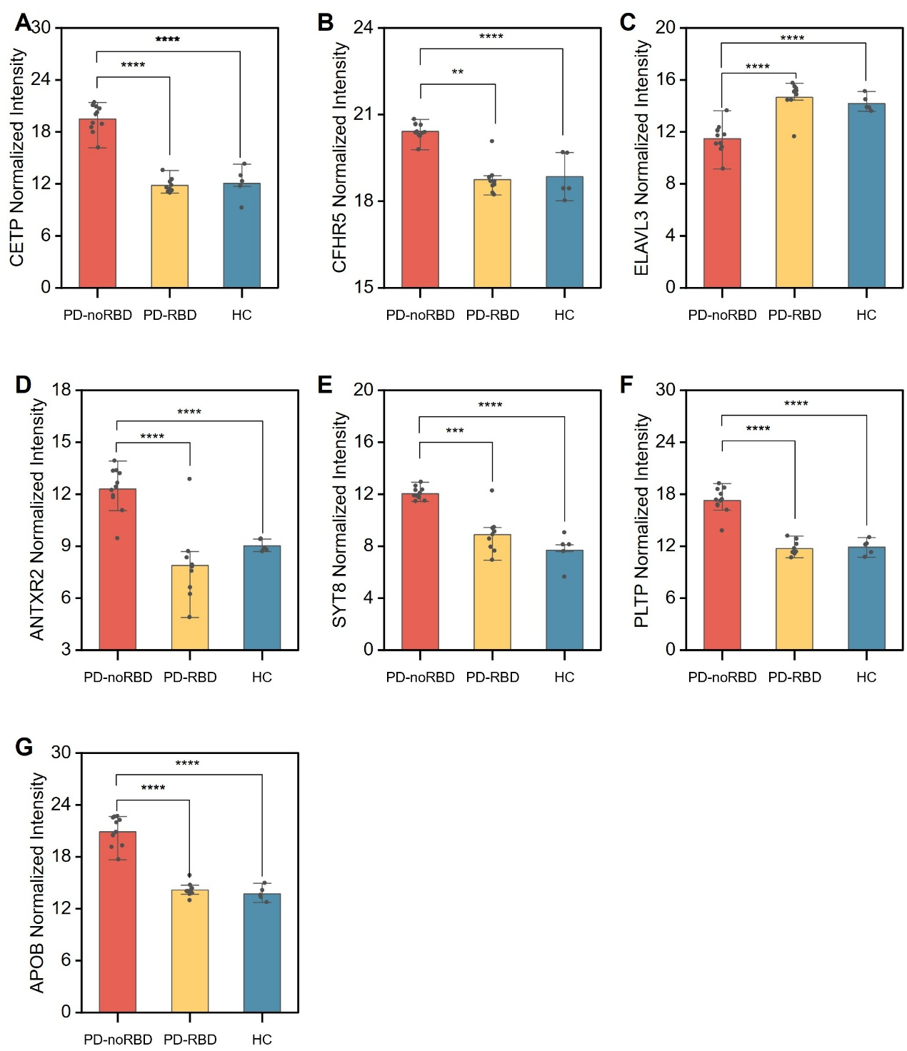
Figure S12 Biomarker Validation in PD Subtypes. (A) Normalized intensity of CETP in plasma nEV across PD-noRBD, PD-RBD, and HC groups. (B) CFHRS, (C) ELAVL3, (D) ANTXR2, (E) SYT18, (F) PLTP, and (G) APOBnormalized intensities in plasma L1Exos. Data are presented as mean ± SD, with asterisks indicating statistical significance (**** p < 0.0001, *** p < 0.001, ** p < 0.01) based on Welch’s ANOVA for multiple comparisons. This analysis is part of the validation of selected biomarkers for PD subtypes.
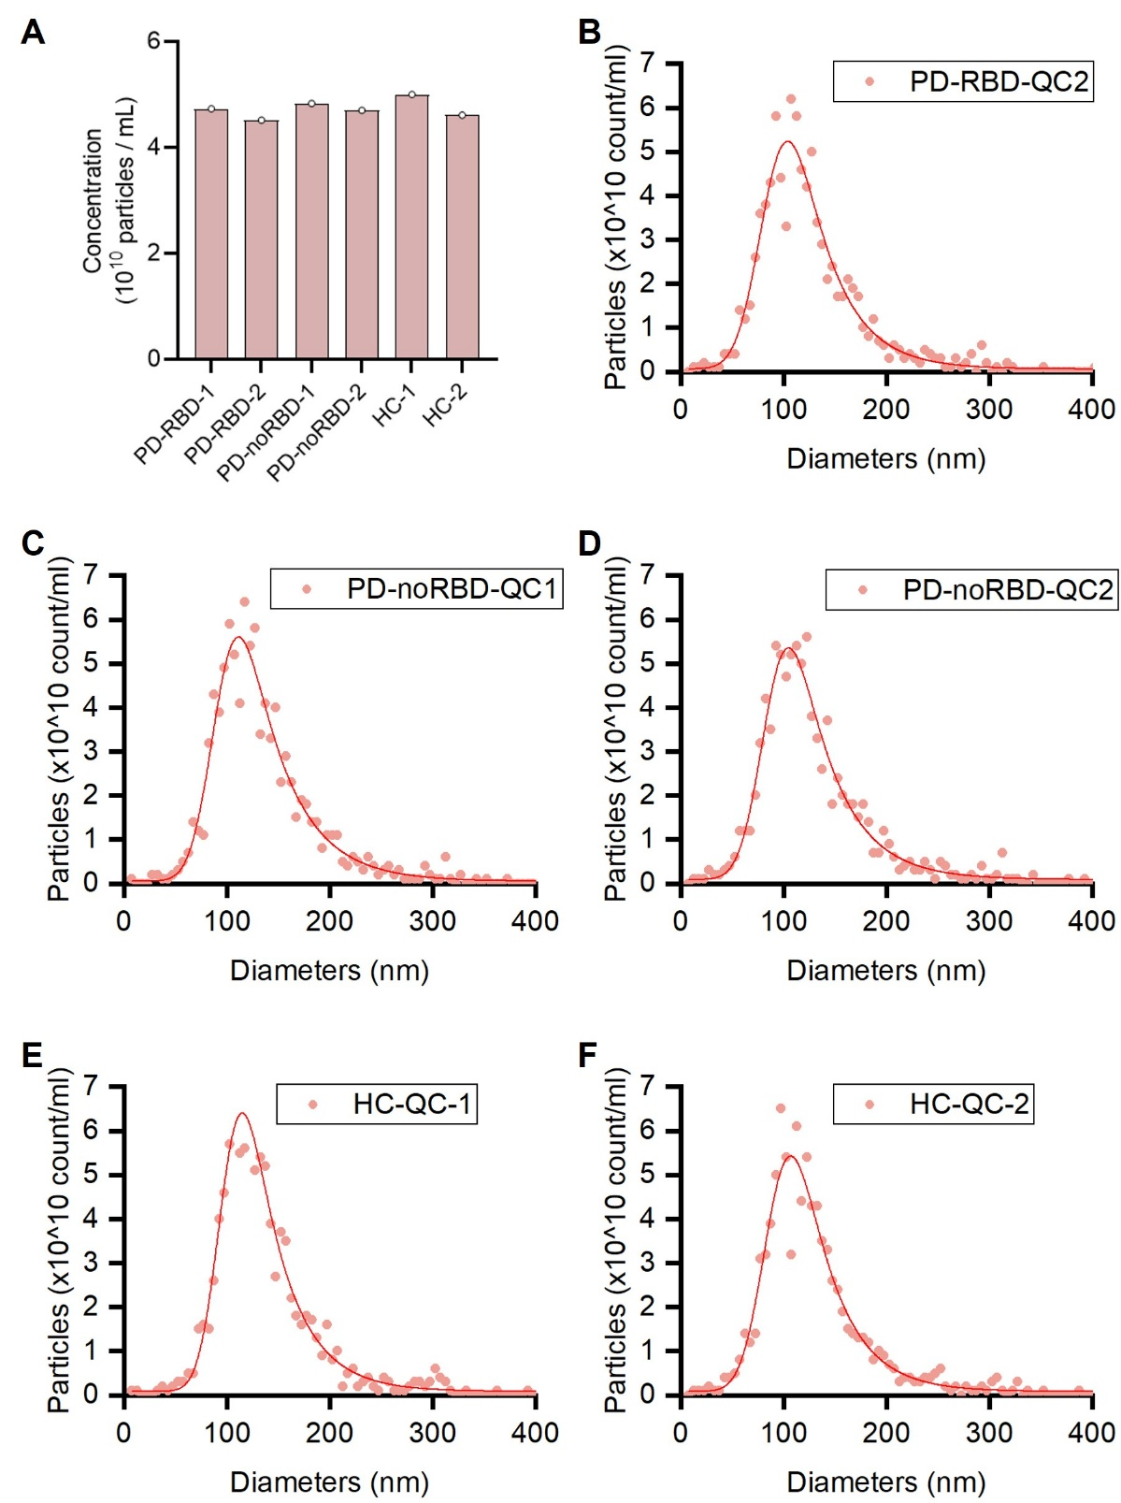
Figure S13 Nanoparticle tracking analysis (NTA) quality control profiles of L1CAM antibody conjugated immunomagnetic beads isolated EVs. (A) Total particle concentrations across randomly selected individuals from the PD-RBD, PD-noRBD, and HC cohorts, demonstrating uniform isolation efficiency. (B–F) Size distribution tracks of individual QC samples from each clinical arm. (B) The second QC sample of PD-RBD group. (C) The first QC sample of PD-noRBD group. (D) The second QC sample of PD-noRBD group. (E) The first QC sample of Health Control group. (F) The second QC sample of Health Control group The profile for PD-RBD-QC1 is presented in Figure 1A and is omitted here.

Table S1- Characteristics of PD-noRBD and PD-RBD patients
Characteristics | PD-RBD (n = 9) | PD-noRBD (n = 11) | Healthy Controls (n = 8) | p-value | Statistical Test
Age (years, mean ± SD) | 69.4 ± 8.1 | 61.6 ± 10.5 | 64.9 ± 13.1 | 0.280 | One-way ANOVA
Sex (Female / Male, n) | 5 / 4 | 9 / 2 | 4 / 4 | 0.223 | Two-sample t-test
Disease Duration (years, mean ± SD) | 3.9 ± 2.4 | 4.6 ± 1.5 | N/A | 0.433 | Two-sample t-test
Age at Onset (years, mean ± SD) | 66.1 ± 6.9 | 59.2 ± 10.6 | N/A | 0.111 | Two-sample t-test
UPDRS Part III (mean ± SD) | 31.4 ± 23.1 | 37.6 ± 13.4 | N/A | 0.460 | Two-sample t-test
MMSE (mean ± SD) | 24.6 ± 4.1 | 24.6 ± 4.6 | N/A | 0.985 | Two-sample t-test
Hoehn & Yahr Stage (mean ± SD) | 1.9 ± 0.7 | 2.1 ± 1.1 | N/A | 0.655 | Two-sample t-test
Constipation (Yes / No) | 8 / 1 | 4 / 7 | N/A | — | Descriptive
Orthostatic Hypotension (Yes / No) | 2 / 7 | 1 / 10 | N/A | — | Descriptive
Diabetes Mellitus (Yes / No / Predromal) | 1 / 8 / 0 | 3 / 6 / 2 | 0 / 8 / 0 | — | Descriptive
Notes: Disease duration indicates the period from symptom onset to sample collection, extracted from the clinical records of Fujian Provincial Hospital. Empty cells for healthy controls indicate data not applicable.
Abbreviations: PD, Parkinson’s disease; RBD, REM sleep behavior disorder; UPDRS, Unified Parkinson’s Disease Rating Scale; MMSE, Mini-Mental State Examination.
Table S2- Characterized protein and peptide number across three groups.
sample | group | Protein number | Peptide number
All | All | 1356 | 9665
PD-noRBD_1 | PD-noRBD | 1056 | 6340
PD-noRBD_2 | PD-noRBD | 1099 | 6482
PD-noRBD_3 | PD-noRBD | 1059 | 6666
PD-noRBD_4 | PD-noRBD | 1085 | 6082
PD-noRBD_5 | PD-noRBD | 1024 | 5867
PD-noRBD_6 | PD-noRBD | 1071 | 5567
PD-noRBD_7 | PD-noRBD | 851 | 4943
PD-noRBD_8 | PD-noRBD | 1215 | 7586
PD-noRBD_9 | PD-noRBD | 1039 | 6231
PD-noRBD_10 | PD-noRBD | 1053 | 6554
PD-noRBD_11 | PD-noRBD | 1079 | 6520
PD-RBD_1 | PD-RBD | 1105 | 6840
PD-RBD_2 | PD-RBD | 1049 | 6013
PD-RBD_3 | PD-RBD | 1077 | 6211
PD-RBD_4 | PD-RBD | 1128 | 6565
PD-RBD_5 | PD-RBD | 1149 | 6672
PD-RBD_6 | PD-RBD | 1025 | 5701
PD-RBD_7 | PD-RBD | 1071 | 5852
PD-RBD_8 | PD-RBD | 1032 | 5908
PD-RBD_9 | PD-RBD | 1055 | 6076
HC_1 | HC | 1131 | 6499
HC_2 | HC | 1060 | 6044
HC_3 | HC | 1110 | 6337
HC_4 | HC | 1011 | 5949
HC_5 | HC | 926 | 5452
HC_6 | HC | 959 | 5772
HC_7 | HC | 1035 | 6141
HC_8 | HC | 968 | 5747

