Supplementary Figure 1: Screenshot of A) intraoperative image-guidance system showing alignment of toric markings with nominated target axis and B) postoperative iTrace display showing in situ alignment of the IOL. Target axis (A) and postoperative alignment (B) are highlighted in red boxes. IOL = intraocular lens.
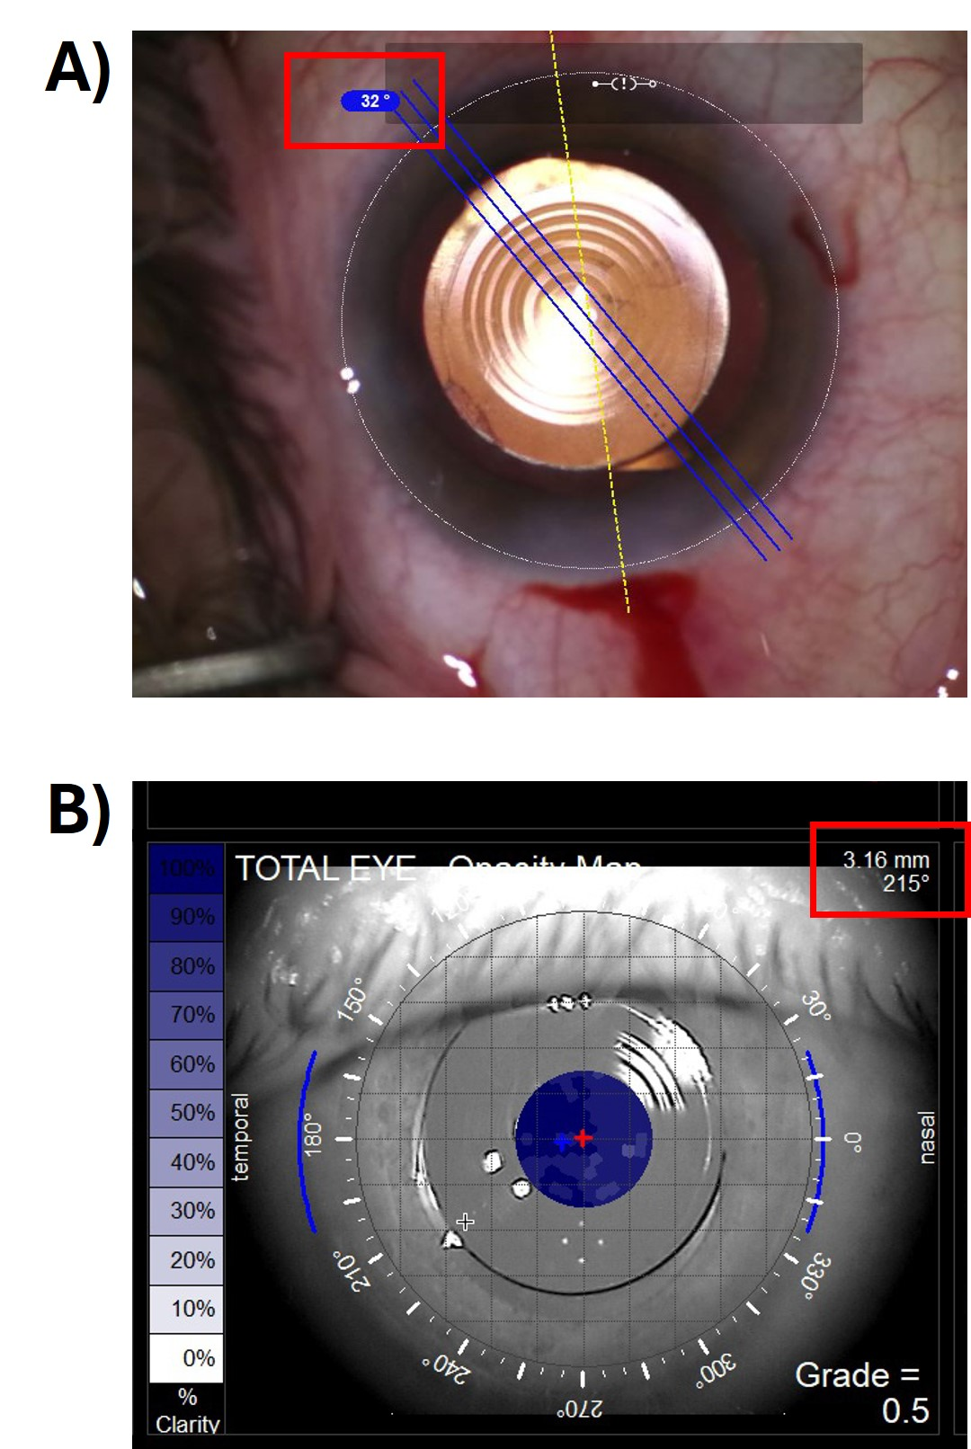

 | NAVQ | Stereoacuity | CS | UDVA | UIVA | UNVA-40 | UNVA-33
Patient satisfaction | 0.35; 0.11 | 0.15; 0.11 | 0.04; 0.83 | 0.15; 0.52 | 0.07; 0.76 | 0.14; 0.54 | 0.15; 0.52
Visual function |  | 0.23; 0.30 | 0.1; 0.67 | -0.1; 0.70 | -0.15; 0.5 | -0.07; 0.76 | 0.02; 0.93
Supplementary Table 1: Outcomes of Pearson correlation tests (r; P)

