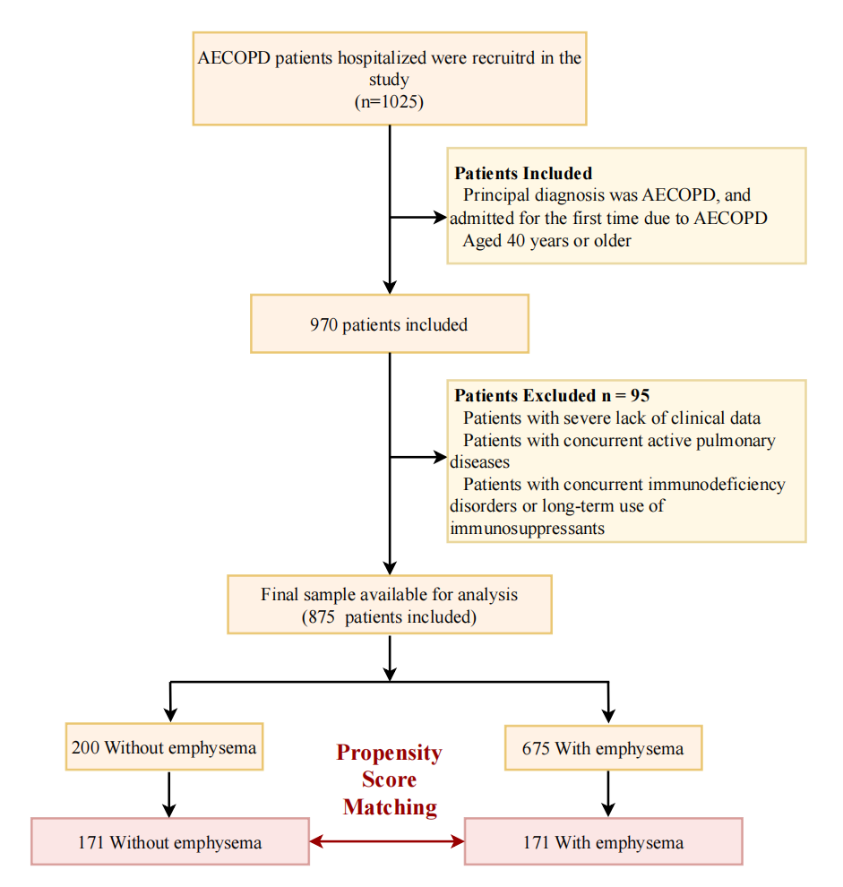
Supplemental Figure S1. Flow chart of the screening and enrollment of study participants.
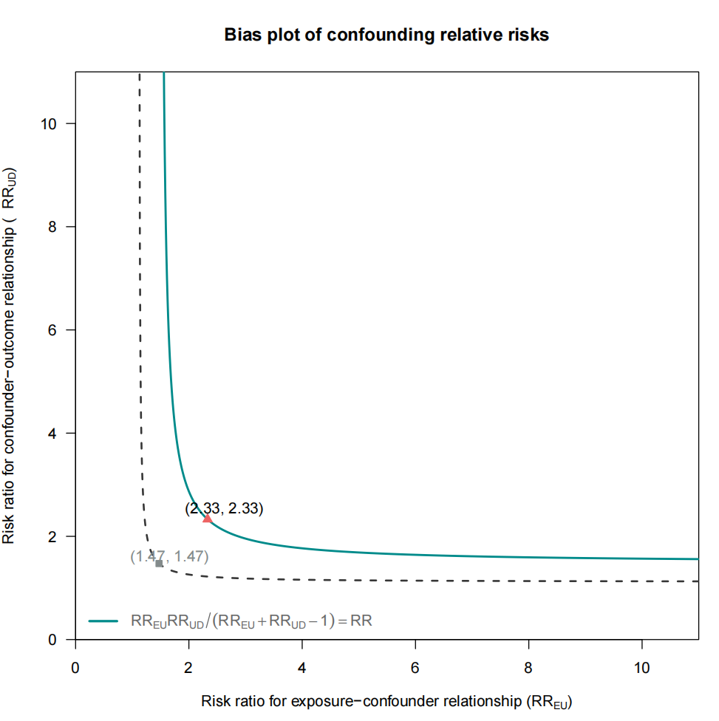
Supplemental Figure S2. Sensitivity analysis for unmeasured confounding using E-value methodology. Solid line represents the E-value for the observed risk ratio (RR). Dashed line represents the E-value for the lower bound of the 95% confidence interval. Grey squares indicate the combination points (RR_EU, RR_UD) at which an unmeasured confounder would fully explain away the observed association. Red triangles highlight the minimum joint risk ratios (RR_EU = RR_UD) required to shift the observed association to the null. The E-value for the observed risk ratio is 2.33, explicitly marked by a red triangle on the solid line.

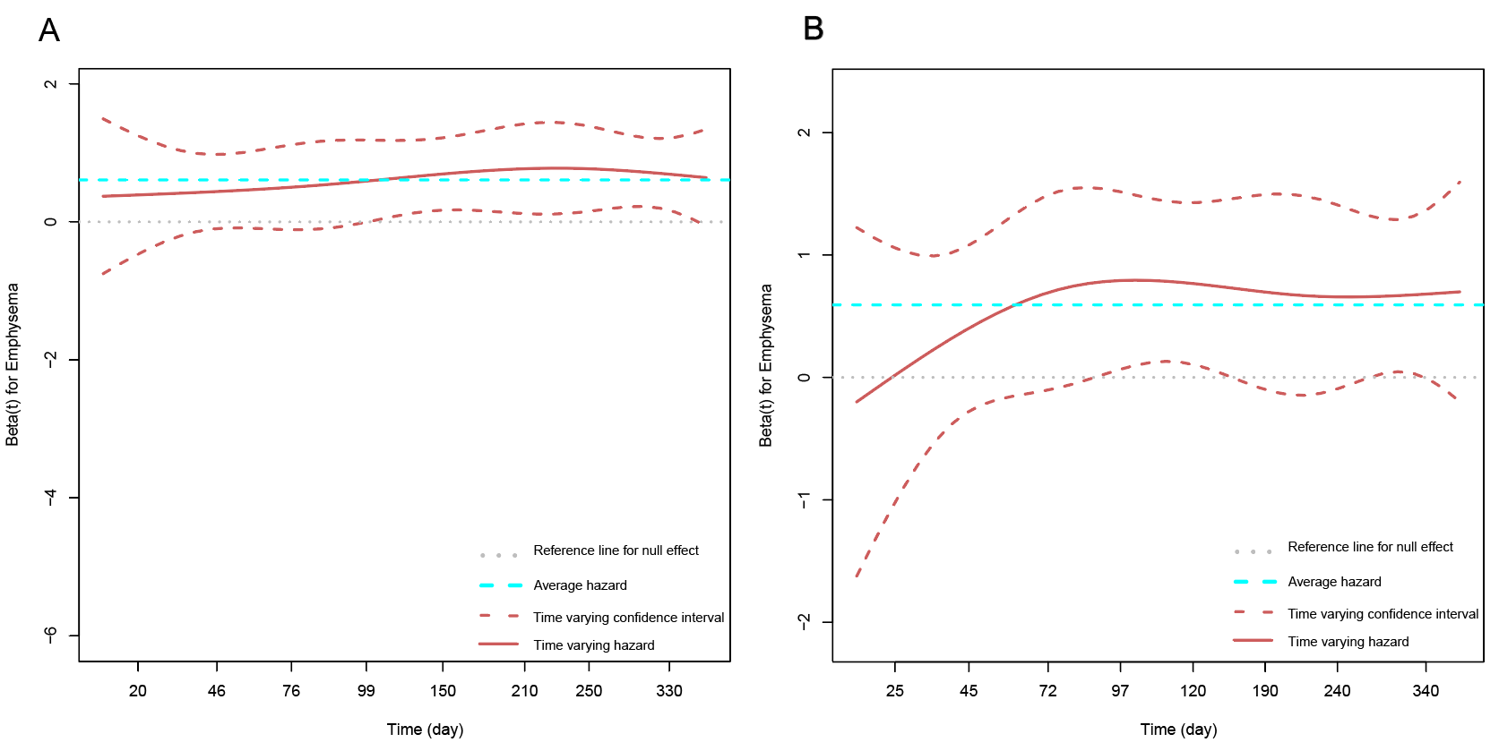
Supplemental Figure S3. Residual plot of proportional hazards hypothesis test.
- before propensity score matching, with P for proportional hazards assumption = 0.51. (B) After propensity score matching, with P = 0.47.

