Supplementary Figure S1
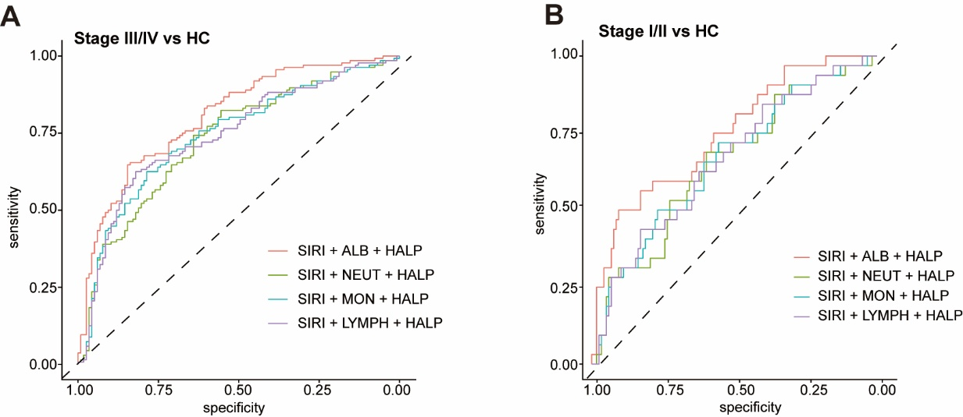
Comparison of ROC curves for different combined models in discriminating esophageal cancer from healthy controls.
(A) Pathological stage III/IV esophageal cancer versus healthy controls.
(B) Pathological stage I/II esophageal cancer versus healthy controls.
The evaluated models included SIRI + albumin (ALB) + HALP, SIRI + neutrophil count (NEUT) + HALP, SIRI + monocyte count (MON) + HALP, and SIRI + lymphocyte count (LYMPH) + HALP. All combined models were constructed using binary logistic regression.
Supplementary Figure S2.
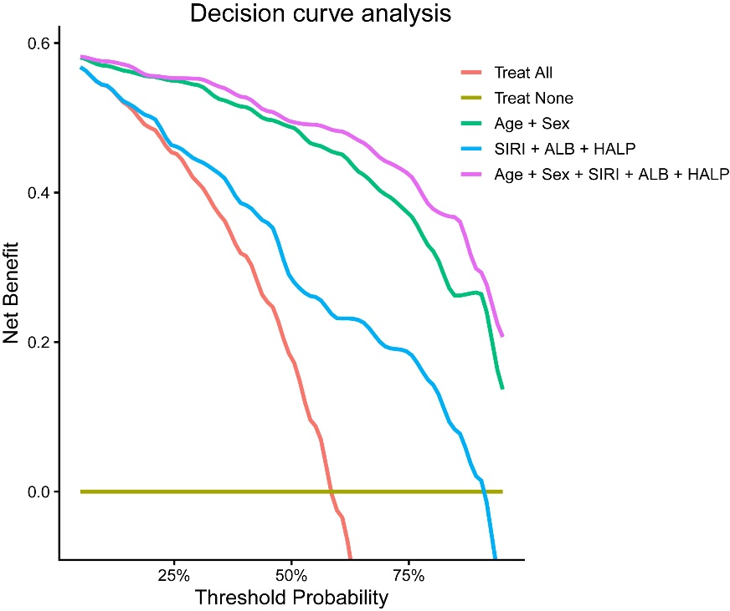
Decision curve analysis (DCA) comparing the clinical model (age and sex), biomarker model (SIRI, ALB, and HALP), and full model (age, sex, SIRI, ALB, and HALP) for discrimination of esophageal cancer. The full model demonstrated a higher net benefit than the biomarker-only model and the treat-all or treat-none strategies across most threshold probabilities.
Supplementary Table S1: Age- and sex-adjusted multivariable logistic regression analyses.
Comparison | Term | OR_95CI | P_value
all cancer vs HC | Age | 1.174 (1.110-1.243) | <0.001
all cancer vs HC | Male vs Female | 3.971 (1.293-12.193) | 0.016
all cancer vs HC | SIRI | 2.280 (0.938-5.544) | 0.069
all cancer vs HC | ALB | 1.010 (0.901-1.132) | 0.866
all cancer vs HC | HALP | 0.973 (0.953-0.994) | 0.013
stage III/IV vs HC | Age | 1.164 (1.095-1.238) | <0.001
stage III/IV vs HC | Male vs Female | 3.194 (0.991-10.290) | 0.052
stage III/IV vs HC | SIRI | 2.323 (0.831-6.496) | 0.108
stage III/IV vs HC | ALB | 1.026 (0.905-1.163) | 0.687
stage III/IV vs HC | HALP | 0.965 (0.942-0.989) | 0.005
stage I/II vs HC | Age | 1.148 (1.068-1.233) | <0.001
stage I/II vs HC | Male vs Female | 3.972 (0.675-23.369) | 0.127
stage I/II vs HC | SIRI | 1.750 (0.642-4.772) | 0.274
stage I/II vs HC | ALB | 1.013 (0.856-1.199) | 0.882
stage I/II vs HC | HALP | 0.986 (0.959-1.014) | 0.326

Supplementary Table S2: Bootstrap internal validation results
Comparison | N | AUC_95CI | Optimism | AUC corrected | N boot | N valid boot
all cancer vs HC | 285 | 0.970 (0.952-0.988) | 0.004 | 0.966 | 1000 | 1000
stage III/IV vs HC | 253 | 0.974 (0.958-0.990) | 0.005 | 0.97 | 1000 | 1000
stage I/II vs HC | 149 | 0.955 (0.925-0.985) | 0.015 | 0.94 | 1000 | 1000

Supplementary Table S3: ROC analysis in the age- and sex-matched cohort
Indicator | AUC | CI_low | CI_high
SIRI | 0.73 | 0.60 | 0.85
ALB | 0.61 | 0.47 | 0.75
HALP | 0.76 | 0.65 | 0.88
SIRI + ALB + HALP | 0.81 | 0.70 | 0.92

