
Supplementary Figure 1: Content Validity Form as given to the reviewers for relevance, clarity and essentiality of each item.
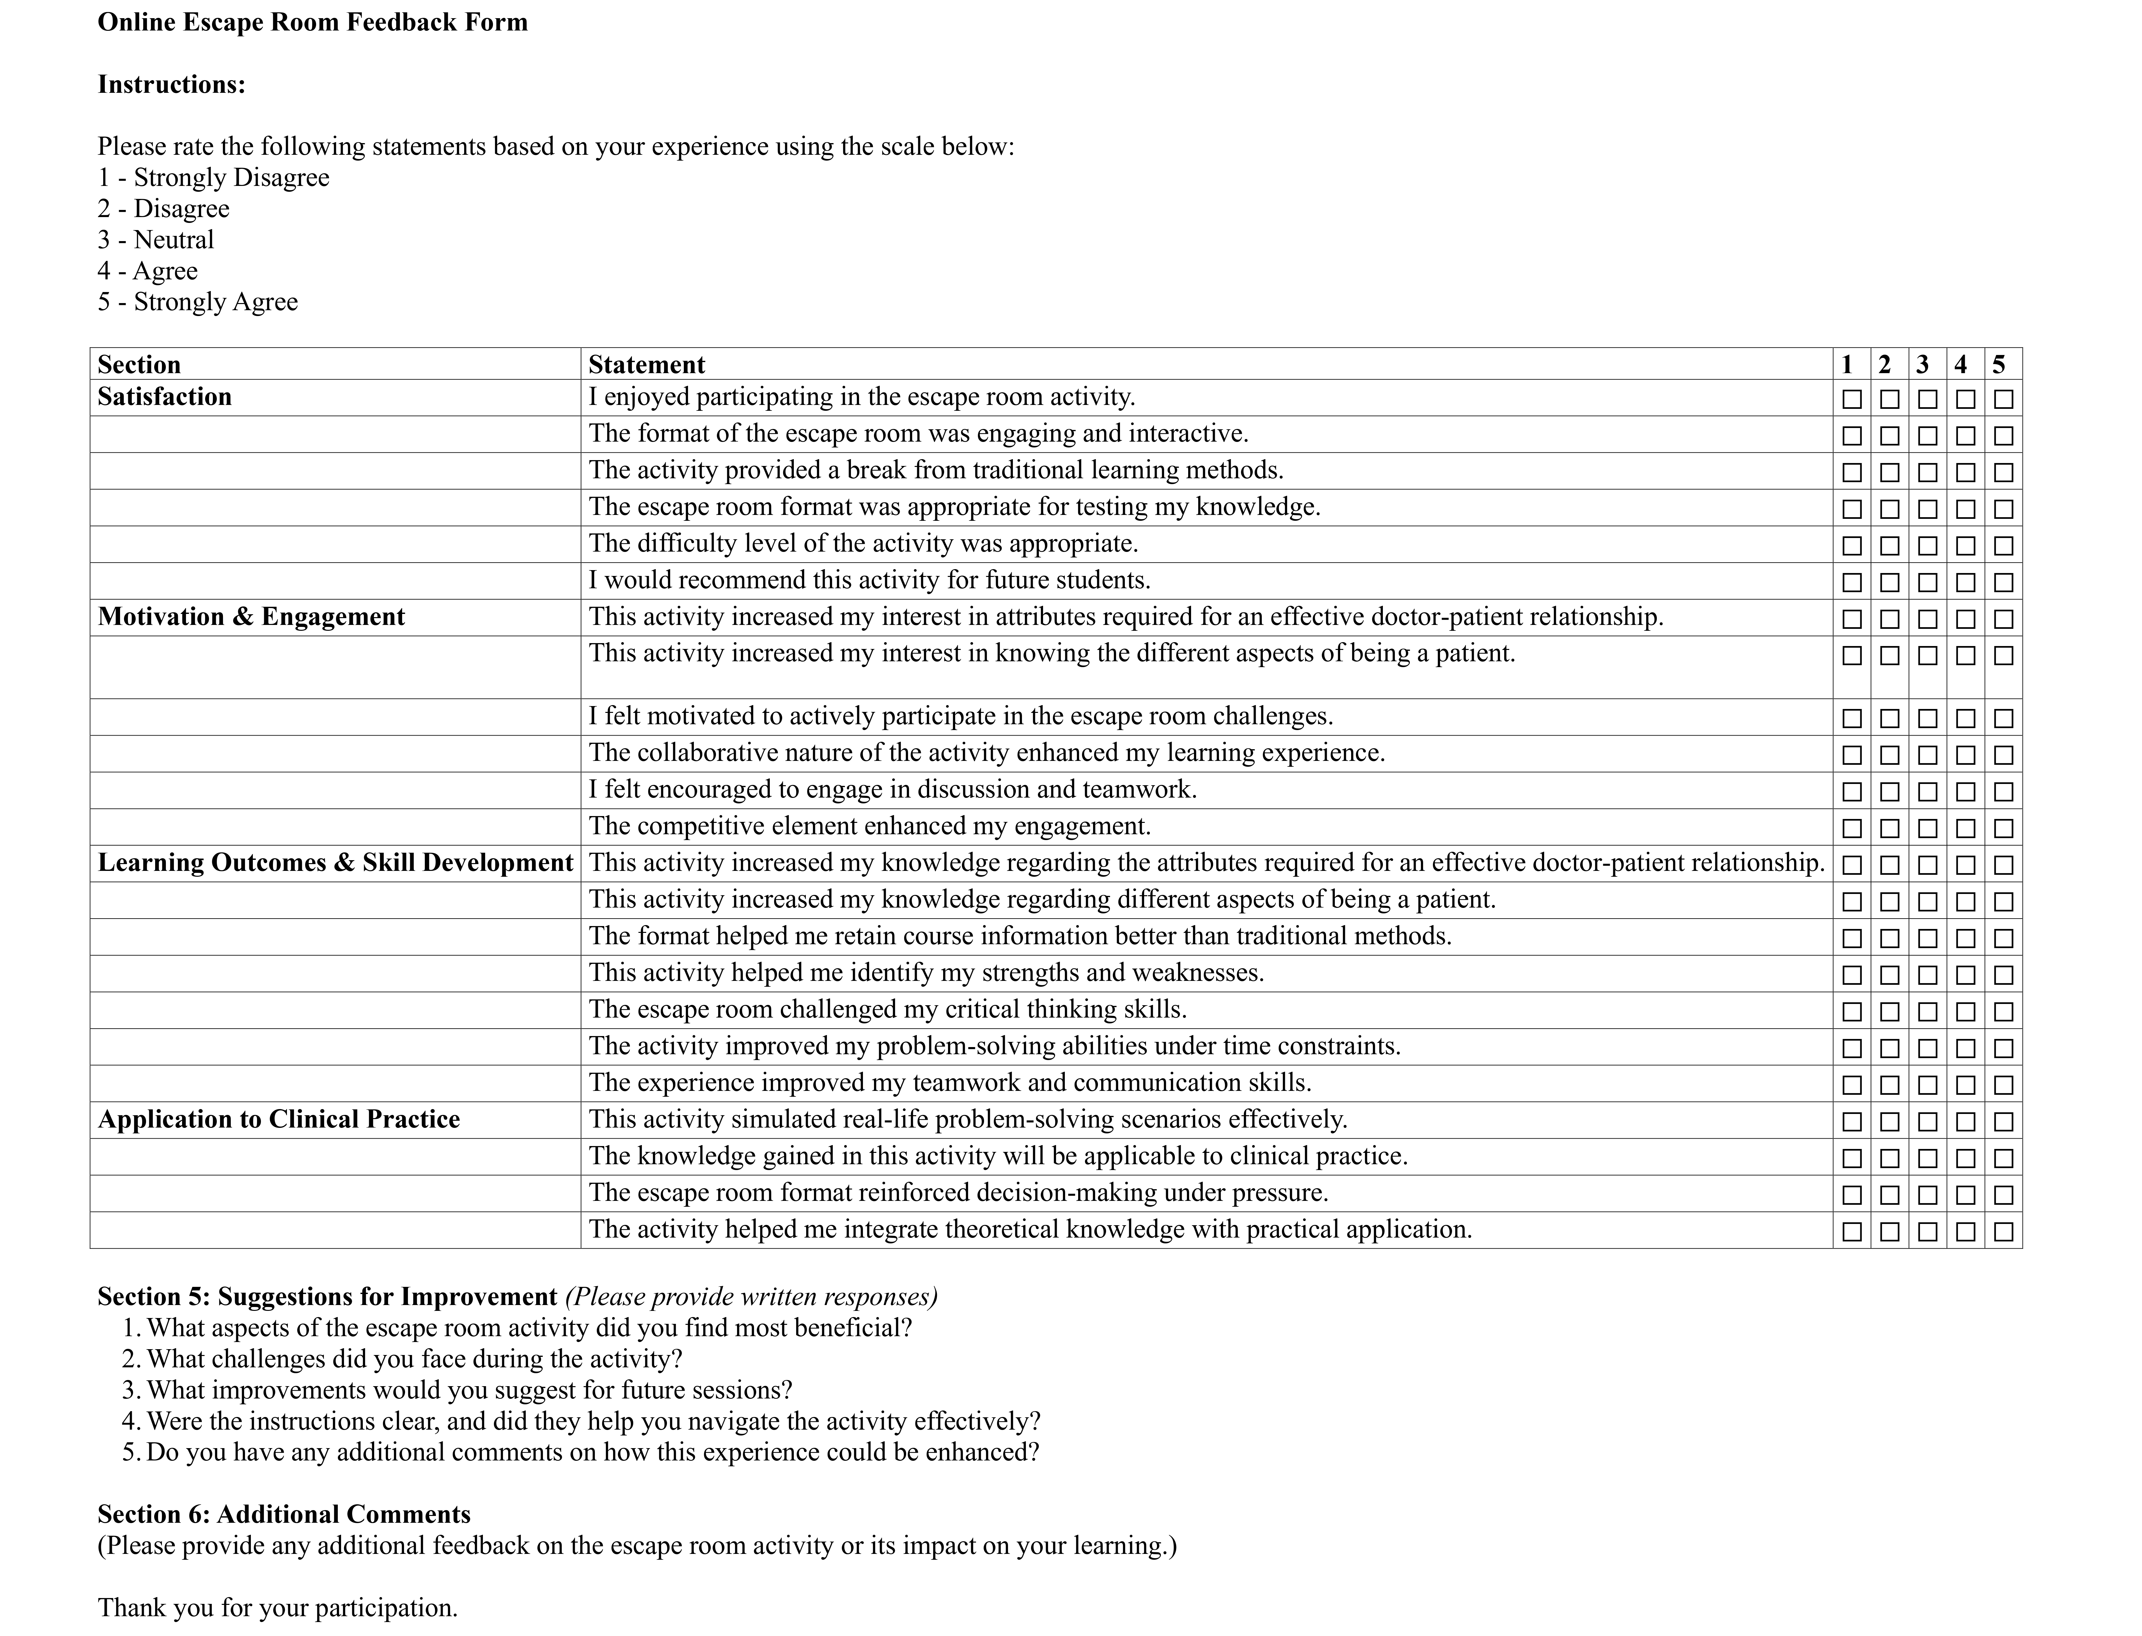

Supplementary Figure 2: Feedback form used for the study

Supplementary Table 1: Pre and post assessment questions pertaining to AETCOM module 1.2 and 1.3
S.no. | Questions |  | Answers
1 | A doctor-patient contract must always be explicit and written for it to be legally valid. |  | False
2 | A doctor can terminate a doctor-patient contract at any time if they feel uncomfortable treating the patient. |  | False
3 | Professional equanimity means that doctors should always suppress their emotions and avoid personal engagement with their patients. |  | False
4 | A patient’s cultural background has no impact on their coping mechanisms during illness. |  | False
5 | Effective non-verbal communication, such as body language and eye contact, is just as important as verbal communication in building trust with patients. |  | True
6 | A doctor must always prioritize their own professional judgment over a patient’s preferences. |  | False
7 | Maintaining professional boundaries means doctors should avoid all emotional connections with patients. |  | False
8 | Confidentiality can be breached if a patient poses a serious threat to themselves or others. |  | True
9 | If a patient refuses a life-saving treatment, does the doctor always have the right to override their decision? |  | No
10 | Can a doctor accept expensive gifts from a patient as a token of appreciation without violating professional boundaries? |  | No
11 | If a doctor unintentionally breaches patient confidentiality, are they still legally and ethically responsible for the breach? |  | Yes
12 | Can a patient’s illness impact their family members’ mental health and social life? |  | Yes
13 | Is curing a patient always the primary goal of medical treatment? |  | No
14 | Does shared decision-making mean that the patient has the final say in all medical decisions, regardless of the doctor’s expertise? |  | No
15 | Can a doctor refuse treatment to a patient based on personal biases? |  | No
16 | If a patient lacks the capacity to make medical decisions, does a doctor always make decisions alone? |  | No
17 | 1. Informed Consent  2. Empathy  3. Autonomy  4. Confidentiality  5. Beneficence | a) Keeping patient information private and secure  b) Patient’s right to make decisions about their care  c) The ability to understand and share a patient's feelings  d) A process where a patient agrees to treatment after understanding the risks and benefits  e) The principle of acting in the best interest of the patient | 1 ->d, 2 ->c, 3 ->b, 4 -> a, 5 -> e
18 | 1. Professional Boundaries  2. Power Imbalance  3. Paternalism  4. Patient Autonomy  5. Non-Verbal Communication | a) The ability of a patient to make their own medical decisions based on adequate information and mental capacity.  b) The inherent difference in authority between doctors and patients, which can impact communication and decision-making.  c) When a doctor makes decisions on behalf of a patient, assuming it is in their best interest, often limiting patient autonomy.  d) The ethical and professional limits that ensure appropriate doctor-patient interactions.  e) Using body language, facial expressions, and gestures to enhance doctor-patient interaction. | 1 -> d, 2 -> b, 3 -> c, 4 -> a, 5 -> e
19 | Instructions: Arrange the following steps in the correct order for building an effective doctor-patient relationship.  a) Engage in active listening and ask open-ended questions  b) Establish a professional and respectful introduction  c) Provide clear explanations and set expectations for treatment  d) Address the patient’s emotions and concerns with empathy  e) Encourage shared decision-making and patient involvement |  | b, a, d, c, e
20 | Instructions: Arrange the following steps in the correct ethical decision-making process in patient care.  a) Identify the ethical dilemma and gather relevant facts  b) Consider ethical principles (e.g., autonomy, beneficence, justice)  c) Discuss possible options with the patient and healthcare team  d) Implement the decision while respecting patient rights  e) Evaluate the outcome and reflect on lessons learned |  | a, b, c, d, e

