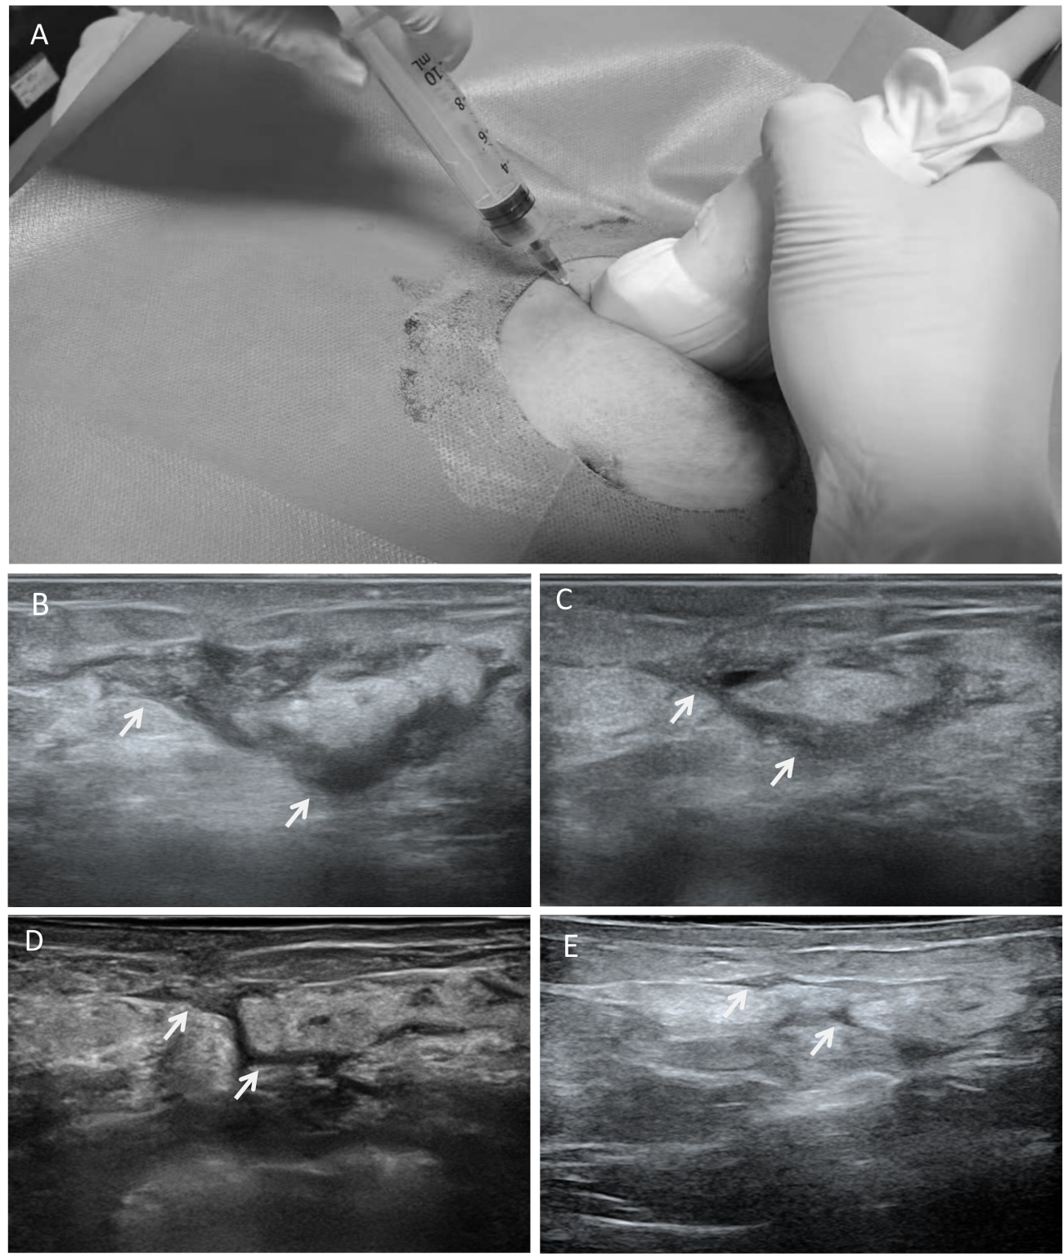
Figure S1. Treatment process of a 36-year-old female patient diagnosed with granulomatous mastitis who received local injection therapy. (A) Schematic illustration of the local intralesional injection procedure. (B–E) Serial ultrasound images showing the lesion at different time points: (B) February 6, 2023(Smax=3.97cm²); (C) March 10, 2023 (Smax=2.52cm²); (D) April 15, 2023 (Smax=0.30cm²); (E) April 26, 2023 (Smax=0.18cm²). White arrows in panels B–E point to the inflammatory lesions.Progressive resolution of the inflammatory lesion was observed during follow-up.

